To sign the Certifications and Assurances pull up your grantee profile in recipients and select View/Modify Recipient.

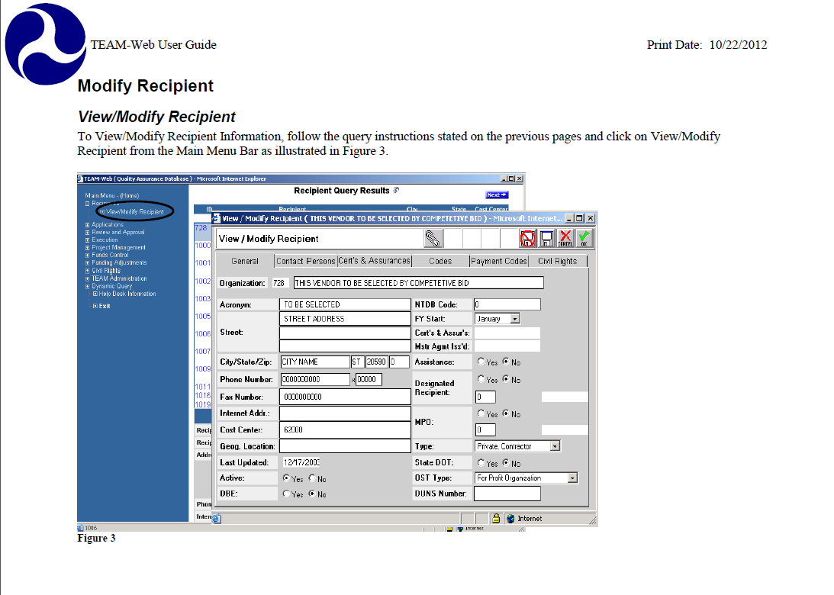

**2. Select the Certs and Assurances Tab then click and PIN your affirmation.**