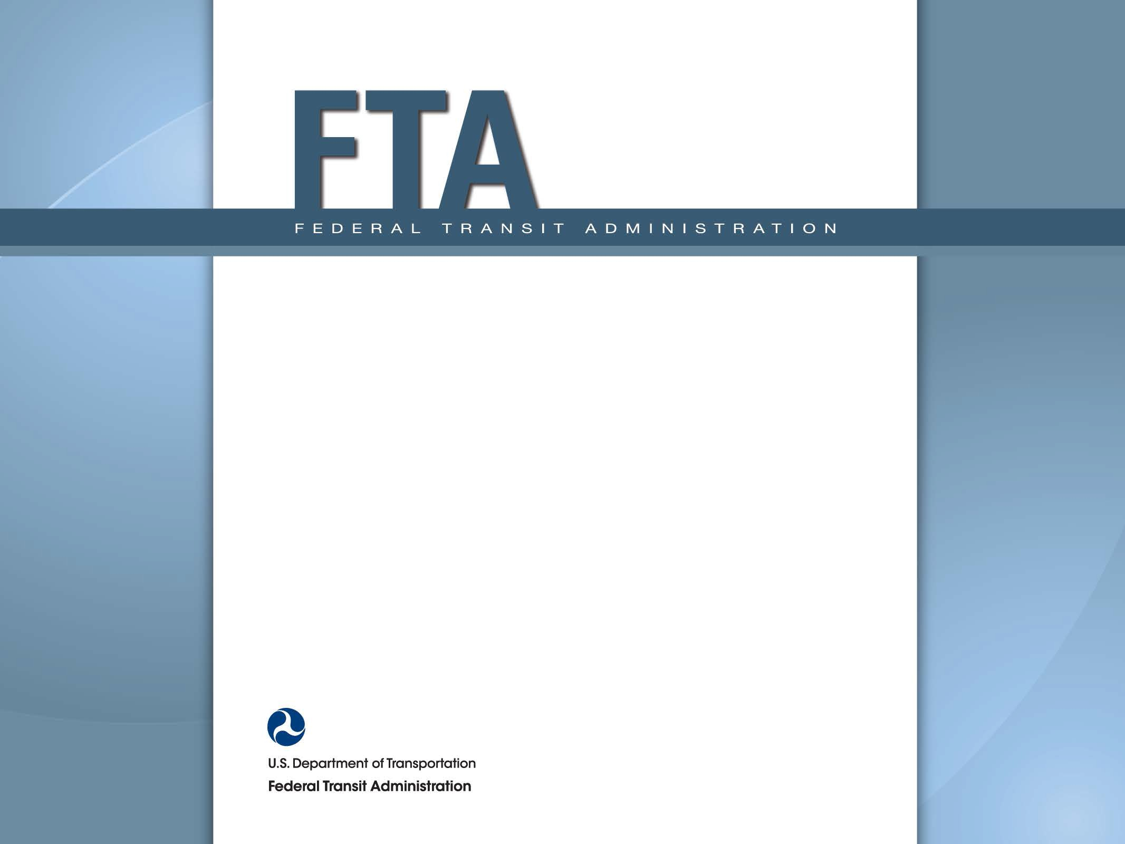

National Transit Database
Annual Reporting

2014 User Manual

Table of Contents

Table of Contents 2
Table of Figures 5
New Reporting System (NTD 2.0) 7
Background 7
Steps for Starting Annual Reporting 7
What is a Kickoff? 7
NTD Contact Logs in to NTD 2.0 8
Navigate to Kickoff 9
How to Start Report Kickoff 10
Accept Kickoff Task 11
Manage Reporter Users 12
Manage Modes 13
Previous Reporter Type Confirmation 14
Complete Kickoff 16
Getting to “Forms” Page 17
Report Packages Screen 18
Report Package Summary Page 19
Individual Annual Forms by Mode/TOS 20
Identification Form (B-10) 21
Update B-10 Organization Type 22
Update B-10 Demographic Information 23
Update B-10 Filing a Separate Report 24
What Happened to Name, Address and Other B-10 Data? 25
Profile Information (formerly on B-10 form) 26
Profile Page 27
Profile Summary Page 28
Profile Forms Page 29
Basic Information (P-10) 30
B-30 Add/Remove/View Contract 31
Contract Summary 32
Key Financial and Operation Statistics 33
Enter Operating and Financial Data 34
Source of Funds (F-10) 35
Funding Categories 36
Customized Federal Funds Reporting 43
Customized Federal Data Entry 44
Federal Funding Summary Page 45
Uses of Capital (F-20) 46
Operating Expenses (F-30) 47
Operating Expense Summary (F-40) 48
Reconciling Items (F-40) 49
Statement of Finances Form (F-60) 50
Stations Maintenance Facilities (A-10) 51
Transit Way Mileage (A-20) 52
Entering Rail Transit Way Data 53
Entering Bus Transit Way Data 54
Revenue Vehicle Inventory (A-30) 55
“Add Fleet” Data Entry Screen 56
“Edit Fleet” Data Entry Screen 57
Reporting Mileage by Fleet 58
Reporting Energy Consumption 60
Key Data Summary Screen 62
Service Supplied (S-10) 63
VOMS and Periods of Service 64
Services Supplied 65
Services Consumed 66
Services Operated (Days) 67
Directional Route Miles 68
Employees (R-10) 69
Maintenance Performance (R-20) 70
Federal Funding Allocation Statistics (FFA-10): No FG or HIB 71
CEO Certification (D-10) 72
D-10 Federal Funding Allocation Data 73
D-10 Financial Data 74
D-10 Funding Allocation Review 75
D-10 PMT Sampling 76
D-10 UPT Sampling 77
National Transit Database Offices 77
Training 78

Table of Figures

Figure 1- Example of Process flow on editing the B-10 and A-10 forms 6
Figure 2 - NTD 2.0 Reporter Type Questionnaire 15

Figure 1- Example of Process flow on editing the B-10 and A-10 forms

New Reporting System (NTD 2.0)

Background
Monthly ridership reporting started October for reporting September data. Annual reporting started December 15 for FY 2014 reporting. There are no changes in data requirements. NTD 2.0 has the same requirements in as the previous system.

Steps for Starting Annual Reporting
- Perform “report kickoff”
- Systems now in FY 2014 will do on first day of FY 2015
- No action needed from reporters now in FY 2015 (kickoff already completed)
- All systems perform reporting after the end of FY 2014.

What is a Kickoff?
Kickoff is the confirmation of the current “profile” information at the beginning of the fiscal year. The purpose of Kickoff is to create annual reporting forms for the prior year (e.g., FY 2014), and create monthly reporting forms for the current year (e.g., FY 2015). The profile information is gathered from the old B-10, and B-20 data. Below is a summary of steps for Kickoff.

Kickoff steps:
- Log-in as NTD Contact
- Kickoff Starts on News Page
- Click on Task link
- Confirm reporter contact information is accurate.
- Confirm mode information is accurate.
- Confirm declared reporter type for previous FY is still accurate (e.g., small systems waiver)
- Declare reporter type for new fiscal year

NTD Contact Logs in to NTD 2.0

To access NTD, log-in
- Enter your User Name and Password
- Click on Sign In

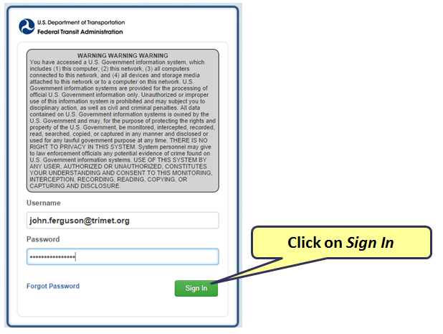

Navigate to Kickoff

Kickoff Starts on the News Page.
- A notice will be posted on News that Report Year is ready for Kickoff
- Click on Task to start (e.g. FY2015)

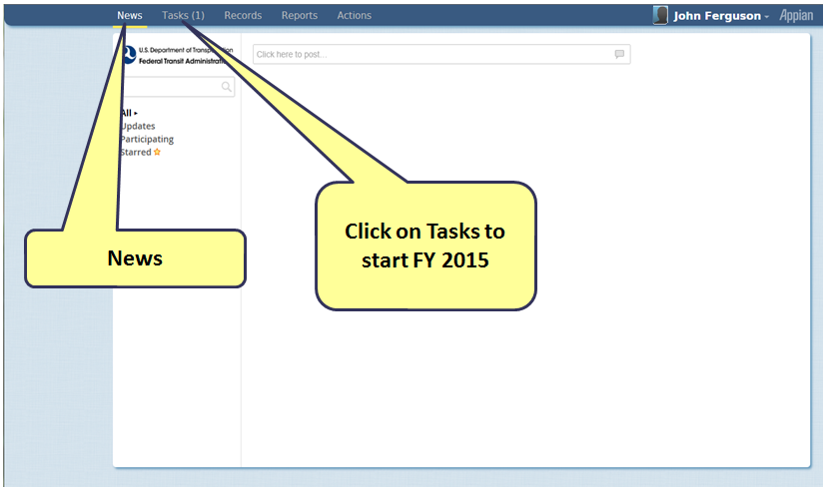

How to Start Report Kickoff

Click on Report Kickoff for Reporter #NTD ID# - #NTD Name# link in order to kick-start the Report Kickoff

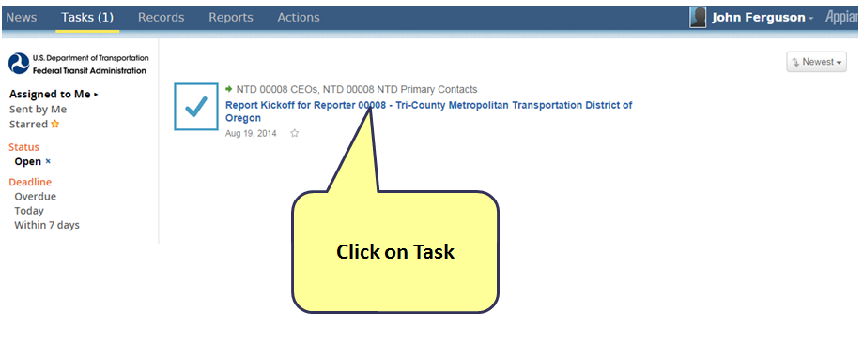

Accept Kickoff Task

Begin the Kickoff by accepting the task
- Click Accept
- Click Proceed

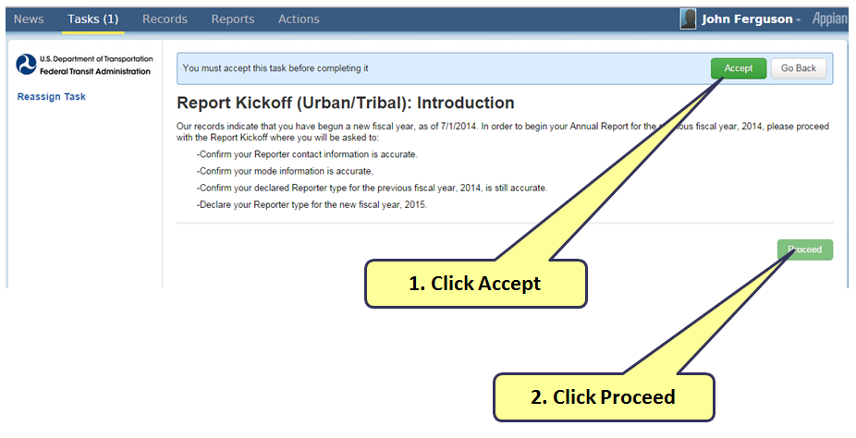

Manage Reporter Users

Add, remove, or edit user information on the manage Reporter User screen.

- Only user manager can add new users
- Individual users can edit own profile
- Once finished viewing and/or editing users & profiles, click Continue to go to next confirmation.

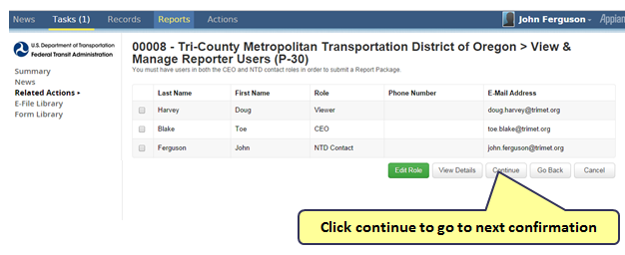

Manage Modes

Manage Reporter Mode screen you can add, remove, and edit modes

- The next screen prompt should read View & Manage Reporter Modes
- Click to add mode
- Click to edit/delete selected mode/TOS
- Add, edit, or end mode/TOS as needed

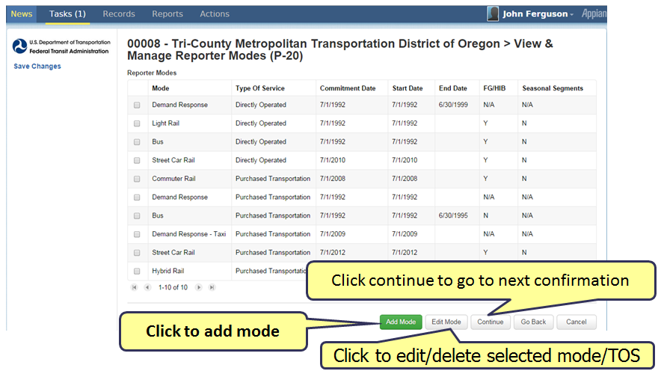

Previous Reporter Type Confirmation

Confirm the Reporter Type. If it has changed, select “Yes” for questionnaire.
- Reporter type determines your required forms
- For each question, click yes or no to proceed through each prompt
  - Cycle to the next question with each user selection
  - The questionnaire is strongly suggested for first-time NTD 2.0 users
- Click continue to complete kickoff

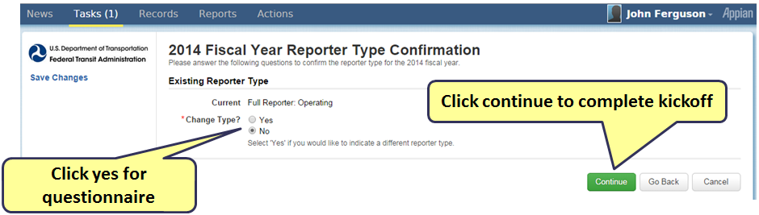
Figure 2 - NTD 2.0 Reporter Type Questionnaire
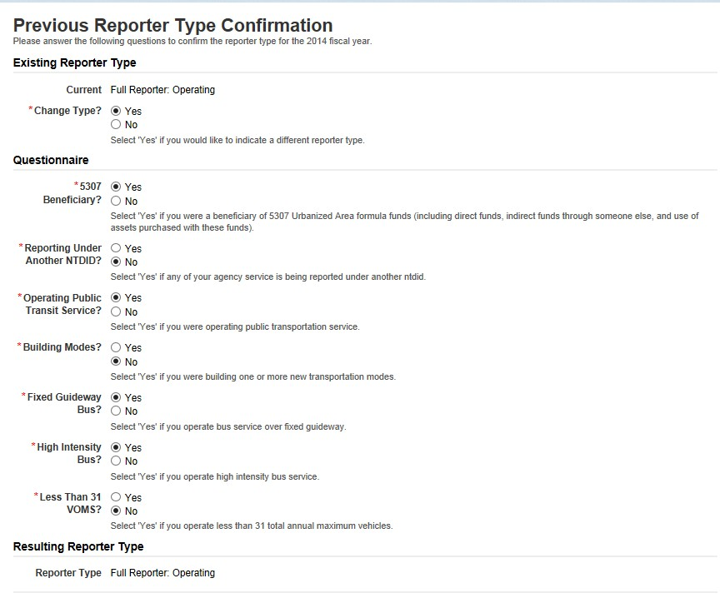

Complete Kickoff

- Once finished with last selection in questionnaire, click submit to complete kickoff
- The questionnaire will validate itself to ensure all selections have been completed
- If successful, next screen prompt will read: Thank you for completing your Report Kickoff

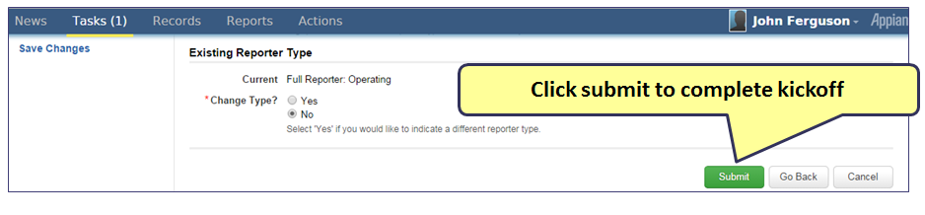
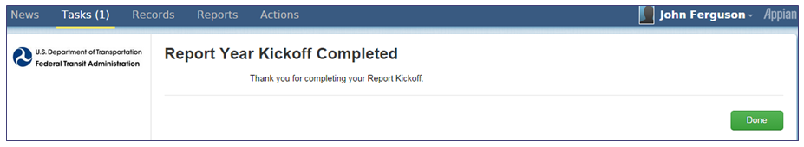

Getting to “Forms” Page

After the Kick-off is submitted the “Forms” page allows you to access forms. Follow these steps below to get there:
- Click “Records”
- Click “NTD Report Packages” to get to forms
- Click to get to monthly 2015 forms, or to the annual 2014 forms
- This will take you to the forms summary page, click on Related Actions to take action on a form

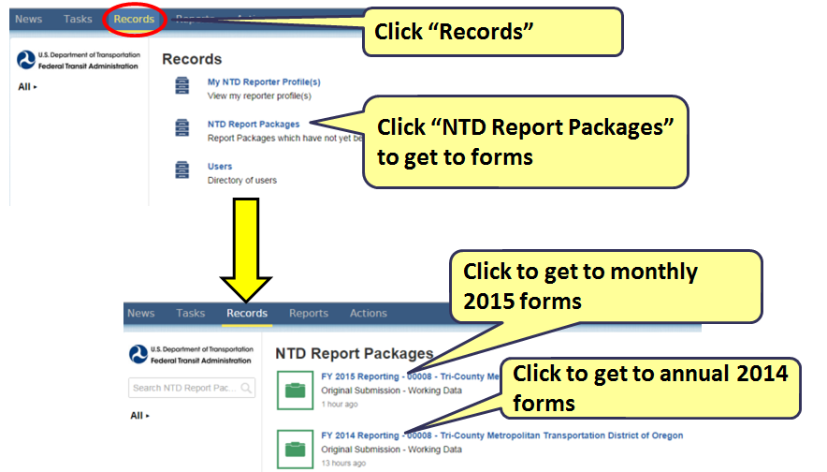

Report Packages Screen

Clicking on the annual reporting package will take you to the agency Summary page.
Click on Related Actions on the left side of the summary page.
Click Annual Forms to view or manage all Annual Forms associated with the package.

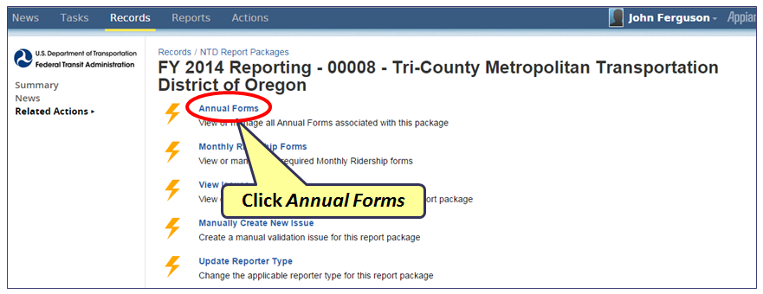

Report Package Summary Page

The Summary page displays when you first enter into the report package.
Click Related Actions to view the forms

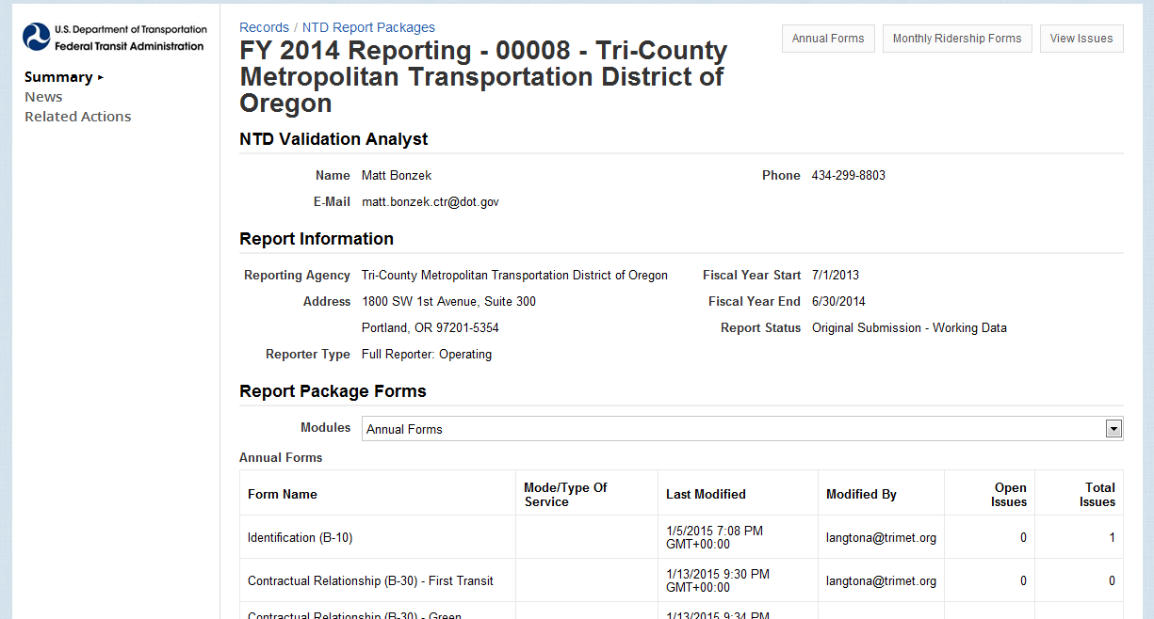
Click Related Actions

Individual Annual Forms by Mode/TOS

The forms available are shown, by mode and type of service, on the forms summary pages.
Select the form you want to view or edit:
- Check box for specific form and mode/TOS
- Then click View Form

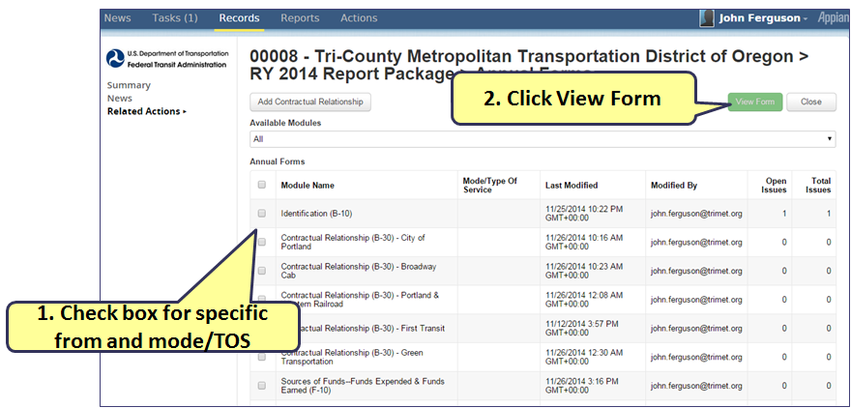

Identification Form (B-10)

- The form is broken into sections
  - Organizational type
  - Demographic information
  - Filing a separate NTD report (seller)

Update
- Click on one of the Update icons to edit that section

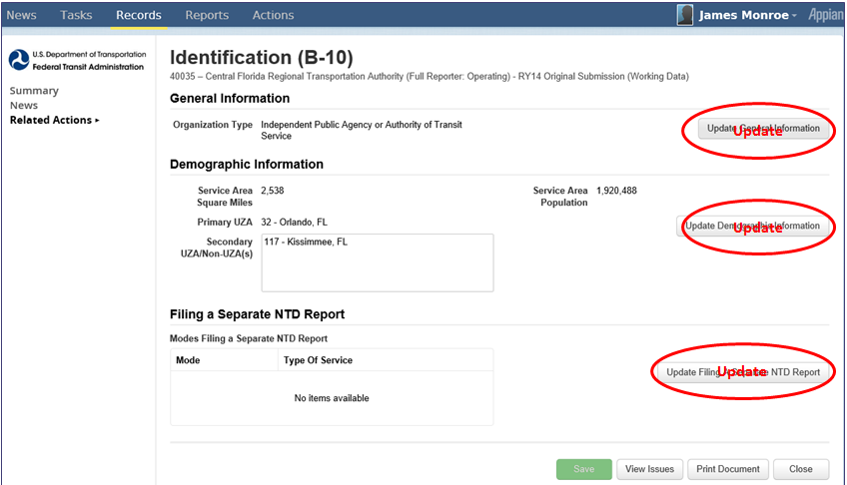

Update B-10 Organization Type

The General Information section has a list of Organization Types to select when updating
- At the screen prompt, select a value from the dropdown box
- After the selection is completed, click Continue to move forward

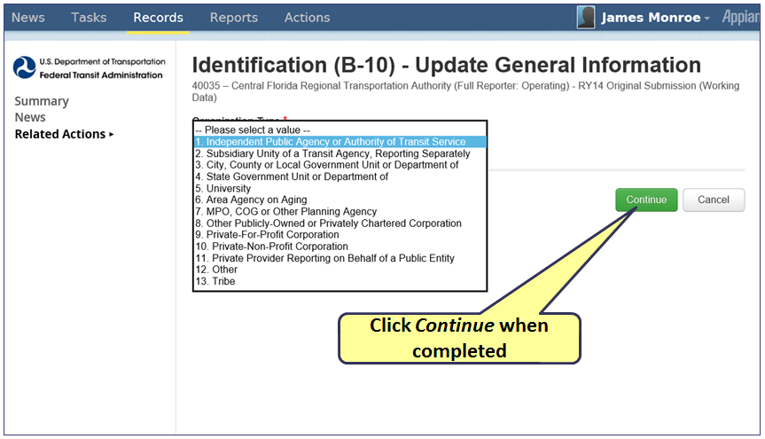

Update B-10 Demographic Information

The Demographic Information section has a list of Urbanized Areas (UZAs) in which your agency may provide service
- Click to select all UZAs that apply to your agency
- Once satisfied, click Continue to update sections

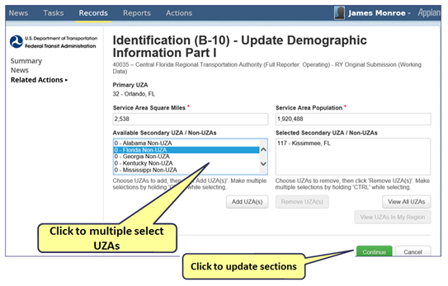

Update B-10 Filing a Separate Report

Select any of your agency’s service modes that file a separate Report (typically none do)
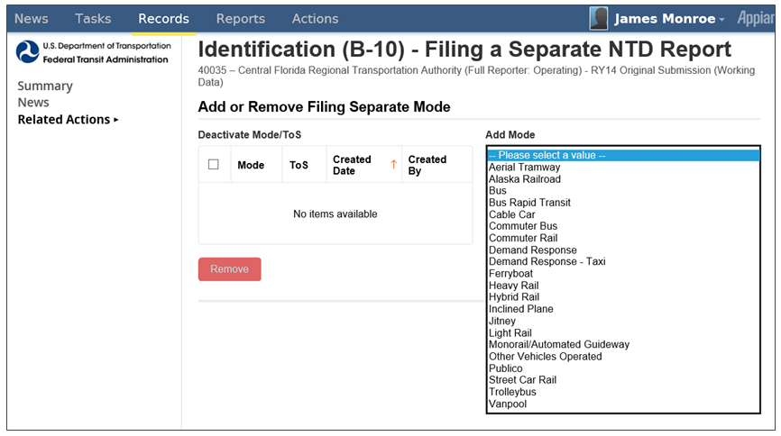

What Happened to Name, Address and Other B-10 Data?

Other B-10 Data is now located on a new P-10 form. To view the P-10, click on Records

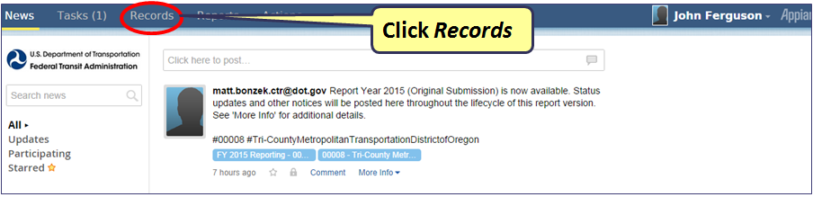

Profile Information (formerly on B-10 form)

From the Records page you can access Profile information in order to update other (formerly) B-10 data such as name, and address
- Click on Records
- Click My NTD Reporter Profile(s)
- Select your reporter Name (see Profile Page)
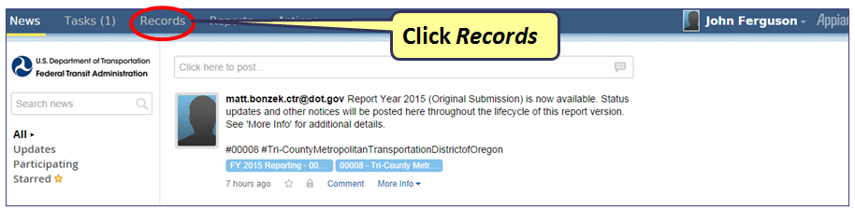

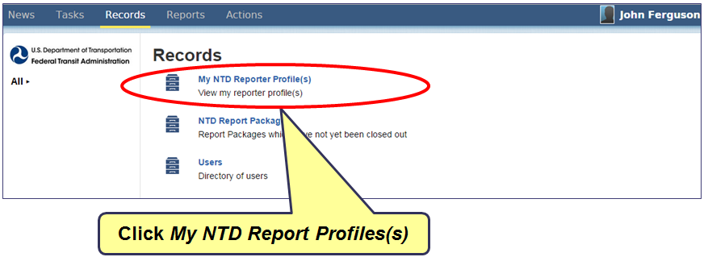

Profile Page

From My NTD Reporter Profile(s), select your agency name in order to update Other B-10 data that is now found in a new form, P-10

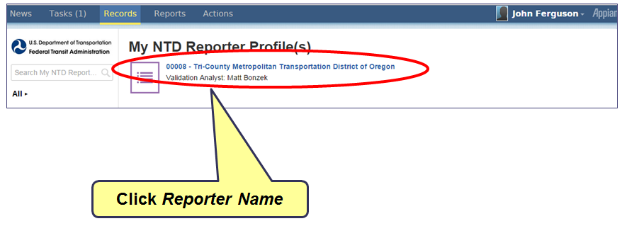

Profile Summary Page

The Summary page first displays when you first enter into the profile.
Click Related Actions to view the forms

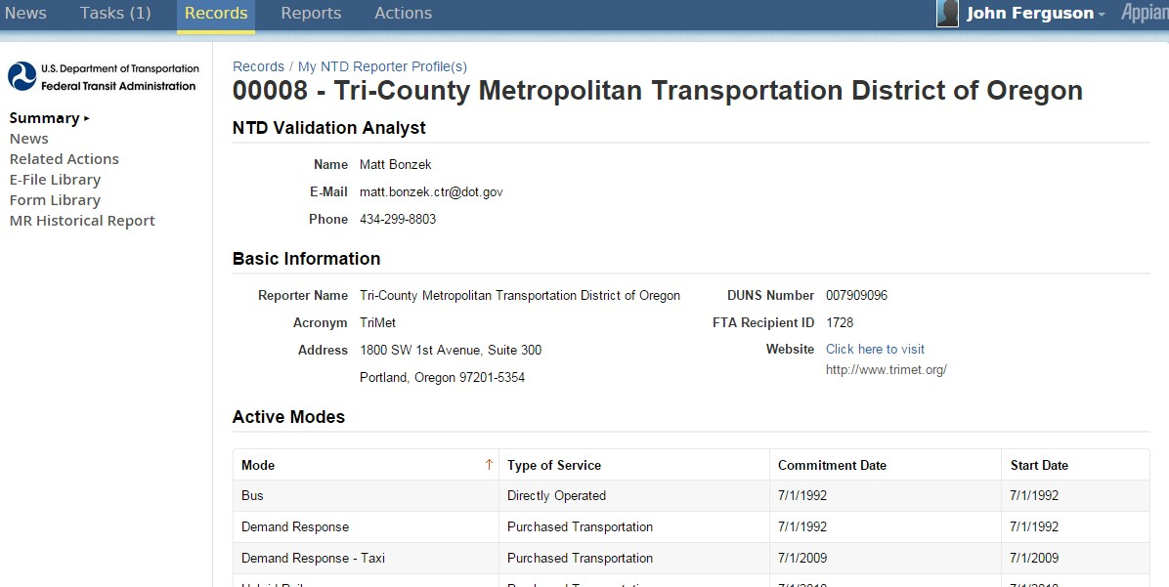
Click Related Actions

Profile Forms Page

Profile Forms page displays the forms related to the Profile (ex. P-10, P-20, P-30, P-40)
Click View & Manage Basic Information (P-10)

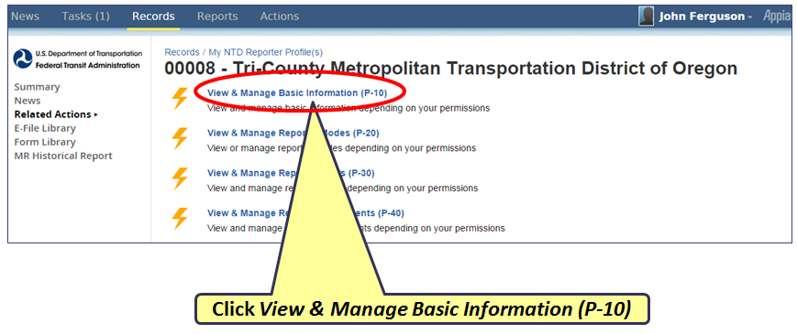

Basic Information (P-10)

The P-10 is a form found under the Profile sections
Update fields and click Save

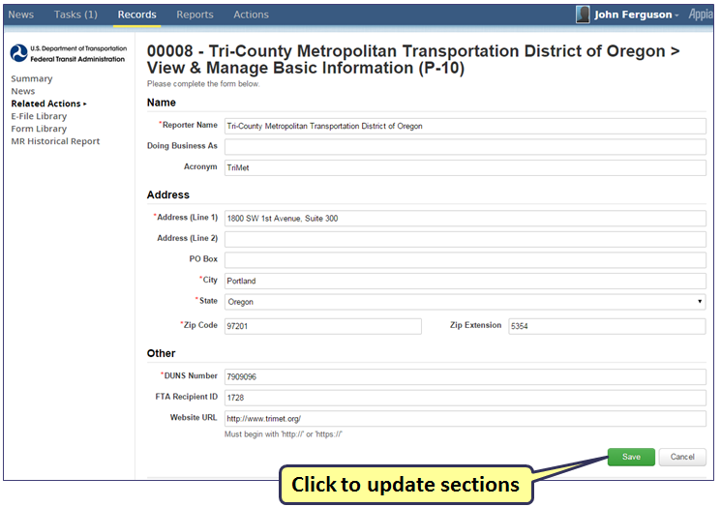

B-30 Add/Remove/View Contract

Return to Individual Forms Page and select the B-30 form

On the Annual Form section you can remove, add, or edit Contractual Relationships
- On the screen, you have the option to either Add or Remove Contractual Relationship
- Select prior RY contract and click View Form

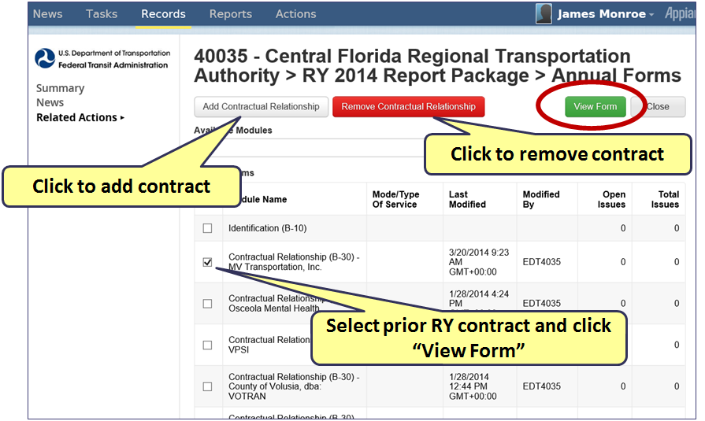

Contract Summary

When you select View Form to an existing B-30 Contractual relationship, you can then edit the entry fields..

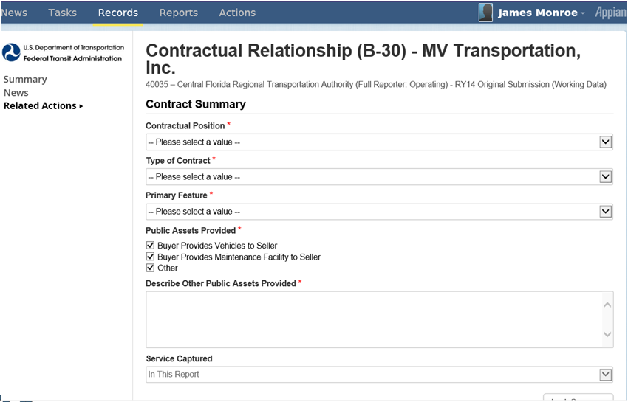

Key Financial and Operation Statistics

Scroll down B-30 screen to Key Financial and Operations Statistics
- Select Mode via checkboxes
- Once done with selection(s), click Edit Mode

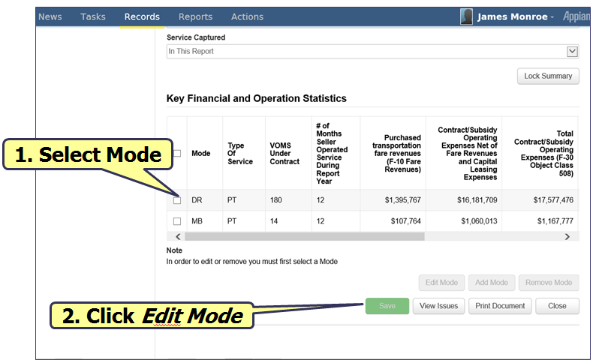

Enter Operating and Financial Data

After you selected the Mode, enter Key Financial Expenses.

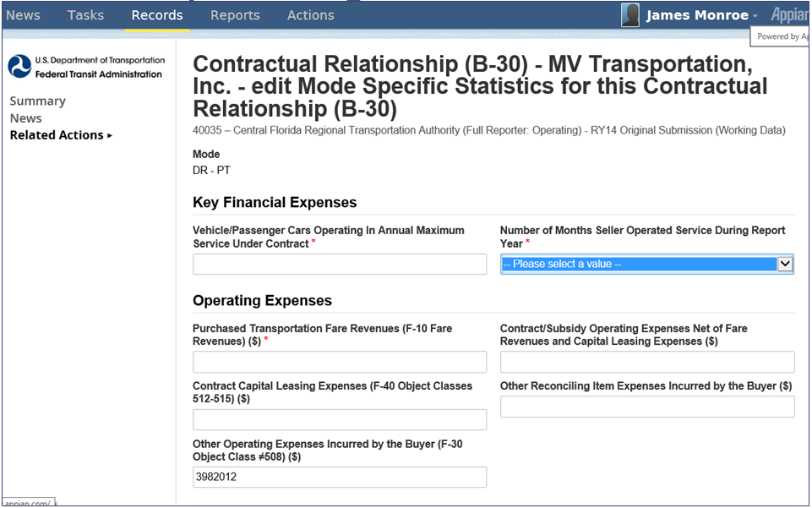

Source of Funds (F-10)

Return to Individual Forms Page and select the F-10 form

A list of Sources of Funds displays on the Summary screen

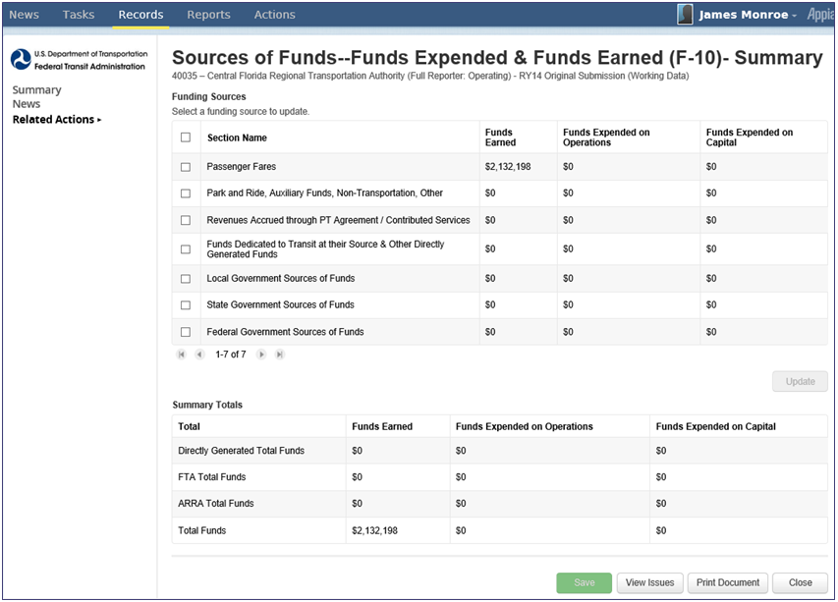

Funding Categories

The funding categories are found in the F-10 form
- Select a Funding Source to update
- Once selection(s) is made, click Update

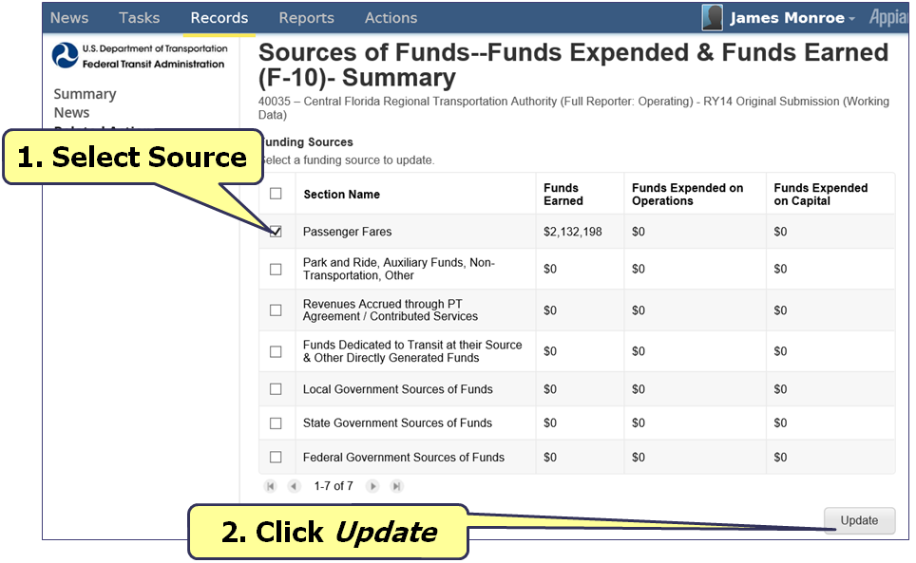

Passenger Fares DO and PT Services

Passenger Fares are found in the F-10. This is a type Source of Funds
Fill in the requested data and click Continue when complete

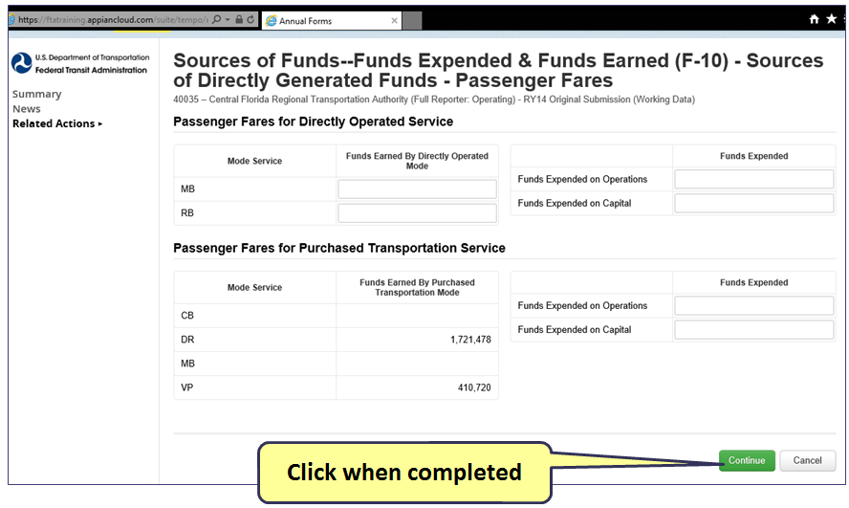

Park and Ride, Other, Auxiliary and Non-Transportation

Park and Ride, Other, Auxiliary and Non-Transportation are sources of funding.
Fill in the requested data and click Continue when complete
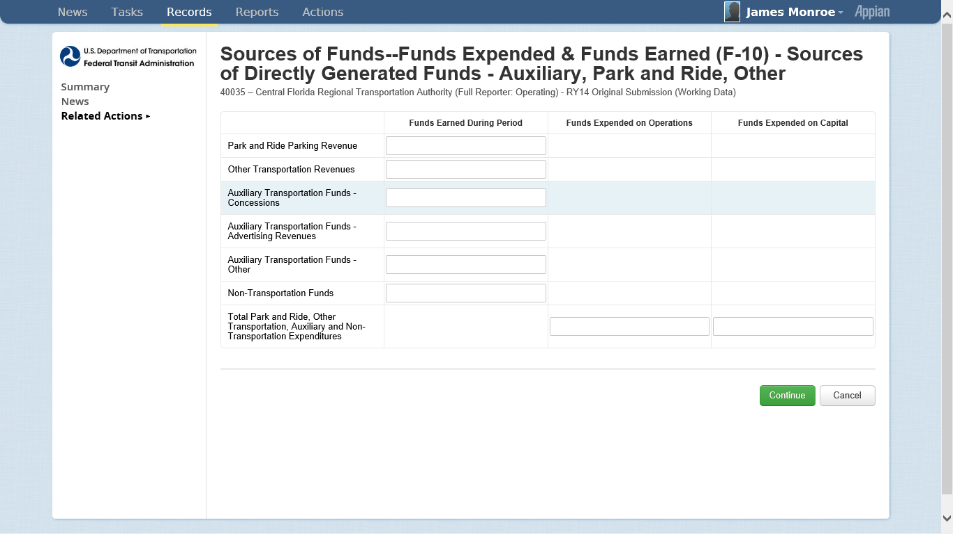
Click when completed

Revenues Accrued from PT, Contributed Services and Subsidy

Purchased Transportation, Contributed Services and Subsidy are sources of funding.
Fill in the requested data and click Continue when complete

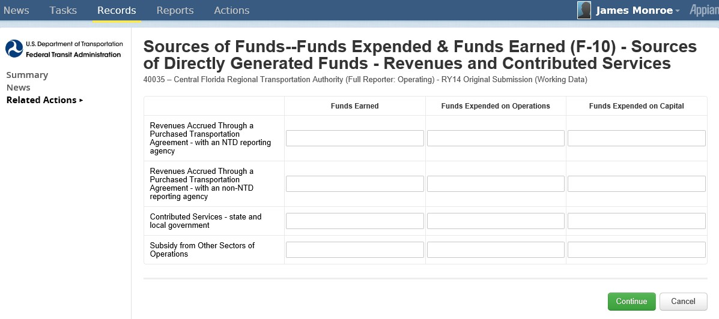
Click when completed

Revenue Sources of Independent Political Entities

Revenue Sources of Independent Political Entities are sources of funding.
Fill in the requested data and click Continue when complete
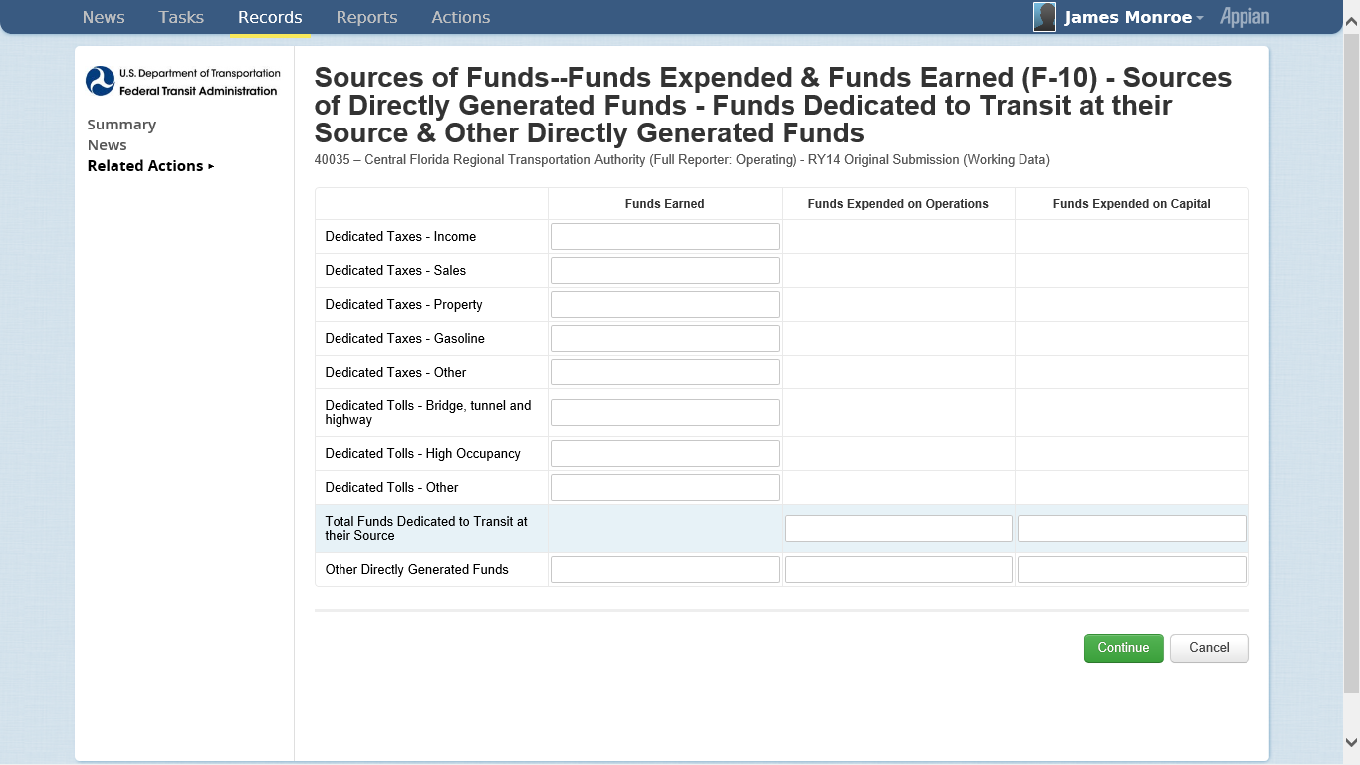
Click when completed

Local Government Funds

Local Government Funds are sources of funding.
Fill in the requested data and click Continue when complete

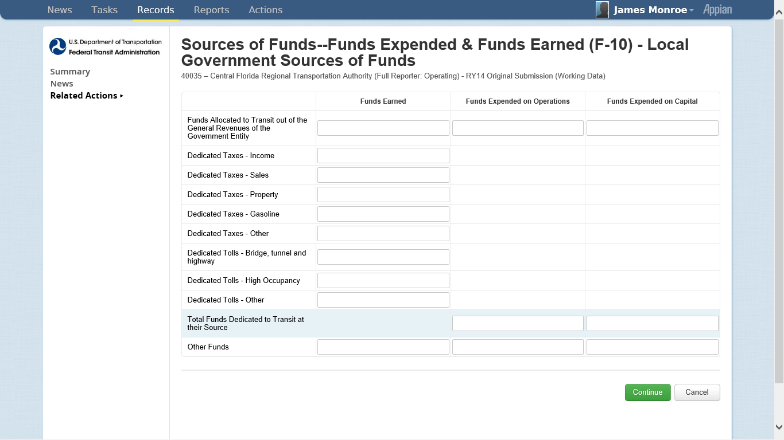

Click when completed

State Government Funds

State Government Funds

State Government Funds are sources of funding.
Fill in the requested data and click Continue when complete

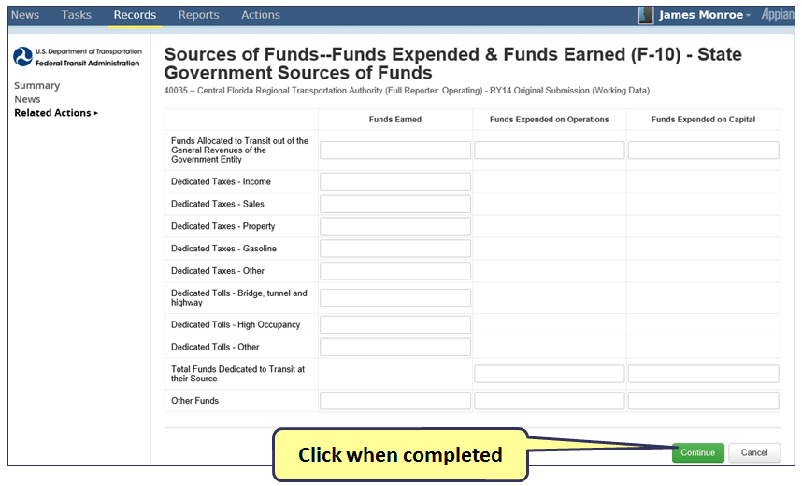

Customized Federal Funds Reporting

You can customize the Federal Funds to display the areas relevant to your agency.
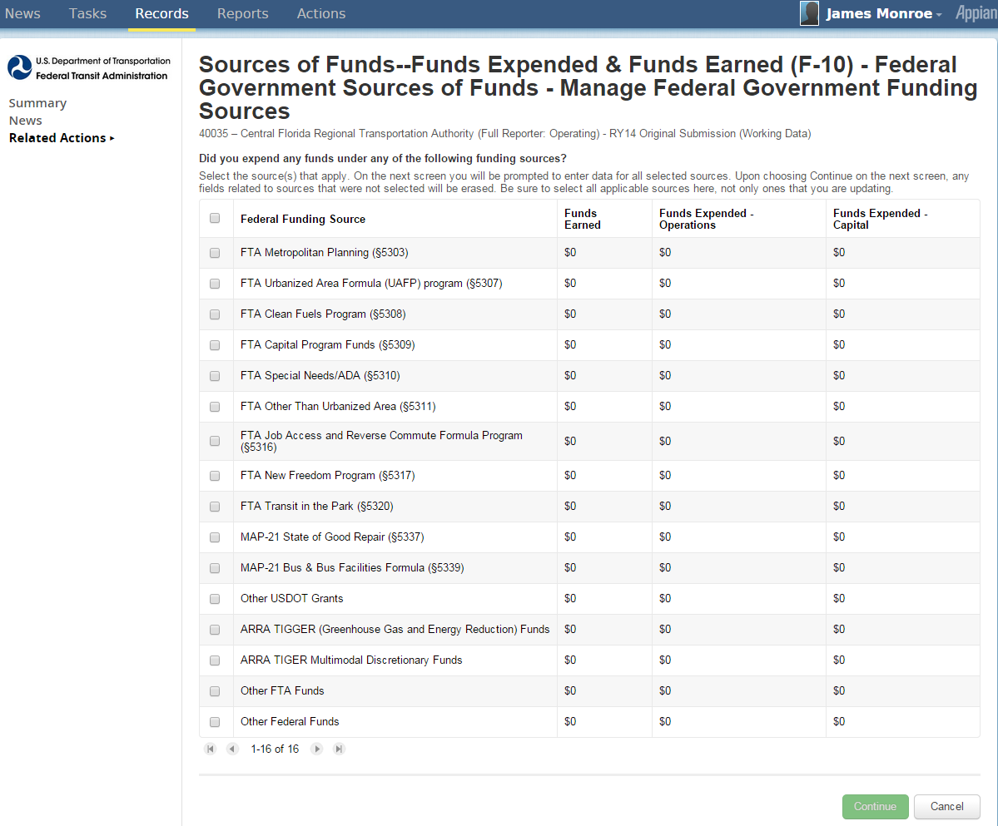
1. Click multiple boxes to select all your funding sources
2. Click when completed

Customized Federal Data Entry

You can customize the Federal Data entry by clicking on Change Funding Sources.

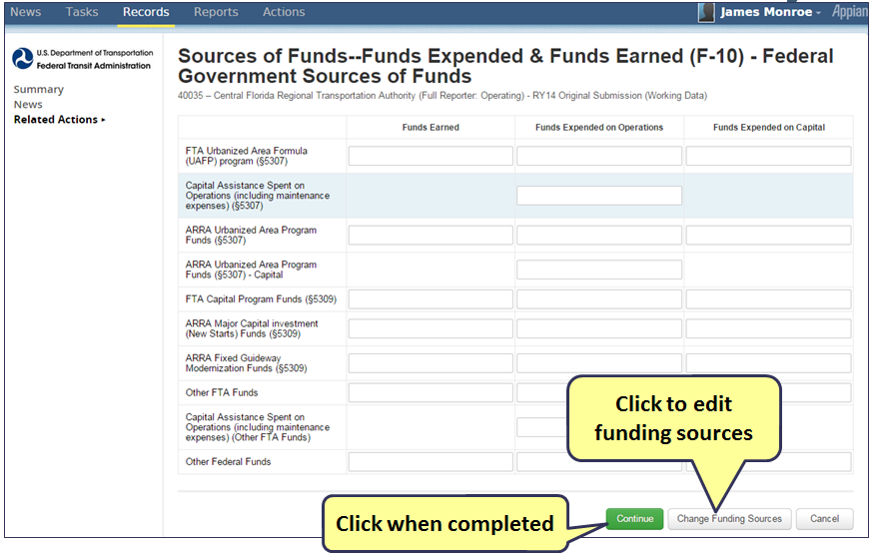

Federal Funding Summary Page

In the F-10 summary page you can view a summary of the data that was entered.
Click Save before exiting to save your changes. Click Close to return back to the “Forms” page

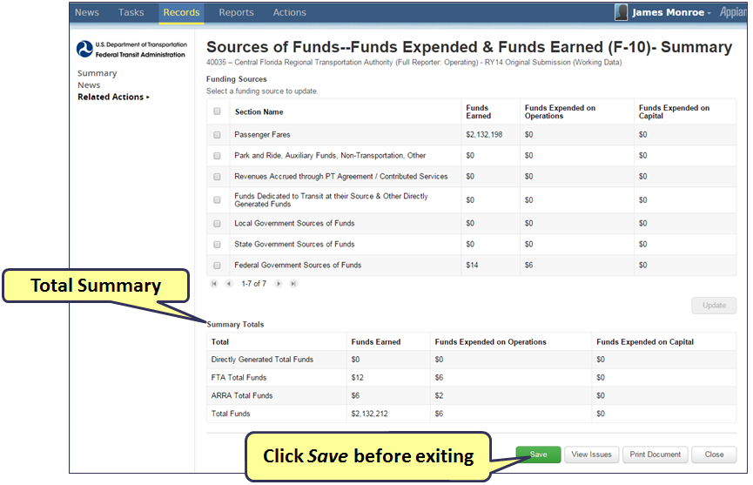

Uses of Capital (F-20)

Return to Individual Forms Page and select the F-20 form

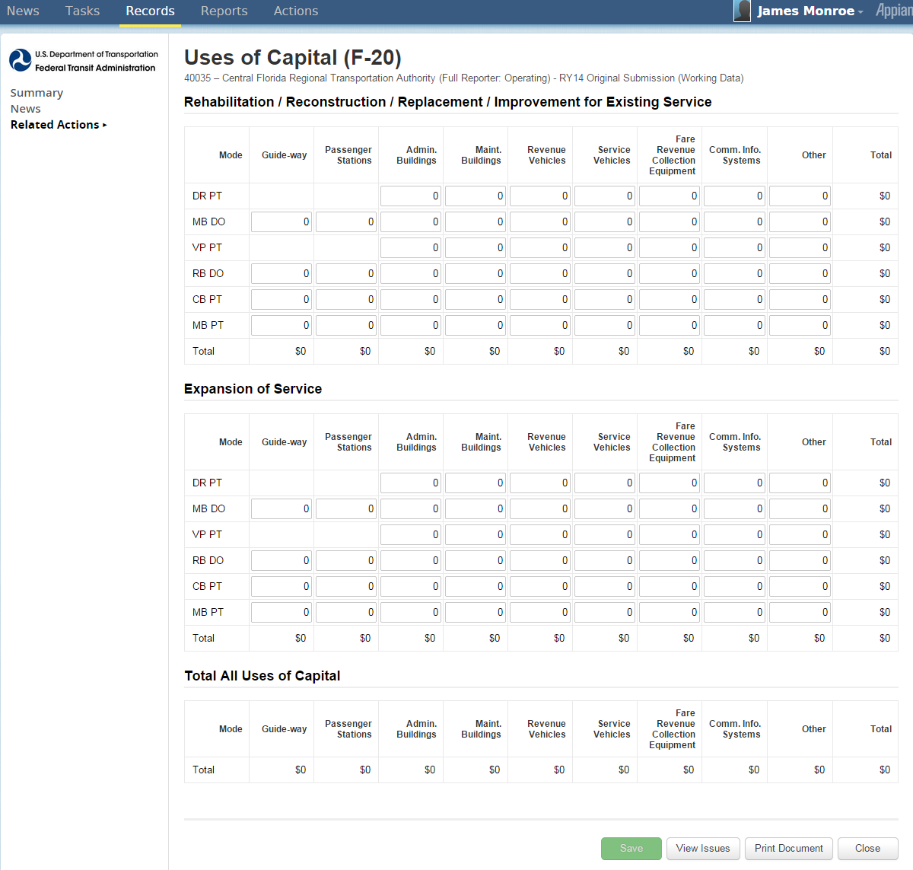
Edit or view the F-20 form. Click Save to save changes.
Click Save before exiting

Operating Expenses (F-30)

Return to Individual Forms Page and select the F-30 form

Edit or view the F-20 form. Click Save to save changes.
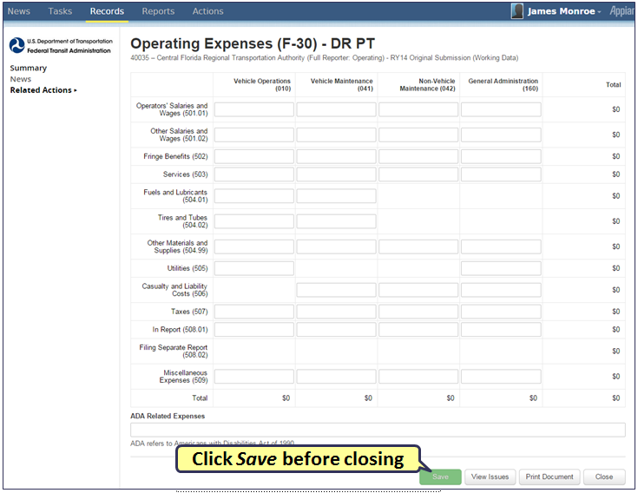

Operating Expense Summary (F-40)

Return to Individual Forms Page and select the F-40 form

When viewing the F-40 form you can view a summary and reconcile data entry items.
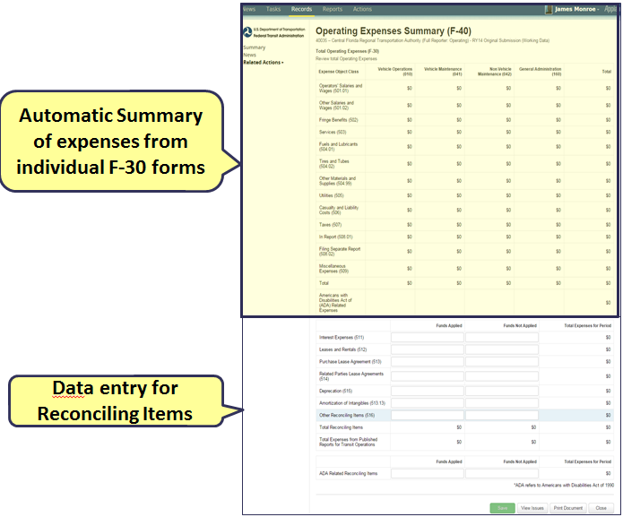

Reconciling Items (F-40)

Edit the Reconciliation Items and click Save before closing the screen.

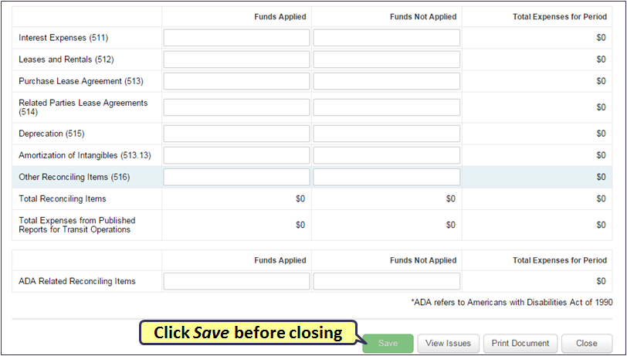

Statement of Finances Form (F-60)

Return to Individual Forms Page and select the F-60 form

The F-60 form collects data on assets an liabilities, complete the requested data and click Save.

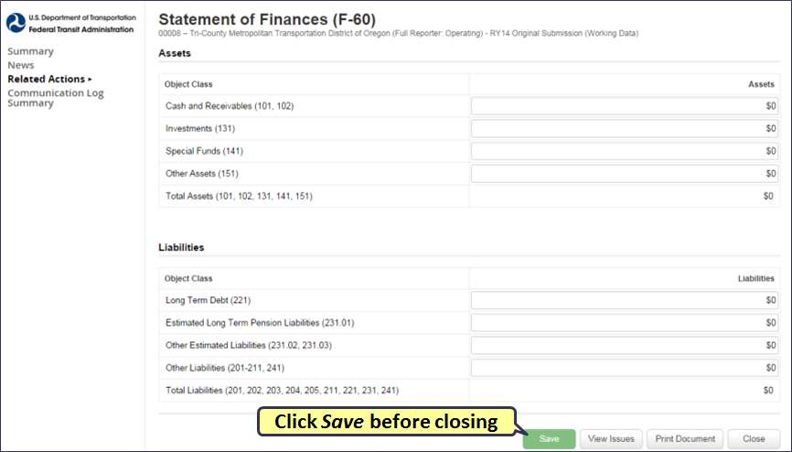

Stations Maintenance Facilities (A-10)

Return to Individual Forms Page and select the A-10 form

The A-10 form collects data on stations and maintenance facilities, complete the requested data and click Save.

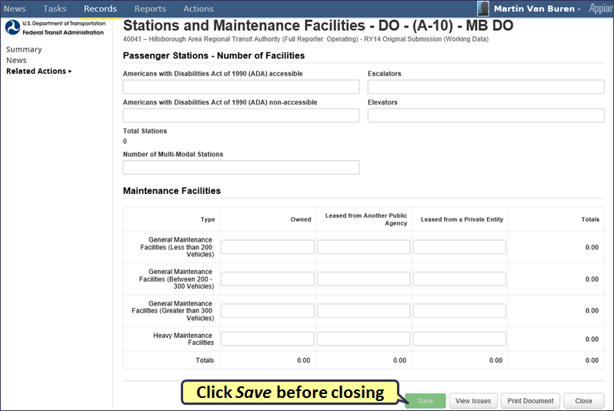

Transit Way Mileage (A-20)

Return to Individual Forms Page and select the A-20 form

The A-20 collects data on transit way mileage, complete the requested data and click Save.
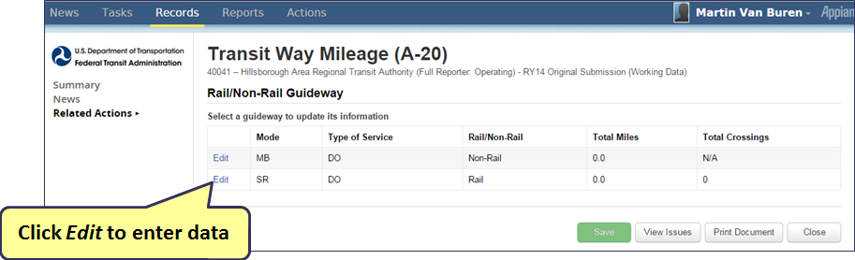

Entering Rail Transit Way Data

Enter Rail Transit Way Data, by clicking on the Edit hyperlink. The bottom screen will then open to editable data fields.
Click Save before exiting the screen in order to save any edits made to the data.

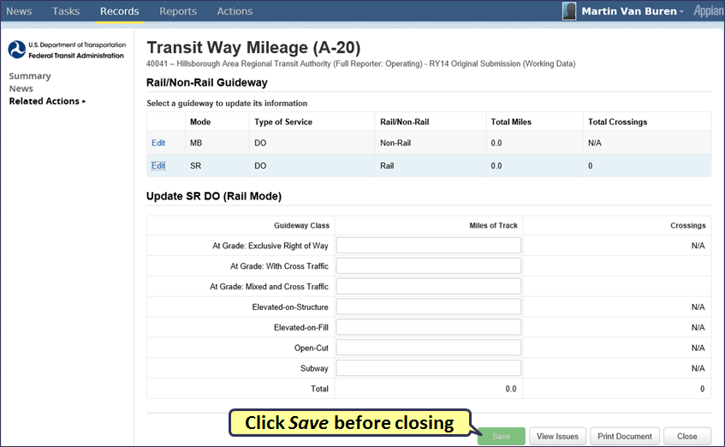

Entering Bus Transit Way Data

Enter Bus Transit Way Data, by clicking on the Edit hyperlink. The bottom screen will then open to editable data fields.
Click Save before exiting the screen in order to save any edits made to the data.

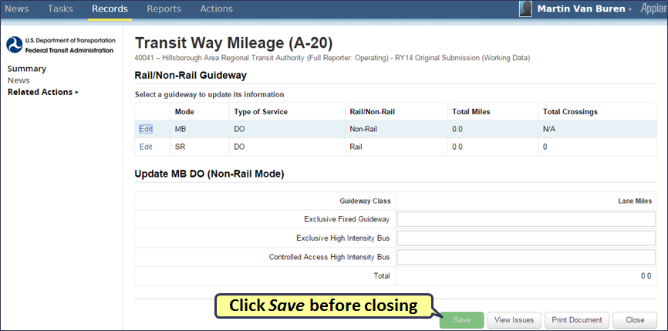

Revenue Vehicle Inventory (A-30)

Return to Individual Forms Page and select the A-30 form

The A-30 form collects fleet information, complete the requested data and click Save.

To edit an existing fleet  - Select an existing Fleet  - Click on Updates/Edit to edit the selected Fleet | To add new fleet  - Click on Add Fleet button

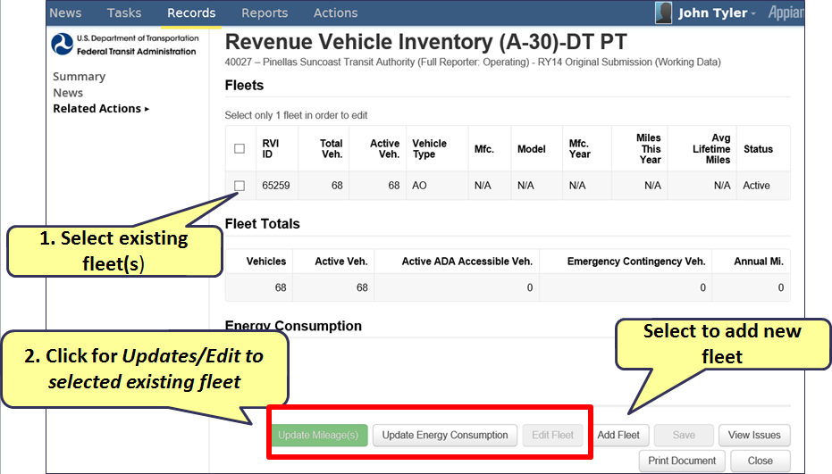

“Add Fleet” Data Entry Screen

Enter data in the Add Fleet window and click Continue.

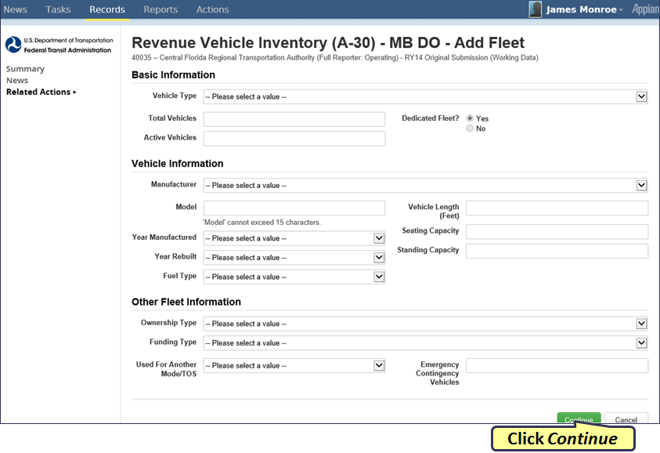

“Edit Fleet” Data Entry Screen

If editing an existing fleet on the A-30 form, enter data in Edit Fleet window and click Continue

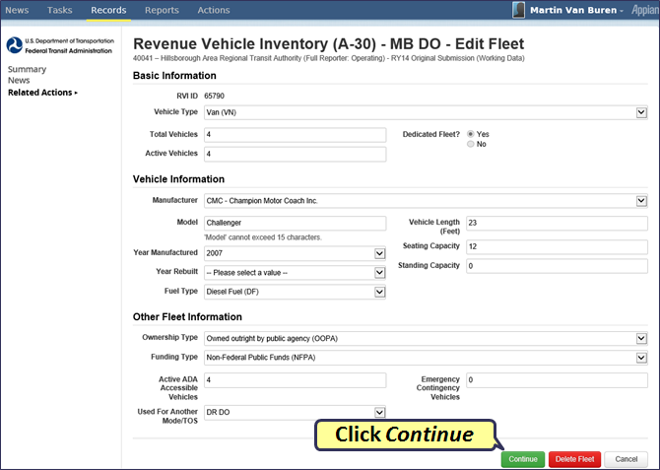

Reporting Mileage by Fleet

The Mileage update is found on the A-30 form. Follow the steps below to update the mileage on a selected fleet:
- Select a fleet
- Click on Update Mileage(s)

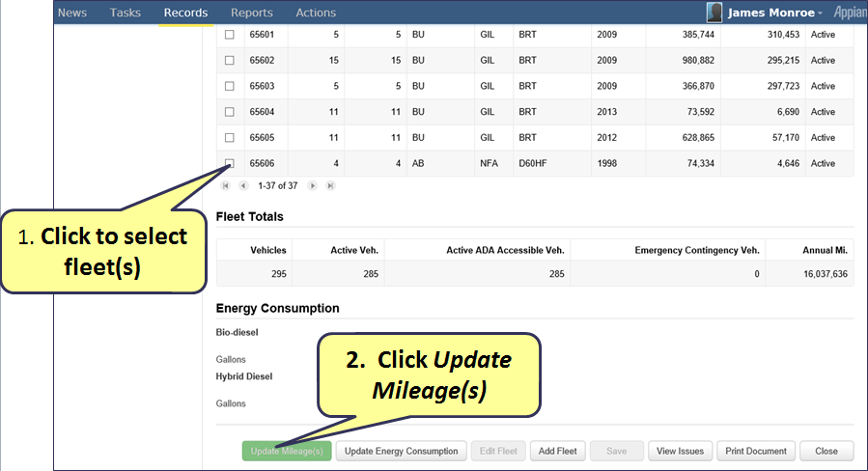

Enter Updated Mileage

After you click on Update Mileage, edit the mileage and click Continue

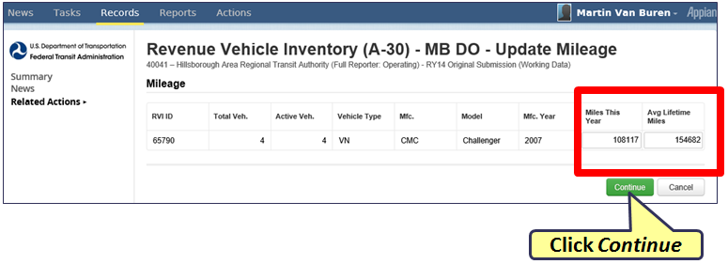

Reporting Energy Consumption

Reporting Energy Consumption is a new field added to the A-30 form. The Data was previously reported on the R-30 form, but now is found on the A-30.
- Click on the Update Energy Consumption button to update the data.

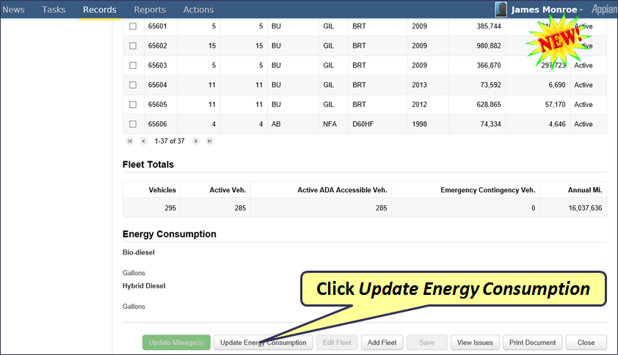

Enter Energy Consumption

Update the energy consumption for the mode selected and click Continue once you are finished.

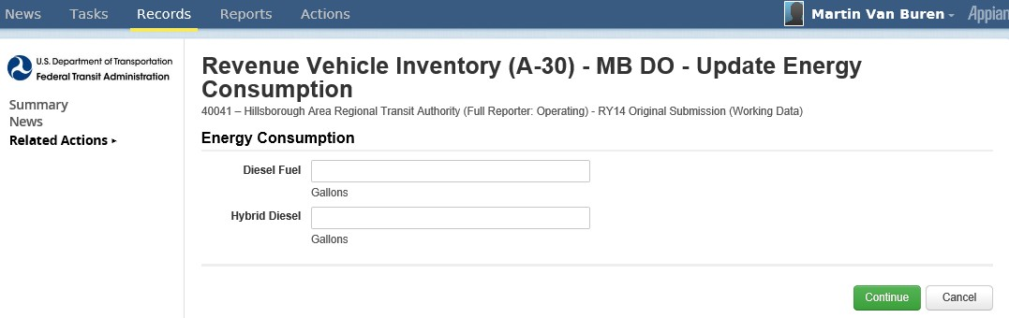
Click Continue

Key Data Summary Screen

On the Summary screen of the A-30, you can view key data, for example, Fleet Total and Energy Consumption.

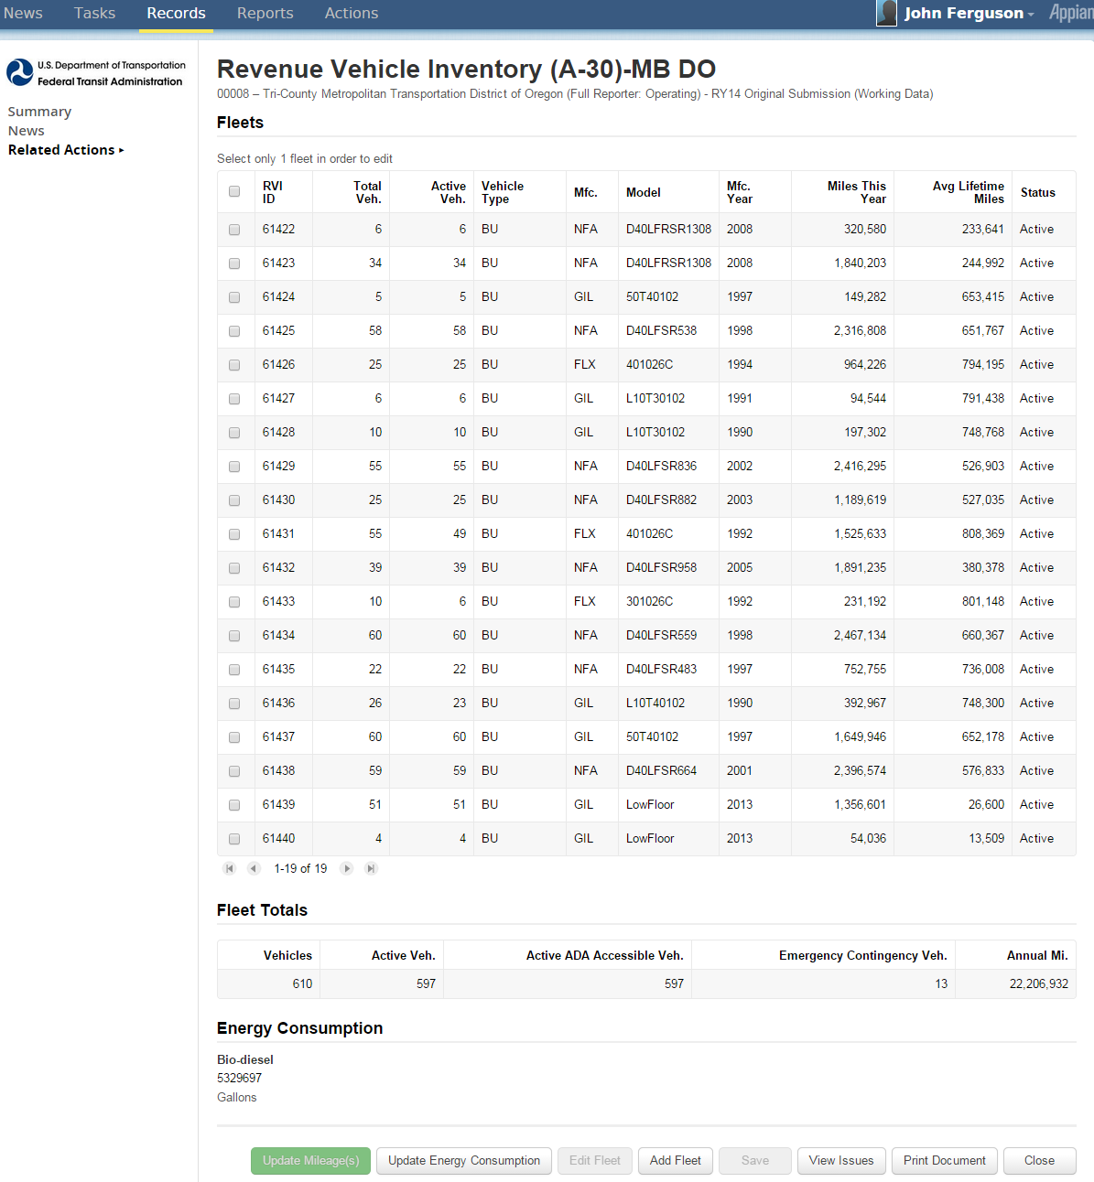

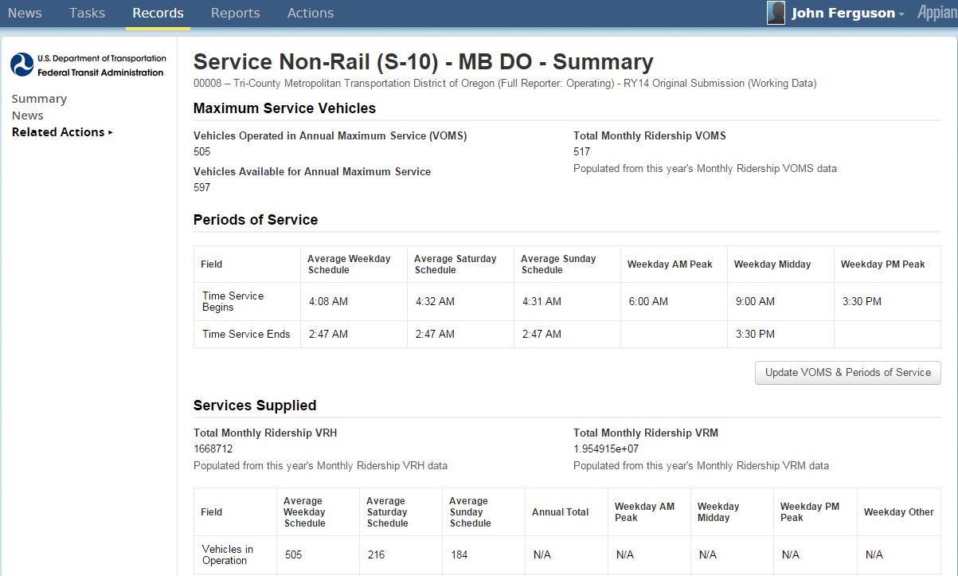
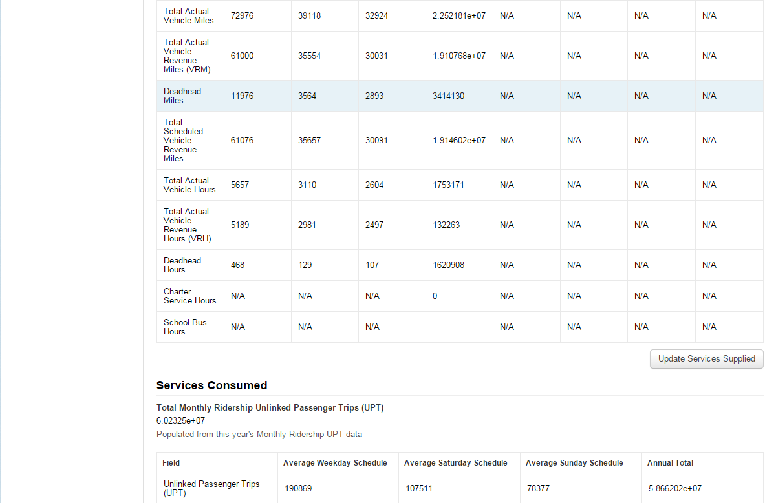
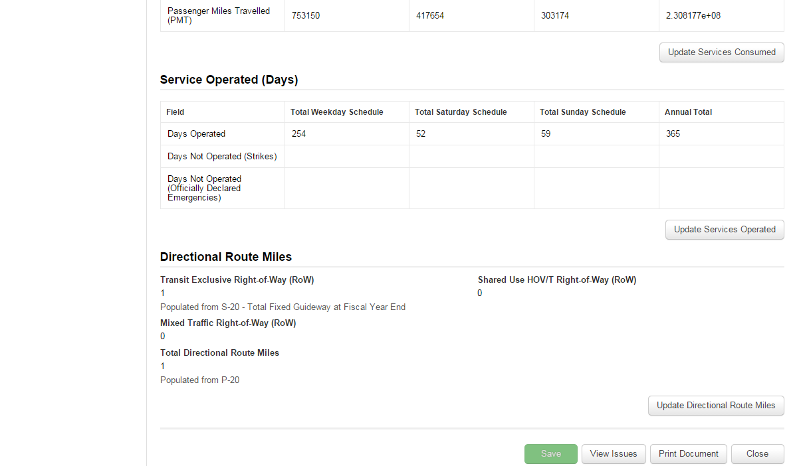
Service Supplied (S-10)
Update
Update
Update
Update
Update

Return to Individual Forms Page and select the S-10 form

The S-10 form collects service data. Click Save to
save any changes made before exiting.

- Form broken into sections
  - VOMS and Periods of Service
  - Service Supplied
  - Services Consumed
  - Service Operated (Days)
  - Directional Route Miles
Update
- Enter sections by clicking update icons

VOMS and Periods of Service

VOMS and Periods of Service is a section in the S-10 form that can be updated by clicking on the Update button.
- Click Continue when finished editing the section

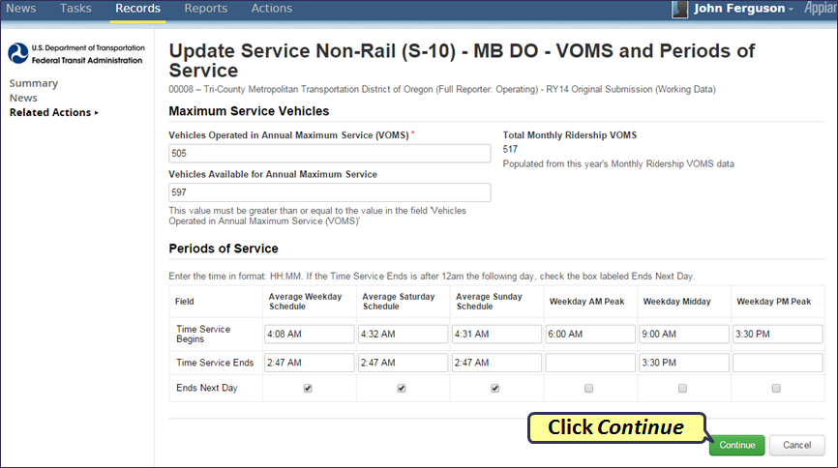

Services Supplied

Service Supplied is one of the broken-down sections in the S-10 form that can be updated by clicking on the Update button.
- Click Continue when finished editing the section

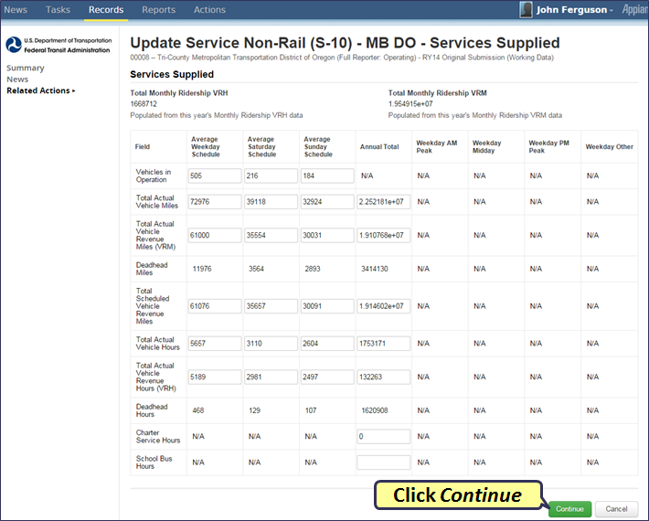

Services Consumed

Service Consumed is one of the broken- down sections in the S-10 form that can be updated by clicking on the Update button.
- Click Continue when finished editing the section

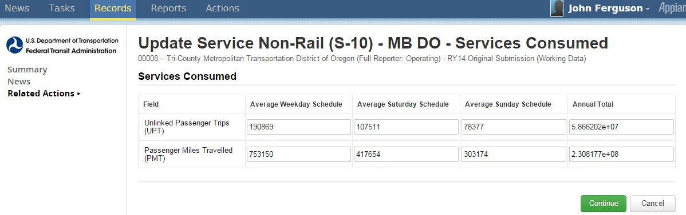

Click Continue

Services Operated (Days)

Service Operated (Days) is one of the broken- down sections in the S-10 form that can be updated by clicking on the Update button.
- Click Continue when finished editing the section

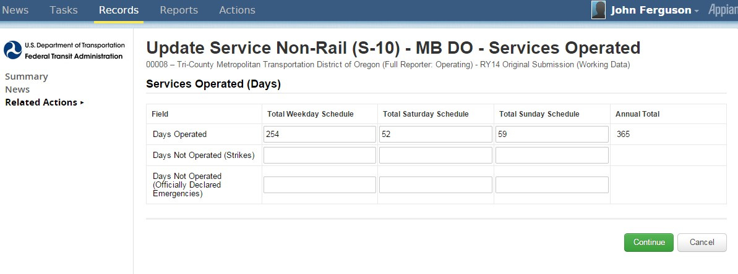

Click Continue

Directional Route Miles

Directional Route Miles is one of the broken- down sections in the S-10 form that can be updated by clicking on the Update button.
- Click Continue when finished editing the section.

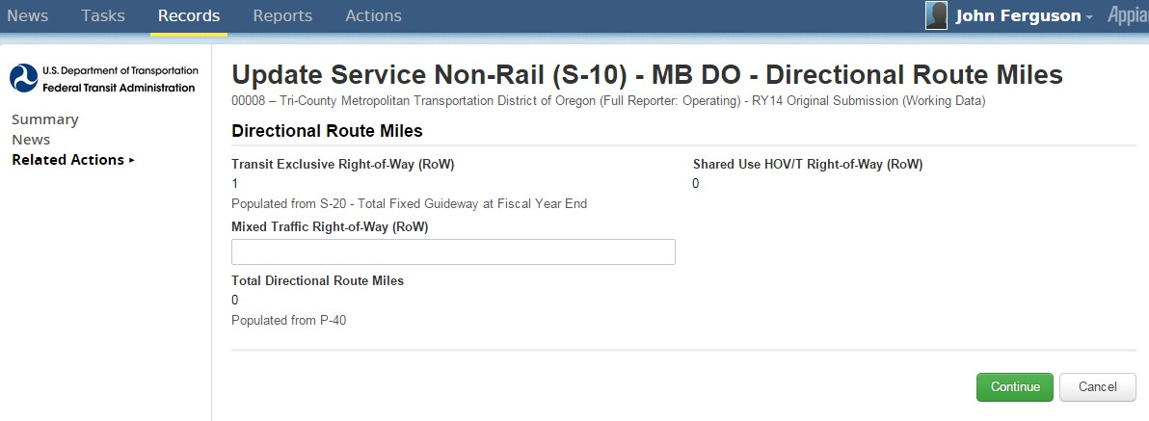

Click Continue

Employees (R-10)

Return to Individual Forms Page and select the R-10 form

The R-10 form collects data on employment. Click Save to save any changes made before exiting.

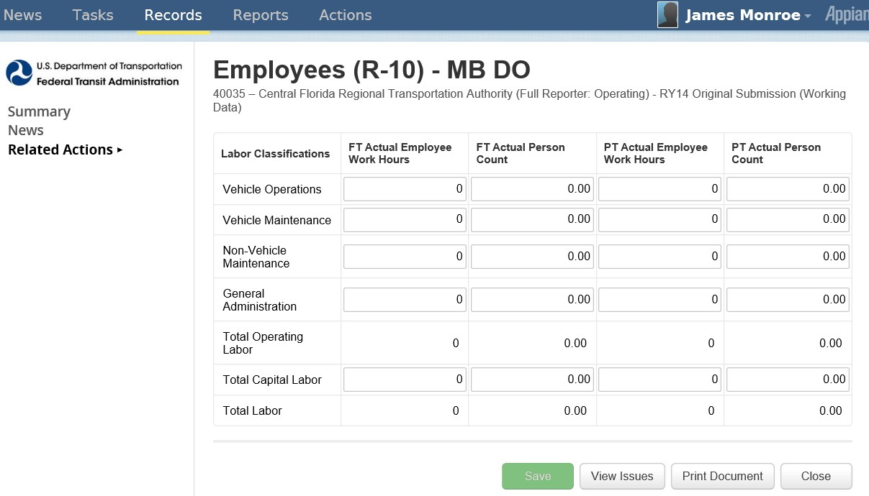

Click Save before closing

Maintenance Performance (R-20)

Return to Individual Forms Page and select the R-20 form

The R-10 form collects data on maintenance. Click Save to save any changes made before exiting.

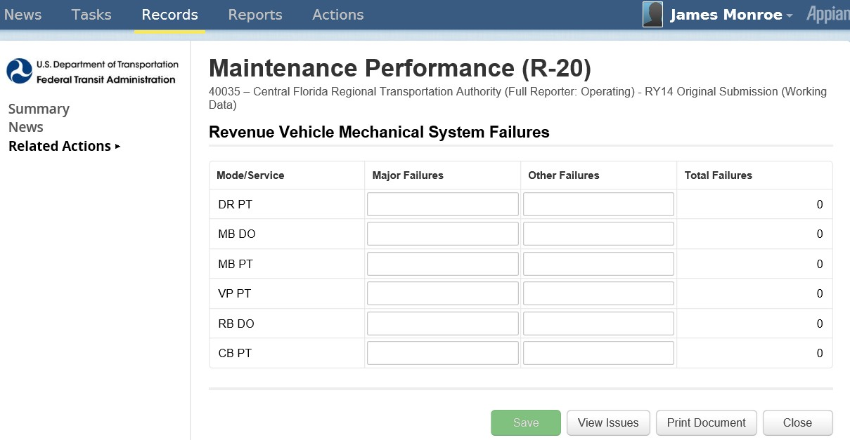

Click Save before closing

Federal Funding Allocation Statistics (FFA-10): No FG or HIB

Return to Individual Forms Page and select the FFA-10 form
The FFA-10 form collects data on service allocation by UZA. To edit the form:
- Select a UZA Reporting Method. The entry fields will then become editable
- To edit or move to another UZA, click Previous or Next
- Click Save to save any changes made.

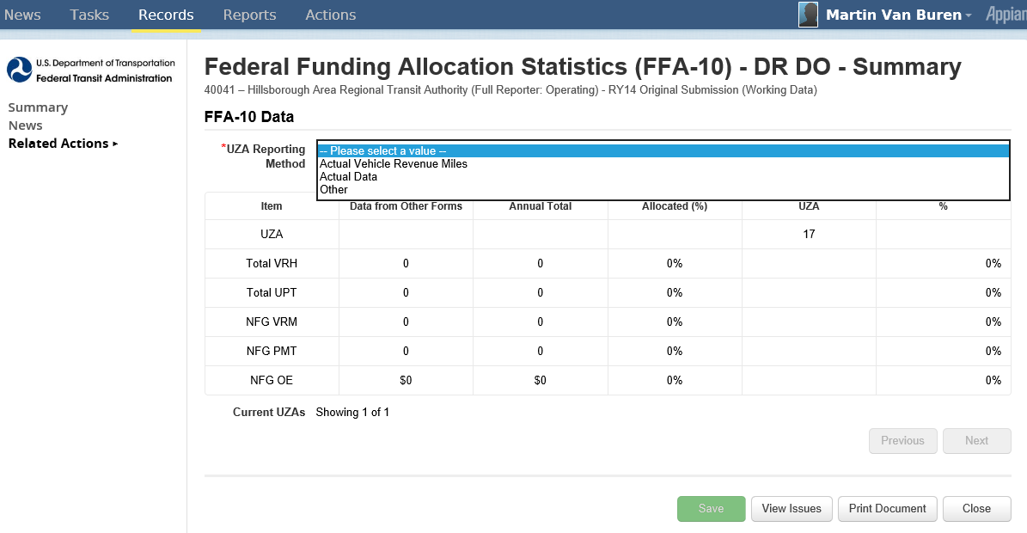
Click to select
UZA Reporting Method
Click to move from UZA to UZA
Click Save before closing

CEO Certification (D-10)

Return to Individual Forms Page and select the D-10 form

The D-10 form is for CEO certification. The D-10 form is completed in a sequence of 6 screens.
- Overall Accuracy
- Federal Funding Allocation Data
- Financial Data Review
- Federal Funding Allocation Review
- Passenger Miles Data
- Unlinked Passenger Trip Data
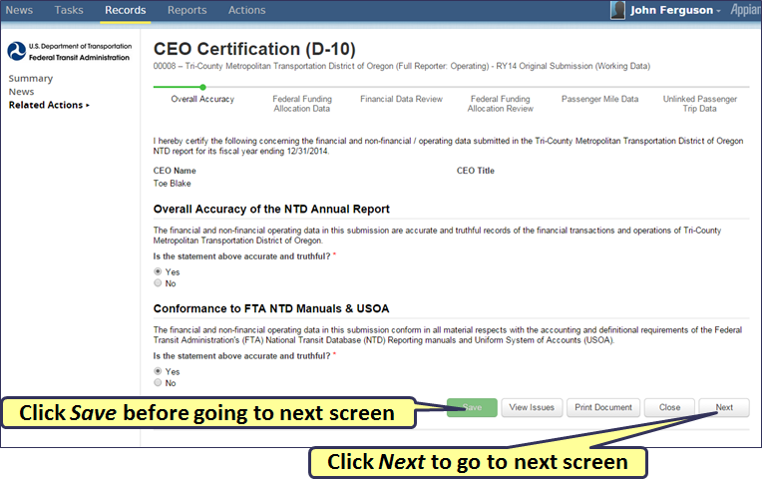

D-10 Federal Funding Allocation Data

The Federal Funding Allocation Data is the second sequence step when completing the D-10 form.
To go to the next sequence step, click Save to save to save any changes, and then click on the Next button.

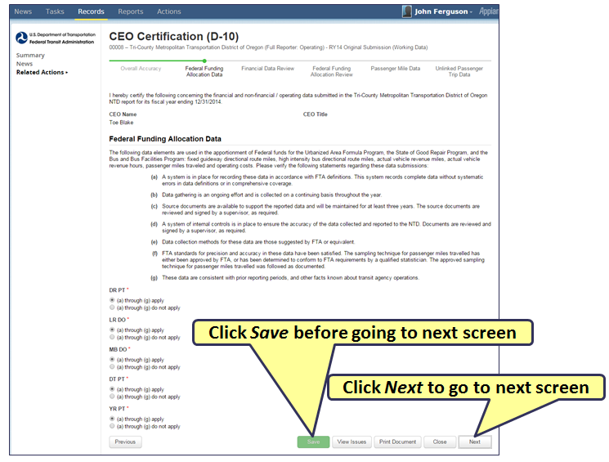

D-10 Financial Data

The Financial Data is the third sequence step when completing the D-10 form.
To go to the next sequence step, click Save to save to save any changes, and then click on the Next button.

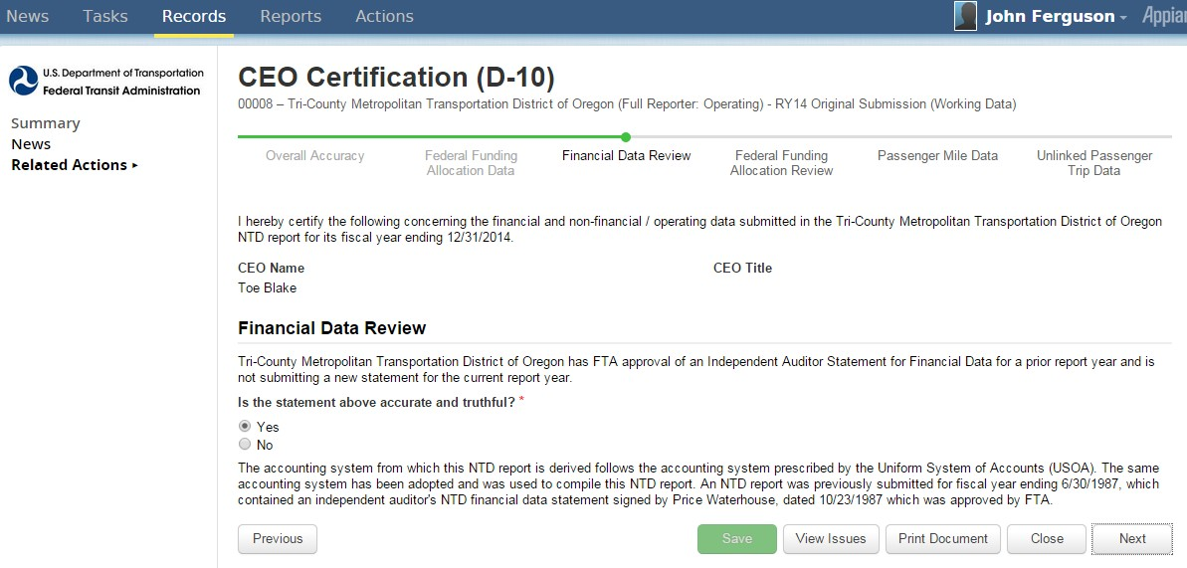
Click Save before going to next screen
Click Next to go to next screen

D-10 Funding Allocation Review

The Federal Allocation Review is the fourth sequence step when completing the D-10 form. Click on the Add Finding button to add findings. To go to the next sequence step, click Save to save to save any changes, and then click on the Next button.
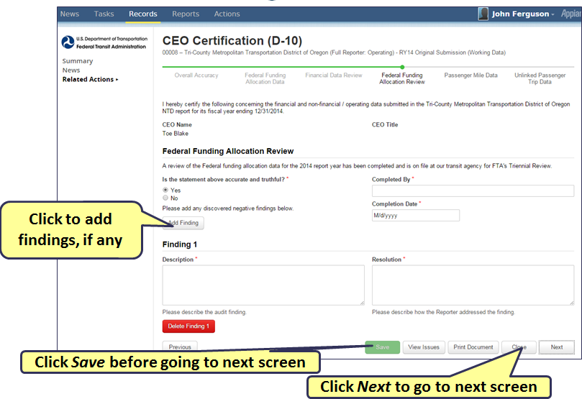

D-10 PMT Sampling

The Passenger Mile Data is the fifth sequence step when completing the D-10 form.
To go to the next sequence step, click Save to save to save any changes, and then click on the Next button.

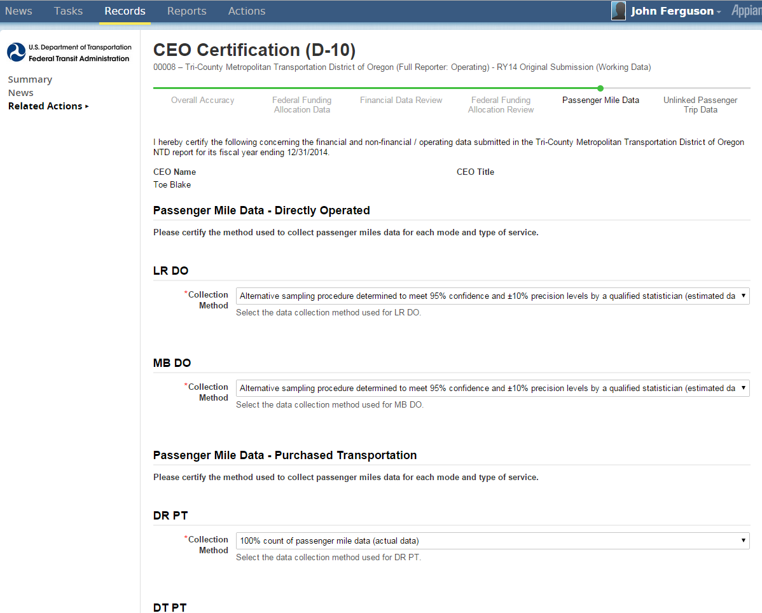

D-10 UPT Sampling

The Unlinked Passenger Trip Data is the sixth, and final step in the sequence of completing the D-10 form.

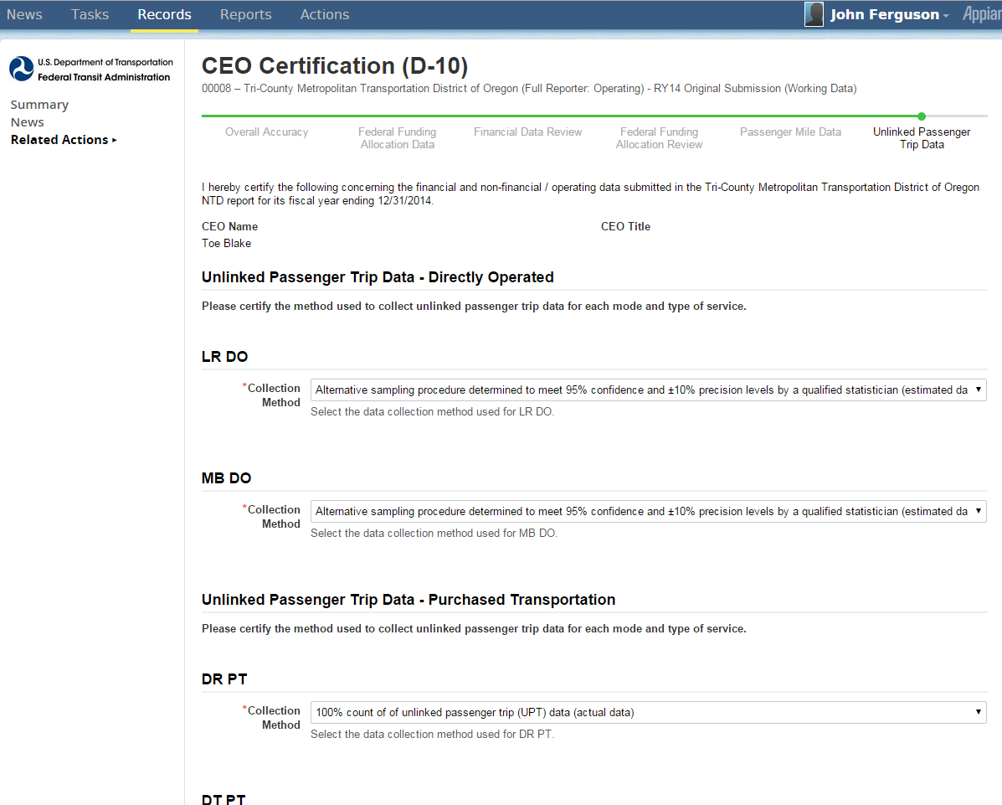
National Transit Database Offices

- NTD Operations Center
Charlottesville, Virginia
Monday to Friday: 0800 –1900 Eastern
NTD Help Desk
(888) 252-0936
NTDHelp@dot.gov

- NTD Program Office
Washington, DC
Keith Gates, Program Manager
(202) 366-1794
keith.gates@dot.gov

Training

- NTD Website training page:
http://www.ntdprogram.gov/ntdprogram/seminars.htm
- National Transit Institute, NTD courses:
http://www.ntionline.com/courses/courseinfo.php?id=7
- NTD Website presentations page:
http://www.ntdprogram.gov/ntdprogram/announcements.htm

