

National Transit Database

User Management and

Monthly Reporting

2014 User Manual

# Table of Contents

Table of Contents 2

Table of Figures 4

New Reporting System (“NTD 2.0”) 7

Background 7

Local System User Manager (LSUM) 7

LSUM NTD Startup Tasks 7

LSUM Receives Email Instructions 8

LSUM Starts Password Process 9

Request Password Reset 10

LSUM Receives Password Instructions 11

LSUM Logs In to Create Users 14

News Page is the Home Page 15

Records Page 16

My NTD Reporter Profile(s) 17

Reporter Profile 18

Related Actions for Reporter Profile 19

View & Manage Users (P-30) 20

CEO and NTD Contact Required 25

LSUM Sign Out 26

NTD Contact Startup Tasks 27

What is a Kickoff? 27

NTD Contact Logs in to NTD 2.0 28

Kickoff Starts on News Page 29

How to Start Report Kickoff 30

Accept Kickoff Task 31

Manage Reporter Users 32

Manage Modes 33

Add Mode Screen 34

Edit Mode Screen 35

Proceed to Reporter Type Confirmation 36

Previous Reporter Type Confirmation 37

NTD 2.0 Reporter Type Questionnaire 38

Reporter Type Questionnaire 39

Complete Kickoff 40

Ridership Activity Form (MR-20) 41

MR-20 Data Items 42

Access MR-20 Report Package 43

Report Package Summary Screen 44

Report Packages Screen 45

Individual MR Forms by Mode/TOS 46

MR-20 Data Entry Form 47

Print Document 48

Link Created after Print Request 49

Issue Checks 50

Addressing Issue Checks 51

View Validation Issues 52

Address Single Issue 53

National Transit Database Offices 54

Additional Training 54

# Table of Figures

Figure 1 - LSUM Flow Chart 5

Figure 2 - Example of Process Flow on editing an Individual MR-20 form 6

Figure 3 – NTD Roles 23

Figure 1 - LSUM Flow Chart



Figure 2 - Example of Process Flow on editing an Individual MR-20 form



# New Reporting System (“NTD 2.0”)

## Background

Monthly ridership was first operational module. Reporting started October for reporting September data. Annual reporting will start December 15 for FY 2014 reporting. There are no changes in data requirements. Data definitions are the same in NTD 2.0 as in the previous on-line reporting system for monthly data.

# Local System User Manager (LSUM)

1. LSUM at each reporting agency approves (certifies) new users of FTA Systems

* NTD 2.0
* TRAMS (updated TEAM)

1. FTA requires each agency to identify a LSUM to FTA for “authentication”

* TEAM users upload designation letter in TEAM
* Non-TEAM users send letter to FTA NTD project manager in Washington DC

## LSUM NTD Startup Tasks

1. Create LSUM password
2. Approve and enter local users into NTD 2.0

### LSUM Receives Email Instructions

1. Open e-mail that you received from Administrator
2. Click the link on the e-mail to be directed to the NTD website.

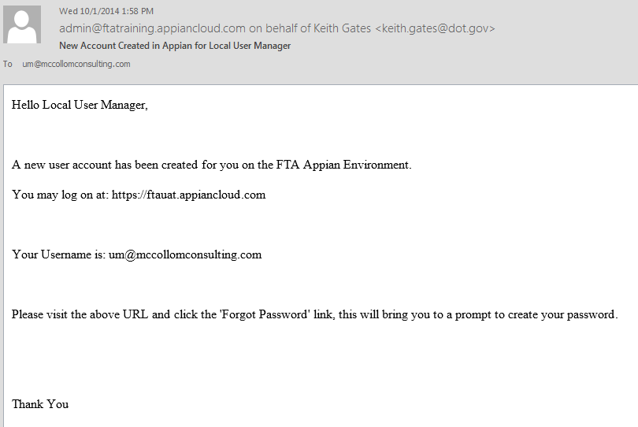

walter.mondale@mankato.org

walter.mondale@mankato.org

Log on using LSUM email address as username

### LSUM Starts Password Process

Follow the steps below to start up the password process.

1. Read the Government Disclaimer, then click on the *I agree* button to accept terms of use
2. Begin log-in process using the government e-mail address you hold as your username
3. Click on the *Forgot Password* link to begin process to set a new password

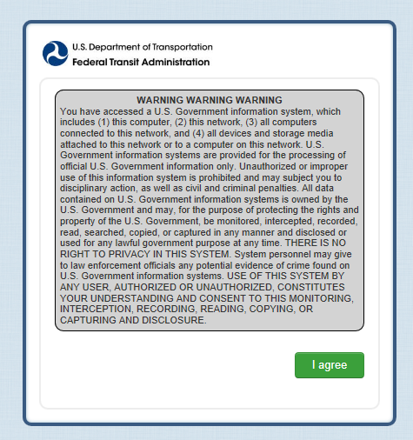

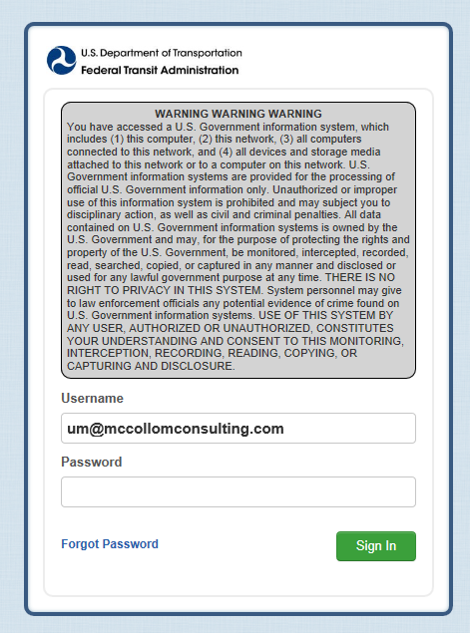

**walter.mondale@mankato.org**

Click on I agree to accept government warning

Enter Username (all lower case letters)

Click on Forget Password to start process to set password

### Request Password Reset

1. Once again enter in the e-mail address that is your username
2. Click on *Request Password Reset* button to continue

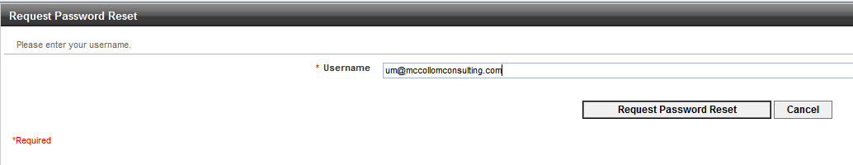

[**walter.mondale@mankato.org**](mailto:walter.mondale@mankato.org)

Click on *Request Password*

*Reset*

Enter user name (email address)

### LSUM Receives Password Instructions

1. Wait for an automated admin e-mail to arrive, then open to read its content
2. Click on the hyperlink that will take you to the set password form

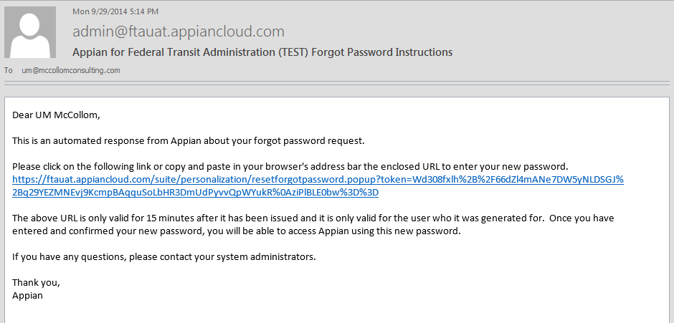

Mon 12/15/2014 8:00 AM

[walter.mondale@Mankato.org](mailto:walter.mondale@Mankato.org)

Dear Walter Mondale

Click to go to set password

#### Set Password

1. Enter in your *Username/E-mail*
2. Enter in your desired *Password* (Make sure that your password meets the Federal requirement for length & complexity)
3. Confirm your desired *Password* by re-entering the unique sequence of characters

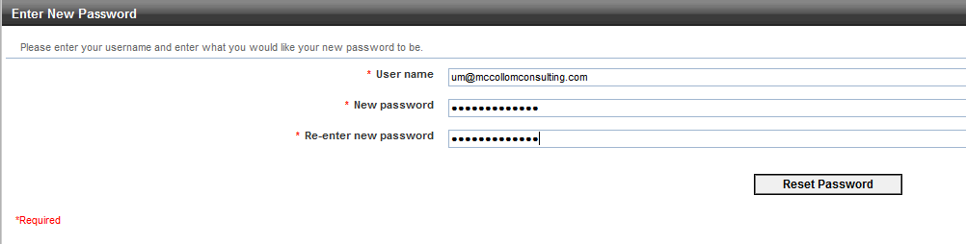

Enter user name (email address)

[**walter.mondale@mankato.org**](mailto:walter.mondale@mankato.org)

Enter and re-enter password

Click on Reset Password

#### Password Features (All Users)

The Password security requirements are the same as the current system.

* + Federal requirements for length and complexity
    - Password length
      * must be 12 characters and not more than 20 characters
    - Complexity
      * 3 out of 4 – Lower case, Upper case, Numbers, Special Characters
    - Password History
      * Password must be different from 10 previous passwords and must be different from any password used in the last 6 months
    - Password expiration period is 60 days

### LSUM Logs In to Create Users

1. Click on ***I agree*** button to accept the Government’s terms of use
2. Enter in ***Username/E-mail***
3. Enter in your newly-created ***Password***
4. Click on ***Sign In*** button to Log In to the System

Enter Username and Password

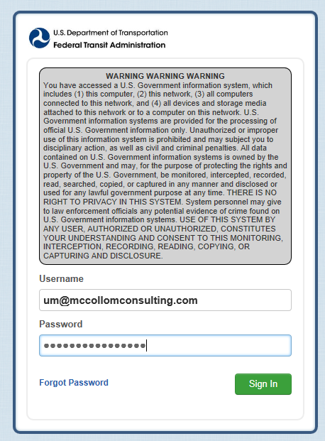

Click on *I agree* to accept government warning

Click on *Sign In*

**walter.mondale@mankato.org**

# News Page is the Home Page

The **News** menu item is the defaulted page when you first log-in to NTD. Click on **Records** to enter users.

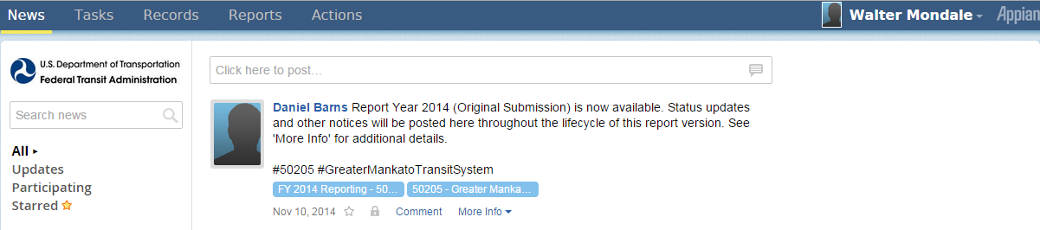

Click on *Records* to enter users

# Records Page

The **Records** menu item is where you can select Reporter Profiles to enter users.

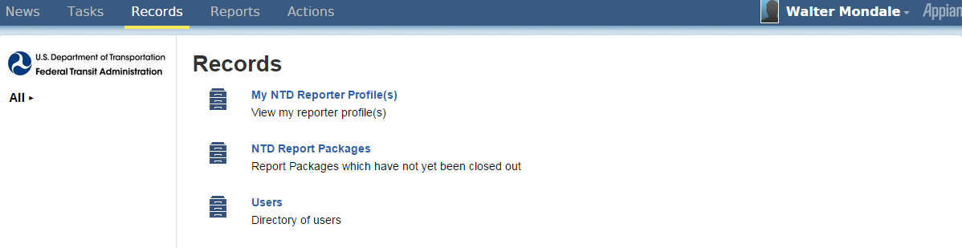

Click on *My NTD Reporter Profile(s)*

# My NTD Reporter Profile(s)

After selecting **Records** menu item, click on the reporting agency name in order to view the reporter profile.

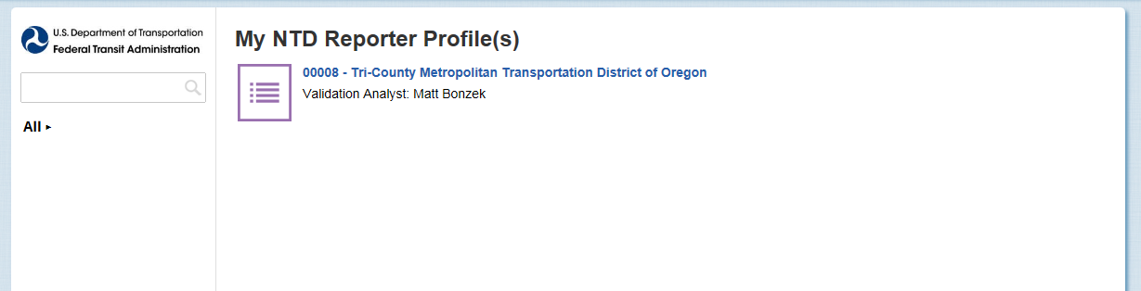

Click on reporting agency name

## Reporter Profile

On the Reporter Profile **Summary** page click on **Related Actions** to manage **Reporter Users**.

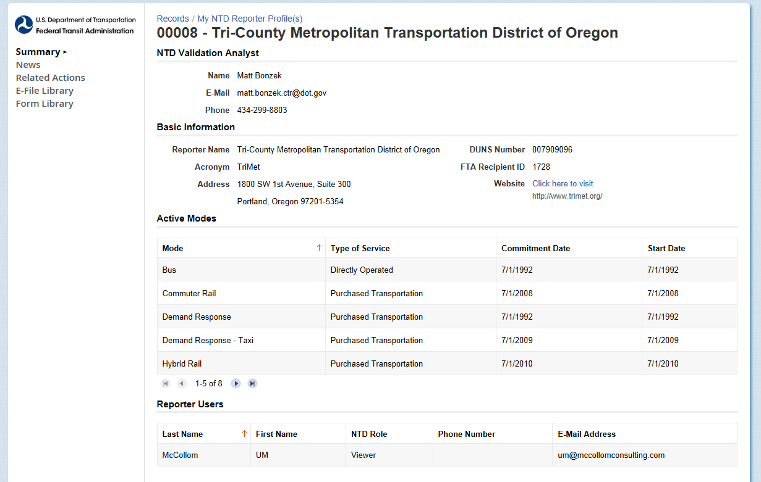

Click on *Related Actions*

## Related Actions for Reporter Profile

Under **Related Actions**, click on **View & Manage Reporter Users (P-20)** to manager users.

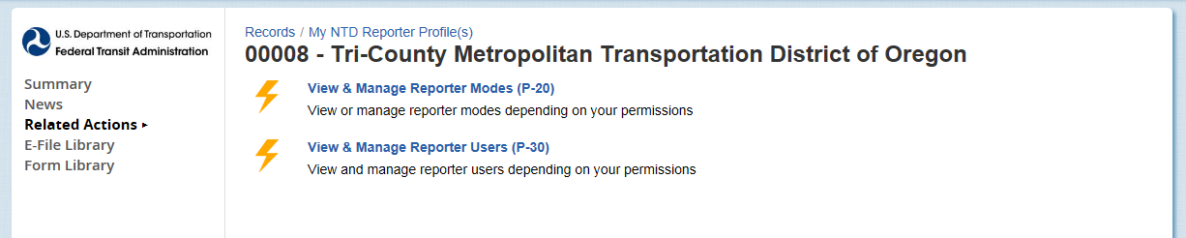

Click on *View & Manage Reporter Users (P-30)*

### View & Manage Users (P-30)

In the P-30 form you can Add, Edit, or Deactivate users, or View Details on a user. To add a user, click on **Add User** button.

Click on *Add User*

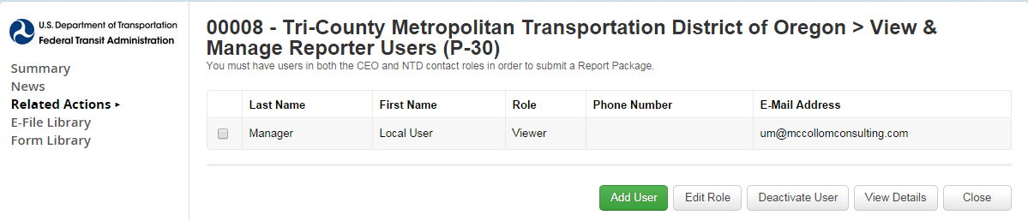

#### Add New System User

After you click on **Add user** button, fill out the information on the form and click **Next** when complete.

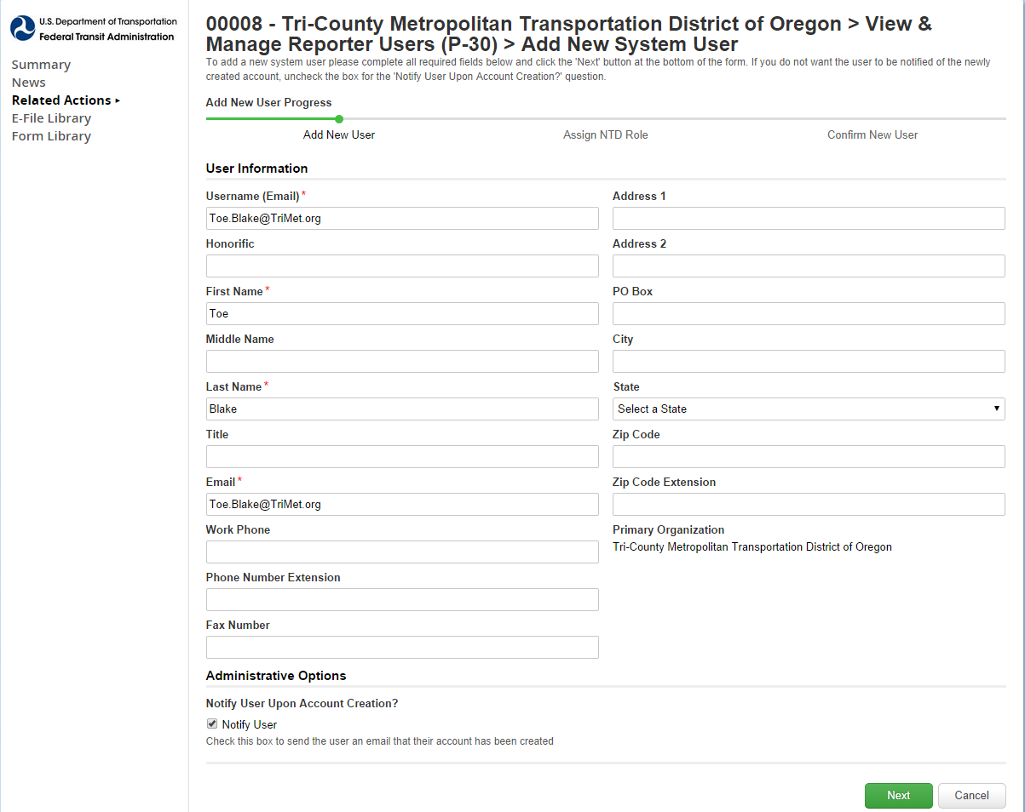

Click *Next* when completed

Add user information (name, email, address)

Click *Next* when completed

#### Select Reporter Role

Select the user’s role from a drop-down menu and click **Next** when complete.

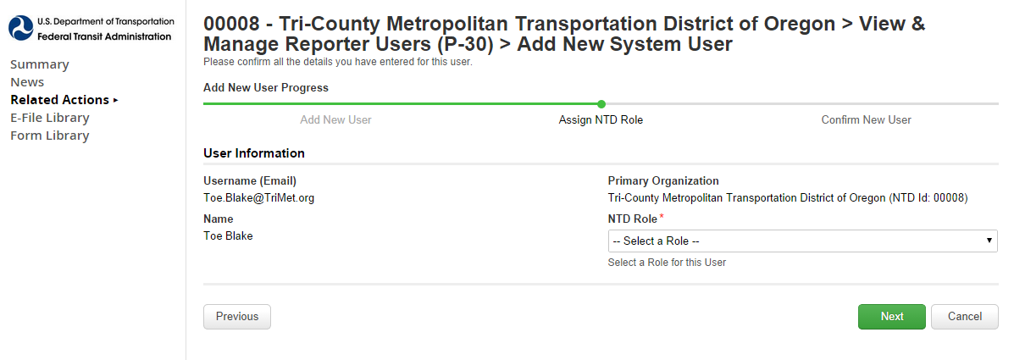

Click *Next* when completed

Select Role

Figure 3 – NTD Roles

|  |  |
| --- | --- |
| **Role** | **Functions** |
| **CEO** | Data entry, submit report, submit the CEO certification, all reporting areas |
| **NTD Contact Person** | Data entry, submit report, all reporting areas |
| **Editor** | Data entry, view forms |
| **Viewer** | View forms |

#### Review and Submit User

* After submission, instructions are emailed to user to set up password
  + Identical process used for LSUM password

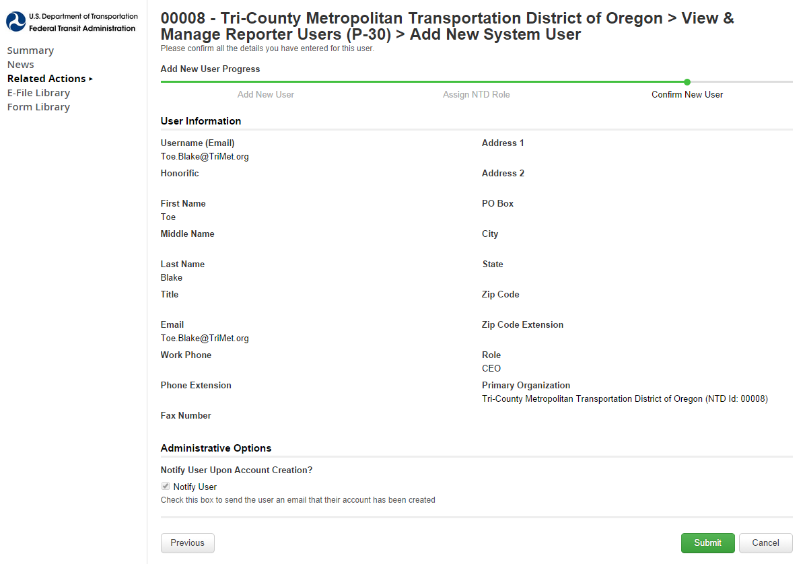

Click *Submit*

### CEO and NTD Contact Required

* LSUM should create CEO and NTD users
* Required for report “kick-off

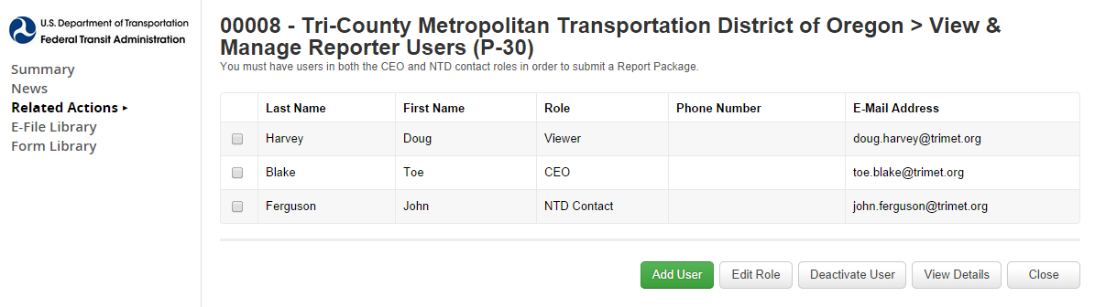

## LSUM Sign Out

After the CEO and NTD contact have been created the LSUM can log-off if they are finish with managing accounts.

Click on username and click *Sign Out*

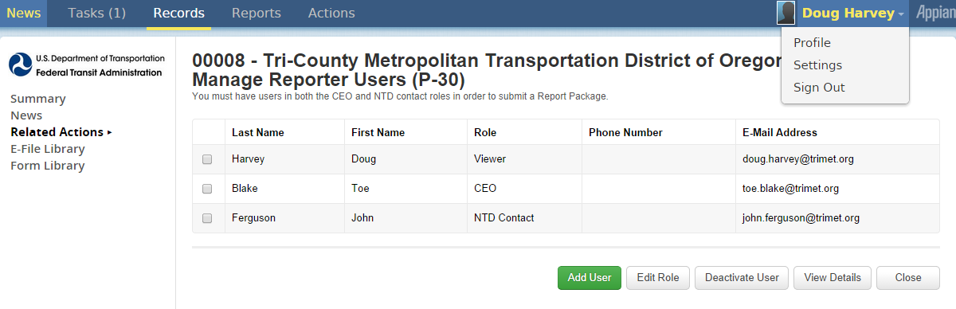

# NTD Contact Startup Tasks

The NTD contact can start up the following task:

* Perform “report kickoff”
* Enter annual data into NTD forms

# What is a Kickoff?

Kickoff is the confirmation of current “profile” information at beginning of fiscal year

* Kickoff Actions
  + Confirm reporter contact information is accurate.
  + Confirm mode information is accurate.
  + Confirm declared reporter type for previous FY is still accurate (e.g., small systems waiver)
  + Declare reporter type for new fiscal year

## NTD Contact Logs in to NTD 2.0

Enter your **Username** and **Password** to log-in to the NTD system.

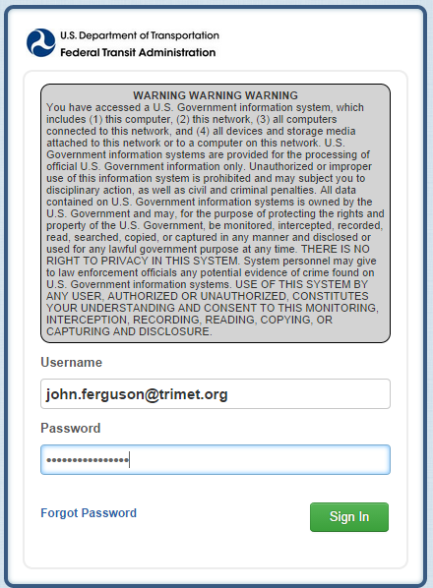

Click on *Sign In*

## Kickoff Starts on News Page

The **News** menu item is the defaulted page when you first log-in. The **Task** menu item displays how many task(s) are in your cue. Click on **Task** to start the Kickoff of the fiscal year reporting.

Click on *Tasks* to start FY 2015 and FY 2014 Annual Reporting

News

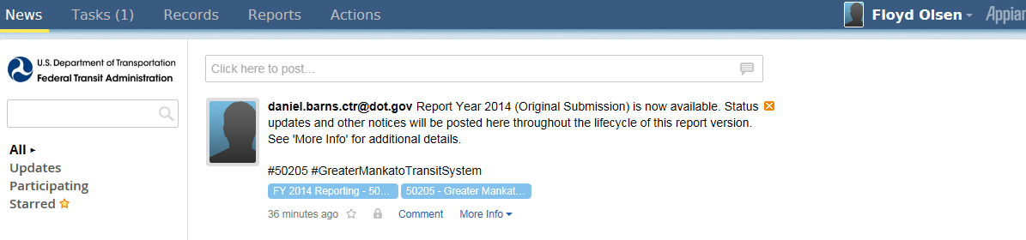

## How to Start Report Kickoff

On the **Task** menu item, there will be a task hyperlink to **Kick off** the Fiscal year.

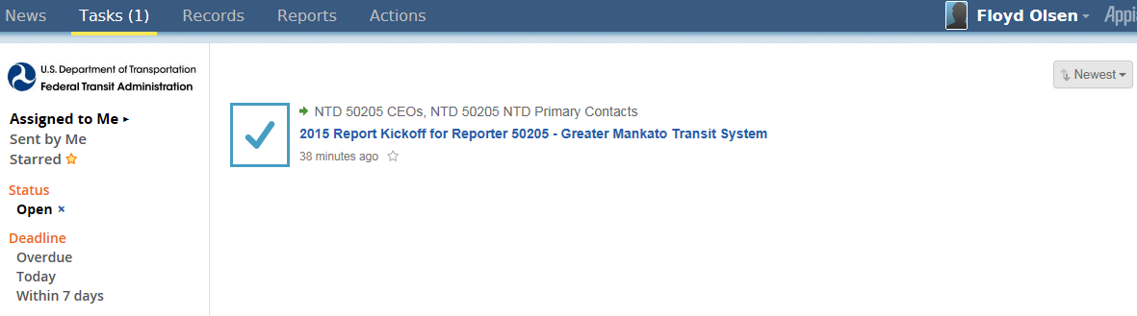

Click on *2015 Report Kickoff t*ask

## Accept Kickoff Task

Read the **Introduction** to the Report Kickoff, and **Accept** the task, then you can click on **Proceed** button to begin the Kickoff.

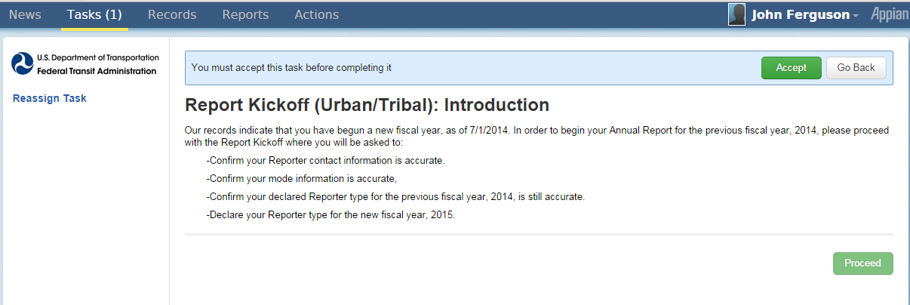

1. Click Accept

2. Click Proceed

## Manage Reporter Users

In the Report Kickoff you can Manage Reporter Users. Only user managers can add new users.

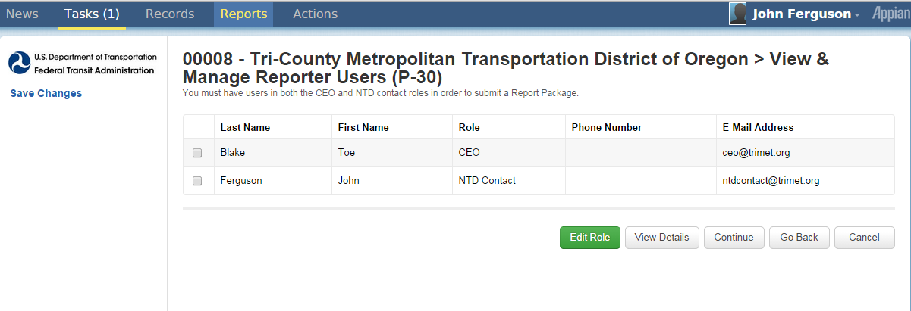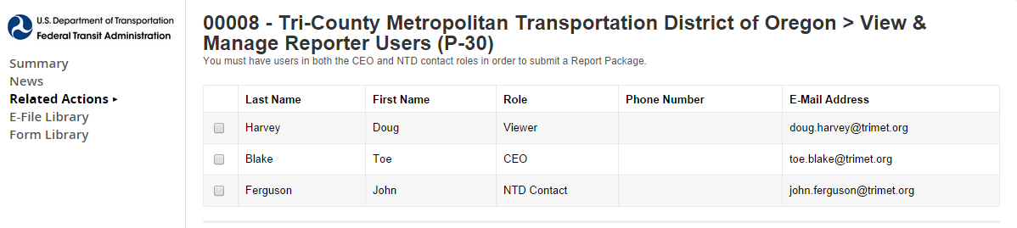

Click *Continue* to go to next confirmation

## Manage Modes

You can manage modes in the Report Kickoff (add, edit, or end mode/TOS as needed).

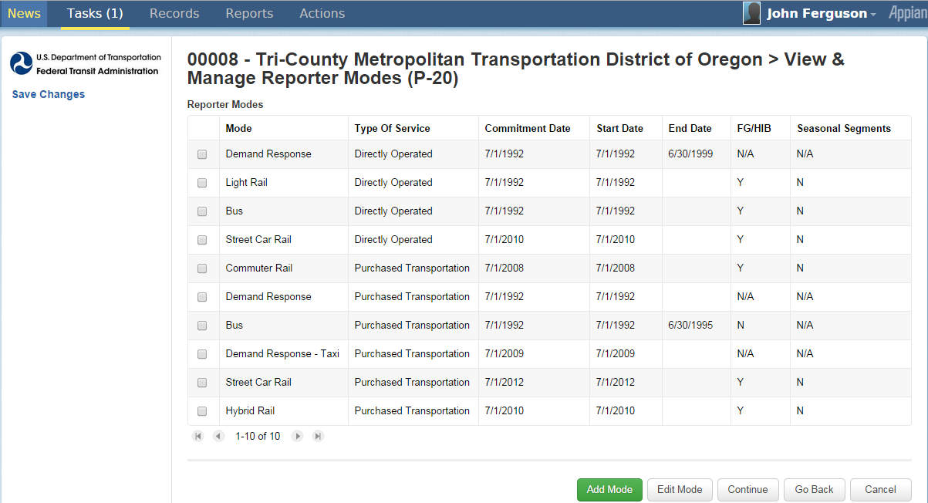

Click to edit/delete selected mode/TOS

Click to add mode

### Add Mode Screen

When adding a mode in the Report Kickoff, the following items will display:

* Mode drop down menu
* TOS selection = directly operated or P.T.
* Commitment date = date capital funds first expended
* Start date = first day of revenue service

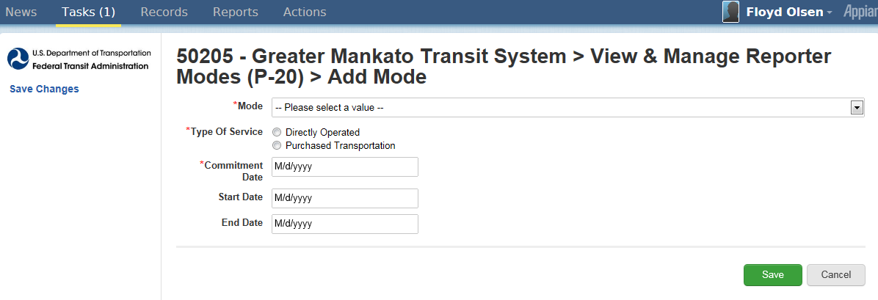

Click to save

Drop down menu

### Edit Mode Screen

When editing a mode in the Report Kickoff, the following items will display:

* End date = Last day of revenue service
* Modes are ended, not deleted

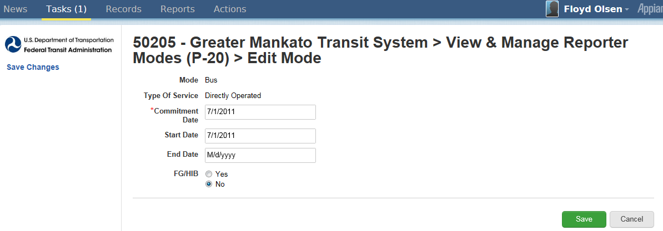

Click submit to save changes

## Proceed to Reporter Type Confirmation

Once you have completed managing modes, you can click on **Continue** to go to the **Reporter Type Confirmation** section.

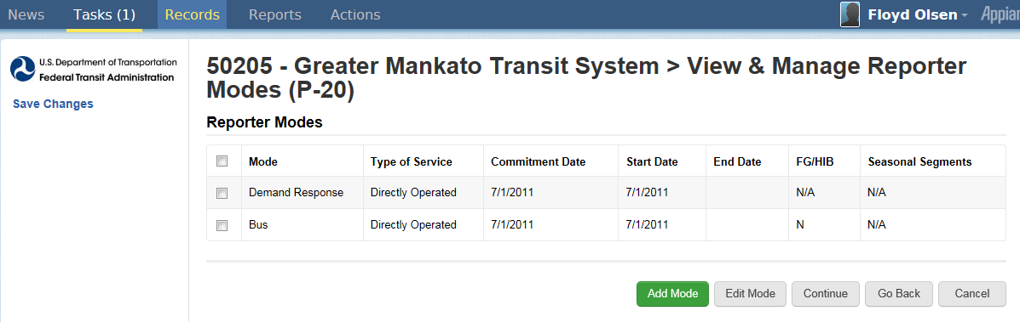

Click continue to go to next confirmation

## Previous Reporter Type Confirmation

The answers you select on the **Reporter Type Confirmation** will determine the required forms.

* Click *yes* to go through questionnaire
  + Questions appear
  + Strongly suggested for first-time NTD 2.0 users even if they are confident about their type
  + Click **Continue** once you have completed the questionnaire

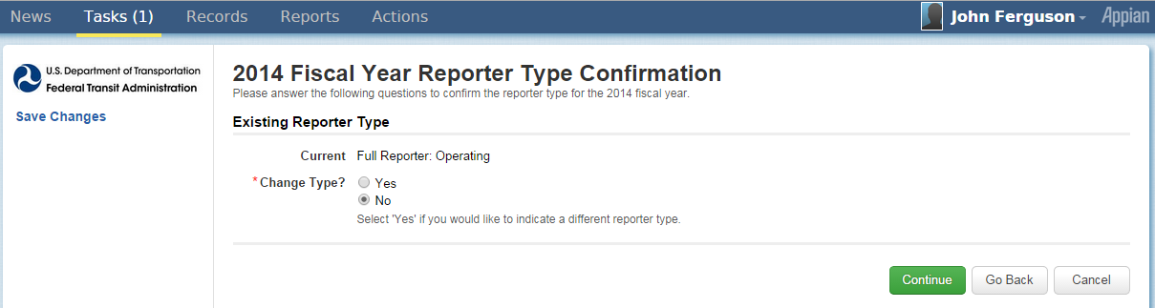

Click continue to complete kickoff

Click yes for questionnaire

## NTD 2.0 Reporter Type Questionnaire

The Resulting Reporter Type is based on the answers given on the questionnaire. Click **Continue** when all questions are complete.

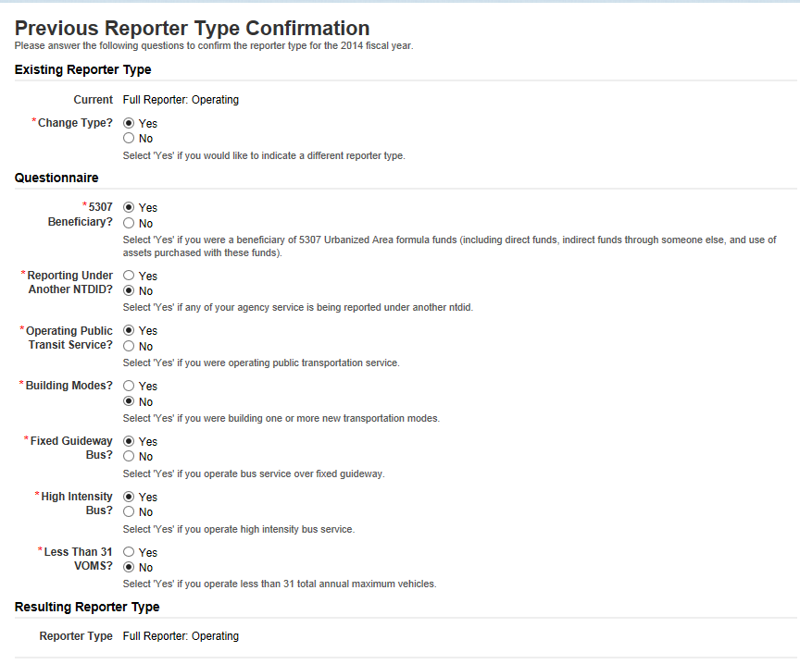

*Resulting Reporter Type* based on answers to questions

### Reporter Type Questionnaire

The lists below are examples of the questions asked in the Reporter Type Questionnaire.

* 5307 beneficiary?
* Reporting under another NTD ID?
* Operating public transit service?
* Building new modes?
* Fixed guideway or high intensity bus or both?
* Operating less than 31 VOMS?

## Complete Kickoff

Click **Submit** to complete the Kickoff. A confirmation will display after it’s submitted. Click **OK** on the confirmation.

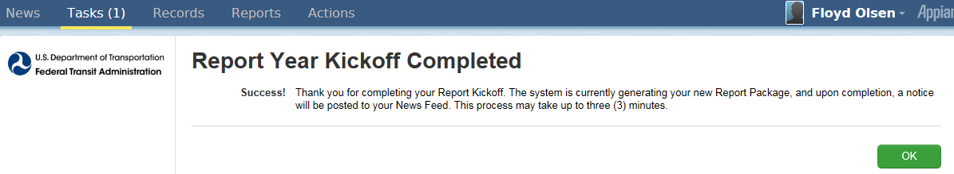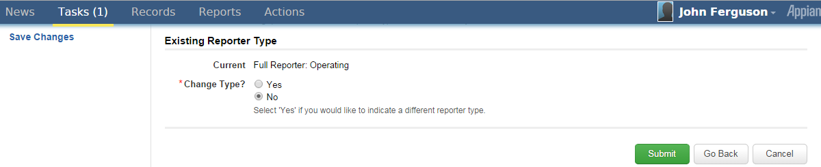

Click *OK*

Click *Submit* to complete kickoff

# Ridership Activity Form (MR-20)

The Ridership Activity Form (MR-20) is collected by mode and TOS. It provides FTA with monthly trends in passenger usage and service levels. Submit data by the end of the month for the previous month

* For example, September data is submitted by the last day of October



## MR-20 Data Items

There are two Ridership Activity forms (MR-20). Each is tailored for:

* 1. Rail
  2. Non-rail

The Ridership Activity form (MR-20) is used to report monthly data by mode and TOS for the revenue vehicles used to provide transit service. The data includes:

* Unlinked passenger trips(UPT)
* Actual vehicle revenue miles (VRM) and vehicle revenue hours (VRH)
  + - Car miles/hours for rail modes
* Vehicles operated in maximum service (VOMS)

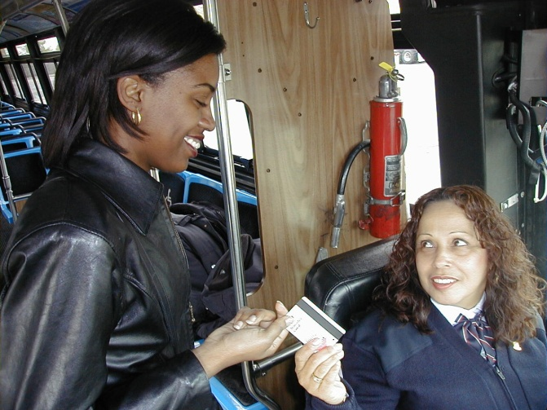**Total data reported must be consistent with annual total in S-10

## Access MR-20 Report Package

Follow the steps below to access the MR-20 Report Package

1. Go to the News tab.
2. Look under [Analyst email] Report Year 2015 (Original Submission) is now available.

Note. The screen will show Report Year 2014 for systems still their RY 2014

1. Click left box to go to Summary Screen

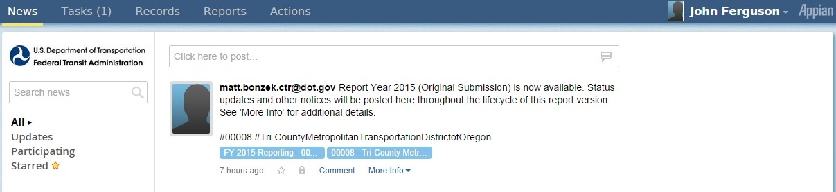

Click to access report packages

## Report Package Summary Screen

When you first open to the Report package screen, the screen is defaulted to a **Summary** page, which displays summary information on transit agency’s package. Click **Related Actions** to go to report packages screen.

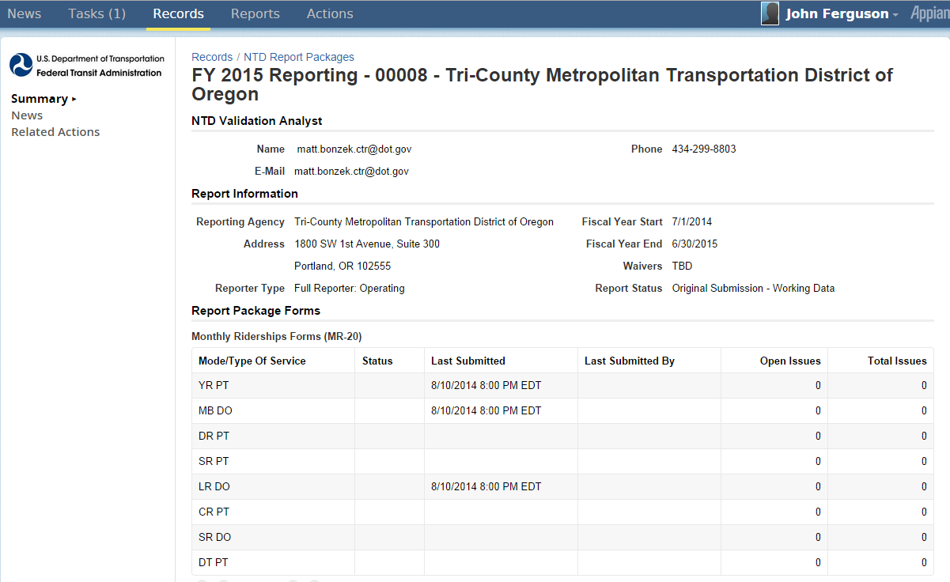

Click to access report packages

## Report Packages Screen

After you click on **Related Actions**, the screen will display a list of report package items. Click **Monthly Ridership** **Forms** to access the MR-20 forms.

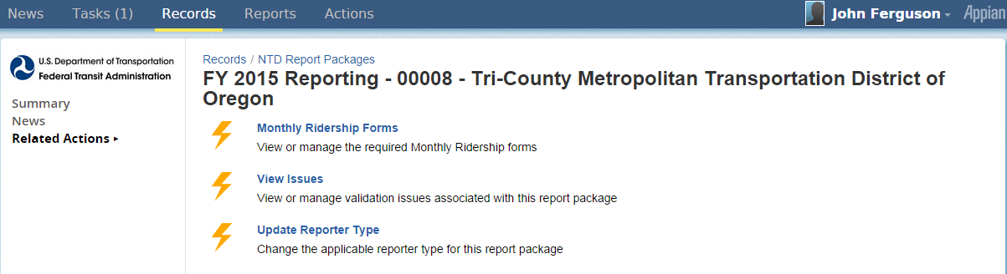

Click to access individual mode/TOS forms

## Individual MR Forms by Mode/TOS

After you click on Monthly Ridership Forms from the report package screen, you can then select individual MR form by Mode/TOS.

1. Check box for specific mode/TOS
2. Click **View Form**

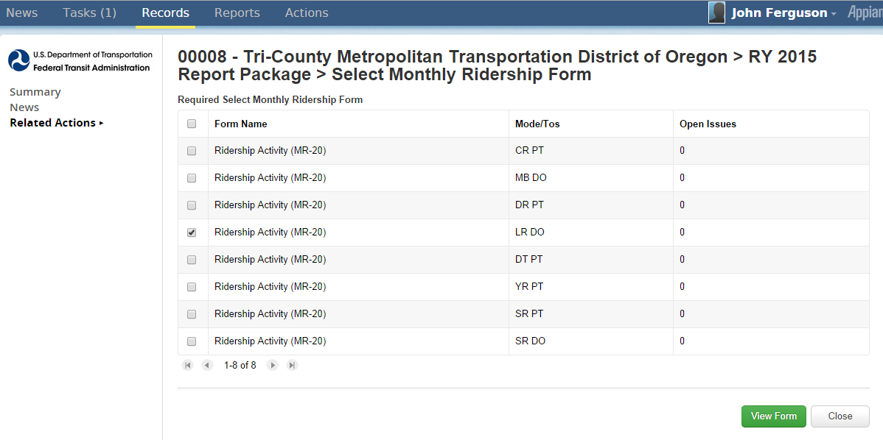

1. Click for mode/TOS forms

2. Click View Form

## MR-20 Data Entry Form

Once you select an individual MR form and View Form, then you can enter monthly MR data.

* There are two data entry options that will save the report.
  1. The **Submit** button is used when you have completed all data specific to the reporters Fiscal Year and are ready to submit to FTA. Once you submit, the reporter will not be able to make further changes.
  2. With the **Save** button, the reporter is still able to make further changes prior to submission/
* Submission date’s and submitter’s name will automatically be generated by the system.

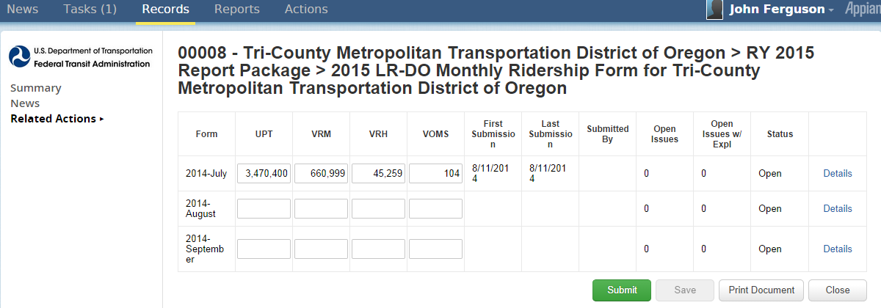

## Print Document

A printer friendly version of the MR-20 form is available by selecting **Print Document** on the individual MR-20 form. You can either view the file in your browser or print the file. The **Print Document** creates an HMTL file (copy of form) for downloading and saving to your computer, or for printing.



Click to create HMTL copy

### Link Created after Print Request

When the **Print Document** button is selected, a link is created at the top of the form with the following information, “**View Printable Version of Form – [as of MM/DD/YYYY HH:SS]**”

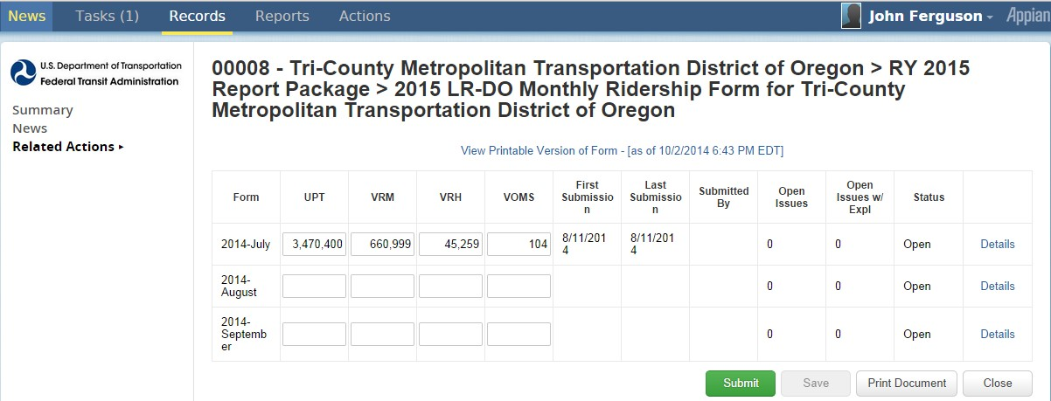

Click to download

HMTL copy

## Issue Checks

When you **Save** a form, the system will automatically check the form for any issues. If any issues are found, a count of issues will display on column, “**Open Issues**”. If any of the open issues are given an explanation, they will also be counted under column, “**Open Issues w/Expl**”.

1. Click **Save** to check the form for any issues.

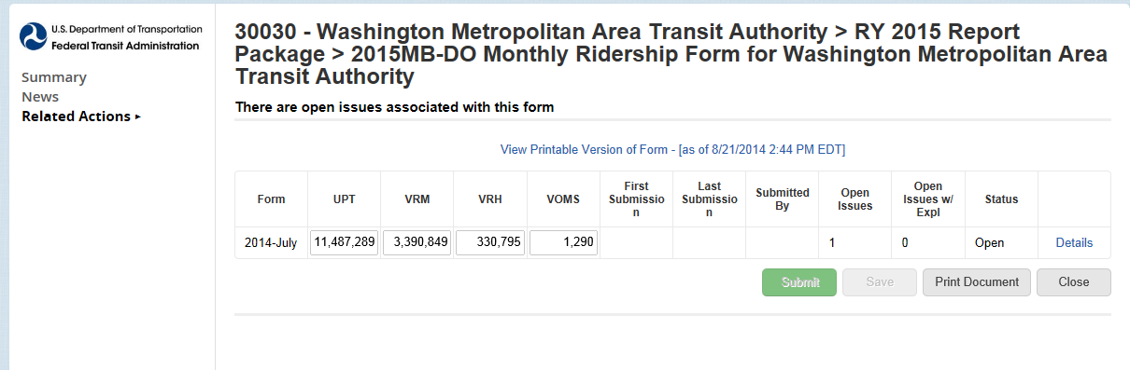

Click to save

### Addressing Issue Checks

To address an **Open Issue**, follow the steps below:

1. Click on **Details**. A table will then display with **Percentage Changes**.
2. Click on **View Issues**.

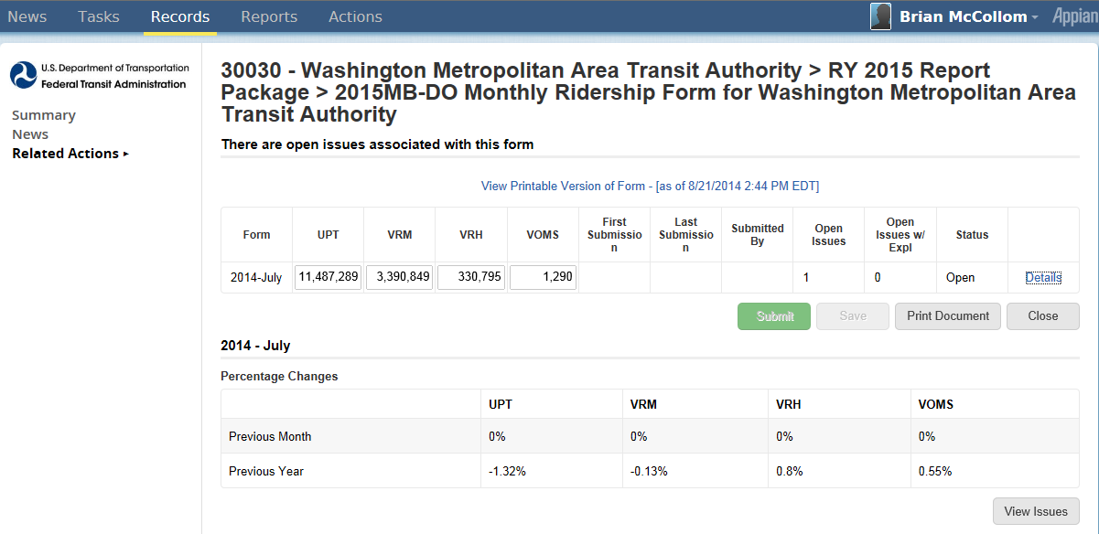

2. Click on *View Issues*

1. Click on *Details*

### View Validation Issues

After selecting the **View Issues** button, the screen will then display a **Validation Issue List**. To view and address an individual issue from the list, follow the steps below:

1. Select Issue
2. Click on **View** to address issue

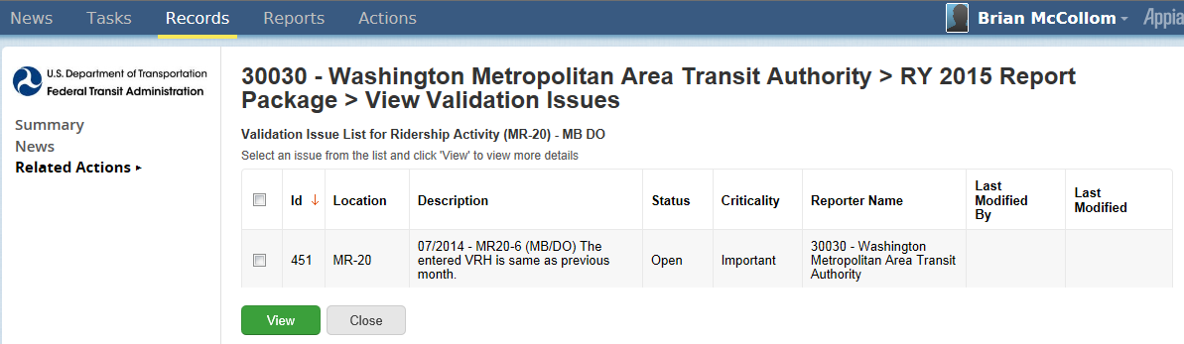

1. Select issue

2. Click on View

### Address Single Issue

After you select an issue and **View**, then the **Issue Review Details** will become editable. Follow the steps below to complete the Issue Review Details.

1. Provide explanation on the **Comment** box
2. Click on **Save** button

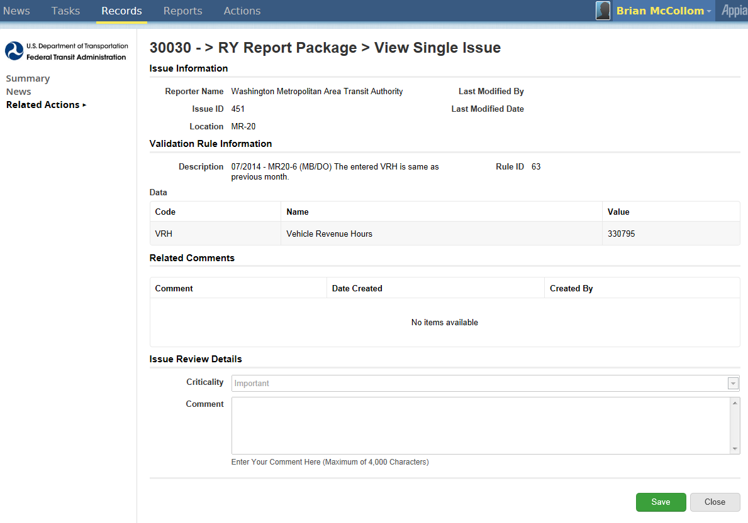

1. Provide explanation

2. Click on save

# National Transit Database Offices

* **NTD Operations Center**
  + Charlottesville, Virginia
  + Monday to Friday: 0800 –1900 Eastern

**NTD Help Desk**

* + (888) 252-0936
  + [NTDHelp@dot.gov](mailto:NTDHelp@dot.gov)
* **NTD Program Office**
  + Washington, DC
  + Keith Gates, Program Manager
  + (202) 366-1794
  + [keith.gates@dot.gov](mailto:keith.gates@dot.gov)

# Additional Training

* NTD Website training page:

<http://www.ntdprogram.gov/ntdprogram/seminars.htm>

* National Transit Institute, NTD courses:

<http://www.ntionline.com/courses/courseinfo.php?id=7>

* NTD Website presentations page:

<http://www.ntdprogram.gov/ntdprogram/announcements.htm>