Follow these instructions to specify User Managers for the National Transit Database or TrAMS, using TEAM:

**Identifying a new User Manager**

1. Select the **Recipients** menu tab.
2. Type your organization’s **Name** or TEAM **Recipient ID**.
3. Select **Submit Query**.

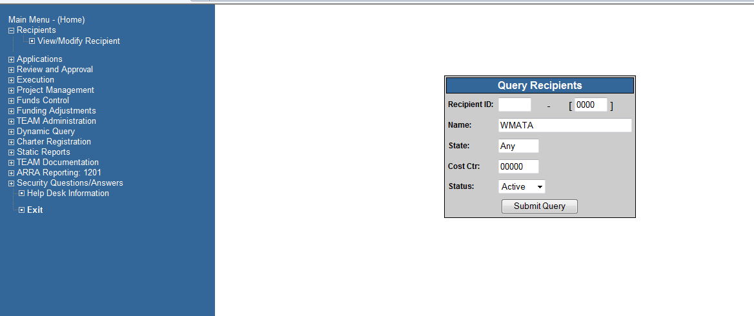

Once your Organization has populated:

1. Select the **View/Modify Recipient** option in the menu

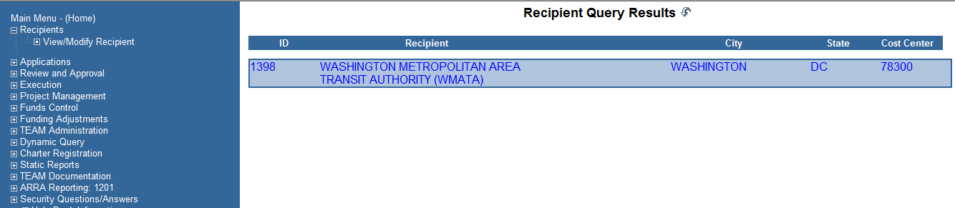

1. Select the **Contact Persons** tab.
2. Select Officers Titles from the Dropdown Menu
3. Selectthe **ADD** button to add a new contact.
4. Type **USER MANAGER--TRAMS** in the title field.
5. Type the **Name** and **ALL** **Contact Information** for the User Manager. Email and Phone number is essential
6. Check **Grants** in the set of “Contact For” checkboxes.
7. Click the Save Icon.
8. Select the Paperclip to upload the signed user manager document(s)
9. then Click on the Check Mark/OK button to Save and Close

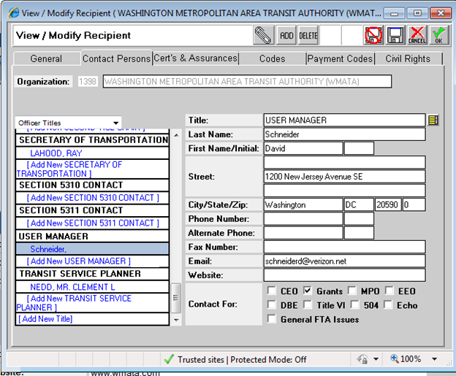

Repeat steps 5-11 to identify additional TrAMS user managers and/or NTD user manger. In Step 7, type USER MANAGER—TrAMS or USER MANAGER-NTD in the title field, as applicable.