Autoridad Metropolitana de Autobuses (AMA)
Metropolitan Bus Authority (MBA)
San Juan, Puerto Rico

Review of Lift Reliability and Maintenance
for
Operation of Accessible Fixed Route Bus Service

March 5-8, 2007

Summary of Observations

Prepared for

Federal Transit Administration
Office of Civil Rights
Washington, DC

Prepared by

Planners Collaborative Inc.
with
TranSystems Corp.

Final Report: October 15, 2007
CONTENTS

1 Purpose of the Review 1
2 Background 3
3 Overview of the Review 5
4 Observations of Lift and Ramp Reliability & Maintenance 9
4.1 Consumer Input 9
4.2 AMA’s Policies and Procedures Regarding Lifts 12
4.3 Review Team Observations 18
5 Findings and Recommendations 35
5.1 Findings 35
5.2 Recommendations 39

List of Tables

Table 4.1 – Sample of AMA Complaints for 2006 12
Table 4.2 – AMA Fleet Roster – February 2007 16
Table 4.3 – Summary of AMA Pull-out Observations, March 6, 2007 23
Table 4.4 – Operation of Lift/Ramp by Vehicle Type 24
Table 4.5 – Repair to Inoperable Lifts 25
Table 4.6 – Summary of Vehicles with Inoperable Lifts in Service 27
Table 4.7 – Vehicles in Service, February 1 to 5, 2007 27
Table 4.8 – AMA Inoperable Lifts on February 1, 2007 27
Table 4.9 – AMA Fleet Status – February 2007 31
Table 4.10 – AMA Expenses & Funding History 2000-2006 34

Attachments

A AMA’s Response Letter
B FTA’s Notification Letter to AMA
C On-Site Review Schedule
D On-Site Review Forms
E Customer Comment Form
F OPPI Strategic Plan Agreement
G AMA Notices and Bulletins Regarding Accessible Fixed Route Service Operating Policies and Procedures
H Sample AMA Maintenance Logs, Reports, and Forms

Purpose of the Review

The U.S. Department of Transportation (DOT) regulations implementing the Americans with Disabilities Act of 1990 (ADA) contain two primary provisions to ensure that vehicles with accessibility features are reliable and properly maintained. General equipment maintenance requirements, which pertain to all types of entities and services, are contained in 49 CFR § 37.161:

(a) Public and private entities providing transportation services shall maintain in operative condition those features of facilities and vehicles that are required to make the vehicles and facilities readily accessible to and usable by individuals with disabilities. These features include, but are not limited to, lifts and other means of access to vehicles, securement devices, elevators, signage and systems to facilitate communications with persons with impaired vision or hearing.
(b) Accessibility features shall be repaired promptly if they are damaged or out of order. When an accessibility feature is out of order, the entity shall take reasonable steps to accommodate individuals with disabilities who would otherwise use the feature.
(c) This section does not prohibit isolated or temporary interruptions in service or access due to maintenance or repairs.

In addition to the general maintenance provisions described above that apply to all transportation providers, 49 CFR § 37.163 requires public entities to keep vehicle lifts (and ramps) in operative condition as follows:

(a) This section applies only to public entities with respect to lifts in non-rail vehicles.
(b) The entity shall establish a system of regular and frequent maintenance checks of lifts sufficient to determine if they are operative.
(c) The entity shall ensure that vehicle operators report to the entity, by the most immediate means available, any failure of a lift to operate in service.
(d) Except as provided in paragraph (e) of this section, when a lift is discovered to be inoperative, the entity shall take the vehicle out of service before the beginning of the vehicle's next service day and ensure that the lift is repaired before the vehicle returns to service.
(e) If there is no spare vehicle available to take the place of a vehicle with an inoperable lift, such that taking the vehicle out of service will reduce the transportation service the entity is able to provide, the public entity may keep the vehicle in service with an inoperable lift for no more than five days (if the entity serves an area of 50,000 or less population) or three days (if the entity serves an area of over 50,000 population) from the day on which the lift is discovered to be inoperative.
(f) In any case in which a vehicle is operating on a fixed route with an inoperative lift, and the headway to the next accessible vehicle on the route exceeds 30 minutes, the entity shall promptly provide alternative transportation to individuals with disabilities who are unable to use the vehicle because its lift does not work.

The DOT ADA regulations also contain several requirements related to the operation of accessibility features. Part 38 of the regulations requires that accessible vehicles be equipped with mobility aid securement systems and passenger restraint systems. Technical and functional specifications for these securement and restraint systems are included in Part 38. The regulations require that transit systems use the securement system that is available on vehicles. § 37.165 requires that agency personnel assist individuals with disabilities with the use of lifts, ramps and securement systems (and that they leave their seat if necessary to provide this assistance). §37.173 then requires that transit agencies ensure that “personnel are trained to proficiency, as appropriate to their duties, so that they operate vehicles and equipment safely and properly assist and treat individuals with disabilities who use the service in a respectful and courteous way, with appropriate attention to the differences among individuals with disabilities.”

The Federal Transit Administration (FTA) is responsible for ensuring compliance with the ADA and the DOT implementing regulations (49 CFR Parts 27, 37, and 38). As part of its compliance efforts, FTA, through its Office of Civil Rights, conducts periodic reviews of fixed route transit services operated by grantees.

This report includes the results of the review of lift reliability, maintenance, and operation at the Metropolitan Bus Authority (MBA), known in Spanish and hereafter referred to in this report as Autoridad Metropolitana de Autobuses (AMA), based in San Juan, Puerto Rico. The review was conducted from March 5-8, 2007. This report summarizes the observations and findings of the on-site review of AMA’s fixed route bus service. A description of key features of the fixed route bus service is first provided, followed by a description of the approach and methodology used to carry out the review. Observations and findings related to the ADA requirements are then described, and the major findings of the review are summarized at the end of this report. Recommendations of the review team for addressing issues identified also are provided. AMA’s response to the review findings and recommendations is provided in Attachment A.

Background

Autoridad Metropolitana de Autobuses (AMA) is a governmental organization of the Commonwealth of Puerto Rico created by Act No. 5 of May 11, 1959, as amended. AMA is one of several authorities under the Puerto Rico Department of Transportation and Public Works (DTPW). The AMA President and General Manager supervises the operations of AMA and reports to the Secretary of the DTPW. Created to serve the San Juan metropolitan area, AMA is the only public transportation authority in the Commonwealth.

The AMA service area includes the municipalities of San Juan, Bayamón, Carolina, Cataño, Guaynabo, Loíza, Toa Baja, and Trujillo Alto. The entire San Juan metropolitan area has a population of 2.2 million, according to the 2000 U.S. Census. AMA operates a network of 30 fixed-routes. One of these routes is a “Metrobus II” route, which provides premium express service. AMA provides fixed route service seven days a week from approximately 4:30 a.m. to 10 p.m. Service hours were expanded in 2004, when the Tren Urbano rail service started. Buses operate at average intervals of 20 to 25 minutes, with core routes operating more frequently.

AMA operates the Metrobus II route under contract to the Puerto Rico Highway and Transportation Authority (PHRTA), which is an authority under DTPW. PHRTA also contracts with a private company to operate another “Metrobus” route. Although not operated or controlled by AMA, to the public, this contracted Metrobus route is indistinguishable from other AMA routes.

AMA’s active fleet includes 259 buses serving 195 daily runs. Four of the buses are equipped with ramps; the rest are equipped with lifts. Significantly, as will be discussed in Section 4, many of the lifts on older vehicles in the fleet are not in working condition.

AMA operates all of its services, including fixed-route and paratransit service, from a single maintenance and administration facility (the San Francisco facility), located at 37 Avenido de Diego in Rio Piedras (San Juan). AMA’s paratransit service, “Llame y Viaje,” operates a separate fleet of 54 vehicles, 20 to 28 of which are used in service at a time. AMA also has nine transit centers and two transfer terminals located throughout its service area.

Major AMA capital improvements since 2001 include:

- Modernization of the communication center, including installation of an automated vehicle location (AVL) system for both fixed route and paratransit service.
- New vehicle purchases, including:
- 30 new 2005, 35-foot buses for replacement (4) and expansion (26)
- 30 new 2004, 35-foot buses for replacement (20) and expansion (10)
- 4 new 2004, 35-foot hybrid buses (diesel/electric), as a pilot project to evaluate the technology’s viability
- Construction of a battery room in the vehicle maintenance area to comply with environmental and safety requirements

Additionally, AMA is in the process of implementing the following major projects:

- Modernization of shop equipment and reorganization of the bus maintenance shop
- Development of a Fleet Management Plan
- Installation of security surveillance camera equipment at the central San Francisco facility, bus terminals, and on revenue service vehicles (request for proposals under development)

The adult fixed route bus fare is 75 cents. Reduced fares are offered to senior citizens and persons with disabilities (35 cents) and students (60 cents). Riders 75 years of age and older ride for free. No transfers are issued; a separate fare must be paid for each boarding.

Overview of the Review

The review focused on AMA’s compliance with DOT’s ADA regulatory requirements related to the operation and maintenance of lifts as required for accessible fixed route bus service. The specific regulatory requirements that were the focus of the review are outlined in the first section of this report.

FTA provided AMA with written notification of the review on January 29, 2007. A copy of the notification letter is provided in Attachment B. This letter requested that AMA submit certain key service information prior to the on-site visit, including:

- A current fixed route system map
- A complete set of schedules for each fixed route
- Identification of which routes are operated directly and which, if any, are operated by private contractor
- Fixed route bus fleet inventory and division/garage information
- A description of ramp/lift maintenance procedures
- A copy of the current fixed route operators manual
- Copies of notices, bulletins, and memoranda detailing ramp/lift operations and maintenance policies and procedures
- Documentation of ramp/lift operations and lift operations monitoring procedures
- A list of all complaints received by AMA regarding ramp/lift operations during the past year

The letter also requested that an opening conference be scheduled on Monday, March 5, 2007, and an exit conference be scheduled on Thursday, March 8, 2007.

Prior to the on-site visit, the review team conducted telephone interviews with several local riders and staff of agencies that serve people with disabilities. Those interviewed included riders who have disabilities who use the AMA system, as well as employees of disability organizations who assist individuals who use the service. Input on experiences in using the fixed route bus service was requested. All interviews were conducted in Spanish.

Planners Collaborative Inc. of Boston, Massachusetts, and TranSystems of Medford, Massachusetts, conducted the review on behalf of FTA. Rosemary Gerty of TranSystems served as the team leader. Don Kidston and David Chia of Planners Collaborative, and Pilar Rodriguez of TranSystems assisted with the review. A schedule of the team’s on-site review activities is provided in Attachment C.

The following individuals participated in the opening conference held at 9 a.m. on Monday, March 5:

Evan Gonzalez | President, AMA
Nydia Falcon Garcia | Vice President of Operations (Maintenance), AMA
Angel L. Hernandez | Vice President of Service Programs and Development, AMA
Lourdes Suarez | Director of External Programs, AMA
Rafael D. Valentin | Special Assistant to the President for Llame y Viaje (Paratransit), AMA
Rosemary Gerty | TranSystems (Review Team Leader)
Don Kidston | Planners Collaborative
David Chia | Planners Collaborative
Pilar Rodriguez | TranSystems

Jonathan Klein of the FTA Office of Civil Rights in Washington, DC, and Frank Billue, the Regional Civil Rights Officer for the FTA Region IV Office in Atlanta, participated via conference call.

Mr. Klein thanked AMA for its cooperation with the review. He described the purpose of the review as identifying whether people with disabilities were receiving accessible fixed route services to which they are entitled in accordance with the DOT ADA regulations. He also noted that it was an objective of the review to offer assistance to AMA in meeting the ADA requirements and that the review team was available for that purpose. Mr. Klein outlined the process that would be followed for the review, noting that preliminary findings would be presented by the review team at the exit conference on Thursday, March 8. He explained that the review team and FTA would then prepare a draft report, which would be transmitted to AMA for review. Any errors identified by AMA would be corrected and AMA’s response letter to the draft report and findings would then be incorporated into a final report. Mr. Klein noted that the final report with any corrections and AMA’s initial comments would become a public document in accordance with the Freedom of Information Act. After issuance of the final report, AMA would be requested to provide quarterly progress reports on advancement of corrective actions for those findings that identify potential for improvement in delivering the ADA required service and those that identify non-compliance with DOT ADA regulations. Progress reports will continue until FTA has been satisfied that all findings have been adequately addressed, and releases AMA from the requirement for additional reporting.

Ms. Gerty distributed a copy of a review schedule that had been forwarded to AMA the prior week. She reviewed the planned on-site activities and meetings. She noted that the review would focus on the working condition, maintenance, and use of the bus ramps/lifts and wheelchair securement systems. She explained that observations would be made during the morning pull-out and that vehicle inspection and maintenance records and operator training materials would be reviewed. She also explained that approximately 10 operators would be interviewed and AMA’s service monitoring efforts, including the handling of complaints regarding accessible fixed route service, would be reviewed. She noted that in-service observations and “ride-alongs” with consumers also were planned.

Following the opening conference, the review team met with senior AMA managers to discuss policies, maintenance and operating procedures, fleet resources, and other issues related to data that AMA had forwarded in advance. Internal complaint records that related to accessible fixed route service also were reviewed and operator interviews (conducted in Spanish) were initiated. The team toured the AMA facility, including the communication center. The team began its review of maintenance records related to lifts and ramps. The team also began inspecting vehicles to determine whether they met ADA vehicle requirements. The vehicles inspected were representative of the different makes and models in the AMA fixed route fleet.

On Tuesday, March 6, the review team observed the morning pull-out process, whereby bus operators take their assigned buses from the bus yard into passenger service. The team specifically observed the cycling of lifts and ramps and made random checks of the wheelchair securement systems. Following pull-out, team members met with garage maintenance staff to review recent vehicle inspection and maintenance records. Bus operators were also interviewed throughout the day, as they reported for duty or as they completed their work shifts. The team also began interviews with the repair shop and parts department staff.

On Wednesday, March 7, Mr. Kidston, Ms. Gerty, and Ms. Rodriguez accompanied riders who use lifts and ramps to board AMA’s fixed route service, and observed them attempting to use the service. They completed three trips during the morning and afternoon, noting the performance of the operators and equipment. Simultaneously, the team also reviewed AMA’s maintenance and complaint records, training curriculum, and dispatch logs, and conducted operator interviews.

The team members spent Thursday morning, March 8, analyzing the information and preparing for the exit conference. The exit conference took place at 2 p.m. that afternoon. The following individuals participated in the exit conference:

Evan Gonzalez | President, AMA
Nydia Falcon Garcia | Vice President of Operations (Maintenance), AMA
Angel L. Hernandez | Vice President of Service Programs and Development, AMA
Lourdes Suarez | Director of External Programs, AMA
Rafael D. Valentin | Special Assistant to the President for Llame y Viaje (Paratransit), AMA
Rosemary Gerty | TranSystems
Don Kidston | Planners Collaborative
David Chia | Planners Collaborative
Pilar Rodriguez | TranSystems

Jonathan Klein and David Knight of the FTA Office of Civil Rights in Washington, DC, and Frank Billue, the Regional Civil Rights Officer for the FTA Region IV Office in Atlanta, participated via conference call.

Prior to the exit conference, the Review Team had briefed FTA on its overall findings. Mr. Klein thanked AMA for its cooperation throughout the review and stressed that while the review was intended, in part, to provide technical assistance to AMA, FTA expected AMA to make significant progress toward correcting the deficiencies cited during the review. He urged AMA to begin to take corrective actions right away and not to wait for the written report to be issued. Mr. Billue offered any assistance that his office could provide to assist AMA. Mr. Gonzalez indicated that AMA would work with FTA on those items where recommendations for improvement were made, notwithstanding constrained finances in Puerto Rico in all areas of the transit system operation and noting that the system had been running more than $10 million in the red.

The review team then presented its observations and preliminary findings and recommendations for discussion with AMA officials. Ms. Rodriguez summarized the results of the customer interviews, complaint review, ride-alongs with passengers, and operator interviews. Ms. Gerty described the training curriculum for operators. Mr. Chia reviewed the results of the pull-out observations and fleet availability. Ms. Gerty then described the overall maintenance program, as well as observations related to the communication center procedures for reporting in-service ramp/lift failures. Mr. Kidston then reviewed the transit agency resources (including vehicles, finances, and budgeting practices), along with the results of an analysis of the parts inventory system and its relationship to the lift/ramp maintenance program.

Observations of Lift and Ramp Reliability & Maintenance

To assess AMA’s current performance with respect to accessible fixed route reliability, maintenance, and operation, the review team performed the following activities:

- Gathered consumer input by various means, including telephone interviews in Spanish with individuals who use wheelchairs who are regular riders of the AMA bus system and with personnel from various agencies whose clients are regular riders
- Reviewed policies and procedures regarding lift operations, service monitoring, and equipment inspection
- Observed bus operations
- Interviewed bus operators (in Spanish) to gauge their understanding of ramp and wheelchair securement use policies and procedures
- Observed vehicle pull-out and inspection
- Reviewed maintenance procedures and performance
- Reviewed recent bus procurements, current fleet accessibility, and bus stop accessibility
- Reviewed availability of resources for lift/ramp operation.

Team member observations made during each of these review activities are detailed below. Copies of the forms used to collect information on-site are included in Attachment D.

Consumer Input

The review team gathered input from AMA fixed route service customers to assist in identifying any problems with the use of lifts and ramps from the perspective of the consumer. Three methods were used for gathering consumer input: review of complaints on file with FTA, interviews with consumers and consumer representatives, and review of AMA’s complaint files.

FTA Complaint

There was one formal ADA complaint related to AMA’s fixed route and paratransit service on file with FTA’s Office of Civil Rights at the time of the on-site review. The complaint included an ongoing dialogue with FTA on various areas of concern that spanned several years. In a letter dated February 16, 2007, FTA closed that complaint, noting the following:

“The specific issues in your complaint, including AMA’s failure to properly maintain lifts and driver sensitivity, will be addressed from a broader perspective by this compliance review, with the intent of resolving any issues of non-compliance identified. You also raised concerns about AMA’s paratransit service, Llame y Viaje; however recent conversations with you indicate that you are not a current rider of Llame y Viaje. We will focus on your fixed route bus concerns at this time. If you have additional Llame y Viaje concerns, please contact us again. As part of this review, if we make findings of deficiencies, FTA will monitor activities until we determine that the deficiencies noted are corrected. When the compliance review report is final, we will provide a copy to you. For the reasons discussed above, we will not pursue additional investigation of your specific complaint at this time.”

Customer Interviews

The review team conducted four telephone interviews with individuals who ride or have attempted to ride AMA’s fixed route buses. All interviews were conducted in Spanish. One of the interviews was with the spokesperson for a local disability organization. The reviewers also unsuccessfully attempted to contact several other organizations in an effort to identify people who need to use lifts/ramps when riding AMA buses. Among those organizations were the Center for Independent Living in San Juan (in Spanish, “Movimiento para el Alcance de Vida Independiente”) and the Puerto Rico chapter of the Paralyzed Veterans of America; however, the publicized phone numbers for both organizations were disconnected or went unanswered. Furthermore, the team could not identify representatives in Puerto Rico for some major disability rights groups, such as Americans Disabled for Accessible Public Transportation and the National Organization on Disability. The team did, however, contact the Puerto Rico offices of the Protection and Advocacy Agency (known locally as “OPPI,” which stands for Oficina del Procurador Para Impedidos). OPPI receives and processes complaints from AMA users; however, its mission appears to be more focused on legislative issues and less on consumer advocacy.

There was a consensus among the interviewees that, for persons with disabilities, using either the fixed route or paratransit service is challenging, and the service is unreliable and often unsafe. The problems encountered when using the AMA fixed route system that were described by the interviewees fall into two main categories.

The first group of problems encountered by people using wheelchairs or scooters concerns the lack of stop accessibility. According to interviewees, AMA bus stops are often inaccessible because access from the streets to the sidewalks is blocked by parked cars or the sidewalks are too narrow for lifts/ramps to properly deploy. As a result, when alighting from the bus, passengers are often left in the street because the lift cannot be deployed on the sidewalk.

The second group of cited problems concerns lift reliability. Three interviewees estimated that more than 50 percent of the lifts do not work. The other interviewee noted that neither she nor her disabled family members rely on AMA’s fixed route system anymore because it is almost impossible to access the stops near their house. However, she also said that on the few occasions when she used the fixed route bus system in the past year, she has had an acceptable experience with the reliability of the lifts and the operators.

Two of the interviewees had particularly serious complaints about operators’ lack of courtesy and apparent unwillingness to transport people with disabilities. They noted that operators are often disrespectful and hurtful in the way they address customers with disabilities, even telling such customers that they “do not belong in the fixed route system” and should call the ADA paratransit service (Llame y Viaje) for a ride. The interviewees felt that the operators often just make up excuses to avoid transporting them. According to the interviewees, the most common excuses are:
- “The lift is broken”
- “I don’t have the key to operate the lift”
- “The supervisor did not activate the lift”

Additionally, one interviewee uses a walker and cannot use the steps to board the bus. When she asks operators to deploy the lift or ramp for her, she said they will often refuse to do so, stating that the lift is only for people who use wheelchairs.

Customer Comments and Complaints Received by AMA

Customers can file complaints concerning accessibility of AMA’s fixed route service not only at AMA but also through the Protection and Advocacy Office (known locally as OPPI) and several other government agencies and departments. One of the customers interviewed mentioned that he would rather file a complaint at OPPI because the process at AMA is “confrontational and disadvantageous for the customer.” A copy of the AMA comment form is included in Attachment E.

The review team attempted to review the internal complaint records related to the provision of accessible fixed route service in 2006. However, the team encountered problems locating and validating the records because of the decentralized process used by AMA to handle customer complaints. There is no one central office where complaints are collected and processed. Complaints may be filed through various departments by phone, in person, or even by sending text messages or e-mails to staff. As a result, although according to AMA most complaints are filed with the Programming and Services Department, the communication center, the Legal Department, or the Office of the President/General Manager, many complaints may go unrecorded and undocumented.

Procedurally, complaint records are generally filed and organized according to bus operator. Service complaints are associated with an operator and the case is documented in the operator’s file, rather than in a central file. Typically, each complaint is first handled by the Programming and Services Department. If the customer wants a hearing, one is arranged by the department and all parties involved (customer, operator, an AMA representative, and a union representative) are called in. The customer can opt out of the hearing; however, it appears that this right is not understood by some customers. Additionally, many customers believe that they must go to a hearing by themselves. In cases where the customer opts out of a hearing, AMA will do an internal investigation and take steps toward resolving the issue, but there is no record of the actions taken. If a hearing is held, the department attempts to resolve the issue and records all actions taken in the operator’s file.

If the issue is not resolved at the Programming and Services Department or if the customer wants to bring a lawyer, the issue is referred to the Legal Department. If the problem is still not resolved at this level, it is forwarded out of the agency, to the Department of Labor.

The Legal Department maintains the operators’ files, which include the customer complaints. The review team obtained a list of all complaint hearings scheduled in 2006 from the Programming and Services Department. This list included all complaints filed against operators, not only by customers but also by supervisors and other AMA employees.

In 2006, there were 76 scheduled hearings in the Programming and Services Department for customer-related complaints. Of the 76 complaints with hearings, the review team selected a sample of 20 complaints to determine their status and whether the complaints were related to lift/ramp and ADA issues. Files for four of the complaints could not be found. Of the remaining 16 complaints in the sample, seven were unrelated to lifts, ADA requirements, paratransit service, or operator conduct involving a disabled passenger. Table 4.1 identifies the issues cited in the nine accessibility-related complaints. Some complaints identified more than one issue, and as a result the total of complaints for each issue exceeds nine.

Table 4.1 – Sample of AMA Complaints for 2006
Type of Complaint | Number of Complaints
Poor bus operator conduct | 6
Inoperable lift | 3
Elderly passengers were not provided appropriate assistance | 2
Operator did not secure passenger wheelchair | 1
Complaint about paratransit service | 1

There was a record of AMA follow-up for six of the nine complaints. In some cases, AMA responded by issuing a memorandum to all operators regarding policies and procedures. In other cases memos were issued to the responsible individual and apologies sent to the customer involved.

Overall, the analysis for this review points to the great difficulty in tracking complaints using AMA’s current process.

On February 8, 2007, AMA signed a letter indicating its intent to work with OPPI on a strategic plan to improve services for individuals with disabilities. A February 8, 2007 letter stating AMA’s intent to participate with OPPI in development of a plan to comply with supporting the rights of people with disabilities (“Implantacion del Plan Estrategico de la AMA Para Cumplir con la Ley 238 DEL 31 de Agosto de 2005 ‘Carta de Derechos de las Personas con Impedimentos’”) is included in Attachment F.

AMA’s Policies and Procedures Regarding Lifts

Following is a description of policies and procedures adopted by AMA regarding accessibility of the fixed route system and the provision of accessible fixed route bus service. Copies of relevant AMA policies and procedures are included in Attachment G.

Operator Training

AMA requires bus operators to complete a 25-day classroom and hands-on training program. Although not specified in the associated “Academia 2001” curriculum outline, AMA reports that on day 5, trainees begin to work with wheelchair securement and lift/ramp boarding and alighting procedures. On day 15, there is a half-day presentation by OPPI describing passengers with disabilities and their needs. On the other hand, AMA noted that there have been virtually no new hires in the past five years; therefore, the curriculum may be out of date and detailed information about what exactly what topics were covered in recent trainings could not be provided.

No formal bus operator retraining is offered. Any retraining that occurs is the result of a complaint or incident.

Several driver bulletins are included in Attachment G. Two driver bulletins, dated February 3, 2006 and March 29, 2006, state that drivers are required to allow passengers to board using lifts or ramps upon request, whether or not they use a wheelchair or scooter.

Bus Operations

Operators are assigned a vehicle when they report to the desk (pull-out) dispatcher each day.

AMA operators are supposed to inspect their assigned vehicle before entering into passenger service. Most AMA operators do not include cycling of lifts as part of the inspection. Accordingly, there is no consistent cycling of lifts on a daily basis.

Further, there is no written documentation of the operator’s inspection. If the operator identifies a problem, he or she makes an oral report to the supervisor. If the needed repair is minor, requiring only a few minutes labor and no significant expense, the operator will take the bus to the shop and, upon completion of the repair, continue to use the bus in service. If the required repair appears to be major, the supervisor will take the bus to the shop and the operator will be assigned to another bus. Only such major repairs are regularly tracked in AMA’s maintenance system records.

Additionally, lift failures that are discovered for buses assigned to service are to be reported to the communication center, either by the operator or transportation supervisor. A sample copy of the log is included in Attachment H. As noted earlier, however, operators do not typically look for problems with lifts/ramps prior to pull-out.

If a lift/ramp problem is identified in service, the operator is required to follow the procedures outlined in an April 24, 2003 memo (see Attachment G). The procedures include notifying the communication center that the lift has failed, advising the customer of the outcome of the communication center contact, and providing alternative transportation if the next accessible bus is more than 30 minutes away. This policy is consistent with the DOT ADA regulatory requirements at 49 CFR § 37.163.

The communication center records the operator’s report on a log sheet (called “Control de Reparacion de Rampa de Impedidos”) and dispatches a mechanic to meet the vehicle. The mechanic either repairs the reported defect or returns the bus to the shop. Notably, the first record for inoperable lifts identified while in service is the dispatch log maintained by the communication center.

Normally, at the end of the day the operator returns the bus to the revenue collection area and reports out to the desk dispatcher. If, however, the operator identifies a problem upon returning the bus at the end of the run, the vehicle is brought to the shop. Buses with defective wheelchair lifts are brought to the doors outside the wheelchair maintenance bays in the garage. As with inoperable lifts identified at pull-out, the first written record of an inoperable lift identified at pull-in is created when a work order is issued for a major repair.

AMA has standby operators at the outlying terminals and transfer locations to provide immediate assistance when lift boarding issues arise and the next accessible bus is estimated to be more than 30 minutes away. Although having such procedures for backup service is good practice, AMA’s records indicate little use of the service. The lack of use is significant because it conflicts with the documented lift-failure rate of 50 percent and the fact that buses with inoperable lifts are often kept in service (discussed below). The discrepancy suggests that either operators are not reporting lift failures while in service or passengers who need to board using a lift are not attempting to access AMA’s fixed route service.

Service Monitoring and Enforcement of Policies and Procedures

AMA does not have a formal service monitoring program for the enforcement of policies related to the provision of accessible fixed route services. Traffic checkers ride buses to observe and record travel times and the number of passengers using the bus, but do not specifically look for performance related to accessibility concerns. Similarly, although AMA Road Supervisors monitor operator performance, with four supervisors assigned on weekdays and two on weekends, AMA does not use “secret” or “mystery” riders to monitor service. Secret or mystery riders are people unknown to the operator who ride buses and observe and record performance of the operator and vehicle components. Many transit providers have found them indispensable to ensuring operator compliance with DOT ADA regulatory requirements, including proper provision of lift and ramp service.

Maintenance and Inventory Control

Maintenance performance is tracked using written forms and paper copies of maintenance records. Records are maintained for each vehicle and are kept in paper form in file cabinets. Fleet management software was being installed at the time of the review. Upon installation of the electronic system, AMA plans to conduct preventive maintenance inspections (PMIs) for each bus based on mileage intervals, as described below.

Currently, AMA procedures call for scheduled preventive maintenance inspections every 35 to 45 days or every 400 hours of service. Item #105 “wheelchair y mecanismo de ‘interlock’” is shown on the “yellow” preventive maintenance checklist (“Reporte de Mantenimiento Preventivo (Inspeccion)”), which is included in Attachment H. In June 2006, a revised preventive maintenance schedule was proposed, which includes “Type A” inspections every 6,000 miles, “Type B” inspections at 12,000 miles, “Type C” inspections every 18,000 miles, and “Type D” inspections every 24,000 miles. Among other items, the Type A inspections will include the following lift-related elements:

- Operation of wheelchair lifts/ramps
- Sensors, switches, and linkages
- Electrical connections
- Large hydraulic tanks
- Cleanliness of lifts/ramps

AMA staff members have also proposed a more detailed form (“Mantenimiento de Rampas”), which is included in Attachment H. Additionally, the new proposed inspection handbook (“Procedimento Para el Mantenimiento Preventivo de Vehiculos de 30, 25 y 40 Pies”) also includes a statement indicating the need for information about the ADA requirements related to preventive maintenance.

When bus maintenance staff members need parts, they must get them from AMA’s warehouse. Significantly, if lift/ramp parts are not available, repair work is suspended, and the bus is returned to the active fleet of buses available for service. As is described further in Section 4.3.6, it had been AMA’s practice for the warehouse to notify maintenance staff by e-mail, on a daily basis, when special order parts are received. When the parts become available, buses awaiting parts are supposed to be scheduled for maintenance at a rate of two per day until the associated repairs are completed. At the time of the review, however, this practice had not occurred for a couple of months, apparently because of a significant breakdown in communication between the Maintenance Department (alternatively referred to as the Operations Department) and warehouse concerning special order parts. As a result, no repairs for buses awaiting parts had been made over the same period. The breakdown is particularly perplexing because the warehouse and maintenance facilities are next door to each other, in the same building.

The current system for inventory control relies largely on manual procedures and paper records. The Parts Department maintains an inventory of in-stock spare parts for vehicles. Stocks of parts from the bus parts lists are maintained in the inventory, with the exception of parts for the 2004-2005 Orion buses. The inventory is kept on computer, but it is based on the paper records.

Parts are stored in bins or shelf areas in the warehouse. The warehouse manager makes regular visual inspections of the parts inventory to determine whether minimum quantities of each part are available, and additional parts are ordered as needed when the manager observes that stocks are depleted. Parts are also ordered when parts requested for vehicle maintenance are out-of-stock. Notably, the recent breakdown in repairs requiring special order parts, described above, was not due to failure to acquire needed parts. In recent months, the needed parts have been received, but the repairs have not been made.

The warehouse initiates all requisitions, which are forwarded to the Purchasing Department. The requisitions are circulated to the Director of External Affairs and the Chief of the Budget Office for confirmation of the availability of Federal and local funds, respectively. Upon receiving funding approval, the Purchasing Department issues a purchase order for each needed part. The process to issue the purchase order typically takes one to three days, which is in addition to seven to ten days needed to receive the part once the requisition has been issued.

As is also discussed in Section 4.3.6, AMA is in the process of installing a new Inventory Control System. The system will maintain a tally of parts in-stock, tracked according to base line inventory, parts drawn from stores, and additional parts received. For each part, minimum and maximum units in inventory are being developed based upon rate of use and the lead time for restocking the part. Automatic reordering when minimums are reached should minimize parts shortages, and adhering to maximums when reordering should minimize the amount of money needed to maintain an adequate parts inventory. At the time of the on-site review, the new inventory control system was scheduled for installation between March and December 2007.

Fleet Roster

AMA has a fleet of 315 buses; however, as will be described later in this report, 56 of those buses are old and unavailable for passenger service and, at the time of the review, 9 others were off-site for warranty work and therefore also unavailable (see Table 4.2). This leaves 250 buses to serve 195 weekday runs, yielding a spare ratio of 0.28, exclusive of buses being serviced under warranty. Furthermore, of the 250 buses available for service, 24 are 12 years old and an additional 61 are 10 years old.

Table 4.2 – AMA Fleet Roster – February 2007
Year | Make | Model | Ramps /Lifts | Total Vehicles
2005 | New Flyer | Delf-35 | Ramps | 4
2005 | Orion | Orion V | Lifts | 30
2004 | Orion | Orion V | Lifts | 30
2002 | Nova | 6.2 VN | Lifts | 10
2000 | Nova | 8.2 VN | Lifts | 70
1999 | Nova | T802 VN | Lifts | 29
1998 | Nova | T802 VN | Lifts | 18
1997 | Nova | T802 VN | Lifts | 79
1995 | Flxible | 400964D50 | Lifts* | 45
Totals |  |  |  | 315
Note: none of the 1995 lifts are operable.

In addition to the fixed route fleet, AMA maintains retired paratransit vehicles for use as needed, to respond to in-service failures of the lifts on fixed route buses.

Bus Stop Accessibility

Section 810 of Appendix A to 49 CFR Part 37 requires that new bus stop boarding and alighting areas have a firm stable surface 96" deep (from the road edge) and 60" wide (along the road edge). Section 810 also requires that such areas be connected to streets, sidewalks, or pedestrian paths by an accessible route. New bus shelters must have a clear floor area of 30" by 48" and must also be connected to an accessible route.

AMA identifies bus stops to customers on the street with signs, many of which include information about which routes serve the specific stop and schedule frequency. Shelters and benches are available at some, but not all stops.

Passengers are expected to signal operators to stop by waving at them; if they do not wave, the operators will not stop. As noted later in this report, AMA has significant issues with vehicles parking or waiting illegally in the bus stop areas. According to AMA, law enforcement does not appear to place a high priority on keeping bus stops clear of vehicles. Consequently, parked vehicles often block access to fixed route bus stops, making it difficult for passengers to use the stops and for operators to spot passengers waiting for the bus.

Budget and Financial Resources

As stated above in Section 2, AMA is a division of DTPW and the AMA President and General Manager reports to the DTPW Secretary. Approximately 15 to 20 vice presidents, directors, and assistants report to the president. Senior staff who have significant impact on lift operations include: the Vice President of Programming and Development (transportation), Vice President of Operations (passenger vehicle maintenance), Vice President of General Services (purchasing and warehouse), Assistant for Special Major Capital Projects (management information systems), Vice President for Administration (budget & financial control), and Director of the Office of External Resources (Federal funding).

The AMA budget process is based on a fiscal year ending June 30, and is scheduled in coordination with the commonwealth budgeting process. In July or August of each year, the commonwealth issues budget instructions to all agencies for the next year’s budget. AMA develops the agency budget during the period from September through November. The AMA process overlaps with presentation of agency budgets for review by the commonwealth, which occurs between September and February. The commonwealth finalizes its proposed budget in February and the governor presents the budget to the legislature. Between February and June, the legislature reviews the budget, which it typically approves in June.

The annual AMA budget is for both capital and operating expenses. Funds for vehicle parts are included in the Preventive Maintenance (PM) element of the capital budget. Other costs included in the PM element are labor, supplies (parts), and equipment (machinery) needed to perform preventive maintenance.

The Chief of the AMA Budget Office is responsible for preparing the annual budget. Major initiatives in the capital budget are developed by, or with input from, the President and General Manager’s Office. The budget chief also obtains input from a number of senior managers.

The PM component of the annual AMA capital budget is developed by the External Resources Department, based on the budget for the previous year and a straight line projection from expenditures for recent years. The PM component is further adjusted to reflect changes in fleet or other equipment. During the on-site review, AMA proposed that the Purchasing Department develop future PM budgets using information from the new Inventory Control System.

The equipment component of the annual capital budget is developed by the Purchasing Department, which receives a baseline budget from the Budget Office. Funding to complete projects initiated in the prior year is provided first. Next, funding for new projects is prioritized and added to the proposed budget, based on remaining available funds.

Funding for service comes from four principal sources:

- Agency revenues
- Local funds
- Commonwealth funds
- Federal funds

Agency revenues are derived from passenger fares, contract services and leases, concessions, and advertising. The sources of commonwealth funds are general revenues appropriated annually by the legislature and 4-cents out of an 8-cents-per-gallon tax on diesel and propane sales. Federal funds consist of formula grant funds for capital investments, including preventive maintenance of vehicles and planning.

In January 2006, AMA increased base fixed route bus fares from 25 cents to 75 cents. AMA estimated that the fare increase will result in an overall annual increase in fare revenues from approximately $6 million to $12 million.

Review Team Observations

In addition to interviewing riders and examining AMA’s policies and procedures, the review team conducted firsthand observations of service, reviewed AMA’s internal records, and conducted further interviews, as follows:

- Conducted “ride-alongs” with consumers who use wheelchairs
- Interviewed bus operators
- Observed pull-out and vehicle accessibility equipment
- Reviewed maintenance records and dispatch logs
- Reviewed fleet availability records and related resource considerations
- Inspected one of each type of fixed route bus purchased by AMA for compliance with ADA vehicle design (Part 38) standards
- Reviewed resources and budget

The remainder of this section of the report summarizes these observations.

In-Service “Ride-Alongs”

As part of the review, team members arranged to meet with two local customers who use the lifts or ramps to access the AMA bus system. Three rides were observed on Wednesday, March 7. One rider used a walker and the other used a power wheelchair, which was of a size and weight that fit the DOT regulation’s definition of a “common wheelchair.” The reviewers recorded whether the boarding and alighting processes were successful, if the lifts / ramps were operable, and whether the operators properly secured the rider’s wheelchair.

The ride-alongs resulted in the following observations:

- Out of six boarding attempts, only three resulted in completed trips. The other three buses did not have working lifts, according to the operators.
- Operators with buses that reportedly had non-functioning lifts did stop and advise the passenger. However, only one operator appeared to radio the communication center to report that he was unable to transport the passenger using a wheelchair because the lift was broken.
- One operator said that he had to check the lift because he wasn’t sure that it worked (it did).
- In two of the three trips, the wait time for an accessible bus was longer than 30 minutes (the wait time was 35 minutes for each).
- The operators seem to be knowledgeable in operating the lift. However, two operators did not properly secure the wheelchair, using only one or two straps to secure the wheelchair and failing to offer use of the shoulder belt.
- Operators were generally respectful, although one did make a comment stating that the passenger should be using paratransit service.
- Lack of accessibility to the stops and areas around stops was observed to be a barrier to accessing AMA buses (see summary comment below).
- Curb ramps are often either non-existent near the bus stops or blocked by parked vehicles.

Overall, the review team observed that the infrastructure in San Juan is not readily accessible for persons using wheelchairs and scooters as well as for persons who have difficulty walking up steps (discussed further in Section 4.3.8). Particularly in the congested downtown business areas, sidewalks may be obstructed by posts, planters, or other barriers, and curb ramps are often blocked by parked or waiting vehicles. Additionally, at some crosswalks and intersections, there are no curb ramps at all. As a result of cars parked at bus stops, the operator may not be able to pull the bus up to the curb, forcing both ambulatory and non-ambulatory passengers to board or alight in the street, rather than on the sidewalk. As a result, persons using wheelchairs or scooters may not be able to access the bus because they cannot get to the street due to absence of curb ramps. Additionally, boarding with wheelchairs or scooters from the street is problematic because deployment of lifts and ramps at street level can result in excessive slopes, which violates Federal law and is dangerous for customers and operators. Even where the bus can reach the curb, persons using wheelchairs or scooters may still be prevented from accessing the bus because of inaccessible sidewalks and curb ramps, which make the stop inaccessible.

During a ride-along, a review team member noted a blocked bus stop that prevented a rider who uses a wheelchair from accessing the sidewalk from the bus, and forced the rider to travel in the street, in vehicular traffic, a half block before being able to use a curb ramp to access the sidewalk. This situation will become a bigger issue as more low-floor buses with ramps are introduced into the system. Low-floor buses are designed to deploy ramps onto the sidewalk. If deployed onto the street, the ramp may be too steep to negotiate or there may not be enough room to maneuver between the ramp and an obstruction for boarding or alighting from the bus.

Bus Operator Interviews

During the on-site review, the team interviewed 10 bus operators at the garage, either before or after their shifts. The interviews were conducted in Spanish. A copy of the form used in the interviews is presented in both English and Spanish in Attachment D. Before the interviews, reviewers observed an apparent misunderstanding among AMA staff regarding who could use the lifts, resulting in operators routinely denying requests to use lifts from people who were not using wheelchairs or scooters. Accordingly, an extra question regarding eligibility to use the lift was added to the questionnaire. At the beginning of each interview, the interviewer explained the purpose of the review and told the operators that any identifying information collected during the interviews would be kept confidential.

Bus operators were randomly selected and included a mix of operators with varying years of service. It should be noted that AMA has not hired new bus operators during the last five years. Accordingly, the least experienced operator interviewed has been at AMA for seven years, and several interviewed operators had more than 30 years of experience with AMA. Two women and eight men were interviewed. Additionally, AMA has no part-time operators. As a result, all operators interviewed work full time and almost always operate a lift-equipped bus.

Three of the 10 operators indicated that they transport someone with a disability at least once a day. Five operators indicated that they do so at least once a week, one said once every two months on average, and one said that he hardly ever has passengers with disabilities on board.

All of the operators who have worked for AMA for more than 20 years said that they did not receive training regarding disability issues at the time of their hiring. All of the operators with 15 years of experience or less indicated they received training in serving passengers with disabilities as part of the “Academia” (a training course for new operators). All of the operators who received training thought it was appropriate.

Six of the ten interviewed operators said they have not received any refresher training. Two of the remaining four operators indicated that refresher courses are provided when new buses arrive and that they are instructed how to operate the lift at that time. It does not appear, however, that there is any refresher training in other areas related to disability issues, such as passenger assistance or use of securements. Additionally, there are apparently no refresher trainings offered apart from those that occur when new buses arrive.

The majority of the operators (eight) said that they check the lift everyday. One operator indicated that she checks the lift every two or three days, and the other said that he only checks the lift when he needs to pick up a passenger with a disability.

All but one of the operators said that if the lift does not work, they report it to a supervisor or communication center. Notably, all of the operators agreed that in the event of a broken lift discovered at pull-out, they continue with pull-out unless the lift is stuck while deployed. One operator indicated that he does not report the broken lift, stating “no action is taken even when they report it, thus it does not really matter” (translated).

All operators except one, who did not want to answer the question, agreed that it will take a very long time (expressed in months, years, or never) for all the lifts to be repaired. All operators agreed that at some point, they have left the garage with a broken lift.

All operators said that if the lift is deployed and gets stuck while in service, they call dispatch or a supervisor to arrange for a mechanic to be sent and another vehicle to transfer the passengers. If the lift breaks and the bus can continue in service (i.e., where the lift is in the stored position), some operators said that they report it immediately to the communication center and some said they just continue without taking any action.

Many operators appeared unaware of required procedures when operating a bus with a broken lift. Some operators indicated that when they see a person with a disability waiting for the bus and the lift is broken, they call the communication center and stop to inform the passenger that the lift is broken. Some, however, said they either call the communication center or inform the passenger, but not both. One operator said that he would tell the passenger to call AMA to arrange for a ride on his or her own.

All operators acknowledged that the lift should be deployed on the sidewalk but recognized that it is not always possible to do so and that having parked cars obstructing the bus stops is a major issue preventing them from deploying lifts properly.

All operators said that the assistance that they provide to customers who use wheelchairs or scooters consists of operating the lift and securing the customer. One operator mentioned that he would also help with fare payment.

Most operators correctly responded that if there is no designated space for a wheelchair or scooter available, they cannot allow the person onboard. However, one operator noted that if there was no room, he would “ask the customer to press the brake and hold on tight, and drive slowly.” Another operator said that if the person could be transferred to a regular seat, he would help the customer to use a regular seat and continue on.

There appeared to be some misunderstanding regarding who is entitled to use the lift. Seven operators said that only people using wheelchairs or scooters could use the lift. Two operators indicated that AMA had asked them to allow all people with disabilities (e.g., people using walkers, canes, or who cannot use the stairs) to use the lift; however these two operators considered it unsafe to do so because the lifts do not operate smoothly and they therefore prefer not to board standees. Only one operator correctly responded that all people with disabilities may use the lift when needed.

All operators understood the procedures associated with priority seating. All indicated that they ask passengers using those seats to move and to allow a person with a disability to use the seats, if needed.

In addition to responses to the questions, some operators provided comments, which are summarized below.

- Two operators indicated that a major problem preventing them from deploying the lifts is that the keys to the control box (required in some buses) are missing. One operator suggested that AMA make more keys and provide all operators with a key as part of the “uniform” that must be carried.
- Various operators commented on lift maintenance. Two indicated that maintenance was better in the past and that AMA should make an effort to catch up repairing broken lifts. Three other operators indicated that the lifts are dirty, especially the securement straps, which makes some customers, and even operators, unwilling to use them.
- Two operators said that the scooters are usually too heavy and they tend to break the lifts.
- Three operators said that most of the lifts do not work.
- One operator noted that if the customer does not want to be secured, the operator cannot let the customer onboard

The interviews indicated that, in general, operators are not familiar with ADA requirements and AMA operating procedures. Inconsistencies in bus operator understanding of the procedures were evident with respect to passenger assistance, reporting procedures, and lift use eligibility. On the other hand, operators seemed familiar with procedures for priority seating. In addition, it appears that operators perceive lift reliability as a problem for AMA management and do not feel involved in either the problem or the solution. One operator said that “if the lift does not work, it’s not my problem, it’s AMA’s.”

Pull-out and Condition of Accessibility Equipment

The review team observed the morning pull-out on Tuesday, March 6 at the AMA facility. The purpose of the observation was to assess the working condition of lifts/ramps and other accessibility equipment, to observe procedures used by bus operators for cycling and inspecting equipment, and to determine whether bus operators are familiar with the operation of accessible equipment.

The review team observed and AMA officials confirmed that cycling of lifts is not a part of AMA operators’ daily practice. In fact, operators did not perform regular pre-trip vehicle inspections and did not have any checklist to complete and submit.

The practices and vehicle features that review team members looked for during the morning pull-out included:

- Operation of lift/ramp
- Display of international symbol of accessibility (ISA) on vehicle exterior
- Working exterior destination signs
- Working securements (the equipment to secure the wheelchair in place) for passengers who use wheelchairs
- Working restraints (lap and shoulder belts to secure the passenger) for passengers who use wheelchairs
- Clean securements and restraints

Review team members used a standard form to record results of the observations and inspections. A copy of this “Record of Lift Cycling/Working Condition of Lifts and Access Features” form is included in Attachment D.

Table 4.3 provides a summary of the pull-out observations. Note that in some cases, not all items were observed and/or tested on every bus. The total of the “Yes” and “No” columns therefore does not always sum to the total number of buses observed.

Table 4.3 – Summary of AMA Pull-out Observations, March 6, 2007
Observation | Yes | No | Total Observations
Lift/Ramp Works | 28 | 28 | 56
Securements Work | 24 | 1 | 25
Restraints Work | 23 | 0 | 23
Securements and Restraints Clean | 14 | 8 | 22
Operator Familiar with Equipment | 29 | 0 | 29
International Symbol of Accessibility Displayed | 24 | 16 | 40
Destination Signs Work | 34 | 0 | 34

As shown in Table 4.3, the lifts/ramps operated properly on only 50 percent of the buses observed at pull-out (28 of the 56 vehicles observed). For three of the non-operating lifts, the operator was able to deploy the lift, but then could not stow the lift. As expected, none of the five Flxible buses had operating lifts. The operators of these vehicles did not try to cycle the lifts knowing that they did not work. For six other vehicles with non-operating lifts, the operator also did not try to cycle the lifts, but simply stated that they did not work. Notably, all vehicles that did not have operating lifts or ramps were put into revenue service that morning. On a positive note, all operators observed cycling lifts appeared to know how to operate them.

The securements for riders who use wheelchairs worked for all but one of the 25 vehicles tested by team members. The restraint systems worked for all 23 vehicles for which team members made the observations. The destination signs worked properly for all 34 vehicles for which team members made observations.

Two other areas in which AMA vehicles had a relatively high proportion of poor performance were the cleanliness of restraints and securements and display of required signage. Eight of 22 vehicles were observed to have restraints and/or securements that were not clean. Sixteen of the 40 buses observed did not display an ISA on the exterior of the vehicles near the accessible door.

Table 4.4 shows the operation of lifts/ramps for each type of vehicle observed by the review team. As mentioned above, none of the Flxible buses had an operating lift. By contrast, both RTS 30-foot buses that were observed had operating lifts. Of AMA’s existing fleet, only New Flyer buses are equipped with ramps. The one New Flyer observed had an operating ramp.

Table 4.4 – Operation of Lift/Ramp by Vehicle Type
Vehicle Type | Yes | No | Total Observations
Flxible buses | 0 | 5 | 5
RTS 40-foot buses | 12 | 13 | 25
RTS 30-foot buses | 2 | 0 | 2
Orion V buses | 13 | 10 | 23
New Flyer ramp buses | 1 | 0 | 1

Maintenance Records and Dispatch Logs

The DOT ADA regulations at 49 CFR § 37.163(a) require that transit agencies keep accessibility features of transit services, particularly lifts and by implication ramps, in “operative condition.” Additionally, section 49 CFR § 37.163(d) requires transit agencies to take vehicles with inoperative lifts (and implicitly inoperable ramps as well) out of service when discovered to be inoperative and to repair lifts/ramps before returning vehicles to service. DOT Regulations at 49 CFR § 37.163(e) state that when there is no spare vehicle to replace a vehicle that has an inoperative lift, “the public entity may keep the vehicle in service with an inoperable lift for no more than . . . three days (if the entity services an area of over 50,000 population) from the day on which the lift is discovered to be inoperative.”

The assessment team reviewed AMA inspection and maintenance records for lifts and ramps. The purpose of the records review was to identify inoperable lifts and to track lift repairs from identification to completion.

As previously discussed, lifts and ramps are not consistently inspected by AMA operators at pull-out. When they are inspected and found inoperable, there is no record made by the operator or pull-out personnel of this finding.

AMA typically identifies inoperable lifts in one of three ways, which are roughly correlated to the circumstances under which the failures are discovered. If an inoperable lift is identified during pre-trip inspection, a work order may be issued, particularly if major repair work is required. The work order is the first record of such a lift failure. Inoperable lifts are also noted in the communication center logs when operators report them to dispatchers, as typically occurs when the failures are identified while in service. If a lift is found to be inoperable during PM inspections, it is so identified on the PM inspection form, which is kept in the vehicle’s file.

In addition to these typical methods of identifying inoperable lifts, AMA recently conducted two surveys of bus lifts. The surveys evaluated the 259 buses in AMA’s active fleet. One survey was conducted throughout the month of October 2006. The other survey was conducted on January 31, 2007. The results of the surveys are summarized in Table 4.5.

Table 4.5 – Repair to Inoperable Lifts
 |  | Failure Reported in PMI or Survey | Other | Totals
Vehicles
 | Total | 315
 | Out of Service | 56
 | Active Fleet | 259
Reports of Inoperable Lifts
 | October 2006 Survey | 93
 | January 31 Survey | 66
 | February 2007 Communication Center Logs | 16
 | PMIs / Maintenance Files | 33
 | Total Number of Reported Inoperable Lifts | 163
Work Orders Issued
 | Issued | 43 | 9 | 52
 | Awaiting Parts | 35 | 22 | 57
 | Net | 85
Repaired |  | 39 | 5 | 44

The data concerning inoperable lifts in the table below is derived from four data sources: the October 2006 AMA survey, the January 31, 2007 AMA survey, a summary of dispatch logs for the month of February 2007 (compiled by the AMA communication center), and preventative maintenance inspection (PMI) records. From these four sources, the total number of buses identified during the period as having inoperable lifts was 163, representing 63 percent of the active fleet.

A list of work orders for lift repairs for the period from September 20, 2006 through February 22, 2007 was used to identify bus files for review. For each identified lift, the list of work orders includes the vehicle number, a description of the repair, the date that the work order (job order) was issued, and the recorded date of repair. The repair file for each of the work orders was reviewed and the work order information was confirmed. For each lift problem that was identified in a PMI preceding the repair, the date of the PMI was recorded as the date the failed lift was reported and the means of identification was recorded as “PMI.”

The review team evaluated 62 work orders issued for lift repairs during the period from September 20, 2006 to February 22, 2007. Ten of those repairs were multiple work orders for the same bus, resulting in 62 work orders for 52 buses. Based on the review of the work orders, the need for 36 repairs for lifts on 33 buses appeared to have been identified during PMIs. The method used by AMA to identify the need for repair for the remainder of the lifts with work orders is unclear. The work orders that could not be linked to PMIs or one of the surveys are identified in Table 4.5 under the column “other.” A file review indicated that repairs were completed for 51 of the 62 lifts on 44 buses. Parts were not available for the 11 remaining lifts, which were not repaired.

Of the 163 buses identified as having inoperable lifts, work orders were issued for 43 (26 percent). Typically, a work order is not issued if a part needed for repair is not available. Of the 120 buses for which no work order was issued, AMA identified 35 as awaiting parts as of February 2007. This leaves 85 (52 percent) of the 163 buses identified with inoperable lifts which are neither awaiting parts nor have any record of repair. Often, work orders are not issued if the repair is minor, such as replacement of a fuse, and the reviewers were unable to find documentation of such repairs.

Vehicle Lift Availability

The DOT regulations require that a bus operator remove from service a bus whose lift or ramp does not operate before the next service day (49 CFR § 37.163(d)). The regulations allow an exception “if there is no spare vehicle available to take the place of a vehicle with an inoperable lift, such that taking the vehicle out of service will reduce the transportation service the entity is able to provide” (49 CFR § 37.163(e)). For bus operators that serve an area of greater than 50,000 in population, a bus with an inoperable lift may be used for up to three days after the lift is discovered to be inoperable.

The review team conducted an analysis of AMA operations to determine whether AMA was complying with these regulations. The baseline for this analysis was a fleet-wide survey of all AMA vehicles on Wednesday, January 31, 2007. AMA collected data on whether the buses in service on that day had operating lifts. According to the survey, 66 buses in service on that day did not have properly operating lifts. The survey did not include 24 Flxible buses with inoperable lifts that are regularly used in service.

The review team inspected the daily pull-out records for February 1 to 5, 2007. These records identify the route assignments for all buses used in service. Of these 66 vehicles identified with inoperable lifts, 21 were in use for four days over this five-day period and 17 vehicles were in use for all five days. This results in a total of 38 vehicles that were in use for more than three days after AMA had determined that they had an inoperable lift. AMA has no records that any of these lifts were repaired during these five days. Even without considering the Flxible buses, this is clearly a violation of 49 CFR § 37.163. Table 4.6 summarizes the use of these 66 vehicles over the sample five-day period.

Table 4.6 – Summary of Vehicles with Inoperable Lifts in Service
Total buses with inoperable lifts | 66
Days in Service, February 1 to 5, 2007
5 days | 17
4 days | 21
3 days | 13
2 days | 7
1 day | 7
Not used | 1
Note: Does not include 1995 Flxible buses, all of which have inoperable lifts but are still used in service, in violation of 49 CFR § 37.163.

Table 4.7 shows the proportion of the vehicles with operable lifts for each of the five sample days. It is interesting to note that AMA used buses with inoperable lifts on Saturday and Sunday, February 3 and 4, 2007. The required number of vehicles on the weekend days is much lower than on weekdays. It appeared that AMA had a sufficient number of vehicles with operable lifts so that it could have deployed fully accessible fleets on those two days. However, AMA still had 36 percent of its buses in service with inoperable lifts on each weekend day.

Table 4.7 – Vehicles in Service, February 1 to 5, 2007
 | Feb 1 | Feb 2 | Feb 3 | Feb 4 | Feb 5
Total Pull-out | 160 | 166 | 103 | 81 | 163
Lift/Ramp Operable (as of 1/31) | 106 | 112 | 66 | 52 | 108
Lift/Ramp Inoperable (as of 1/31) | 54 | 54 | 37 | 29 | 55
% Inoperable | 33.4 | 32.5 | 35.9 | 35.8 | 33.7
Note: does not include 1995 Flxible buses, all with inoperable lifts used in service in violation of 49 CFR § 37.163.

Inoperable Lifts and Parts Availability

The review team also reviewed the availability of buses with operable lifts. The results of that review are summarized in Table 4.8.

Flxible, the manufacturer of the 1995 buses, has gone out of business, and according to AMA as a result parts are not readily available to repair the lifts on these buses. As a result of lack of spares and continued usage of the vehicles, the lifts on these buses are currently inoperable. However, as of the time of the on-site review, the Flxible buses are still being used in regular service (14 were assigned to service on February 1, 2007). These buses and lifts are further addressed in the discussion on resources below.

An additional 56 lifts on other buses are inoperable and awaiting parts. Of these buses, 27 were assigned to service on February 1, 2007. A number of factors appear to have contributed to these part shortages, as is discussed below.

Table 4.8 – AMA Inoperable Lifts on February 1, 2007
Year | Make | Available Buses | Permanently Inoperable Lifts | Lifts Awaiting Parts | Total Inoperable Lifts | Buses in Service | Inoperable Lifts in Service
2005 | New Flyer | 3 |  | 0 | 0 | 3 | 0
2005 | Orion | 29 |  | 9 | 9 | 24 | 8
2004 | Orion | 23 |  | 4 | 4 | 18 | 3
2002 | Nova | 10 |  | 0 | 0 | 8 | 0
2000 | Nova | 70 |  | 23 | 23 | 35 | 4
1999 | Nova | 15 |  | 3 | 3 | 9 | 2
1998 | Nova | 15 |  | 5 | 5 | 10 | 3
1997 | Nova | 61 |  | 12 | 12 | 36 | 7
1995 | Flxible | 24 | 24 | 0 | 24 | 14 | 14
Total |  | 250 | 24 | 56 | 80 | 157 | 41
% of Buses |  |  |  |  | 32% |  | 26%

First, no spare parts for lifts were purchased at the time the 2004 and 2005 Orion buses were purchased. It had been AMA’s practice to only order parts for these lifts when the Maintenance Department makes an initial request for a part. At the time of the review, there were 13 Orion buses awaiting parts, including sensors for the lifts. AMA’s Purchasing Department revised this practice during the review and ordered spare parts (as identified on the parts list) for the Orion lifts on March 7, 2007, with scheduled delivery on March 14. The Purchasing Department also indicated that parts lists, including parts for lifts and ramps, would be obtained for future bus purchases and parts would be ordered as part of the bus procurement, with delivery at the time the buses are delivered.

Further, as is discussed in Section 4.2.4, there currently is no procedure in place to automatically notify the Operations (maintenance) Department when out-of-stock parts are received. According to AMA personnel, the practice had been for the warehouse to send e-mails to maintenance when parts are received. Maintenance personnel indicated, however, that they had received no notifications in months. Some parts were received, but buses with inoperable lifts were not being repaired because of the apparent breakdown in communication between the warehouse and the maintenance staff.

The present system for parts maintenance relies on visual inspection to identify the needs for reordering parts Although visual inspection is helpful in identifying potential parts shortages, because of its dependence on personal observation, it is subject to human error. As an example, there was no follow-up on a purchase order (#40695) for lift pumps that was cancelled in July 2005. Ten pumps were purchased on March 15, 2005, six were used by December 2005, and the last one was used on January 26, 2007. A new requisition was initiated for the pumps, which are reconditioned in Puerto Rico, on February 9, and they were in stock by March 7. As a result of the failure of the manual tracking system, the item was out-of-stock for over a month. Installation of the Inventory Control System should reduce the number of parts shortages resulting from human error.

AMA also attributed recent parts shortages to AMA financial problems. During 2006, parts requisitions were held and not approved because of the unavailability of sufficient local match to fund purchases. Additionally, because of a failure to pay bills, some suppliers were reportedly holding shipments, requiring cash on delivery (COD), or declining orders outright, collectively resulting in further parts shortages and delays. AMA managers indicated that delays of up to three months were not uncommon around September 2006. As an example, a requisition (#32811) was issued on October 6, 2006, and the purchase order was delayed over four months, until February 14, 2007 because of a lack of funds. A requisition for lift pumps (#40695) was initiated in July 2005 but the purchase order was canceled. AMA received supplemental funds in the form of a $47 million loan from the Commonwealth of Puerto Rico in February 2007 and has paid all debts to suppliers, including debts from as far back as 2003. The loan and associated payment of suppliers appears to have addressed this parts problem in so far as it results from financial problems.

Vehicle Inspections

As part of its review, the review team looked at seven representative buses from the AMA fixed route fleet to determine whether their designs meet the requirements of Subpart B of 49 CFR Part 38, the Americans with Disabilities Act Accessibility Specifications for Transportation Vehicles. This portion of the ADA regulations applies to all new, used or remanufactured buses. Vehicles purchased by public as well as private entities operating services covered by the ADA, regardless of whether or not they receive Federal funding, must comply with these specifications.

A member of the review team inspected the accessibility features of AMA buses, including one each of the five designs represented in the AMA fleet. These included:

- Flxible 40' with front-door lift
- RTS 40' with rear-door lift
- RTS 30' with rear-door lift
- Orion V 40' with rear-door lift
- New Flyer 35' with ramp

The components addressed in the bus inspections included:

- Lift or ramp
- Securement area
- Other vehicle features (e.g., doors, steps, floors, handrails, communication devices)

The review team member used a Bus and Van Specification Checklist to record the observations for each bus (see Attachment D). Following are the key results of these inspections.

Flxible 40' with front-door lift
The review team inspected AMA vehicle #95-096, which had the following compliance issue:
- Lift did not operate (49 CFR § 38.23)
This vehicle is one of AMA’s 45 model year 1995 Flxible buses. According to AMA staff, none of the Flxibles have an operating lift.

RTS 40' with rear-door lift
The review team inspected AMA vehicles #20026 and #99013. Vehicle #99013 had the following compliance issue:
- Lift did not operate (49 CFR § 38.23)
The review team completed the inspection with vehicle #20026, which had an operating lift. Vehicle #20026 had the following compliance issues:
- No sign designating a set of forward-facing seats as priority seats for persons with disabilities (49 CFR § 38.27(a))
- “Stop request” control for the rear securement area did not work (49 CFR § 38.37(a))

RTS 30' with rear-door lift
The review team inspected AMA vehicle #2002-01, which had the following compliance issue:
- Seats designated as priority seats for persons with disabilities were side facing, not forward facing (49 CFR § 38.27(a))

Orion V 40' with rear-door lift
The review team inspected AMA vehicles #2005-03 and #2005-14. Vehicle #2005-03 had the following compliance issue:
- Lift did not operate (49 CFR § 38.23)
The review team completed the inspection with vehicle #2005-14, which had the following compliance issue:
- “Stop request” control for the rear securement area did not work (49 CFR § 38.37(a))

New Flyer 35' low-floor with ramp
The review team inspected vehicle #2005-32. This sample vehicle complied with all required specifications.

Resources

As described earlier, AMA has a fleet of 315 buses. At the time of the on-site review, 56 of those 315 buses were old and unavailable for passenger service and 9 others were off-site for warranty work and unavailable. This leaves 250 buses to serve 195 weekday runs or a spare ratio of .28, exclusive of buses being serviced under warranty. Of the buses available for service, 24 are 12 years old and an additional 61 are 10 years old (see Table 4.9).

To address older buses in the fleet, AMA has proposed the acquisition of new buses in the upcoming years. Twenty lift-equipped Orion buses have been ordered for delivery in 2007 and purchase of 10 additional New Flyer hybrid low-floor buses is planned. These procurements will permit some older buses to be replaced. An additional purchase of 32 low-floor buses is planned for 2008.

Table 4.9 – AMA Fleet Status – February 2007
Year | Make | Model | Total Vehicles | Out of Service | Warranty | Available | Runs
2005 | New Flyer | Delf-35 | 4 | 0 | 1 | 3
2005 | Orion | Orion V | 30 | 0 | 1 | 29
2004 | Orion | Orion V | 30 | 0 | 7 | 23
2002 | Nova | 6.2 VN | 10 | 0 | 0 | 10
2000 | Nova | 8.2 VN | 70 | 0 | 0 | 70
1999 | Nova | T802 VN | 29 | 14 | 0 | 15
1998 | Nova | T802 VN | 18 | 3 | 0 | 15
1997 | Nova | T802 VN | 79 | 18 | 0 | 61
1995 | Flxible | 400964D50 | 45 | 21 | 0 | 24
Totals |  |  | 315 | 56 | 9 | 250 | 195

When the planned bus acquisitions are added to the current fleet, it appears that AMA will have an adequate number of buses for daily service and spares.

As noted previously, the lifts on the 1995 Flxible buses are inoperable and can’t be repaired. As mentioned above, the manufacturer is no longer in business and according to AMA spare parts are not readily available for these lifts. AMA is considering a lift replacement program for the Flxble buses at a cost of $15,000 to $18,000 per lift. AMA is evaluating the proposed program in light of the remaining functional and economic life of the vehicles and the schedule for vehicle replacement. Supplier installation is being considered for later model buses to maintain a warranty, with lower cost in-house installation for older buses with more limited functional life.

Ramps, which are available on low-floor buses, have been observed to be significantly more reliable than lifts. The mechanics of a flip-out ramp are simpler and less prone to failure than hydraulic lifts. Also, absent damage to the frame or blockage, ramps can be easily deployed manually.

Considerations in purchasing low-floor buses should include the need for operation on uneven pavement and the condition of bus stops, particularly any challenges to deployment of the ramp on the sidewalk. As discussed in Section 4.3.1, to maintain traversable slopes, ramps should be deployed on raised sidewalks at accessible bus stops. This requires that bus stops be accessible, be raised to a 6–7 inch curb reveal, that stops be clear of obstructions, such as illegally parked vehicles, and that operators curb the buses. Recognizing that design and construction of bus stops are outside of AMA’s authority, in order for low-floor buses with ramps to be effectively utilized, bus stops should be reviewed and modified as needed. Moreover, bus stops should be kept clear of vehicles, and operators should be required to curb the bus.

Effective management information systems (MIS) such as fleet management and inventory control systems require adequate technical capacity in the form of MIS managers and technicians to support these systems. AMA managers indicated that MIS capacity to operate these systems is good.

Based upon a review of the National Transit Database (NTD) statistics, the typical ratio of buses to mechanics and technicians, for mid-size bus systems, is about 2.35:1. A review of AMA’s roster of maintenance staff indicates a total of 166 maintenance personnel with 9 dedicated to paratransit vehicles and 21 supervisors and administrative staff. Accordingly, 136 mechanics and technicians are assigned to maintain the fixed route bus fleet. This results in 2.32 buses per mechanic for the full 315 bus fleet and 1.90 buses per mechanic/technician for the active 259 bus fleet. The total bus maintenance and technician staffing levels appear to be consistent with that of comparably sized bus systems.

Budget Process

The AMA budget process does not appear to provide all department heads with an effective opportunity to identify capital and operating funds needed to effectively achieve department objectives. Providing an opportunity for such input may have avoided significant oversights, including the failure to order lift parts for the 2004-5 Orion buses. Systematic input from department heads early in the budget process can be an effective tool for identifying needs and setting priorities. Many transit service providers also use a committee of senior managers to set priorities and balance departmental needs against each other and available funding.

A summary of the AMA expenses and funding levels for the years 2000 through 2006 is presented in Table 4.8. During this six-year period, AMA’s operating expenses increased approximately 15 percent for 4 of the 6 years. In 2004, operating expenses declined 13 percent, and in 2006 they increased by 1 percent. Approximately $13 million of the overall increase in expenses over the six-year period is associated with provision of contract services and was off-set by contract payments for the services.

Maintenance expenses, which are closely related to lift performance, have fluctuated during this period between $10.6 million and $18.1 million, ending at $14.8 million in 2006. Annual increases have been as much as 33 percent in 2002 and annual declines as much as 24 percent in 2004. Expenses for vehicle materials and supplies have varied from $3.1 million to $8.5 million during this period, with $3.7 million in expenditures during 2006.

Although overall AMA expenditures have increased substantially over this period, widely fluctuating expenditures for bus maintenance and materials, may be contributing to availability of lift parts and the large number of buses with inoperable lifts.

With respect to funding services, AMA officials reported that the commonwealth does not always provide sufficient funds to match Federal grant programs. This has resulted in foregone Federal assistance and funding shortfalls that have impacted parts supplies, as discussed above.

AMA managers also cited declining gas taxes as a limit to funding for services. As can be seen in Table 4.10, gas tax revenues have declined from $23.4 million in 2000 to $15.9 million in 2006.

As mentioned above, to address funding limits AMA increased base fares from 25 cents to 75 cents in January 2006. AMA estimated that the fare increase will result in an overall annual increase in fare revenues to $12 million from approximately $6 million. The 2006 revenues of $8.9 million indicate an increase of $2.3 million in fare revenue for the first six months of the fare increase. A simple linear projection results in an estimate of $4.6 million in increased fare revenues over the base of $6.6 million for 2005 for a total of $11.2 million for a full year.

Table 4.10 – AMA Expenses & Funding History 2000-2006
 |  | Year | 2000 | 2001 |  | 2002 |  | 2003 |  | 2004 |  | 2005 |  | 2006
Budget |  |  | Amt | Amt | % Change | Amt | % Change | Amt | % Change | Amt | % Change | Amt | % Change | Amt | % Change
 | Operating Expenses
 |  | Operations | 23.5 | 26.9 | 14% | 27.3 | 1% | 28.2 | 3% | 28.2 | 0% | 32.8 | 16% | 35.4 | 8%
 |  | Vehicle Maintenance | 10.6 | 12.1 | 14% | 16.1 | 33% | 18.1 | 12% | 13.8 | -24% | 16.7 | 21% | 14.8 | -11%
 |  | Facilities Maintenance | 1.6 | 1.8 | 13% | 2.6 | 44% | 2.6 | 0% | 2.5 | -4% | 3.4 | 36% | 2.7 | -21%
 |  | General Administration | 9.5 | 11.0 | 16% | 13.1 | 19% | 19.0 | 45% | 14.4 | -24% | 15.4 | 7% | 16.1 | 5%
 |  | Total | 45.2 | 51.8 | 15% | 59.1 | 14% | 67.9 | 15% | 58.9 | -13% | 68.3 | 16% | 69.0 | 1%
 | Other Expenses (Int, Dep) |  | 1.9 | 2.2 | 16% | 2.9 | 32% | 8.1 | 179% | 8.8 | 9% | 10.2 | 16% | 13.1 | 28%
 | Total |  | 47.1 | 54.0 | 15% | 62.1 | 15% | 76.0 | 22% | 67.7 | -11% | 78.5 | 16% | 82.1 | 5%
Funding
 | AMA
 |  | Passenger Revenues | 7.2 | 8.1 | 13% | 7.9 | -2% | 7.6 | -4% | 7.1 | -7% | 6.6 | -7% | 8.9 | 35%
 |  | Contract Services | 12.9 | 17.3 | 34% | 16.0 | -8% | 18.6 | 16% | 19.0 | 2% | 24.6 | 30% | 25.9 | 5%
 |  | Rent, Concessions, Ads | 1.4 | 1.3 | -7% | 1.4 | 9% | 1.6 | 14% | 1.8 | 13% | 1.6 | -12% | 1.6 | 0%
 |  | Interest, Other | 0.7 | 0.3 | -48% | 0.2 | -44% | 0.1 | -33% | 0.3 | 104% | 0.1 | -43% | 0.2 | 32%
 |  | Total | 22.1 | 27.0 | 22% | 25.5 | -6% | 27.9 | 10% | 28.1 | 1% | 32.9 | 17% | 36.5 | 11%
 | Commonwealth
 |  | Fuel Tax (Diesel, Prop.) | 23.4 | 21.5 | -8% | 19.0 | -11% | 15.6 | -18% | 14.8 | -5% | 16.8 | 14% | 15.9 | -5%
 |  | Grants | 0.0 | 0.0 | -74% | 0.0 | 0% | 0.0 | -840% | 0.0 | -100% | 0.1 | N/A | 0.0 | -72%
 |  | Total | 23.4 | 21.5 | -8% | 19.0 | -11% | 15.6 | -18% | 14.8 | -5% | 16.9 | 15% | 15.9 | -6%
 | Federal |  | 2.9 | 5.2 | 78% | 9.3 | 77% | 18.3 | 98% | 14.0 | -24% | 22.5 | 60% | 21.6 | -4%
 | Total |  | 48.6 | 53.8 | 11% | 53.7 | 0% | 61.8 | 15% | 57.0 | -8% | 72.2 | 26% | 74.1 | 3%
Amount in $ millions; % change from prior year.

Findings and Recommendations

This section presents the review team findings and recommendations, based on the information collected and on-site observations. For each numbered finding, there may be one or more corresponding recommendations.

Findings

General findings are provided first, followed by detailed findings under various sections of the review.

Operation of Buses with Inoperable Lifts

- AMA operates buses with inoperable lifts in passenger service. Observations of the pull-out process and the working condition of lifts and ramps at the AMA facility found that on March 6, 2007, only 28 of the 56 buses inspected (50 percent) had an operating lift or ramp. None of the five Flxible buses observed during pull-out had an operating lift. Both of the RTS 30-foot buses had operating lifts. The one New Flyer bus observed had an operating ramp. All 28 vehicles that were observed during pull-out to have a non-operating lift continued into service.
- During interviews with operators, several mentioned that they do not have the keys required to operate the lifts. As a result, some buses with otherwise-operable lifts can not be used.
- AMA appears to place buses with inoperable lifts in service when there are buses with operable lifts available. AMA assigned buses with inoperable lifts to passenger service on Saturday and Sunday, February 3 and 4, 2007—36 percent of the buses in revenue service on each day had inoperable lifts. It appeared that AMA had a sufficient number of vehicles with operable lifts so that it could have deployed fully accessible fleets on those two days.
- Preventive Maintenance and lift and ramp maintenance is performed during peak service hours Tuesday through Saturday on the 6 a.m. to 3 p.m. shift. As a result, usable buses with operational lifts may be withheld from service, requiring the use of buses with inoperable lifts during these hours. AMA managers indicated that they are considering revisions to the work schedule.

Operation of Inoperable Lifts for More than Three Days

- AMA operates buses with inoperable lifts in service for more than three days. Thirty-eight vehicles (representing 23 percent of typical weekday pull-out) with inoperable lifts on February 1, 2007, were assigned to service on more than three days during the period February 1 to 5, 2007, according to AMA daily pull-out records. Twenty-four 1995 Flxible buses are regularly used in service even though their lifts are inoperable. Fourteen of the Flxible buses were assigned to service on February 1, 2007. Fifty-six buses awaiting parts for inoperable lifts are available for daily service. Twenty-seven of theses buses were assigned to service on February 1, 2007.

Routine Maintenance Checks

- AMA employees do not perform regular daily maintenance checks of lifts to determine their operability. AMA operators do not cycle their vehicles’ lifts prior to pull out. Operators do not have regular pre-trip inspections, and they do not have any checklist or inspection form to document vehicle defects for maintenance and repair.

Reporting Lift Failures

- Operators do not immediately report lift failures. Since operators do not consistently perform pre-trip inspections, they are not always able to identify and report inoperable lifts before entering service.
- Operators reported 28 inoperable lifts to the AMA Control Center during February, 2007. AMA reported 66 buses with inoperable lifts used in service on February 1. It appears that operators are not reporting all inoperable lifts to the Control Center.

Maintenance of Lifts & Other Accessibility Features

- AMA fails to maintain lift systems on its fixed route buses in good repair. Based on information collected during the period from October 2006 through February 2007 from four reporting sources, the total number of buses identified as having inoperable lifts during one of the inspections was 163, representing 63 percent of the active fleet of 259 buses.
- Eight (36 percent) of the 22 securement and restraint systems observed at pull-out were not clean.
- Sixteen (40 percent) of 40 vehicles observed at pull-out did not have a proper ISA displayed on the exterior of the bus near the accessible entrance.
- The 40-foot Flxible buses do not have operating lifts.
- An inspection of two sample 40-foot Orion V buses found one bus with a lift that did not operate. The other 40-foot Orion V bus met all but one ADAAG requirements: a “stop request” control that did not work (49 CFR § 38.37(a)).
- An inspection of two sample 40-foot RTS buses found one bus with a lift that did not operate. The other 40-foot RTS bus did not meet two ADAAG requirements: no sign designating priority seating for persons with disabilities, and a “stop request” control that did not work.
- The 35-foot New Flyer buses with low floors and ramps appear to meet all ADAAG vehicle specifications. The 30-foot RTS buses appear to meet all ADAAG specifications except for the sign designating the wheelchair securement locations. The sign was placed over side-facing seats rather than forward-facing seats.
- The first written record of an inoperable lift identified at pull-out or pull-in, is created when a work order is issued for repair. The dispatch log maintained by the communication center provides a record of inoperable lifts reported while a bus is in revenue service.
- Maintenance performance is tracked using written forms and paper copies of maintenance records, making it more difficult to manage and track lift maintenance than if an automated system were used. AMA was installing fleet management software at the time of the review.
- There was a consensus among consumers interviewed that bus stops are not accessible. Sidewalks are inaccessible, curb ramps are limited, and other vehicles park in bus stops making it difficult or impossible to deploy lifts/ramps on the sidewalk level. The on-site review team’s observations while riding the fixed route system confirmed their accounts.
- If properly maintained, the current fleet size and planned bus acquisitions appear to provide AMA with an adequate number of buses for daily service and spares.
- Purchase of 30 low-floor buses is planned for 2008. Use of low-floor buses with ramps, which are mechanically simpler than lifts, should significantly improve reliability of bus access.
- The lifts on the 1995 Flxible buses are inoperable and cannot be repaired. The vehicle manufacturer is no longer in business and according to AMA spare parts are not available for these lifts. AMA is considering a lift replacement program at a cost of $15,000 to $18,000 per lift. If the inoperable lifts are not replaced or repaired, the Flxible buses must be permanently removed from service.

Prompt Repair of Lifts

- AMA fails to repair inoperable lifts promptly. Of the 163 buses identified as having inoperable lifts from four reporting sources spanning the period October 2006 through February 2007, work orders for repairs were issued for 43 (26 percent). Additionally, there was no record of repair for 85 of the 163 buses identified with inoperable lifts (52 percent), which also were not identified as awaiting parts.
- As of February 2007, 35 (29 percent) of the 120 buses for which no work orders were issued were awaiting parts.
- At the time of the review, there were thirteen 2004-5 Orion buses with inoperable lifts because parts were out-of-stock. Parts from the recommended parts list were not purchased at the time of the bus purchase. Parts were being ordered on an as-needed basis, resulting in increased numbers of inoperable lifts.
- At the time of the review there was no procedure in place to automatically notify the Operations (maintenance) Department when out-of-stock parts were received. As a result, buses with inoperable lifts were not being repaired because the maintenance staff was still awaiting parts that, in fact, had been received and were in stock.
- The budget process does not include the identification of needs by major department heads. Such input into the process can be very helpful in identifying resource needs before shortages result in service problems.
- According to AMA managers, during 2006, parts requisitions were held because of insufficient funds. Additionally, because of failure to pay bills, some suppliers held shipments, required cash on delivery, or declined orders. AMA has addressed the requisition problem with supplemental funds received in February 2007.
- AMA officials reported that the Commonwealth does not always provide sufficient funds to match Federal grant programs. This absence of local matching funds has resulted in foregone Federal assistance and funding shortfalls that have impacted parts supplies, and, in turn, accessible services.

Accommodation of Customers with Disabilities

- AMA does not have a centralized program to monitor service, including service for people with disabilities who need lifts to board buses.
- AMA does not have a centralized customer complaint process. Complaints may be filed through various departments by phone, in person, or by text messaging or e-mailing AMA staff. According to AMA, most complaints are filed with the Programming and Services Department, the communication center, the Legal Department, or the Office of the President/General Manager; however, many complaints may not be counted or addressed in an organized way. Complaints are filed by operator or employee, not in a central file.
- AMA does not use secret riders or other methods of monitoring customer service, particularly as it concerns vehicle access. Such programs can be effective in identifying and tracking service delivery problems, from the perspective of the customer.
- Operators do not appear to understand that people with disabilities who do not use scooters or wheelchairs must be allowed to use the lift when, as a result of their disability, it is required to access the vehicle. Nine of 10 operators interviewed said that allowing other mobility aids on lifts was not required or that they would not allow it, based on safety concerns. One rider interviewee who uses a walker and cannot use the steps to board the bus said that operators often refuse to deploy the lift in response to her request, stating that the lift is only for people who use wheelchairs. In 2006, AMA issued two driver bulletins reminding operators that the lift or ramp may be used by passengers upon request, but widespread misunderstanding among operators appears to persist.
- An April 24, 2003 memo describes the procedures for operators to follow if the lift fails while vehicles are in revenue service. The procedures require that the operator notify the communication center that the lift has failed and advise the customer of the outcome of the contact with the communication center. Additionally, alternative transportation must be provided if the next accessible bus is more than 30 minutes away.
- AMA reports that it has a procedure for using back-up operators and vehicles located throughout the service area in the event of a lift failure that cannot be resolved within 30 minutes. There is, however, little documented use of this service.

Recommendations

Operation of Buses with Inoperable Lifts

- AMA should develop and implement a program to improve lift reliability with a goal of having operating lifts or ramps on all buses used in passenger service. AMA should not place buses into service that have non-operating lifts.
- AMA should issue “lift keys” to each operator to ensure that a key is always available to operate the lift. Operators should be required to have a key with them at all times when in revenue service.
- AMA should not schedule buses with inoperable lifts for service when buses with operable lifts are available. AMA should immediately change its practices in this regard for weekend service.
- AMA should continue to seek feasible revised work schedules that will move preventive maintenance away from peak hours and increase the availability of buses with operating lifts. Performing preventive maintenance after buses are returned to the maintenance facility for the day should reduce the number of buses with inoperable lifts that are used in revenue service.

Operation of Inoperable Lifts for More than Three Days

- AMA should immediately discontinue use of buses with inoperable lifts, including all of the 1995 Flxble buses. In no case should buses be used in revenue service for more than three days without operable lifts, as required by 49 CFR § 37.163 (e).

Regular Maintenance Checks

- AMA should develop a pre-trip vehicle inspection process for operators to inspect, record, and report the condition of the vehicle, before the operator uses the vehicle in passenger service. The inspection should include lifts, ramps, wheelchair securements, stop request controls, public address system, variable message signs, passenger information signs, and other accessibility features.

Reporting Lift Failures

- Operators should report lift failures to yard supervisors before pull-out. Operators should submit all completed vehicle inspection forms to a central record keeper as part of an integrated procedure for reporting and tracking all lift failures.
- AMA should enforce the internal procedure for operators to follow when lifts fail while vehicles are in revenue service. Bus operators should contact the communication center and then advise riders of the exact arrangements being made to assist them. AMA should consider monitoring operator reporting through road supervisor inspection. Operator failure to follow the in-service lift failure procedure should trigger remedial personnel action.

Maintenance of Lifts & Other Accessibility Features

- Periodic preventive maintenance procedures should include inspection and repair of all accessibility features, including lifts, ramps, wheelchair securements, stop request controls, public address systems, variable message signs, and door and seating signs.
- AMA is strongly encouraged to develop an integrated system for reporting and tracking inoperable lifts and other failures of vehicle accessibility features. The tracking system should collect information from initial problem reports by operators, pre-trip inspections, communication center reports, supervisor reports, and customer comments. The tracking system should include up-to-date information from the initial identification of the problem through completion of the repair. The tracking system should be compatible with AMA’s fleet management software, which was being installed at the time of the on-site review.
- To strengthen its efforts to make bus stops accessible, it is suggested that AMA work with appropriate local jurisdictions to enforce the no-parking requirements at bus stops. It is also suggested that AMA work with the responsible local government offices to improve bus stop accessibility, including installation and maintenance of adjacent curb ramps.
- AMA is encouraged to continue with the purchase of low-floor buses in conjunction with accessibility improvements to bus stops and training of operators in proper ramp deployment techniques.
- AMA should remove the 1995 Flxible buses with inoperable lifts from service until the lifts are either replaced or repaired, or retire the buses.

Prompt Repair of Lifts

- The program to improve lift reliability in recommendation 5.1.1 should address the schedule for lift repair to ensure that it is sufficiently prompt to avoid the use of buses with inoperable lifts in passenger service.
- AMA is encouraged to expeditiously order all out-of-stock lift parts, and to maintain minimum inventories sufficient to avoid parts being out-of-stock. AMA is encouraged to continue installation of fleet management software, with particular attention to inventory control for lift/ramp parts.
- AMA should continue with its revised practice of purchasing parts on manufacturers’ recommended lists, including parts for lifts and ramps, as it procures new buses.
- AMA should immediately institute a procedure for the warehouse to inform the Maintenance Department when out-of-stock parts are received.
- AMA should consider revising its internal budgeting process to more formally include the needs of departments as identified by department heads early in the process.
- AMA officials should, during the commonwealth’s budgeting process, find a way to effectively communicate the importance of local funds from the commonwealth to obtaining matching Federal grants.

Accommodation of Customers with Disabilities

- AMA should develop a customer-friendly complaint/comment process that captures all complaints and ensures a timely response to complaints. Centralized files should be maintained that document the filing and resolution of complaints. Complaint tracking can be a valuable management tool in identifying, tracking, and addressing service issues, and it should be utilized as such.
- AMA should consider using secret riders or other methods to provide independent customer-based oversight of its service. Such monitoring can be used to provide ongoing performance measures for lifts, ramps, and other accessibility features, as well as general measures of customer service quality.
- AMA should emphasize and enforce operating procedures related to providing accessible service (including proper operation of lifts, ramps, and wheelchair securements) and employ progressive discipline practices when necessary to ensure operator compliance.
Attachment A

AMA’s Response Letter
[See other file for Attachment A]

Attachment B

FTA’s Notification Letter to AMA
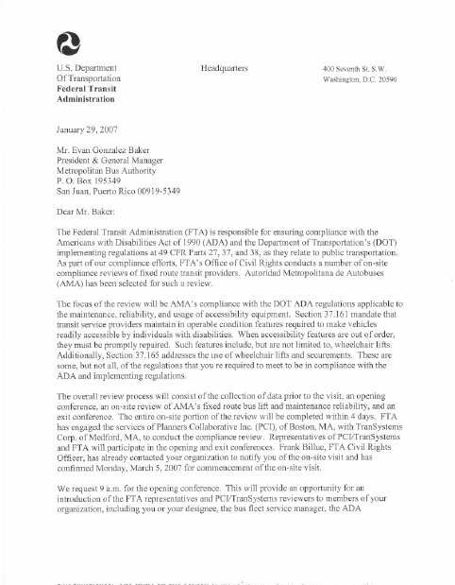
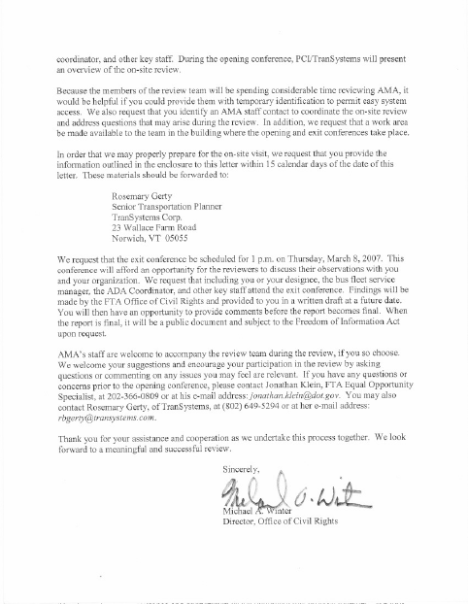

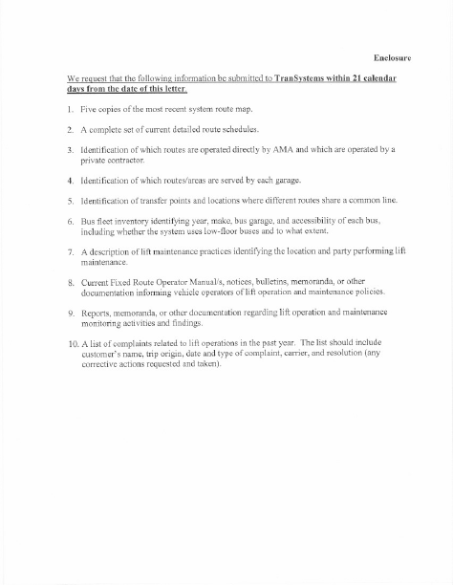
Attachment C

On-Site Review Schedule

ADA Fixed Route Lift/Ramp Service Review
Autoridad Metropolitana de Autobuses (AMA)
San Juan, Puerto Rico
March 5-8, 2007

SCHEDULE

Time | Activity | Who | Where
Monday, March 5, 2007
9:00 AM | Opening Conference (requires conference call connection to FTA) | FTA, AMA, Review Team Members | AMA
9:30 AM-11:00 AM | Interview AMA managers. Review operating policies and procedures, fleet information, service issues and monitoring, and operator training. | Suarez, AMA;  Review Team Members | Same as above
11:00 AM-11:30 AM | Review details of recent ramp/accessibility-related complaints | Suarez, AMA; Review Team Members | Same as above
11:30 AM-12 PM | Tour facility | AMA, All Review Team Members | Same as above
1:00 PM-6:00 PM | Observe service | Review Team Members
Tuesday, March 6, 2007
4:00 AM-9:00 AM | Observe ramp, lift and kneeler Cycling  Inspect securement systems | Review Team Members | AMA
10:00 AM-2:00 PM | Interview maintenance supervisor/staff  Review lift/ramp maintenance procedures and records | AMA, Review Team Members | Same as above
11:00 AM-2:00 PM | Interview drivers | Rodriguez | Same as above
Wednesday, March 7, 2007
8:00 AM 12:00 PM | Observe service | Review Team Members
1:00 PM-5:00 PM | Review lift/ramp maintenance records  Inspect vehicles  Review driver & mechanic training procedures  Interview drivers | AMA; Review Team Members | AMA
Thursday, March 8, 2007
9:00 AM | Final data tabulations & prepare for Exit Conference | Review Team Members
1:00 PM | Exit Conference (requires conference call connection to FTA) | FTA, AMA, Review Team Members | Same as above

Review Team Members:
Rosemary Gerty, TranSystems, Team Leader
Pilar Rodriguez, TranSystems, Reviewer/Translator
David Chia, Planners Collaborative, Reviewer
Don Kidston, Planners Collaborative, Reviewer

AMA Facility:
37 Ave de Diego, Rio Piedras, PR

Attachment D

On-Site Review Forms
AMA (San Juan, PR)
Fixed Route Driver Interview Form

This interview will take about 15 minutes. Your comments will be summarized with other driver’s responses and you will not be identified individually. Feel free to let me know if there is a question you do not wish to answer.

Tell me a little about yourself…
How long have you been a bus driver for AMA? __________

Are you a ____full-time or ____part-time/relief driver?

Do you usually drive a ___ lift-equipped bus or ____ ramp-equipped bus or ____ both

How often do you transport a person using a wheelchair or scooter? (daily, weekly…)

Training

When you started working for AMA, how much and what type of training were you given about the use of lifts, ramps, securement systems, and passenger assistance?

Was the training adequate? (What would make it better?)

Is there refresher/update training for lift, ramp, and securement use? What type and how often?

Lift/Ramp/Securement Information

When and how often do you test cycle the lift/ramp? (Listen for daily during pre-trip inspection)

What do you do if a lift/ramp doesn’t work when you are test cycling it? (How reported/action taken?)

If you report that a lift/ramp is broken, how quickly is it fixed?

Are you ever sent out with a bus that has a broken lift/ramp? If so, how often?

If the lift/ramp breaks while you are in service, what do you do?

If you are driving a bus with a broken lift/ramp, what do you do if you see a person who uses a wheelchair waiting at a stop?

Do you usually deploy the ramp/lift in the street or on a sidewalk?

What type of assistance do you offer to people who use wheelchairs when they are boarding?

If someone using a “scooter” gets on the bus and there are no standard places to attach the securement system straps, what do you do?

What do you do if a person with a disability gets on the bus and asks for priority seating but the priority seats are taken?

Is there anything else you would like to tell me about wheelchair lifts, ramps or securements that I didn’t ask?
AMA (San Juan, PR)
Formulario de Entrevista a Conductores de Rutas Regulares:

Esta entrevista se demorará aproximadamente 15 minutos. Sus comentarios se van a unir y resumir junto con las respuestas de otros conductores y usted no será identificado individualmente. Por favor dígame en su momento si existe alguna pregunta que usted no quiera responder.

Cuénteme un poco sobre usted mismo…
Desde hace cuánto es usted conductor de la AMA? __________

Trabaja usted ____ tiempo completo (full time) o ____tiempo parcial/conductor de relevo (part time)?

Usted normalmente guía una ___ guagua equipada con ascensor ____ equipada con rampa o ____ ambas

Que tan frecuentemente transporta usted una persona en silla de ruedas o scooter? (diaramente, semanalmente, mensualmente…)

Training

Cuando usted empezó a trabajar para la AMA, cuánto y qué tipo de entrenamiento recibió con respecto al uso de rampas, ascensores, cinturones para asegurar a los impedidos y asistencia a los pasajeros impedidos?

El entrenamiento fue el adecuado? (Qué lo haría mejor?)

Existe un entrenamiento de actualización sobre el uso de rampas, ascensores, y cinturones? De qué tipo y qué tan frecuente?

Información sobre Ascensor/Rampa/Cinturones

Cuándo y qué tan frecuentemente usted revisa la rampa/ascensor? (OJO: diariamente durante la inspección pre-viaje)

Que hace usted si una rampa/ascensor no funciona cuando usted la revisa? (Que reportes/acciones se toman?)

Si usted reporta que una rampa/ascensor está dañado, cuánto se demoran en arreglarla?

Alguna vez ha salido usted del garaje a prestar servicio con una guagua que tiene la rampa/ascensor dañado? Si sí, cada cuánto?

Si la rampa/ascensor se daña mientras que la guagua está en servicio, qué hace usted?

Si usted está guiando una guagua con la rampa/ascensor dañada, que hace usted si ve una persona impedida esperando en una parada?

Usted usualmente baja la rampa/ascensor en la calle o en la acera?

Qué tipo de asistencia le ofrece usted a personas en sillas de ruedas cuando están abordando la guagua?

Si alguien que usa un “scooter” se sube a la guagua y no hay espacios designados para asegurar los cinturones de seguridad, qué hace usted?

Qué hace usted si una persona impedida se sube en la guagua y requiere una silla de las asignadas a impedidos pero éstas están ocupadas?

Hay algo más que usted me quisiera decir con respecto a las sillas de ruedas, rampas, o sistemas de cinturones de seguridad que yo no le haya preguntado?
In-Service Assessment Form
Transit Agency: AMA (San Juan, PR)
Check one: ◻ Consumer Ride-Along ◻ In-service Observation
Check applicable: ◻ Power wc ◻ manual wc ◻ standee on lift/ramp ◻ kneeler required
Route # __________ Bus # __________
Check one: ◻ Lift-equipped ◻ Ramp-equipped
Boarding Location: Time: ______ am/pm
Alighting Location: Time: ______ am/pm
Path of Access |  |  | Y |  | N |  | N/A | Comments
1. | Did the stop and the path of travel to the stop appear to be accessible? |  | ___ |  | ___ |  | ___ | _____________________________
Boarding the Bus
1. | Did the driver stop for the passenger? | ___ |  | ___ |  | ___ |  | _____________________________
 | If so, did he pull to the curb (if applicable)? | ___ |  | ___ |  | ___ |  | _____________________________
2. | Did the driver kneel the bus? | ___ |  | ___ |  | ___ |  | _____________________________
3. | Did the ramp/lift work properly? | ___ |  | ___ |  | ___ |  | _____________________________
 | If not, did the driver manually deploy the ramp? | ___ |  | ___ |  | ___ |  | _____________________________
 | If not, did driver appear to call dispatch? | ___ |  | ___ |  | ___ |  | _____________________________
 | If not, did the driver tell the passenger when & how they would be transported? | ___ |  | ___ |  | ___ |  | _____________________________
4. | Was the rider able to board independently? In what direction? | ___ |  | ___ |  | ___ |  | _____________________________
5. | Did the driver assist the rider getting up the ramp? If yes, in what direction? | ___ |  | ___ |  | ___ |  | _____________________________
Securing the Mobility Aid
1. | If needed, did the driver request a passenger to vacate the securement area? | ___ |  | ___ |  | ___ |  | _____________________________
2. | Did the driver assist in securing the wheelchair? | ___ |  | ___ |  | ___ |  | _____________________________
3. | Did the wheelchair appear to be properly secured? |  | ___ |  | ___ |  | ___ | _____________________________
Alighting from the Bus
1. | Did driver pull to the curb (if applicable)? | ___ |  | ___ |  | ___ |  | _____________________________
2. | Did the driver kneel the bus? | ___ |  | ___ |  | ___ |  | _____________________________
3. | Did the ramp/lift work properly? | ___ |  | ___ |  | ___ |  | _____________________________
 | If not, did the driver manually deploy the ramp? | ___ |  | ___ |  | ___ |  | _____________________________
4. | Was the driver professional and courteous? | ___ |  | ___ |  | ___ |  | _____________________________
Path of Egress
1. | Did the stop and path of travel from the stop appear to be accessible? |  | ___ |  | ___ |  | ___ | _____________________________

Notes:

Record of Lift Cycling/Working Condition of Lifts and Access Features
Transit Agency: AMA (San Juan, PR) Bus #:__________ Route #:__________
Check one: ◻ Ramp-equipped ◻ Lift-equipped
Cycled By: ◻ Driver ◻ Mechanic ◻ Starter (check one)
Lift/Ramp Worked? ◻ Yes ◻ No
Ramp Tool On Bus? ◻ Yes ◻ No
Kneeler Worked? ◻ Yes ◻ No
ISA displayed near door? ◻ Yes ◻ No
Illuminated front and side destination signs? ◻ Yes ◻ No
Sign requesting passengers to vacate securement area upon request? ◻ Yes ◻ No
Securements available and functional? ◻ Yes ◻ No
Three-point passenger restraint available and functional? ◻ Yes ◻ No
Securements and passenger restraints clean? ◻ Yes ◻ No
PA Worked? ◻ Yes ◻ No
Auditory & visual stop request? ◻ Yes ◻ No
Operator Familiar with Equipment: ◻ Yes ◻ No ________________________________________
Comments:
-------------------------------------------------------------------------------------------------------------------------------
Bus #:__________ Route #:__________ ◻ Ramp ◻ Lift (check one)
Cycled By: ◻ Driver ◻ Mechanic ◻ Starter (check one)
Lift/Ramp Worked? ◻ Yes ◻ No
Ramp Tool On Bus? ◻ Yes ◻ No
Kneeler Worked? ◻ Yes ◻ No
ISA displayed near door? ◻ Yes ◻ No
Illuminated front and side destination signs? ◻ Yes ◻ No
Sign requesting passengers to vacate securement area upon request? ◻ Yes ◻ No
Securements available and functional? ◻ Yes ◻ No
Three-point passenger restraint available and functional? ◻ Yes ◻ No
Securements and passenger restraints clean? ◻ Yes ◻ No
PA Worked? ◻ Yes ◻ No
Auditory & visual stop request? ◻ Yes ◻ No
Operator Familiar with Equipment: ◻ Yes ◻ No ________________________________________
Comments:

Bus and Van Specification Checklist
Name of Recipient:
Fleet # Assigned by Recipient/Operator (if applicable):
Type of Vehicle: (check one) ___ Minivan ___ Van ___ Minibus (< = 22')
___Minibus(> 22') ___ Bus (> 22')
Make/Model:________________________________________ Year
Name of Person Conducting Review:______________________________________________
Signature:_______________________________________________ Date:________________
Following is a summary of the provisions of Subpart B of 49 CFR Part 38 - the "Americans with Disabilities Act (ADA) Accessibility Specifications for Transportation Vehicles.” This portion of the ADA regulations applies to all new, used, or remanufactured buses and vans (except over-the-road, intercity buses). Also, if portions of a vehicle are modified in a way that affects or could affect accessibility, each portion must comply, to the maximum extent practicable.
Vehicles purchased by public as well as private entities operating services covered by the ADA, regardless of whether or not they receive federal funding, must comply with these specifications. Existing inaccessible buses do not have to be retrofitted to be brought into compliance.
All dimensions listed are subject to conventional engineering tolerances, including normal anticipated wear not exceeding accepted industry-wide standards and practices.
For each required specification below, indicate in the left-hand margin if the vehicle meets the specification, does not meet the specification, or the specification is not applicable to the vehicle being inspected. If the vehicle does not meet the specification, note actual measurements in the space provided to the right. Clearly indicate what the measurements are.
For some specifications (such as lift design load, securement strength, etc.), it may be appropriate to refer back to manufacturers information that was provided with the vehicle.
Lift Specifications: ___ N/A (ramp specs p. 4)
The design load of a lift must be at least 600 pounds. Working parts must have a safety factor of at least six. Non-working parts shall have a safety factor of at least three.
Controls must be interlocked with the brakes, transmission, or door so that the vehicle cannot move unless the interlock is engaged.
Controls must be "momentary contact type" (meaning they require constant pressure) and must allow the up/down cycle to be reversed without causing the platform to "stow" while occupied.
Lifts must be equipped with an emergency back-up system. The emergency back-up system shall be capable of being operated both up and down without the platforms "stowing" while occupied.
Must be designed so that in the event of a power failure, the platform cannot fall faster than 12 inches per second.
Must have an inner barrier or inherent design feature to prevent the mobility aid from rolling off the side closest to the vehicle until the platform is in its fully raised position.
Side barriers must be at least one and one-half inches high.
The "loading-edge" (or outer barrier) shall be sufficient to prevent a power wheelchair from riding over or otherwise defeating it (note that this test must be performed with the wheelchair facing both toward the vehicle and away from the vehicle as boarding in both directions must be permitted). If this barrier is automatic, it must close when the platform is no more than 3 inches off the ground. If the outer-barrier is to be driver operated, it must have an interlock or inherent design that prevents the platform from being raised until the barrier is closed or other system is engaged.
The platform surface must be slip-resistant with no protrusions over 1/4 of an inch.
The platform must be at least 28 1/2 inches wide measured at the platform surface and at least 30 inches wide measured from 2 inches above the platform surface to 30 inches above the surface. It must also be at least 48 inches long measured from 2 inches above the surface to 30 inches above the surface.
Gaps between the platform surface and any barrier can be no more than 5/8 of an inch. Semi-automatic lifts can have a handhold in the platform that measures no more than 1 1/2 inches by 4 1/2 inches.
When in the fully raised position, the platform surface must be vertically within 5/8 inch of the finished floor and horizontally within 1/2 inch of the finished floor.
The ramp from ground to platform (often the lowered outer barrier) must have a slope of no more than 1:8 for a maximum rise of 3 inches (i.e., if platform I inch off the ground, ramp must be at least 8 inches long). If the threshold from ground to ramp (i.e., the thickness of the ramp material) is more than 1/4 inch; it must be beveled with a slope no greater than 1:2.
The platform must not deflect more than 3 degrees in any direction when a 600 pound load is placed on the center of the platform.
The platform must raise or lower in no more than 6 seconds. The platform must be stowed or deployed in no more than 12 seconds. Horizontal acceleration can be no more than .3g.
Lift must be designed to allow boarding in either direction.
Must be equipped with two handrails which move in tandem with the lift platform. Handrails must be 30 - 38 inches above the platform surface and must have a useable gasping area of at least 8 inches. Handrails must be capable of supporting 100 pounds, must have a cross-sectional diameter of 1 1/4 to 1 1/2 inches, and must have at least 1 1/2 inches of "knuckle clearance".
Lifts may be marked to identify the preferred standing position.

Ramp Specifications: ____ N/A
Ramps 30 inches or greater in length must have a design load of 600 pounds. Ramps under 30 inches in length must have a design load of 300 pounds.
Ramp surface must be continuous and sup-resistant. Protrusions can be no more than 1/4 inch.
Ramps must be at least 30 inches wide.
Ramps must accommodate both three-wheeled and four-wheeled mobility aids (e.g., they must be designed to support a wheel in the center of the ramp).
If the threshold from the ground to the ramp surface (e.g., the thickness of the ramp surface) exceeds 1/4 inch, it must be beveled with a maximum slope of 1:2.
Side barriers, at least 2 inches high, must be provided.
Ramps must have the least slope practicable. When the ramp is deployed to ground level the slope cannot exceed 1:4 (i.e., for a vehicle with a finished floor 12 inch above the ground, a 48 inch ramp would be needed). When deployed to a 6 inch curb the following maximum slopes would apply:
finished floor height
above 6 inch curb maximum slope

3" or less 1:4
6" or less, but > 3" 1:6
9" or less, but > 6" 1:8
greater than 9" 1:12
The ramp must be firmly attached to the vehicle.
Gaps between the ramp and vehicle finish floor can be no more than 5/8 of an inch.
A compartment of securement system must be provided for the ramp to keep it from impinging on the space set aside for mobility aid users and to keep it from becoming a hazard in the event of a sudden stop.
Handrails are not required. If they are provided, however, they must support 100 pounds, be between 30 inches and 38 inches above the ramp surface, have a cross-sectional diameter of 1 1/4 to 1 1/2 inches, be continuous for the full length of the ramp, and provide at least 1 1/2 inches of "knuckle clearance".

Securement Area:
Vehicles over 22 feet in length must have two (2) securement locations. Vehicles 22 feet and under must have one (1) securement location. Vehicles are to be measured from the front-most part to the rear-most item (including the bumpers).
Wheelchairs and mobility aids must be oriented as follows:
For vehicles greater than 22 feet in length, at least one securement position must be forward facing. Other securement areas can be either forward or rear-facing.
For vehicles 22 feet in length or less, the one required position can be either forward or rear facing.
If wheelchair and mobility-aid-users are secured in a rear-facing orientation, a padded barrier must be provided. The barrier must be 18 inches wide and extend from 38 inches to 56 inches above the floor.
Securement systems must have the following design loads:
For vehicle with a GVWR of 30,000 pounds or more: 2,000 pounds for each strap/clamp, and 4,000 pounds per mobility aid.
For vehicles with a GVWR of less than 30,000 pounds: 2,500 pounds per clamp/strap, and 5,000 pounds per mobility aid.
Securement area must be located as close to the accessible entrance as possible.
A clear floor area of 30 inches wide by 48 inches long must be provided for each securement area. This can include an area up to 6 inches under a seat as long as there is a vertical clearance of at least 9 inches. If flip-seats are utilized, they cannot obstruct the required floor area. The required floor area can overlap the access path (the path of travel from the accessible entrance to the securement area).
The securement system must accommodate all common wheelchairs and mobility aids (any mobility aid not exceeding 30 inches in width and 48 inches in length and weighing no more than 600 pounds when occupied) and be able to be operated by someone with average dexterity who is familiar with the system.
Securement systems must keep mobility aids from moving no more than 2 inches in any direction.
The securement system must be located to be readily accessed when needed, but must not interfere with passenger movement or be a hazard to passengers. It should also be reasonably protected from vandalism.
A seat belt and shoulder harness must be provided for each securement position. The seat belt and shoulder harness must be separate from the securement system for the mobility aid.
A sign must be provided which indicates that the securement area is to be used by persons who use wheelchairs and mobility aids. Characters on these signs shall have a width to height ratio between 3:5 and 1:1 and a stroke width to height ratio between 1:5 and 1:10. Minimum character height (using a capital X) shall be 5/8 inch. Wide spacing shall be used (generally the space between letters shall be 1/16 the height of upper case letters). Letters must contrast with the sign's background color.
General Vehicle Specifications:
Aisles, steps, and floor areas must be slip resistant.
Step edges, thresholds, and the boarding edge of ramps or lift platforms must have a band of color which contrasts with the step/floor surface. Typically, white or bright yellow is used to contrast against dark floors.
The height of doors at accessible entrances and the interior height along the path of travel between accessible entrances and securement areas shall be as follows:
For vehicles 22 feet or longer, the clearance from the raised lift platform or the ramp surface to the top of the door must be at least 68 inches.
For vehicles less than 22 feet, the overhead clearance must be at least 56 inches.
At least one set of forward-facing seats must be designated as priority seats for persons with disabilities. Signs identifying these as priority seats must be provided. Characters on these signs shall have a width to height ratio between 3:5 and 1:1 and a stroke width to height ratio between 1:5 and 1:10. Minimum character height (using a capital X) shall be 5/8 inch. Wide spacing shall be used (generally the space between letters shall be 1/16 the height of upper case letters). Letters must contrast with the sign's background color.
Interior handrails and stanchions should not interfere with the path of travel of a common wheelchair from the accessible entrance to the securement areas.
Handrails and stanchions shall be provided in the entrance area and through the fare collection area to assist persons with disabilities as they enter and pay a fare. Some portion of this handrail/stanchion system must be able to be grasped from outside the vehicle to assist the person as they start to board. Handrails shall have a cross-sectional diameter of between 1 1/4 and 1 1/2 inches, shall provide a minimum of 1 1/2 inches of "knuckle clearance," and shall have eased edges with corner radii of not less than 1/8 inch.
On vehicles 22 feet in length or longer which have fare collection systems, a horizontal assist shall be provided across the front of the vehicle to allow a person to lean against the assist while paying a fare.
Handrails and stanchions shall also be provided to assist with on-board circulation, sitting and standing, and exiting the vehicle.
For vehicles longer than 22 feet, an overhead handrail or handrails shall be provided which are continuous from front to back except for a gap at the rear doorway.
For vehicles longer than 22 feet which have front door lifts or ramps, vertical stanchions immediately behind the driver shall either terminate at the lower edge of the aisle-facing seats or be "dog-legged" so that the floor attachment does not impede or interfere with wheelchair footrests.
If the driver's seat must be passed by a wheelchair user, the pedestal shall not extend into the aisle or vestibule beyond the wheelhousing, to the maximum extent practicable.
Lighting of at least 2 foot-candles, measured on the step treads or lift platform, shall be provided in the stepwell or doorway immediately adjacent the driver. Lighting shall activate when the door is opened.
Other stepwell and doorways shall have similar lighting at all times.
Lighting of at least 1 foot-candle shall be provided outside all doorways to illuminate the street surface for an area up to 3 feet perpendicular to the bottom step tread outer edge. Lighting shall be located below window level and shall be shielded to protect the eyes of entering and exiting passengers.
Fareboxes are to be located as far forward as possible and must not obstruct traffic in the vestibule area, particularly wheelchairs and mobility aids.
Vehicles in excess of 22 feet used in multiple-stop, fixed route service must be equipped with a public address system.
For vehicles in excess of 22 feet where passengers are permitted to exit at multiple stops at their option, a "stop request" control must be provided adjacent to the securement locations. The system shall provide both auditory and visual indications that the stop has been requested. Controls shall be located from 15 inches to 48 inches above the floor, shall be operable with one hand, shall not require tight grasping, pinching, or twisting of the wrist, and shall be activated by a force no greater than 5 lbf.
If destination or route information is displayed on the exterior of a vehicle, illuminated signs shall be provided at the front and boarding side of the vehicle. Characters on these signs shall have a width to height ratio between 3:5 and 1:1 and a stroke width to height ratio between 1:5 and 1:10. Minimum character height (using a capital X) shall be I inch for signs on the boarding side and 2 inches for front "headsigns". Wide spacing shall be used (generally the space between letters shall be 1/16 the height of upper case letters). Letters must contrast with background color.
Lift Maintenance and Repair Summary Form

Transit Agency: AMA (San Juan, PR)
Bus # and Repair Needed | Date Breakdown Reported | Date Repaired | In Service In Interim? Spares Available?
# _____

# _____

# _____

# _____

# _____

# _____

# _____

# _____

# _____

Notes
Attachment E

Customer Comment Form
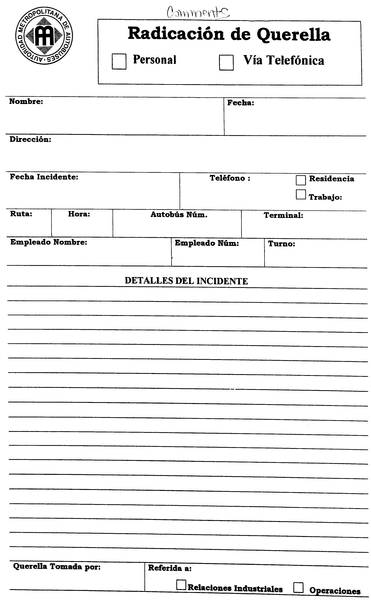
Attachment F

OPPI Strategic Plan Agreement
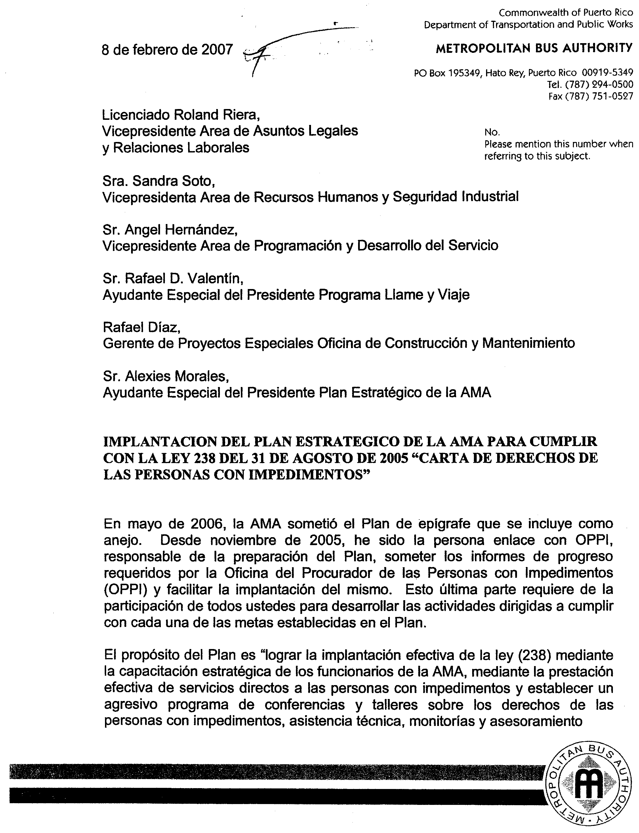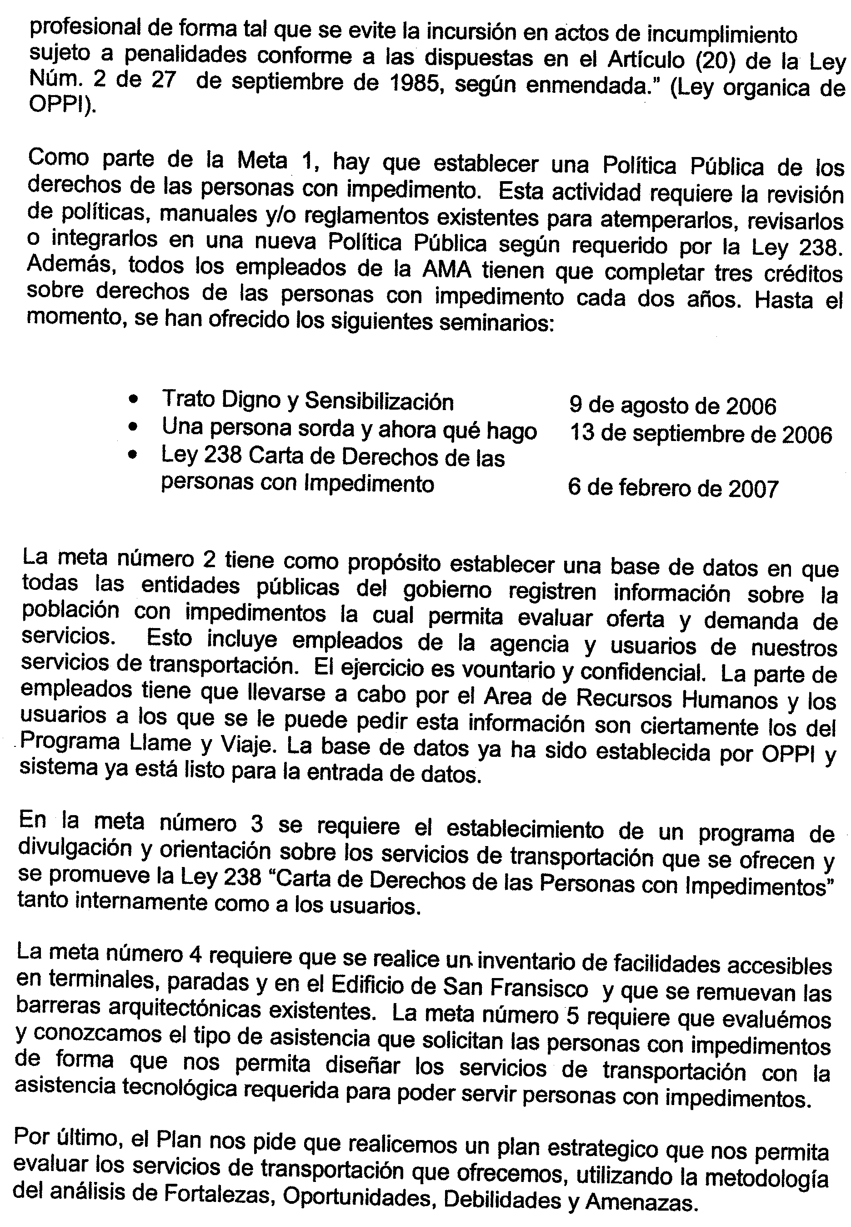
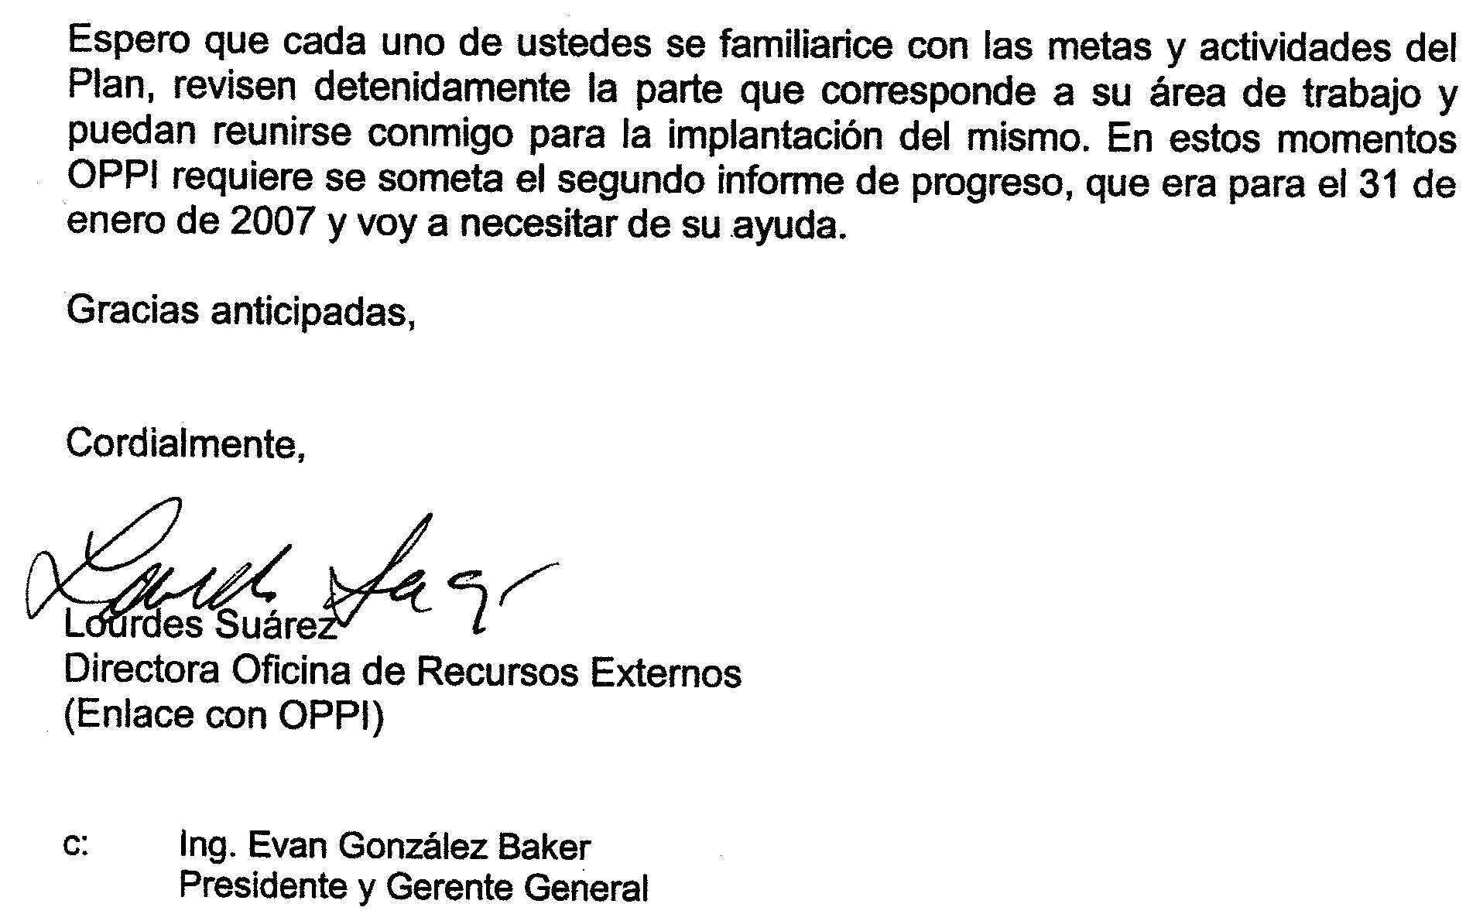

Attachment G

AMA Notices and Bulletins Regarding Accessible Fixed Route Service Operation Policies and Procedures
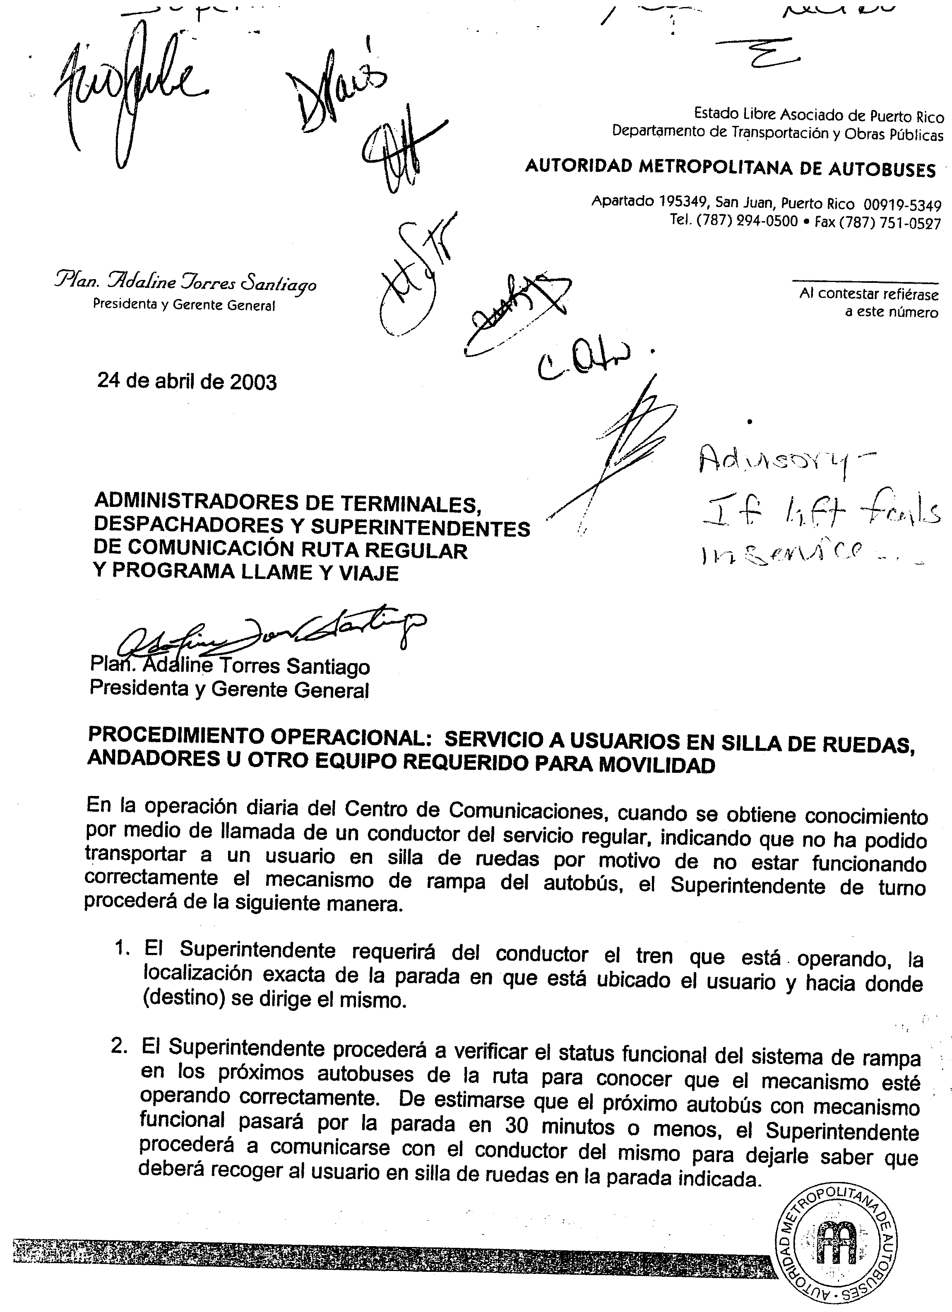
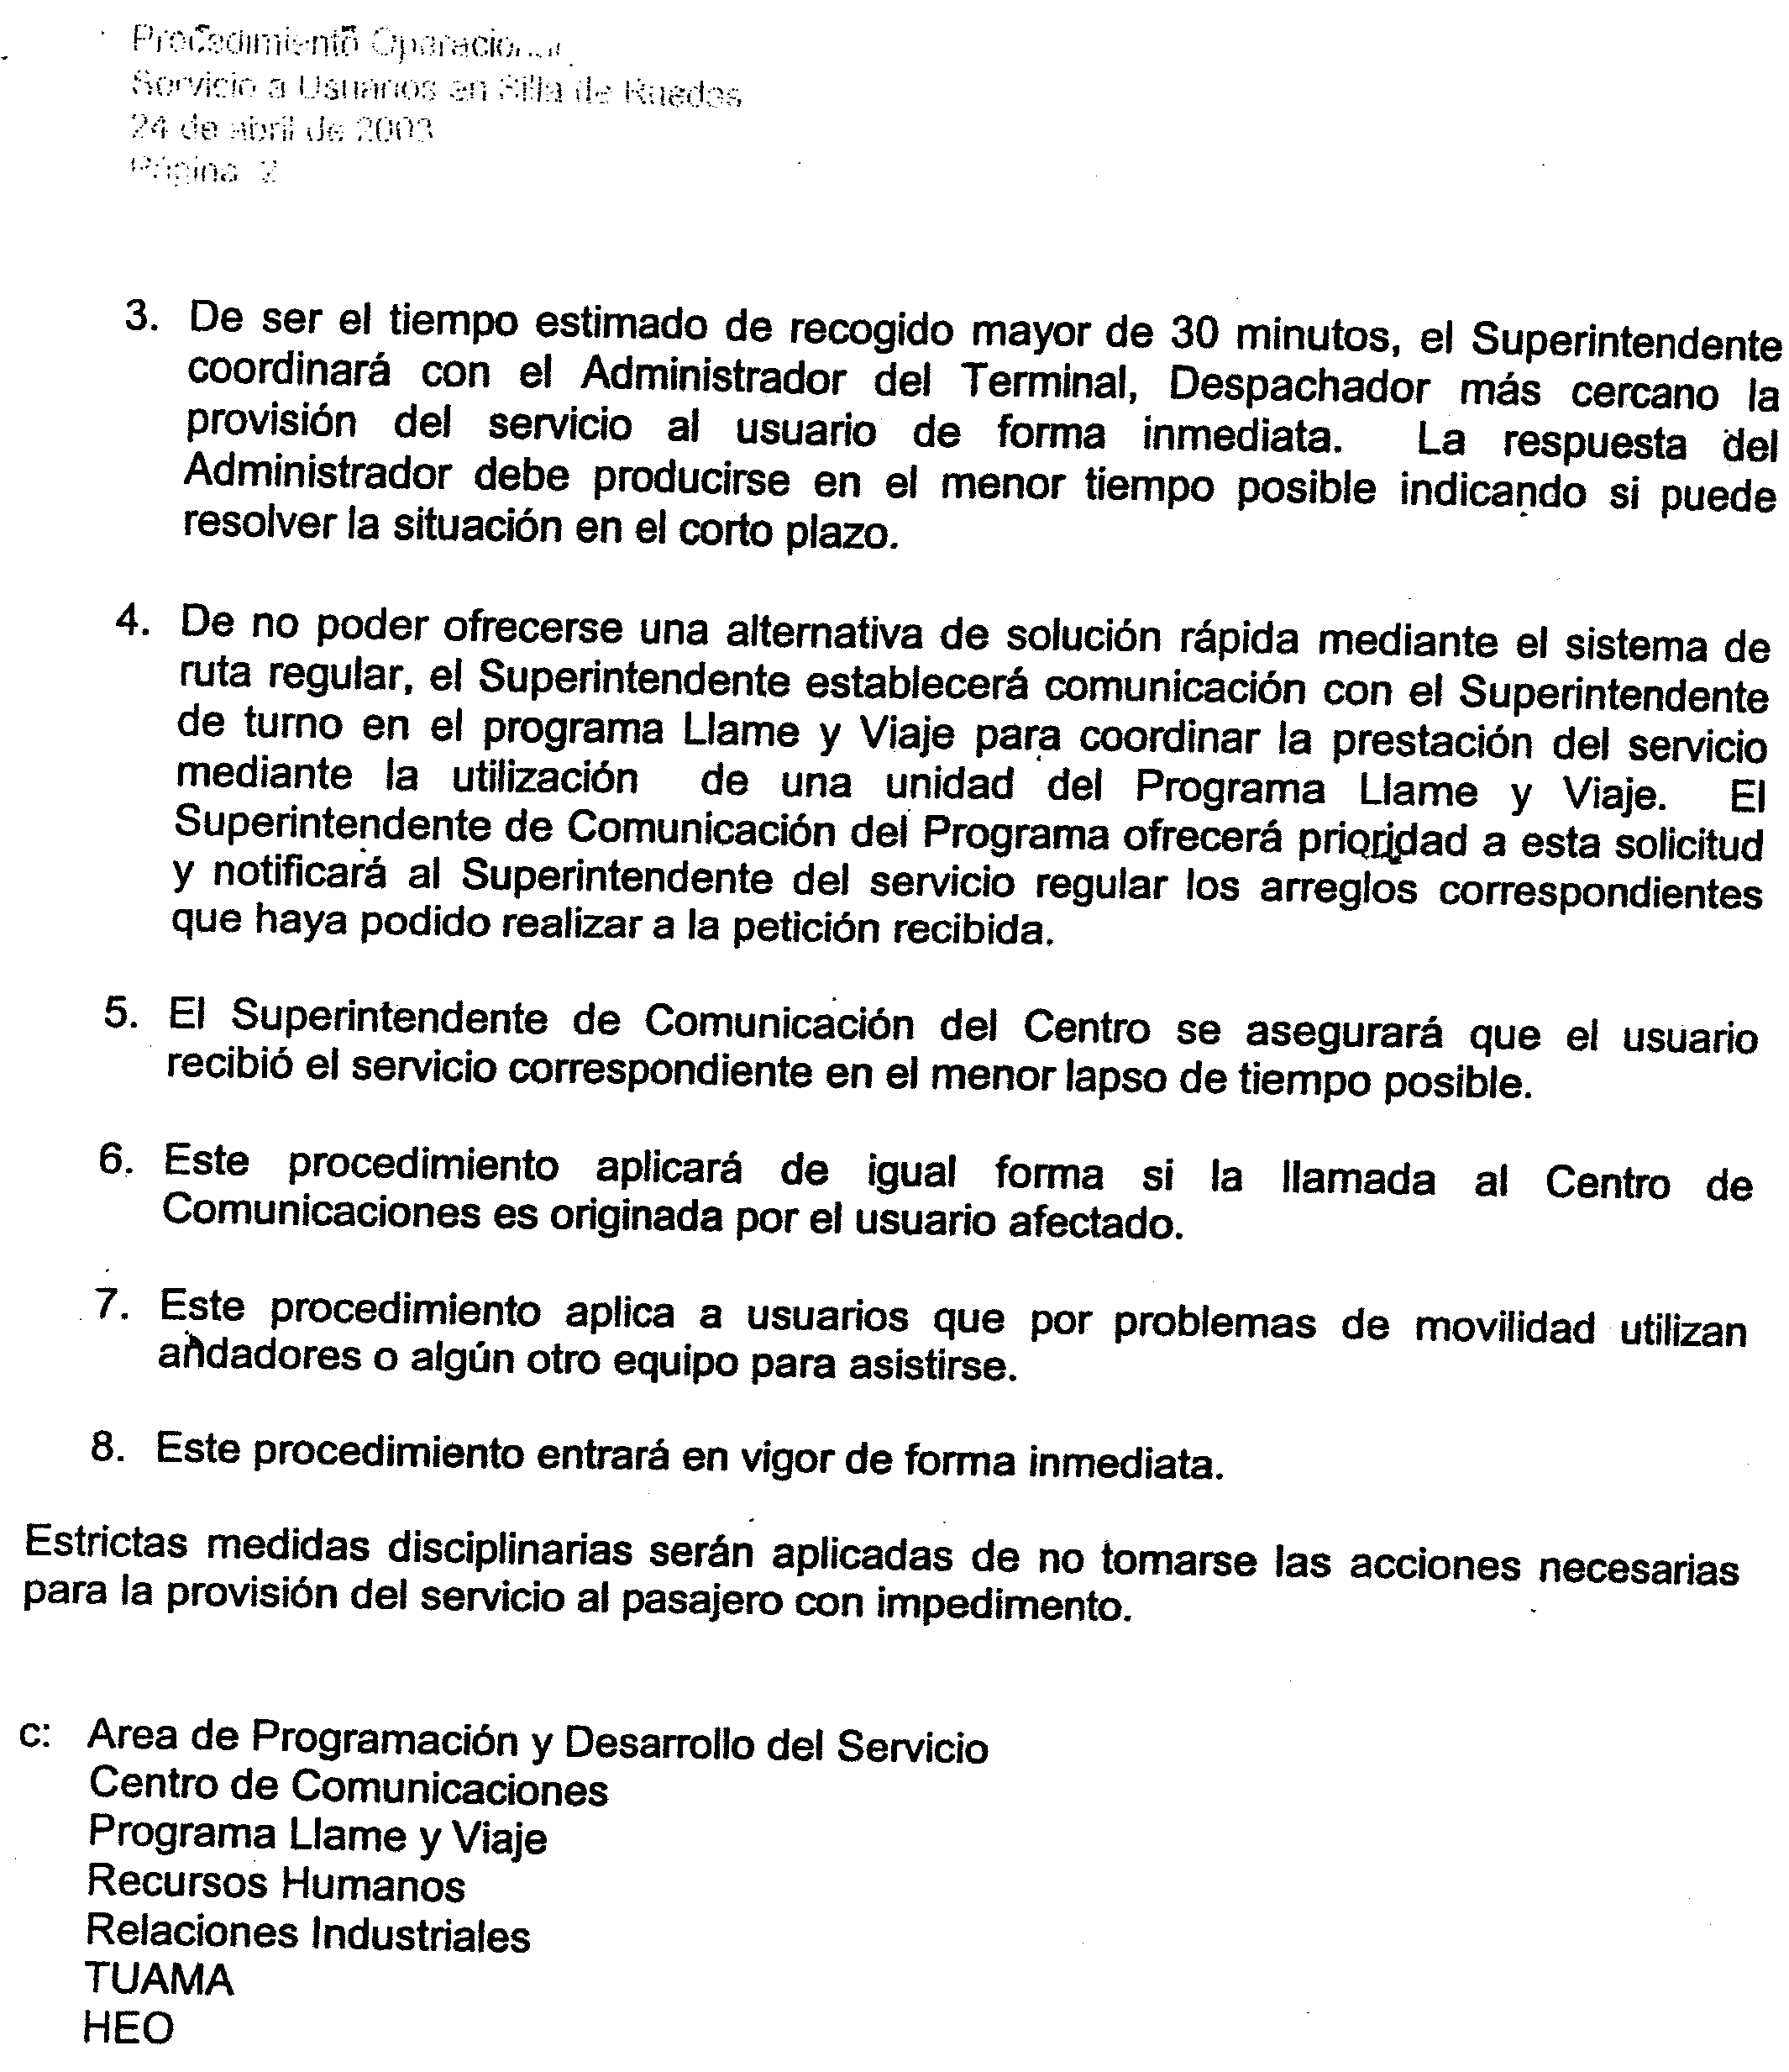

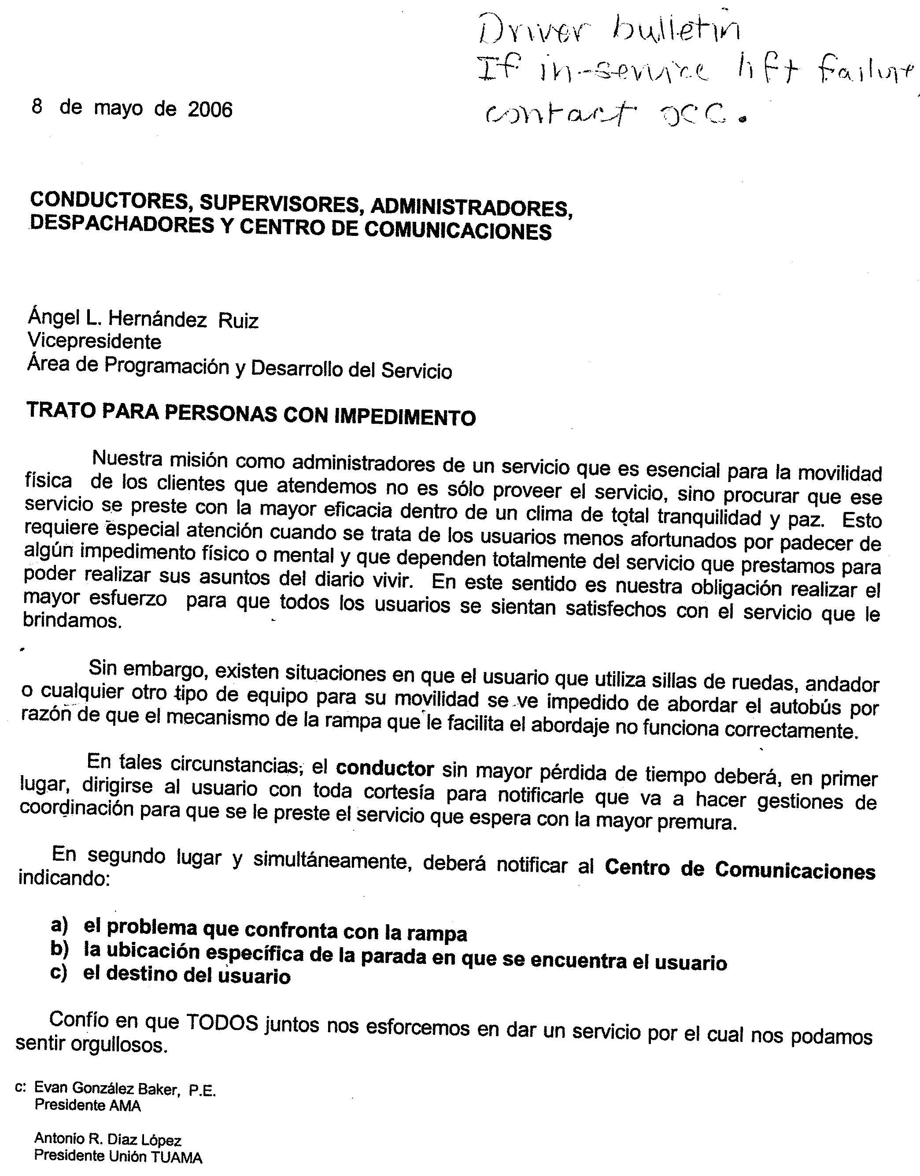

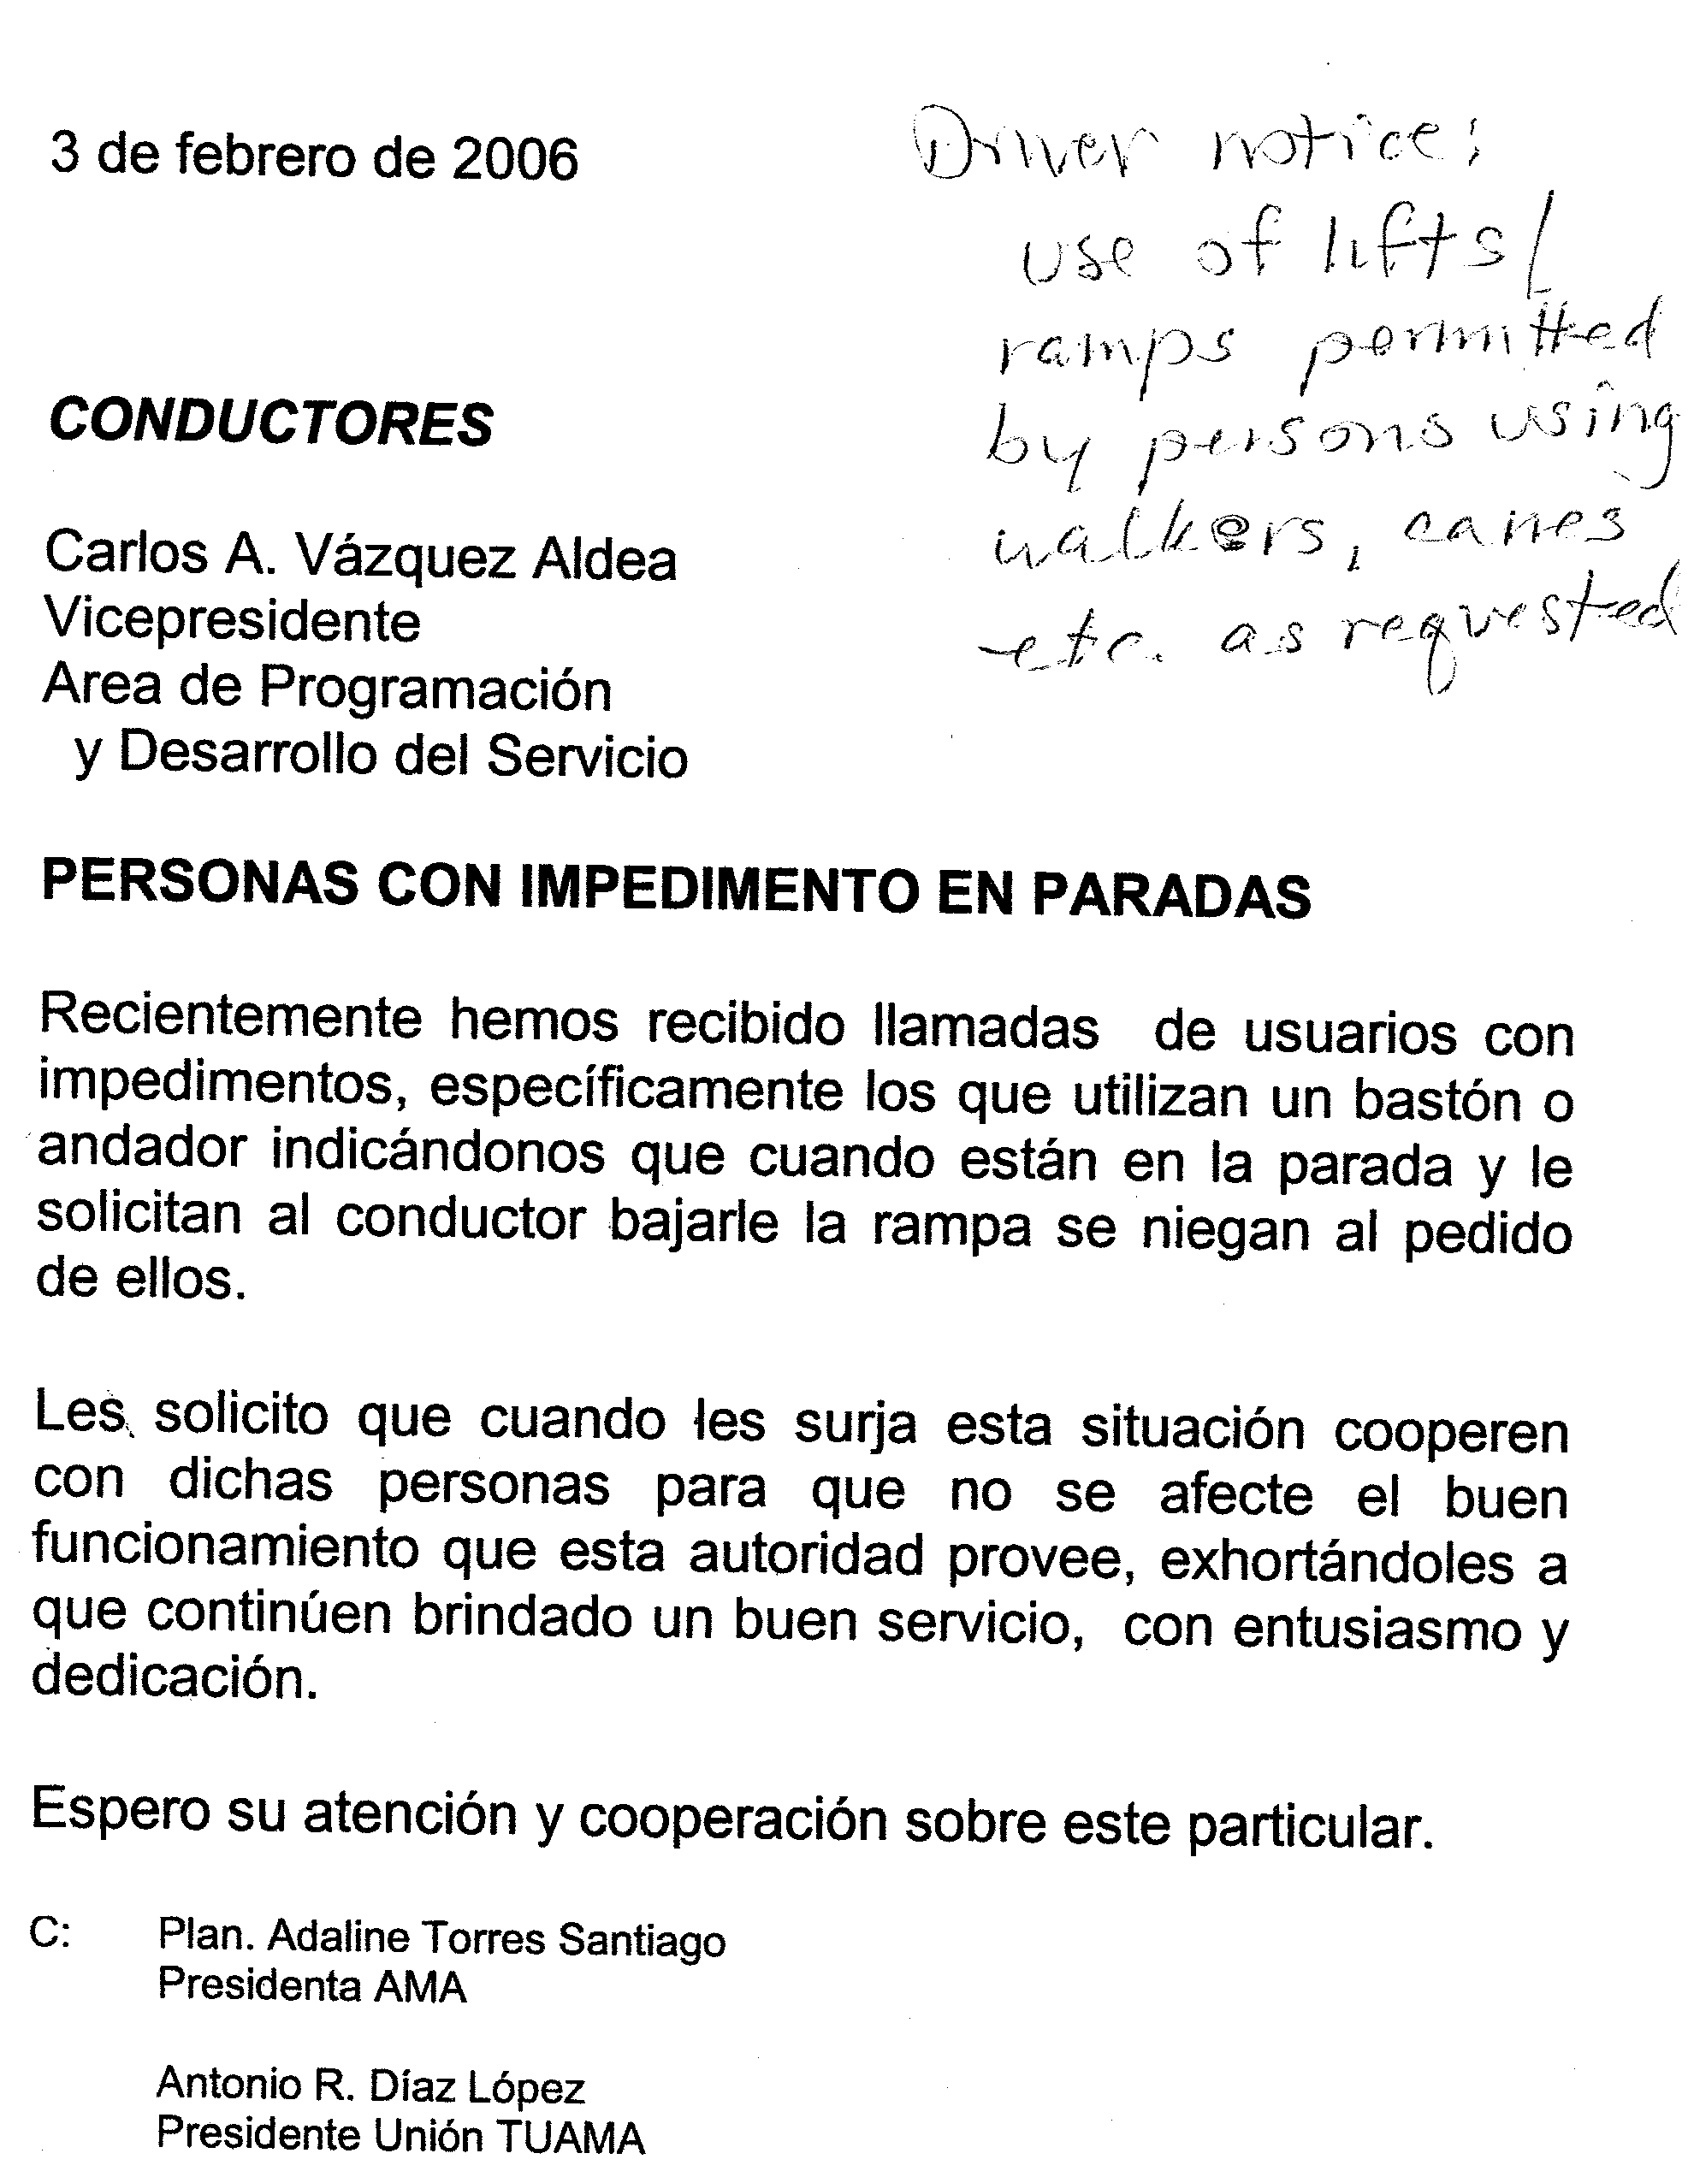
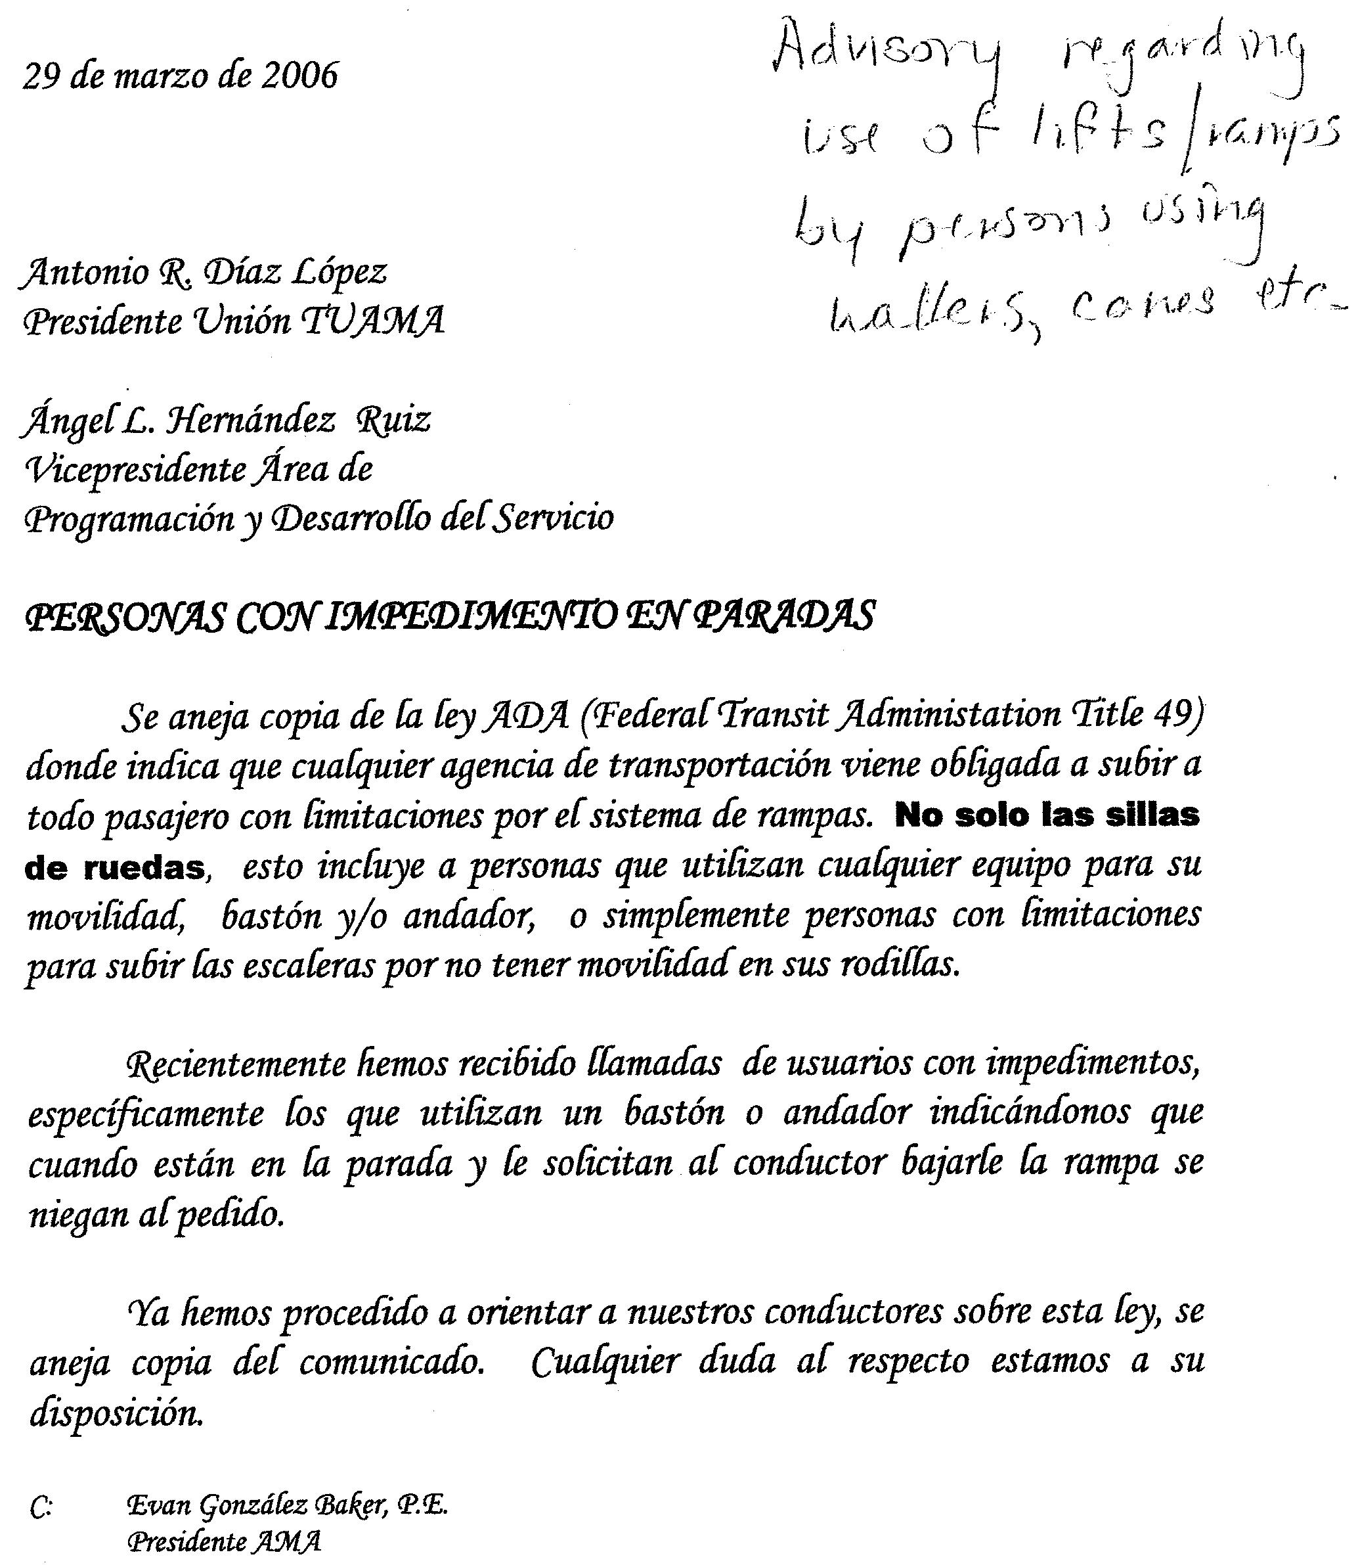
Attachment H

Sample AMA Maintenance Logs, Reports, and Forms
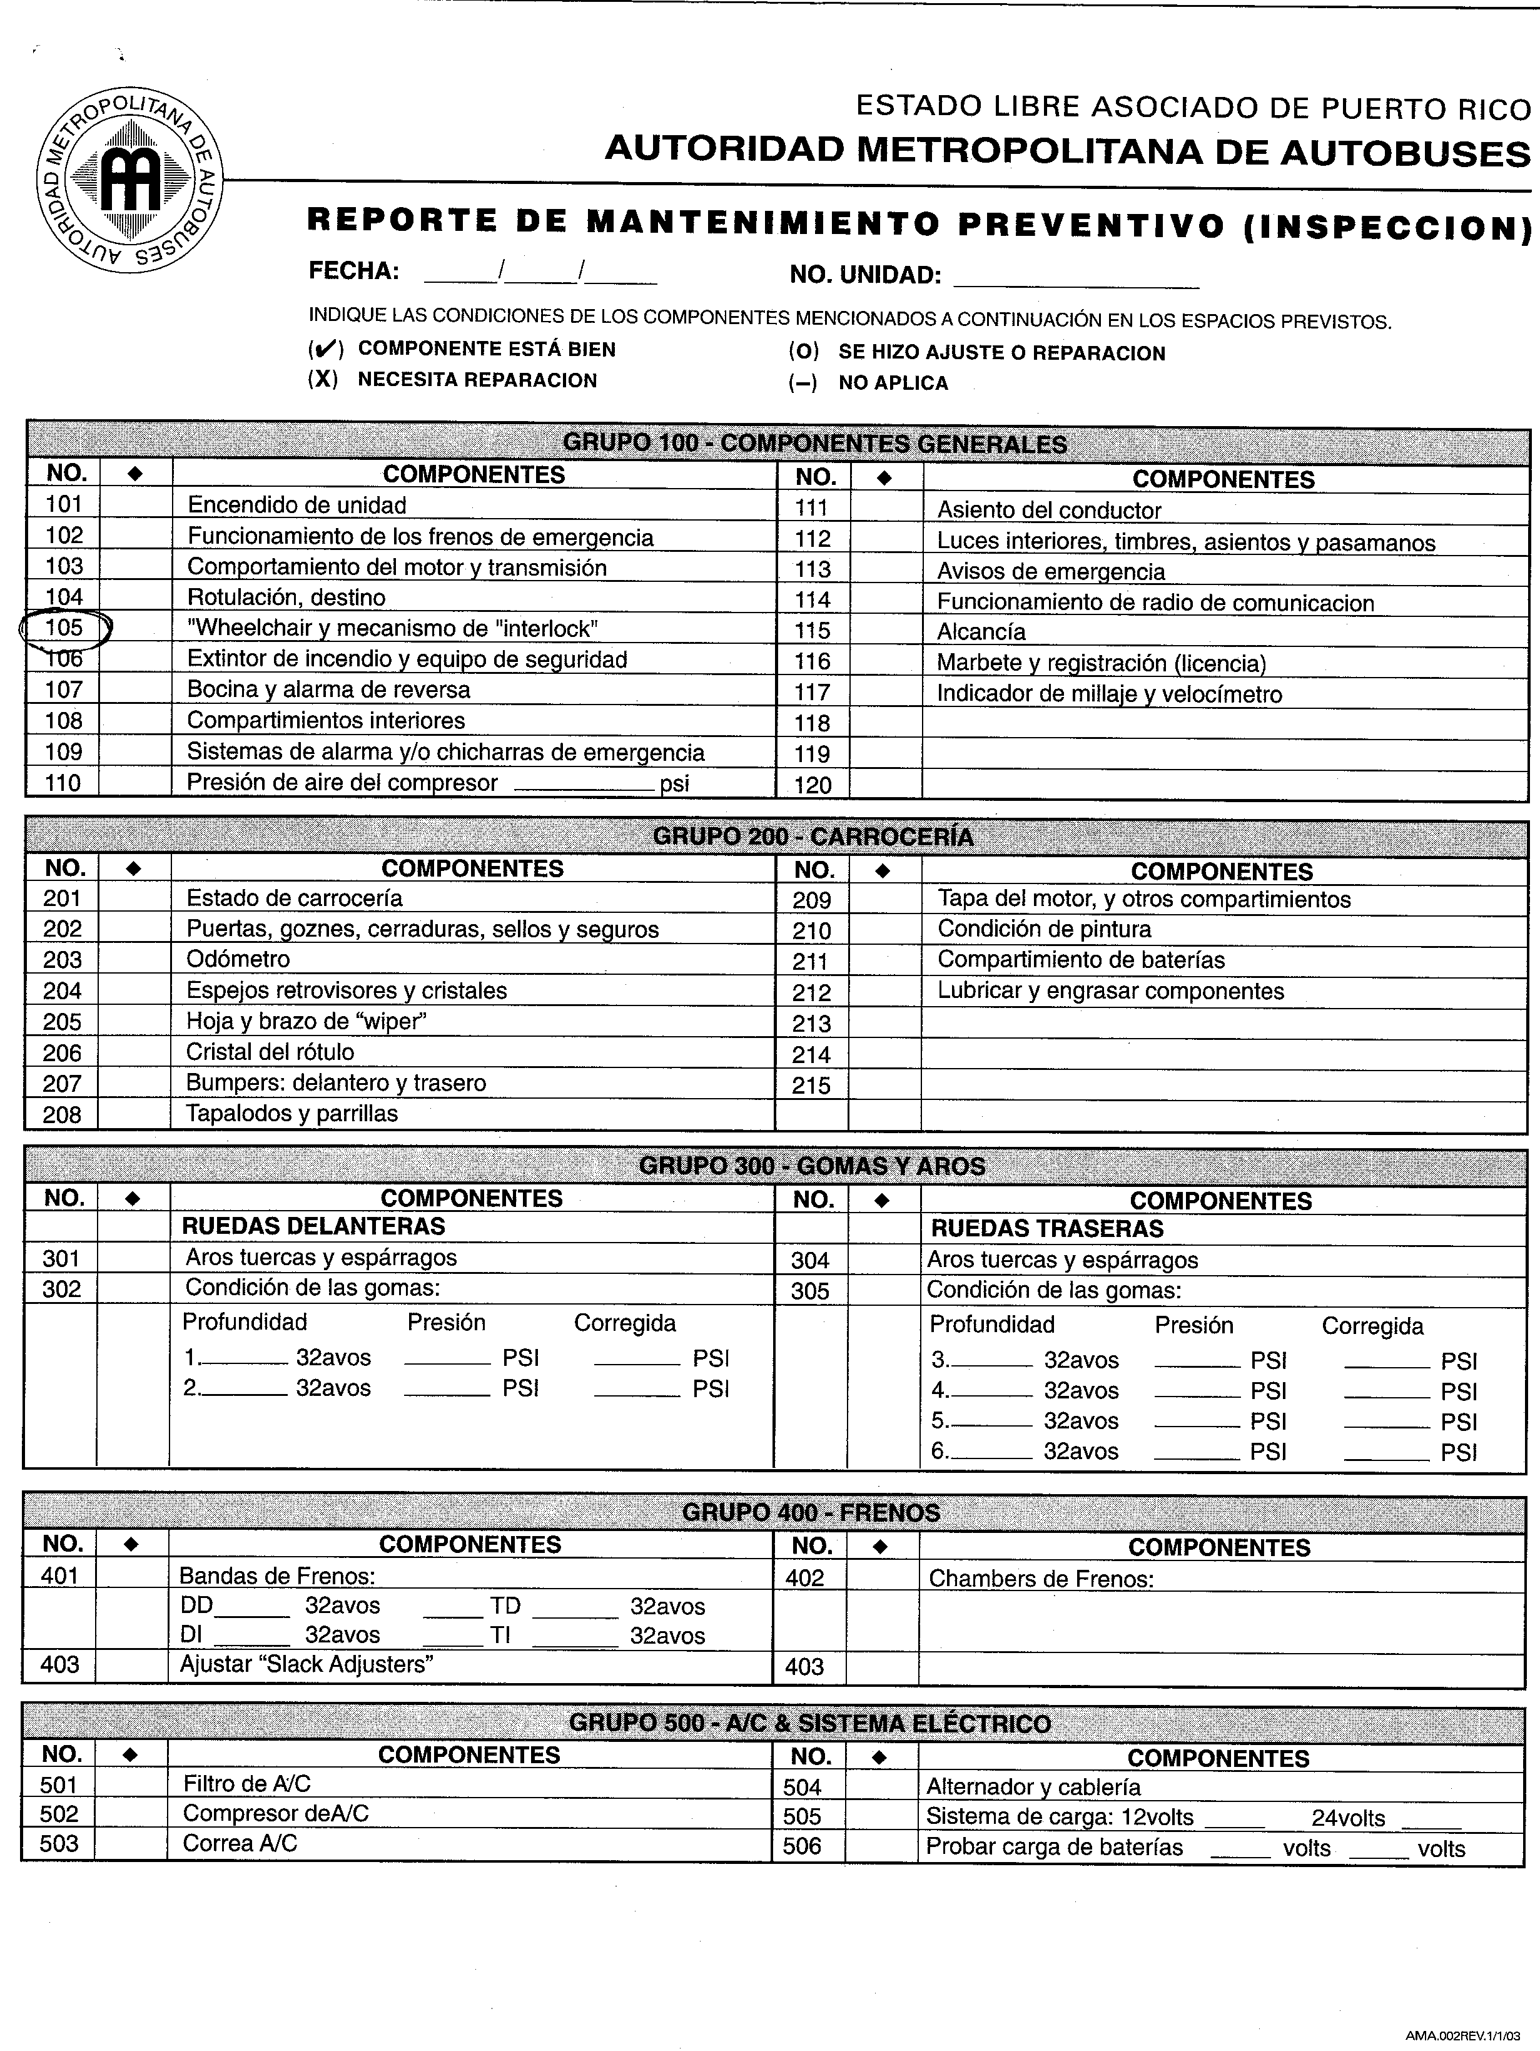

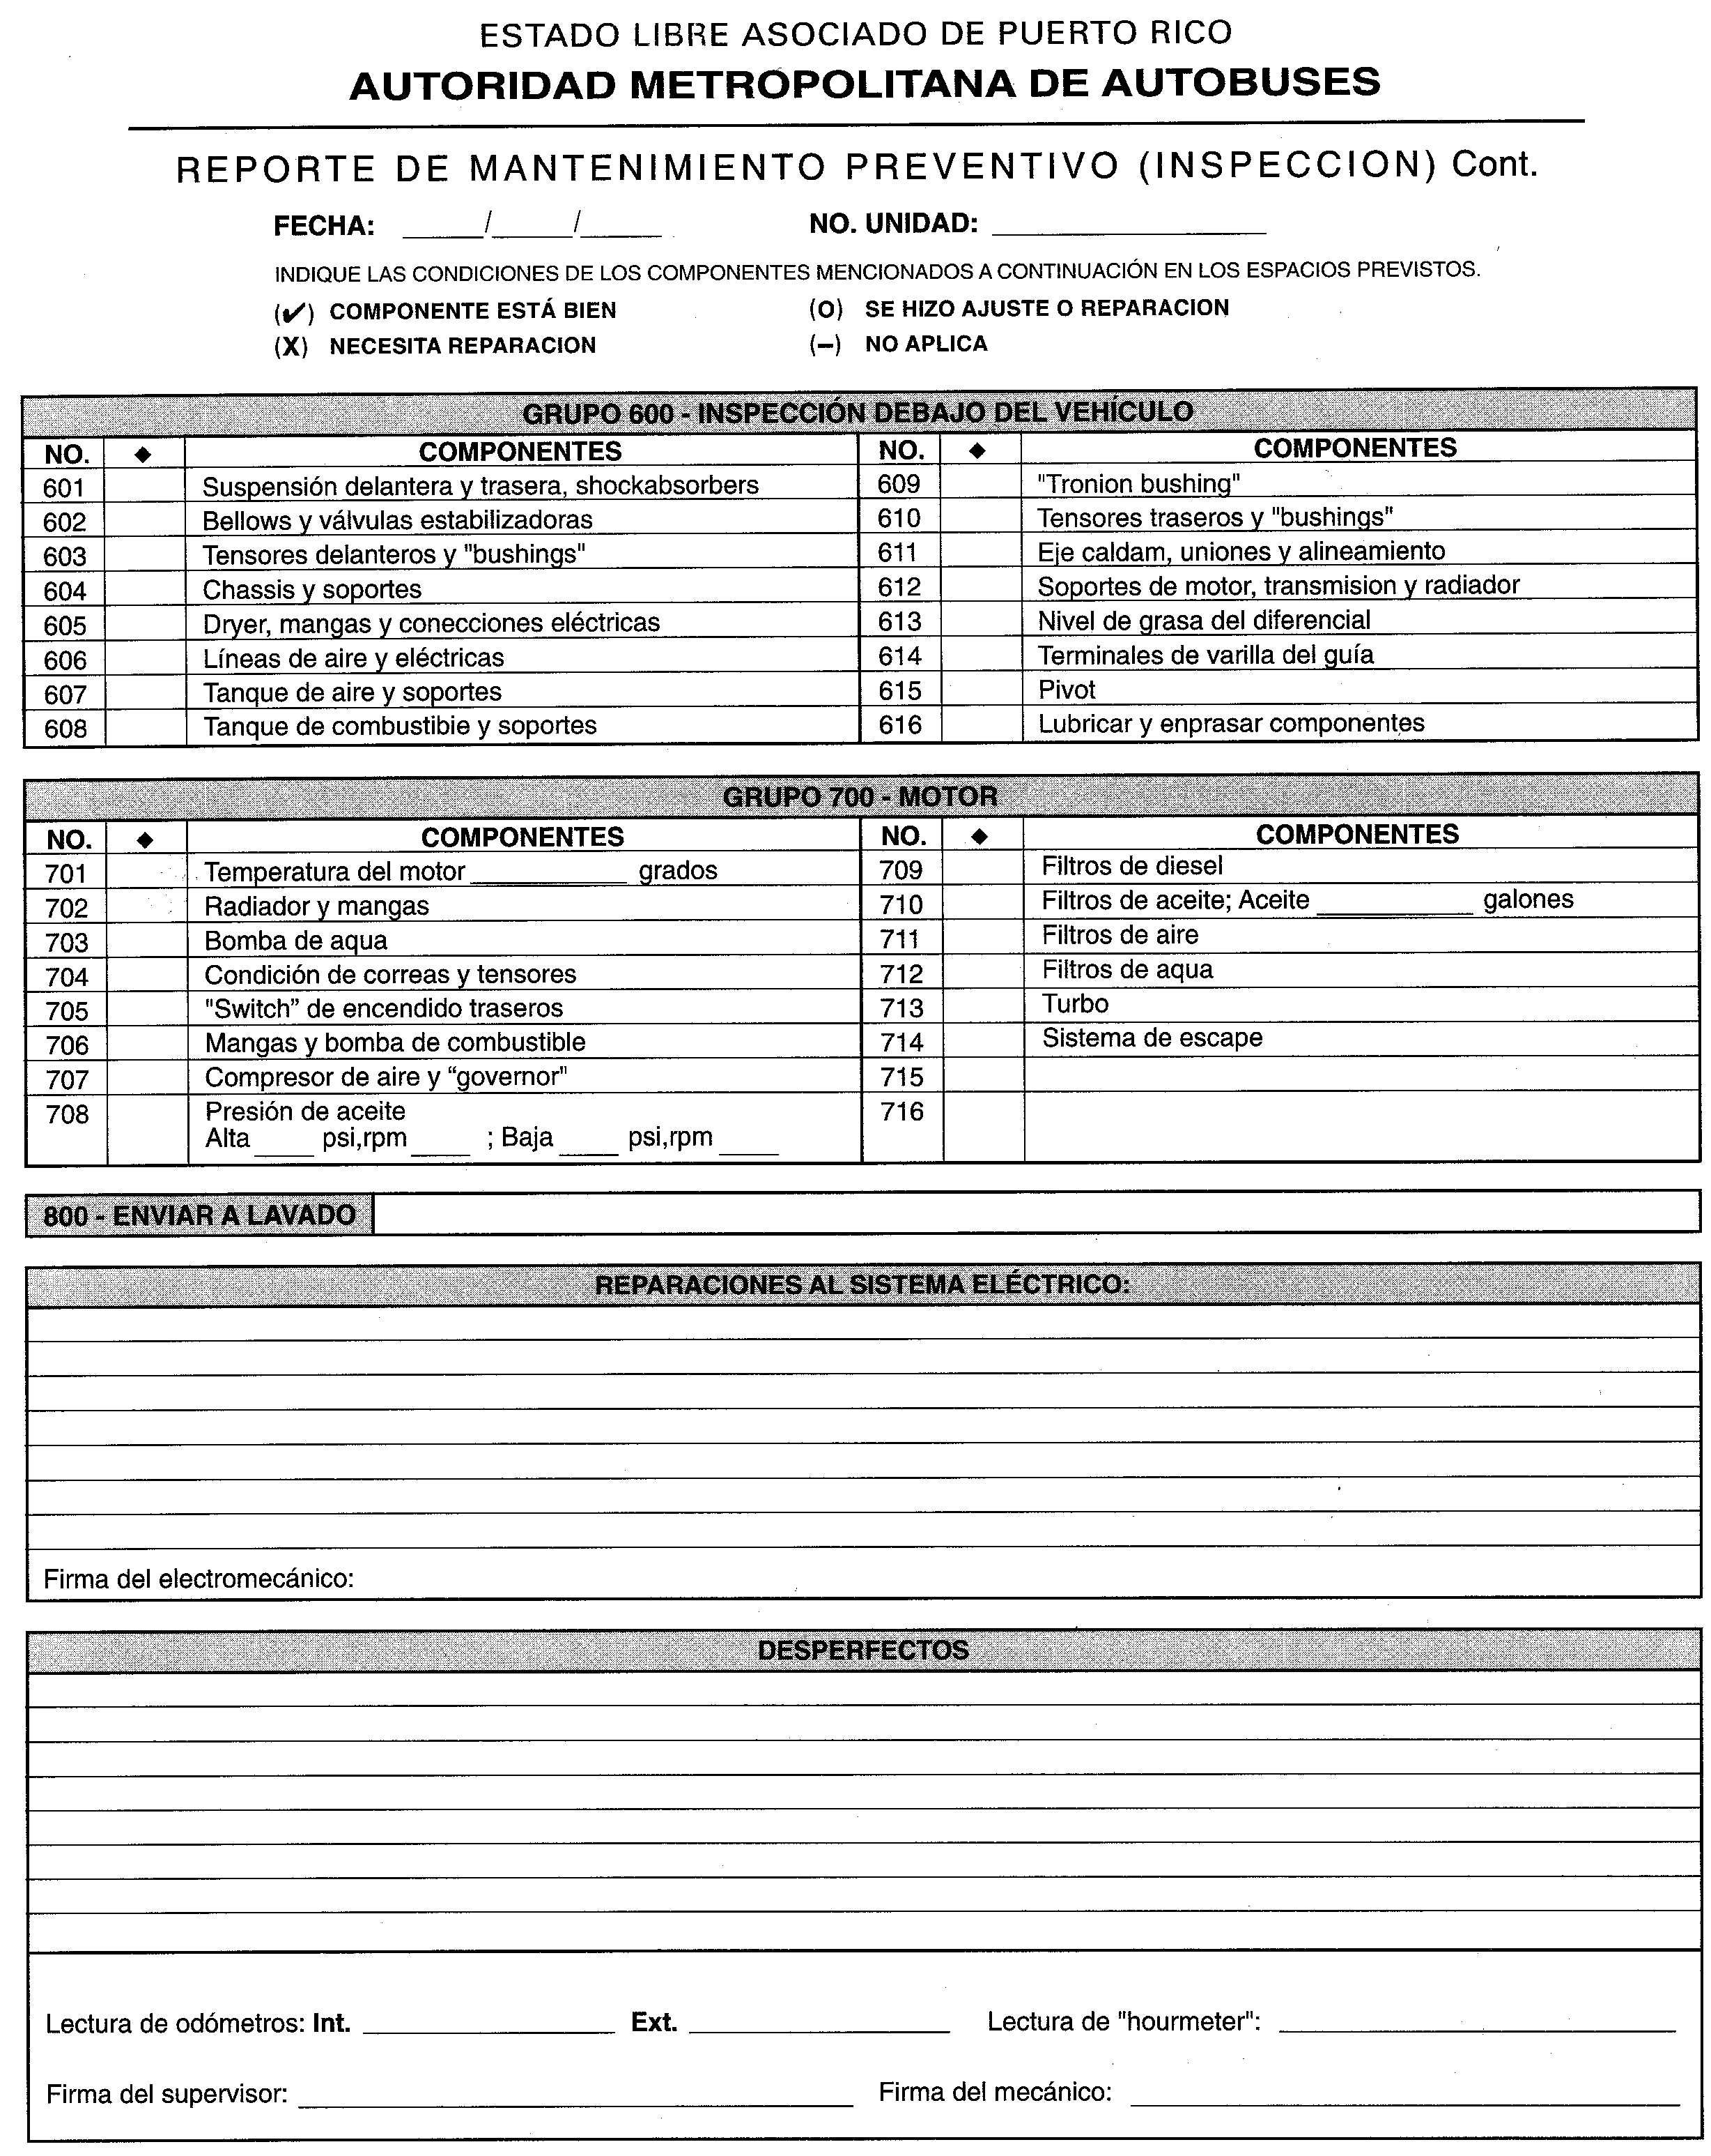
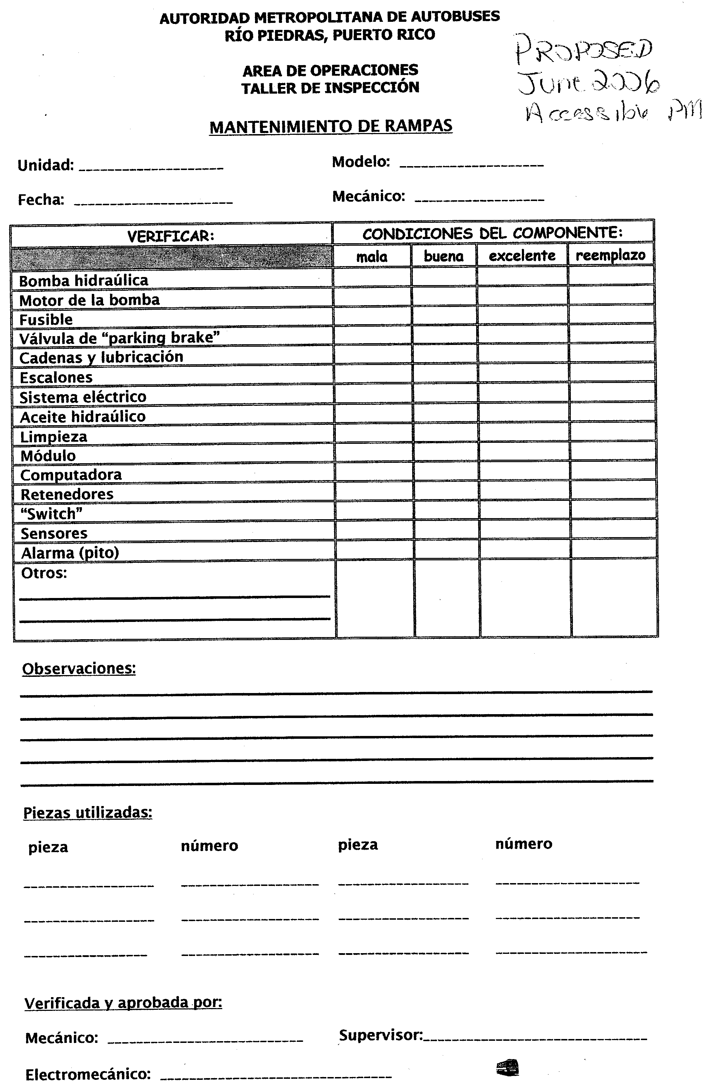
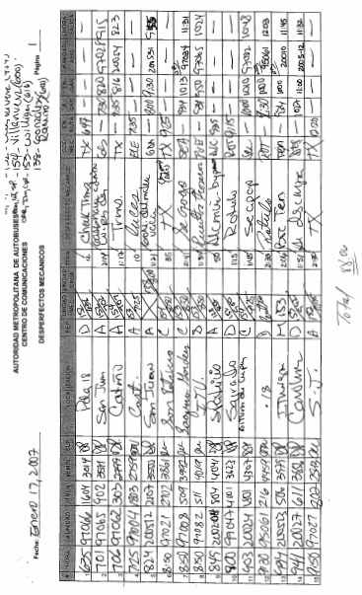

The word “lift” is used in the DOT’s ADA regulations to describe the accessibility feature for boarding and alighting riders using wheelchairs and others unable to use the steps of the vehicle. Similar requirements would apply to other boarding technologies and systems, such as ramps used on low-floor buses. AMA uses the Spanish word “rampa” to describe both lifts and ramps.
The PMI information was identified through a review of bus maintenance files.

