OVERVIEW

BACKGROUND

The Federal Transit Administration (FTA) examines grantee performance and adherence to current FTA procurement requirements and policies using several management tools. FTA is required by 49 U.S.C. §5307 to perform reviews and evaluations of grant programs and to perform a full review and evaluation of the performance of grantees in carrying out grant programs with specific reference to their compliance with statutory and administrative requirements. Accordingly, FTA will perform procurement system reviews as part of its on-going oversight responsibility. The review process assesses the grantee's procurement management practices and program implementation of the FTA funded transit programs to ensure they are being administered in accordance with specific FTA procurement requirements.

WHO SHOULD ATTEND?

These workshops are for transit professionals responsible for procurement management or managing federally funded projects and professionals responsible for contracting or purchasing transit service or the activities that support the transit service. The workshops are designed to help attendees broaden their understanding of the Federal procurement rules and regulations that shape and define their programs. Case studies and exercises will be included to offer examples of acceptable and unacceptable practices.

WORKSHOP LEADERS

The Procurement System Review Workshop will be conducted by transit professionals, who are also reviewers for the FTA's Procurement System Review Program. The instructors will provide guidance in each of the 56 areas to be reviewed, answer questions about how to respond to specific review areas, and share industry best procurement practices. Staff from the FTA will attend the Workshop to answer questions about the Procurement System Review, assist you in any area related to your use of FTA funds, and refer you to printed guidelines or other resources should you require additional information.

WORKSHOP AGENDA

DAY 1 Wednesday June 16, 2010

8:00 am Participant Check-in / Breakfast

9:00 am Welcome and Introductions

9:15 am Presentation of FTA requirements in the areas of PSR Process, System Wide Procurement Elements, Written Standards of Conduct, Protest Procedures, Contract Administration System, Prequalification, Efficient and Economic Purchases. Participant questions and group discussion.

12:00 pm Working Lunch – American Recovery and Reinvestment Act (ARRA) Implementation.

1:00 pm Presentation of OMB ARRA Accountability Objectives, ARRA Management Challenges as identified by the Office of Inspector General, DOT, Oversight and/or Technical Assistance of ARRA-funded projects. Participant questions and group discussion.

Presentation of FTA requirements in the areas of Independent Cost Estimates, Arbitrary Actions, Brand Name Restrictions, Price Quotations, A&E Geographic Preferences. Participant questions and group discussion.

4:30 pm Adjourn

DAY 2 Thursday June 17, 2010

8:00 am Breakfast

9:00 am Presentation of Written Procurement Selection Procedures and Competitive Procurement. Participant questions and group discussion.

Presentation of FTA requirements in the areas of Buy America, Debarment and Suspension, Award to Responsible Contractors, Fair and Responsible Price Determination, Bid Opening, Cost/Price Analysis, Written Record of Procurement History. Participant questions and group discussion.

12:00 pm Lunch on Your Own

1:00 pm Presentation of Most Common Procurement Findings and Resolution of Findings, and PSR Follow - Up Reviews. Participant questions and group discussion.

3:00 pm Wrap-Up, Program Evaluations, and Feedback

4:00 pm Adjourn

HOTEL INFORMATION

The two-day Workshop will be held at the following location:

THE JOHN HANCOCK HOTEL & CONFERENCE CENTER
40 Trinity Place at Stuart Street
Boston, MA USA
Tel: 617-933-7700
Fax: 617-933-7709

http://www.jhcenter.com/

ROOM RESERVATIONS INFORMATION

A sleeping room block of 5 Standard rooms (per night) at the rate of $169.00 per night (without tax) has been reserved for this workshop for the nights of June 15, 2010 and June 16, 2010. The cut-off date for accepting reservations into this room block is June 1, 2010. Reservation requests received after 5:00 p.m. local time at the hotel on the cut-off date will be honored at the group rate as long as guest rooms are still available. The hotel accommodations are for confirmed workshop attendees only. The workshop is free of charge but participants are responsible for making their own sleeping room reservations. Please do not reserve a room until you receive a “Confirmed for Registration” e-mail from Calyptus Consulting Group, Inc.

Participants can book, modify, or cancel guest room reservations by calling the Reservation Line at
1-617-933-7700 between 3/29/10 to 6/14/10. To receive the special rate, participants should ask for the FTA – PSR Workshop room block when making reservations.

PARKING

The hotel entrance is next to the 100 Clarendon Street Parking Garage.

TRANSPORTATION INFORMATION

The workshop site is conveniently located in the Copley/ Back Bay area and is accessible by taxi and Massachusetts Bay Transit Authority (MBTA) via the Green and Orange Lines as well as buses.
General Driving Directions

From West

- Follow the Mass Pike (Rt. 90) East towards Boston
- Take Exit 22 (Prudential Center/Copley Square)
- Bear right to Copley Square onto Stuart Street
- Turn right at Trinity Place
- Destination will be on the left

From North/South

- Follow Route 93 towards Boston
- Take Exit 26 (Storrow Drive/Cambridge)
- Follow signs onto Storrow Drive/Back Bay
- Follow Storrow Drive signs to Back Bay and take the left exit to Copley Square
- Turn right at the lights onto Beacon Street
- At the second set of lights, turn left onto Clarendon Street
- Turn right at Trinity Place
- Destination will be on the right

Driving Directions from Airport to the Hotel

From Logan International Airport

Follow these directions to get to the John Hancock Hotel & Conference Center:
(Estimated Driving Time: 13 Minutes, Distance: 5.1 miles)

- Head Northeast (0.2 mi)
- Turn slight left (0.5 mi)
- Merge onto Massachusetts 1A S via the ramp to Summer Tunnel/Government Center/I-93 N (0.6 mi)
- Turn left to stay on Massachusetts 1A S and pay toll (1.2 mi)
- Take the ramp to MA-3 N/Massachusetts 3A N (499 ft)
- Keep right at the fork to continue toward MA-3N/Massachusetts 3A N (0.6 mi)
- Keep right at the fork, follow signs for MA-28 S/MA-3 N/Storrow Dr and merge onto MA-3 N/Massachusetts 3A N (0.4 mi)
- Slight right at Embankment Rd/MA-28 S, continue to follow MA-28 S (0.6 mi)
- Turn left at Beacon Street (128 ft)
- Take the 1st right onto Arlington St (0.3 mi)
- Turn right at St. James Ave (0.2 mi)
- Turn left at the second cross street onto Clarendon St (0.1 mi)
- Turn right at Trinity Place (466 ft)
- Destination will be on the right

Other Types of Transportations

From Boston Logan International Airport (BOS) to the Hotel

- Taxi:

On average, cab fare is approximately $35 - $55 per one way ride.

- Public Transportation via MBTA:

The MBTA links Copley/Back Bay area with Logan International Airport via Silver Line Route SL1 (Bus) to Red Line (Subway) South Station stop with services from Monday through Sunday. For more information and schedule on the MBTA Subway and Bus, please visit:
http://www.mbta.com/schedules_and_maps/.

Look for designated Silver Line Route SL1 (Bus) stops at the terminals. Buses from the airport depart every fifteen (15) minutes for South Station stop on the Red Line (Subway). From South Station, take the Outbound subway and get off at either of the following two destinations:

- Park Street via MBTA Green Line
  - Take any of the trolleys (A), (B), (C), or (D) and get off at the third stop “Copley Station”
  - Head east on Boylston Street toward Dartmouth Street
  - Turn right at Dartmouth Street
  - Turn left at St. James Avenue
  - Turn right at Trinity Place
  - Destination will be on the left
(Total Walk Time: 4 Minutes)

- Downtown Crossing via Orange Line
  - Take the Inbound subway (with destination of Forest Hill) and get off at the third stop “Back Bay Station”
  - Get off and head to the exit
  - Head north on Dartmouth Street toward Stuart Street
  - Turn right at Start Street
  - Turn right at Trinity Place
  - Destination will be on the left

From Other Destinations to the Hotel

- Amtrak:

Participants have two options:

- Take the Amtrak to South Station stop on the MBTA Red Line
  - Get off and take Outbound subway (Alewife Destination) to Park Street stop
  - Walk upstairs and transfer to any of the four MBTA Green Line trolleys with the following destinations:
    - B – Boston College
    - C – Cleveland Circle
    - D – River Side
    - E – Heath Street
  - Get off at Copley Station stop
  - Walk upstairs
  - Head east on Boylston Street toward Dartmouth Street
  - Turn right at Dartmouth Street
  - Turn left at St. James Avenue
  - Turn right at Trinity Place
  - Destination will be on the left
(Total Walk Time: 4 Minutes)

- Take the Amtrak to Back Bay Station on the MBTA Orange Line
  - Get off and head to the exit
  - Head north on Dartmouth Street toward Stuart Street
  - Turn right at Start Street
  - Turn right at Trinity Place
  - Destination will be on the left
(Total Walk Time: 2 Minutes)

- Massachusetts Bay Transit Authority (MBTA) Subway and Bus:

From the Red Line:

- If coming from Inbound, take the MBTA Red Line subway (with Alewife as destination) and get off at Park Street stop
- If coming from Outbound, take the MBTA Red Line subway (with either Ashmont or Braintree as destination) and get off at Park Street stop
- Walk upstairs and transfer to any of the four trolleys with the following destinations:
  - B – Boston College
  - C – Cleveland Circle
  - D – River Side
  - E – Heath Street
- Get off at Copley Station stop
- Walk upstairs
- Head east on Boylston Street toward Dartmouth Street
  - Turn right at Dartmouth Street
  - Turn left at St. James Avenue
  - Turn right at Trinity Place
  - Destination will be on the left
(Total Walk Time: 4 Minutes)

From the Orange Line:

- If coming from Inbound, take the MBTA Orange Line subway (with Forest Hill as destination) and get off at Back Bay Station stop
- If coming from Outbound, take the MBTA Orange Line subway (with Oak Grove as destination) and get off at Back Bay Station stop
- Get off and head to the exit
- Head north on Dartmouth Street toward Stuart Street
- Turn right at Start Street
- Turn right at Trinity Place
- Destination will be on the left
(Total Walk Time: 2 Minutes)

From the Blue Line:

- If coming from Inbound, take the MBTA Blue Line subway (with Forest Hill as destination) and get off at Back Bay Station stop
- If coming from Outbound, take the MBTA Orange Line subway (with Oak Grove as destination) and get off at Back Bay Station stop
- Get off and head to the exit
- Head north on Dartmouth Street toward Stuart Street
- Turn right at Start Street
- Turn right at Trinity Place
- Destination will be on the left
(Total Walk Time: 2 Minutes)

From the Green Line:

- For any of the four MBTA Green Line trolleys:
  - Get off at Copley Station stop
  - Walk upstairs
  - Head east on Boylston Street toward Dartmouth Street
  - Turn right at Dartmouth Street
  - Turn left at St. James Avenue
  - Turn right at Trinity Place
  - Destination will be on the left
(Total Walk Time: 2 Minutes)

The MBTA map is provided on the next page for your reference.

MBTA Subway:
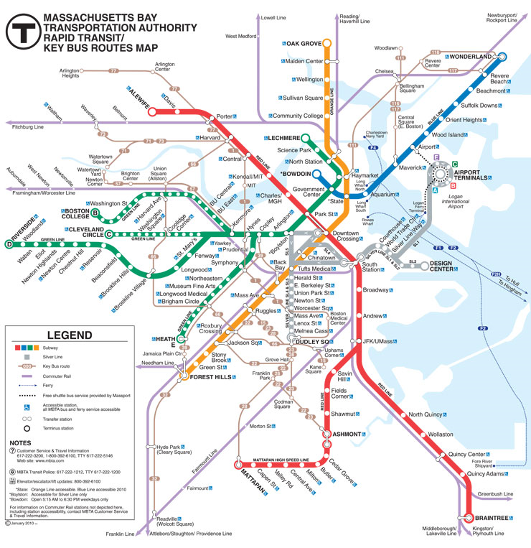
From the Silver Line from Logan Airport, get off here and transfer to Red Line - Outbound ,and either switch of at Downtown Crossing to access the Orange Line or at Park Street to access the Green Line
Get off at “Copley Station” on the Green Line, applicable for all trolleys (B), (C), (D), (E)
Get off at “Back Bay Station” on the Orange Line

REGISTRATION FORM

I will be attending the FY 2010 Procurement System Review Workshop. Please register me:

First Name:
Last Name:
Title:
Agency:
Street Address:
Street Address (cont'd):
City: State:
Zip:
Phone No.: Extension (if any):
Fax No.:
E–mail:
Special Needs (e.g., wheelchair access, hearing impaired):

Important Notes:

- This is an automated registration form. Please fill and review your entries carefully. After completing the form, please save the form and return it as an e–mail attachment to psrworkshop@calyptusgroup.com.

- You will receive two emails: (1) the first email is to acknowledge the receipt of the registration form; and (2) the second email is to confirm you are registered for the workshop. Please do not assume you are confirmed and registered until you receive the second email.

- Calyptus Consulting Group, Inc., a PSR Contractor, is organizing this event. If you have any difficulty returning the form by e–mail, feel free to print and submit by fax to Tiara Tran at (617) 577-0042. You can also call her at 617-577-0041 for more information.

- Submit one form for each participant per guidelines on the previous pages.

- Please submit your registration by June 9, 2010. Early registration is encouraged as the number of participants is limited.

