Budget Revision Examples

* VA-90-X340: FTA Prior Approval NOT Required
  + Minor changes to the budget to account for the actual expenses – Changes below 20% of scope
    - “Reason Box”: “See Attached Justification”

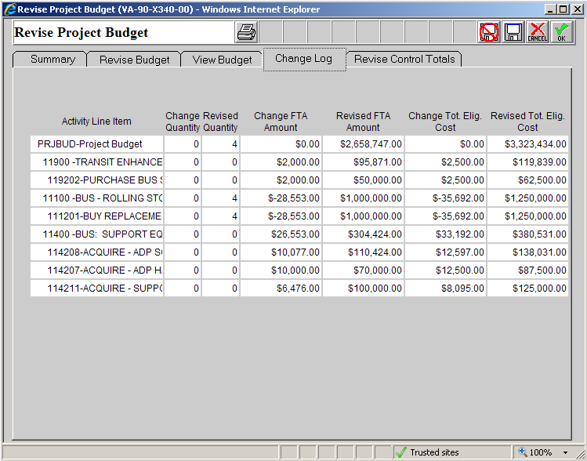

* + - Extended Budget Descriptions
      * 11.92.02
        + BUDGET REVISION #2 6/30/11: $2,000 was transferred to this line item from 11.12.01 to cover the actual cost of the bus shelters.
      * 11.12.01
        + BUDGET REVISION #2 6/30/11: The replacement buses purchased in this line item came in under budget by $28,553. That amount was transferred to 11.92.02, 11.42.08, 11.42.07, and 11.42.11 to account for additional costs in those line items.
      * 11.42.08
        + BUDGET REVISION #2 6/30/11: $10,077 was transferred to this line item from 11.12.01 to cover the actual cost of the software.
      * 11.42.07
        + BUDGET REVISION #2 6/30/11: $10,000 was transferred to this line item from 11.12.01 to cover the actual cost of the ADP hardware.
      * 11.42.11
        + BUDGET REVISION #2 6/30/11: $6,476 was transferred to this line item from 11.12.01 to cover the actual cost of the support vehicles.
* VA-04-0023-01: FTA Prior Approval **Required**
  + Large change to budget (over 20% of scope) – Cost overrun causing one large shift from one project to another.
    - “Reason Box”: “See Attached Justification”

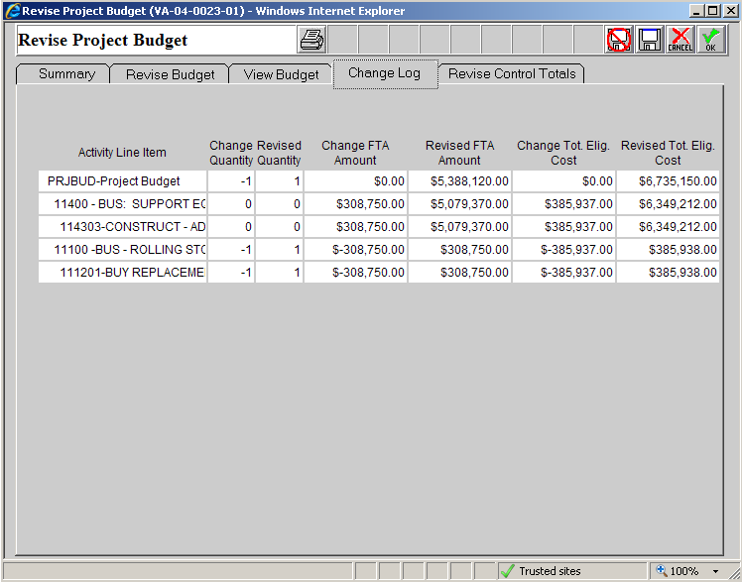

* + - Extended Budget Descriptions
      * 11.43.03
        + BUDGET REVISION #1 6/30/11: In order to ensure the facility funded in this grant is fully funded, the decision was made to decrease the number of vehicles being purchased from 2 to 1 and shift that amount ($308,750) from 11.12.01 to this line item.
      * 11.12.01
        + BUDGET REVISION #1 6/30/11: In order to ensure the facility funded in this grant is fully funded, the decision was made to decrease the number of vehicles being purchased from 2 to 1 and shift that amount ($308,750) from 11.12.01 to this line item.
  + VA-90-X363 (DIFFERENT GRANTEE): Shifting funds between ALIs with different local match ratios
    - “Reason Box”: “See Attached Justification”

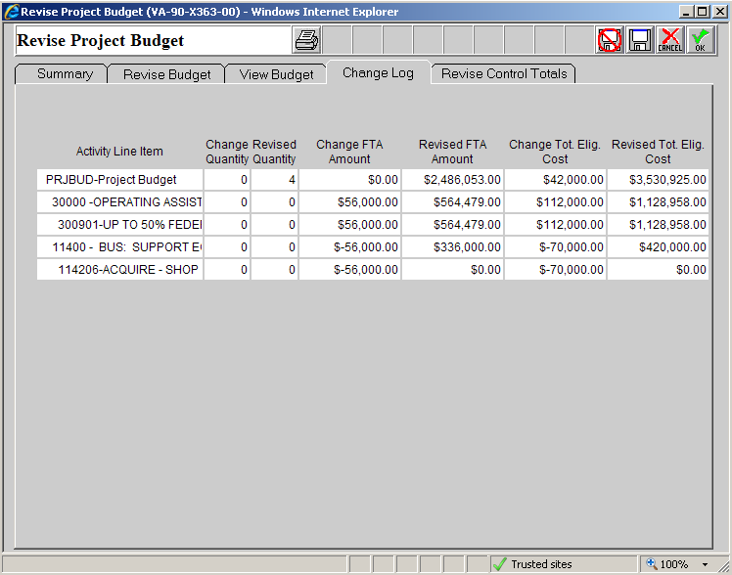

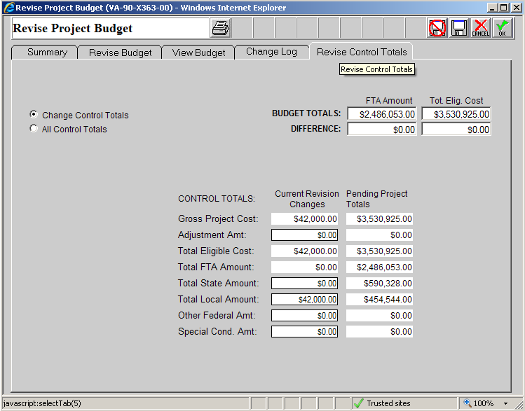

* + - Extended Budget Descriptions
      * 30.09.01
        + BUDGET REVISION #1 6/30/11: $56,000 was transferred from 11.42.06 to cover additional operations needs. Local funds will make up the different in local match.
      * 11.42.06
        + BUDGET REVISION #1 6/30/11: $56,000 was transferred from 11.42.06 to cover additional operations needs. Local funds will make up the different in local match. The project previously included in 11.42.06 will be completed in a future grant.