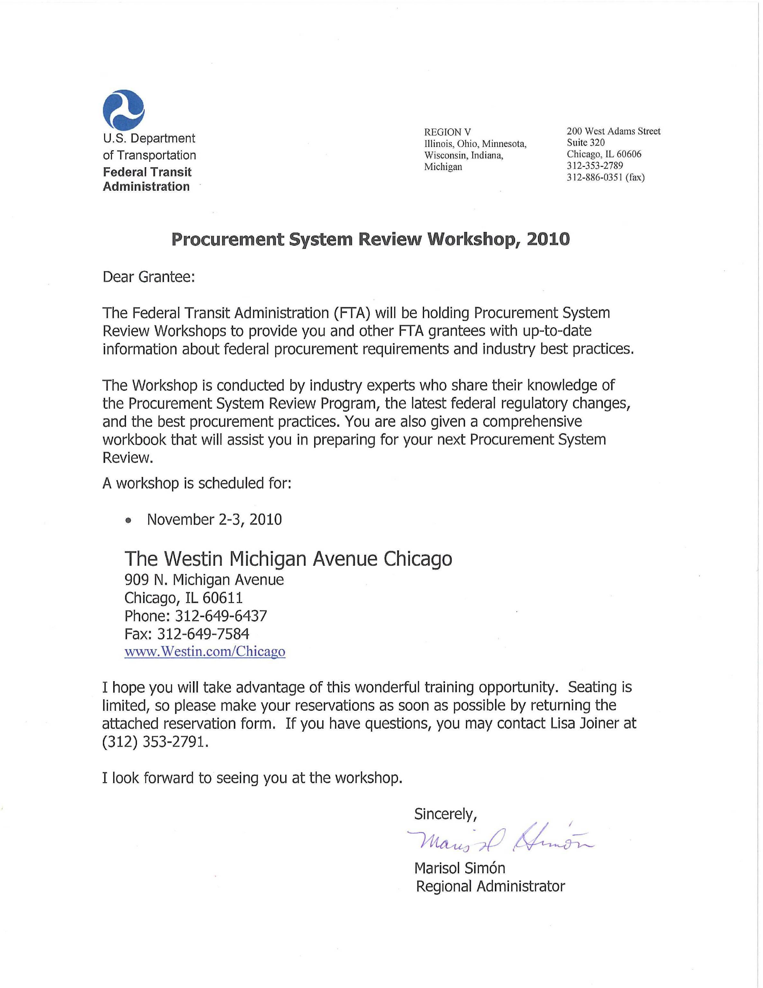

OVERVIEW

BACKGROUND

The Federal Transit Administration (FTA) examines grantee performance and adherence to current FTA procurement requirements and policies using several management tools. FTA is required by 49 U.S.C. §5307 to perform reviews and evaluations of grant programs and to perform a full review and evaluation of the performance of grantees in carrying out grant programs with specific reference to their compliance with statutory and administrative requirements. Accordingly, FTA will perform procurement system reviews as part of its on-going oversight responsibility. The review process assesses the grantee's procurement management practices and program implementation of the FTA funded transit programs to ensure they are being administered in accordance with specific FTA procurement requirements.

WHO SHOULD ATTEND?

These workshops are for transit professionals responsible for procurement management or managing federally funded projects and professionals responsible for contracting or purchasing transit service or the activities that support the transit service. The workshops are designed to help attendees broaden their understanding of the Federal procurement rules and regulations that shape and define their programs. Case studies and exercises will be included to offer examples of acceptable and unacceptable practices.

WORKSHOP LEADERS

The Procurement System Review Workshop will be conducted by transit professionals, who are also reviewers for the FTA's Procurement System Review Program. The instructors will provide guidance in each of the 56 areas to be reviewed, answer questions about how to respond to specific review areas, and share industry best procurement practices. Staff from the FTA will attend the Workshop to answer questions about the Procurement System Review, assist you in any area related to your use of FTA funds, and refer you to printed guidelines or other resources should you require additional information.

WORKSHOP AGENDA

DAY 1 Tuesday November 2, 2010

8:00 am Participant Check-in / Breakfast

9:00 am Welcome and Introductions

9:15 am Presentation of FTA requirements in the areas of PSR Process, System Wide Procurement Elements, Written Standards of Conduct, Protest Procedures, Contract Administration System, Prequalification, Efficient and Economic Purchases. Participant questions and group discussion.

12:00 pm Working Lunch – American Recovery and Reinvestment Act (ARRA) Implementation.

1:00 pm Presentation of OMB ARRA Accountability Objectives, ARRA Management Challenges as identified by the Office of Inspector General, DOT, Oversight and/or Technical Assistance of ARRA-funded projects. Participant questions and group discussion.

Presentation of FTA requirements in the areas of Independent Cost Estimates, Arbitrary Actions, Brand Name Restrictions, Price Quotations, A&E Geographic Preferences. Participant questions and group discussion.

4:30 pm Adjourn

DAY 2 Wednesday November 3, 2010

8:00 am Breakfast

9:00 am Presentation of Written Procurement Selection Procedures and Competitive Procurement. Participant questions and group discussion.

Presentation of FTA requirements in the areas of Buy America, Debarment and Suspension, Award to Responsible Contractors, Fair and Responsible Price Determination, Bid Opening, Cost/Price Analysis, Written Record of Procurement History. Participant questions and group discussion.

12:00 pm Lunch on Your Own

1:00 pm Presentation of Most Common Procurement Findings and Resolution of Findings, and PSR Follow - Up Reviews. Participant questions and group discussion.

3:00 pm Wrap-Up, Program Evaluations, and Feedback

4:00 pm Adjourn

HOTEL INFORMATION

The two-day Workshop will be held at the following location:

The Westin Michigan Avenue Chicago
909 N. Michigan Avenue
Chicago, IL 60611
Phone: 312-649-6437
Fax: 312-649-7584
www.Westin.com/Chicago

ROOM RESERVATIONS INFORMATION

A sleeping room block of 5 Standard rooms (per night) at the rate of $199.00 per night (without tax) has been reserved for this workshop for the nights of November 2, 2010 and November 3, 2010. The cut-off date for accepting reservations into this room block is October 16, 2010. Reservation requests received after 5:00 p.m. local time at the hotel on the cut-off date will be honored at the group rate as long as guest rooms are still available. The hotel accommodations are for confirmed workshop attendees only. The workshop is free of charge but participants are responsible for making their own sleeping room reservations. Please do not reserve a room until you receive a “Confirmed for Registration” e-mail from Calyptus Consulting Group, Inc.

Participants can book, modify, or cancel guest room reservations by calling the Reservation Line at
(312)-649-6437. To receive the special rate, participants should ask for the FTA – Procurement System Review (PSR) Workshop room block when making reservations.

Check in: 3:00 PM
Check out: 12:00 PM

DIRECTIONS

Railway

LaSalle Street Station
Travel Distance: Approximately 3.22 km/2.0 miles
Options for getting to and from the hotel include:

Contact: (312) 829-4222

Union Station
Travel Distance: Approximately 3.22 km/2.0 miles
Options for getting to and from the hotel include:

Contact: (312) 829-4222

The El (Chicago Transit Authority)
Travel Distance: Approximately 0.6 km/0.37 miles
Options for getting to and from the hotel include:

Airport

Midway Airport (MDW)
Travel Distance: Approximately 25.75 km/16.0 miles
Options for getting to and from the hotel include:

Taxi Fee: 20 USD

Train
From Midway Airport, take the CTA Orange Line direction towards Loop to the Roosevelt Road exit. From this point, transfer to the CTA Red Line directions towards Howard and exit Chicago Avenue. From Chicago Avenue, walk 3 blocks east to Michigan Avenue, make a left and walk 3 blocks to Delaware. The hotel entrance is on Delaware.

Airport Express Fee: 36 USD

O'Hare International Airport (ORD)
Travel Distance: Approximately 28.97 km/18.0 miles
Options for getting to and from the hotel include:
Taxi Fee: 50 USD

Airport Shuttle:
For shuttle from Midway Airport or O’Hare International Airport - Continental Airport Express Transport. For shuttle information and reservations, call (888) 284-3826.
Train:
From O'Hare International Airport, take the CTA Blue Line to the Jackson Boulevard exit. From this point, transfer to the CTA Red Line directions towards Howard and exit Chicago Avenue. From Chicago Avenue, walk 3 blocks east to Michigan Avenue, make a left and walk 3 blocks to Delaware. The hotel entrance is on Delaware.

Port

Downtown Boat Dock
Travel Distance: Approximately 4.83 km/3.0 miles
Options for getting to and from the hotel include:

Contact: (312) 829-4222

Bus

Chicago Bus Station
Travel Distance: Approximately 1.61 km/1.0 miles
Options for getting to and from the hotel include:

Contact: (312) 829-4222

Driving Directions

Local language driving directions to print and take with you
From North
- Take Interstate 94 South and exit at Ohio Street
- Travel east on Ohio for approximately 9 blocks to Michigan Avenue
- Turn left onto Michigan Avenue
- Travel north approximately 9 blocks to Delaware
- Turn right onto Delaware and continue to hotel entrance

From West
- Take Interstate 55 East to I-90/94 North
- Exit at Ohio Street
- Travel east on Ohio for approximately 9 blocks to Michigan Avenue
- Turn left onto Michigan Avenue
- Travel north approximately 9 blocks to Delaware
- Turn right onto Delaware and continue to hotel
From South
- Take I-94 North and exit at Ohio Street
- Travel east on Ohio for approximately 9 blocks to Michigan Avenue
- Turn left onto Michigan Avenue
- Travel north approximately 9 blocks to Delaware
- Turn right onto Delaware and continue to hotel entrance
From O'Hare International Airport
- Take Interstate 90 East which turns into JFK Expressway (I-90/94)
- Take Ohio Street exit and travel east on Ohio for approximately 9 blocks to Michigan Avenue
- Turn left onto Michigan Avenue
- Travel north approximately 9 blocks to Delaware
- Turn right onto Delaware

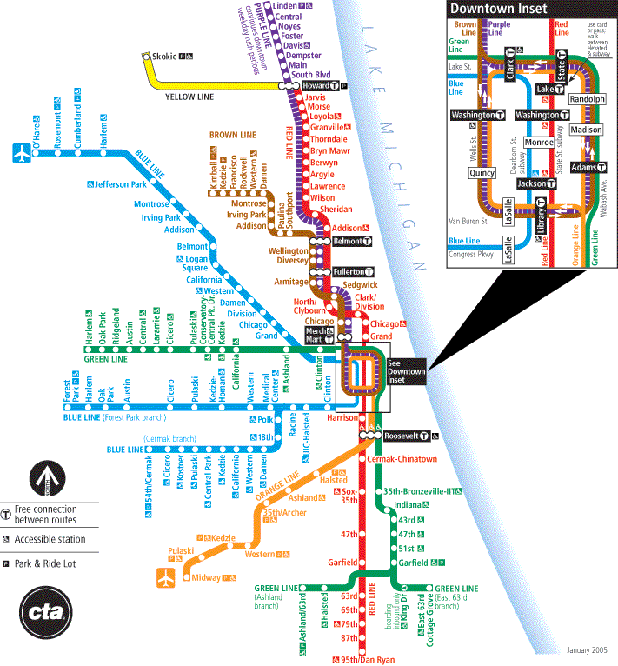

REGISTRATION FORM

I will be attending the FY 2010 Procurement System Review Workshop. Please register me:

First Name:
Last Name:
Title:
Agency:
Street Address:
Street Address (cont'd):
City: State:
Zip:
Phone No.: Extension (if any):
Fax No.:
E–mail:
Special Needs (e.g., wheelchair access, hearing impaired, dietary):

Important Notes:

- This is an automated registration form. Please fill and review your entries carefully. After completing the form, please save the form and return it as an e–mail attachment to dgeoffroy@calyptusgroup.com.

- You will receive two emails: (1) the first email is to acknowledge the receipt of the registration form; and (2) the second email is to confirm you are registered for the workshop. Please do not assume you are confirmed and registered until you receive the second email.

- Calyptus Consulting Group, Inc., a PSR Contractor, is organizing this event. If you have any difficulty returning the form by e–mail, feel free to print and submit by fax to Danielle Geoffroy at (617) 577-0042. You can also call her at 617-577-0041 for more information.

- Submit one form for each participant per guidelines on the previous pages.

- Please submit your registration by October 25, 2010. Early registration is encouraged as the number of participants is limited

