Kansas City Area Transportation Authority
(KCATA)
Kansas City, Missouri

January 16-19, 2007

Summary of Observations

Review of Route Identification
and

Stop Announcements

Prepared for

Federal Transit Administration
Office of Civil Rights
Washington, DC

Prepared by

Planners Collaborative, Inc.

July 30, 2007

CONTENTS

1. Introduction 1
1.1 Overview of the Review 1
1.2 Overview of KCATA 3
1.3 Consumer Input 4
2. Summary of Findings 6
2.1 Findings Regarding Stop Announcement and Route Identification Requirements 6
2.2 Findings Regarding Stop Announcements 7
2.3 Findings Regarding Route Identification 8
3. Stop Announcement and Route Identification Compliance Efforts 9
3.1 Policies and Procedures 9
3.2 Operator Training 11
3.3 Monitoring Procedures 12
3.4 Operator Discipline 14
3.5 Automated Stop Announcement and Route Identification 15
3.6 Findings 18
3.7 Recommendations 19
4. On-Board Stop Announcement Performance 20
4.1 Regulatory Requirements 20
4.2 Consumer Comments 20
4.3 Bus Operator Interviews 21
4.4 Review Team Observations 22
4.5 Selection of Stops to be Announced 25
4.6 Findings 29
4.7 Recommendations 30
5. Vehicle/Route Identification Performance 32
5.1 Regulatory Requirements 32
5.2 Consumer Comments 32
5.3 Bus Operator Interviews 32
5.4 Review Team Observations 33
5.5 Findings 34
5.6 Recommendations 34

Attachment A On-Site Review Schedule
Attachment B KCATA Response to Draft Report
Attachment C KCATA Instructor – Observation or Ride Report of Driving Practices
Attachment D Service Evaluation Form
Attachment E Operators Vehicle Report
Attachment F Periodic Maintenance Inspection Forms
Attachment G Fixed Route Operator Interview Form
Attachment H On-Board Fixed Route Stop Announcement Assessment Form
Attachment I On-Board Stop Announcement Data
Attachment J KCATA Transfer Stops
Attachment K External Route Identification Data

Introduction

Overview of the Review

The Federal Transit Administration (FTA) is responsible for ensuring compliance with the Americans with Disabilities Act of 1990 (ADA) and the U.S. Department of Transportation (DOT) regulations (49 CFR Parts 27, 37, and 38) that implement this civil rights law. As part of its compliance efforts, FTA, through its Office of Civil Rights, conducts periodic reviews of fixed route transit services operated by grantees. In a letter dated November 3, 2006, FTA notified the Kansas City Area Transportation Authority (KCATA) that a fixed route review had been scheduled and would be conducted within 120 days of the date of the letter. The FTA notification letter also explained that the review would consider:

- On-board stop announcements
- Route identification efforts

The requirements for stop announcements and route identification are set forth in 49 CFR §37.167:

(b) On fixed route systems, the entity shall announce stops as follows:
(1) The entity shall announce at least transfer points with other fixed routes, other major intersections and destination points, and intervals along a route sufficient to permit individuals with visual disabilities to be oriented to their location.
(2) The entity shall announce any stop on request of an individual with a disability.
(c) Where vehicles or other conveyances for more than one route serve the same stop, the entity shall provide a means by which an individual with a visual impairment or other disability can identify the proper vehicle to enter or be identified to the vehicle operator as a person seeking to ride on a particular route.

Planners Collaborative, Inc. of Boston, Massachusetts conducted the review. Don Kidston served as the review team leader. Other review team members were David Chia and David Loutzenheiser.

The stop announcement and route identification fieldwork began Tuesday, January 16, 2007, and continued on January 17. The opening conference took place on Thursday, January 18, 2007. The following individuals attended the opening meeting:

Mark Huffer General Manager, KCATA
Robert Kohler Director of Transportation, KCATA
Dolores Brehm Superintendent of Schedules, KCATA
Tommie Hill Driver Training, KCATA
Anthony Smiley Schedules, KCATA
Gloria Young Manager of Safety and Instruction, KCATA
Cindy Terwilliger Deputy Regional Administrator, FTA Region 7
Thomas Harris Civil Rights Officer, FTA Region 7
Don Kidston Planners Collaborative
David Chia Planners Collaborative
David Loutzenheiser Planners Collaborative

David Knight, ADA Team Leader from the FTA Office of Civil Rights, participated in the opening conference via telephone.

Mr. Knight opened the meeting by thanking KCATA for its assistance with the review. He noted that the review team had been on site since Tuesday, January 16. He explained that reviews of on-board stop announcements were conducted by providing a general timeframe for the review, having the team make initial observations, and then notifying the agency and requesting an opening conference. This process was used to ensure that the results of the observations of stop announcements would not be influenced by the transit provider knowing when the FTA review team was on site.

Mr. Knight noted that FTA viewed the review not just as part of its overall ADA compliance effort, but also as a chance to provide technical assistance on ADA issues. He indicated that the review team was available to answer any questions from KCATA staff, or to offer suggestions on addressing any issues that KCATA might have.

Mr. Kidston summarized the activities of the review team for the previous two days. These activities consisted of riding buses and observing stop announcements on KCATA bus routes. Observations also included standing at stops used by multiple bus routes and observing route identification efforts. The review team was assisted in these activities by FTA Region 7 staff. Mr. Kidston then presented a proposed schedule of meetings with KCATA staff for Wednesday and Thursday. Attachment A presents a copy of the review team’s on-site schedule.

During the remainder of the day, team members met with various KCATA managers to gather information about KCATA policies and procedures for stop announcements and route identification. They interviewed managers regarding operator training, operator performance monitoring, and operator discipline. They gathered information about the ongoing program to automate the stop announcements and route identification announcements (hereafter “automated announcements project”) as well as equipment maintenance procedures. They also interviewed KCATA bus operators.

On January 19, team members compiled the data from their field observations and prepared preliminary findings for presentation at the exit conference.

The exit conference took place on Friday, January 19, 2007, at 1 p.m. Those present at the exit conference were:

Mark Huffer General Manager, KCATA
Robert Kohler Director of Transportation, KCATA
Dolores Brehm Superintendent of Schedules, KCATA
Tommie Hill Operator Training, KCATA
Tom Morgan KCATA
Anthony Smiley Schedules, KCATA
Gloria Young Manager of Safety and Instruction, KCATA
Ann Warrington Supervisor Maintenance Department, KCATA
Cindy Terwilliger Deputy Regional Administrator, FTA Region 7
Thomas Harris Civil Rights Officer, FTA Region 7
Don Kidston Planners Collaborative
David Chia Planners Collaborative
David Loutzenheiser Planners Collaborative

Mr. Knight of FTA again participated via telephone. Mr. Knight began the exit conference by thanking KCATA staff for their cooperation and assistance with the review. He indicated that a draft report would be prepared and forwarded to KCATA for review and comment. KCATA’s comments on the draft would then be incorporated into a final report. Mr. Knight noted that once the report became a final document, it would be subject to release in response to Freedom of Information Act (FOIA) requests and available on FTA’s website.

The review team then presented the preliminary findings and recommendations from the on-site visit. KCATA was advised that they will be required to respond to the findings as they are presented in the final report. Recommendations are offered as suggestions and will not require a response. KCATA may, however, consider the recommendations in developing responses to the findings.

Section 2 of this report provides a summary of the findings and recommendations. Section 3 describes KCATA’s efforts to comply with the regulations, including written policies and procedures, operator training, and its automated announcements project. Section 4 presents the review team’s observations, analysis, and findings related to on-board stop announcement performance. Section 5 includes the observations, analysis, and findings regarding route identification performance.

A copy of KCATA’s response to the draft report is included as Attachment B.

The remainder of this section of the report presents an overview of the transportation services provided by KCATA, formal complaints received by FTA regarding KCATA stop announcement and route identification efforts, and results of rider interviews regarding the fixed route service.

Overview of KCATA

KCATA is an interstate agency of Missouri and Kansas. KCATA has a seven-county jurisdiction consisting of Cass, Clay, Jackson, and Platte counties in Missouri; and Johnson, Leavenworth, and Wyandotte counties in Kansas.

KCATA is governed by a Board of Commissioners, consisting of 10 commissioners: five from Missouri and five from Kansas. The Commissioners serve four-year terms, with a two-term limit.

KCATA is the direct operator of all of its 70 fixed bus routes including its Metro Area Express (MAX) bus rapid transit service. KCATA serves a population of 756,557 over a 396 square mile service area with a fleet of 286 buses (as of January 2007). KCATA provides an average of 50,000 unlinked weekday passenger trips.

The KCATA administrative office and bus maintenance facility are in Kansas City, MO at 1200 East 18th Street.

Eighteen routes operate seven days a week. Of the remaining routes, service is provided on weekdays for approximately half, and on Monday through Saturday for the remaining half. Operating hours range from about 4:30 a.m. to midnight on major routes to small rush hour windows for operating a handful of peak period trips on other routes.

The base fare for the bus is $1.25 per unlinked trip. Express bus fares are $2.50 and $3.00. All children between the ages of 6 and 11 and those children between 12 and 18 who are carrying a reduced fare card, pay a fare of $0.60 for the fixed route bus and half fare, $1.25 and $1.50, on express buses. Children 5 and under ride for free. KCATA also offers a $3 day pass and an $8 three-day pass. Monthly passes are also offered.

Approximately one-fifth of KCATA’s $40.5 million operating budget is financed with income from operations, mostly passenger revenue. Smaller amounts are provided by stadium express operations and bus advertising. Approximately two-thirds of the operating funds are from local governmental subsidies. The federal government provides the remaining 12 percent of KCATA’s operating funds.

Consumer Input

In the experience of the FTA Office of Civil Rights, input from people who use transit, such as riders on KCATA services, and particularly those that rely on stop announcements and route identification, can be helpful in conducting reviews. The input can assist the reviewers in identifying specific problem areas to be addressed during the course of the review. The input can also provide anecdotal support for observations made by the reviewers and conclusions drawn from the reviewers’ analyses. The review team gathered consumer input in three ways. Formal complaints on file with FTA were reviewed, consumers were interviewed, and KCATA’s customer comment/complaint records were reviewed.

Formal Complaints

FTA received one written complaint concerning KCATA’s fixed route service. The complaint was filed by a rider in September 2004. The major issues raised in the complaint were that operators often do not announce stops, and that when stops are announced they are inaudible and not sufficiently frequent to orient a passenger who is blind to his/her destination. The complainant cited KCATA routes 25, 54, and 56 as routes where these problems are encountered. In December 2006, FTA referred the complaint to this review to address the issues raised.

Agency and Rider Comments

Prior to the review team’s on-site visit, team members conducted telephone interviews with five people who work for agencies that support individuals who have visual impairments in the Kansas City area and/or people who have visual impairments and ride KCATA fixed route buses. All five of the people interviewed indicated that they use KCATA fixed route bus service. Three identified themselves as blind, and the remaining two said that they have low vision. Two of the respondents indicated that they use a cane, and one uses a guide dog. The agencies represented by those interviewed were:

- Missouri Council for the Blind
- Missouri Department of Social Services – Rehabilitation Services for the Blind
- Kansas City Mayor’s Council for the Blind

During the interviews, these individuals referred to experiences with five KCATA bus routes (25, 132, 175, South Loop, and MAX).

The most common complaints raised in the telephone interviews were:

- long gaps between announcements
- automated announcements at incorrect locations, such as after the stop
- operators frequently failing to announce requested stops
- customers waiting at stops having to request operators to identify the bus route

Interviewees also noted that operators rarely announce stops and that speakers are sometimes hard to hear or not working. Other concerns raised by interviewees were: stops are not announced at turns, operators do not always pull the bus to the curb and sometimes pass the stop, and sometimes the automated system is shut off.

Customer Complaints

KCATA provided a summary of customer comments/complaints that it received during 2006. This summary indicates that of 1,276 comments/complaints, 26 (2.0 percent) related to ADA issues. By month, ADA complaints ranged from zero in February and May to seven in August.

Summary of Findings

This section of the report summarizes the findings made based on this review. The background discussions for these findings are addressed in other sections of this report. The findings should be used as the basis for any corrective actions proposed by KCATA. Recommendations are also included in the report for KCATA’s consideration in developing corrective actions.

Findings Regarding Stop Announcement and Route Identification Requirements

- In Subsection D of the Disability Awareness Section of its Metro Operator Training Manual and Resource Guide, KCATA requires its operators to announce transfer points and destination points on fixed routes. Operators are required to announce stops upon the request of a person with a disability. The ADA requires that stops be announced sufficiently to permit individuals with visual impairments or other disabilities (observable or hidden) to be oriented to their location.
- KCATA does not require operators to identify their route to customers waiting at stops shared by more than one route. In Subsection D of the Disability Awareness Section of its Metro Operator Training Manual and Resource Guide, KCATA requests operators to announce, outside their bus, their route number at transfer points and bus stops serviced by other routes.
- KCATA issues a list of stops to be announced, with changes as they occur, to operators in a ring-bound handbook. Road Supervisors, who are responsible for field location of bus stops, are responsible for reporting changes to schedulers, who maintain the stop lists. According to KCATA managers, road supervisors do not always report stop changes. This can result in inaccurate stop lists.
- KCATA does not monitor operator performance in making route announcements at stops shared by more than one route.
- It appears that KCATA does not include failure to make route announcements at stops shared by more than one route in its operator discipline and remediation program.
- KCATA monitors driver performance through its street supervisors, staff instructors, and undercover observers, including its secret rider program participants.
- KCATA includes failure to make stop announcements in its operator discipline and remediation program. Since February 2005, there have been 21 occurrences of disciplinary action for failure to make stop announcements. None of those occurrences involved suspensions.

Findings Regarding Stop Announcements

- Of 58 observations of route segments, no stop announcements were made on 11 (19 percent) of the routes.
- The average (mean) interval between announcements exceeded five minutes on 16 (28 percent) of the route segments observed by the review team, and the average interval between announcements was between three and five minutes on 13 (22 percent) of the route segments.
- For the 44 route segments observed with automated announcements, the average interval between stop announcements exceeded three minutes on 26 (59 percent) of the route segments.
- The interval between stop announcements exceeded three minutes on all of the routes relying upon operators to make voice announcements. Of the 14 routes with inoperable automated stop announcement systems, operators made voice announcements on only three (21 percent).
- The stop lists used by KCATA do not appear to adequately address DOT regulatory requirements to announce stops at transfers to other routes and to announce stops sufficiently to orientate passengers. A comparison of KCATA’s automated and operator stop lists to lists developed by review team for eight sample routes indicates that many stops where multiple routes converge, diverge, or cross and stops at turns on routes, are not included on KCATA’s lists.
- The list of stops to be announced by the automated system appears to be inconsistent with the list of stops to be announced that is provided to operators. Based on a review of eight routes, 92 stops were common to both lists of stops. There were an additional 75 stops on the operator lists that were not included on the automated list and 26 stops on the automated list that were not on the operator list.
- Stop announcements outside of downtown Kansas City made by the automated system are often made too close or even after the bus stop. In calibrating the time when the automated system makes the stop announcements, KCATA does not appear to fully account for the higher speeds that buses are traveling outside of downtown Kansas City.
- Two of twelve operators interviewed said that they report a malfunctioning public address system when identified; the other ten operators said that they do not.
- There appears to be a large number of vehicles with automated stop announcement systems that are either not turned on or are not reported and recorded as needing repair. The automated stop announcement equipment was not working on 14 (24 percent) of the 58 buses observed. Assuming the same failure rate for all KCATA vehicles, approximately 53 of the approximately 220 buses used in daily service will have inoperable automated announcement systems. As reported in Section 3.5, an average of 10.6 automated stop announcement systems are repaired per week or 2 or 3 repairs per day. The discrepancy between 53 inoperable systems and two to three daily repairs indicates that many systems are either operational and not turned on properly, or inoperable and not reported and recorded as in need of repair.
- Most operators understood the need to make stop announcements when the automated system is not operating properly and said that they make voice stop announcements when this occurs.
- About half of the operators were not aware that the buses had a public address system that could be used for voice announcements.
- Half of the operators interviewed were aware of the stop lists in the ring-bound handbook KCATA provided to them, and the other half were not.

Findings Regarding Route Identification

- The review team observed only one route announcement in 68 observations.
- The automated route announcement equipment is not operational. KCATA plans to make the equipment operational by the end of 2007.
- Of 12 operators interviewed, none understood the requirement to make route announcements at stops shared by more than one route so that people who are blind, have low vision, or cognitive disabilities which prevent them from identifying the bus can identify the route.
- A number of operators were observed stopping only in response to a signal from waiting customers.

Stop Announcement and Route Identification Compliance Efforts

This section of the report presents information about KCATA’s efforts to comply with the regulations requiring that operators announce stops and identify routes to fixed route bus service customers. KCATA’s efforts include:

- KCATA policies and procedures
- KCATA operator training practices and written material
- KCATA monitoring procedures
- KCATA’s ongoing automated announcements project

Prior to the site visit, the review team received written information from KCATA on its policies and procedures for stop announcements and route identification, as well as samples of completed monitoring reports. KCATA also provided a copy of its operator training materials.

While on site, team members interviewed KCATA managers about training, monitoring, and the implementation of the automated system. Team members also reviewed additional information on the automated system.

Policies and Procedures

Route Notification Stop Announcement Procedures

DOT ADA Regulations
The DOT ADA regulations require announcement of stops to passengers on transit vehicles and identification of transit routes to people waiting at stops. Specifically, the regulations state:

Stop Announcements, 49 CFR §37.167(b):

On fixed route systems, the entity shall announce stops as follows:
(1) The entity shall announce at least at transfer points with other fixed routes, other major intersections and destination points, and intervals along a route sufficient to permit individuals with visual impairments or other disabilities to be oriented to their location.
(2) The entity shall announce any stop on request of an individual with a disability.

Identifying Vehicles and/or Passengers, 49 CFR §37.167(c):

Where vehicles or other conveyances for more than one route serve the same stop, the entity shall provide a means by which an individual with a visual impairment or other disability can identify the proper vehicle to enter or be identified to the vehicle operator as a person seeking a ride on a particular route.

KCATA Policies and Procedures
KCATA addresses route identification and stop announcement procedures in the KCATA Metro Operator Training Manual and Resource Guide (hereafter “Training and Resource Guide,” except for findings), February 2006. In Subsection D, “Persons with Disabilities – An ADA Overview of the Disability Awareness,” route notification and stop announcements are addressed as follows:

11) Operators must announce transfer points and destination points on fixed routes. Operators are required to announce stops upon the request of a person with a disability. The ADA requires that stops be announced sufficiently to permit individuals with visual impairments or other disabilities (observable or hidden) to be oriented to their location.
12) Operators are requested to announce, outside their bus, their route number at transfer points and bus stops serviced by other routes.

The Training and Resource Guide text concerning stop announcements does not explicitly require announcement of stops at major intersections, as required by the regulations. The “request” for operators to announce their bus route number is insufficient by itself to provide a means for many people with visual impairments to identify the route. Additionally, a common practice of many transit agencies is to announce the route destination as well as the route number. Such a practice is often necessary to satisfy DOT ADA regulations, particularly where a route has more than one possible destination.

A “Route Book” section of the Training and Resource Guide provides guidance to the operator for setting route destination signs. Otherwise, the guide does not address operator responsibility for route identification or stop announcements.

KCATA also uses a document entitled Services to Passengers with Disabilities – Accessible Bus Operating Procedures, Dec ’06 (hereafter “Procedures”). Section V addresses stop announcements. This section of the Procedures requires operators to announce stops and, unlike the Training and Resource Guide, to identify their route to customers waiting at stops served by more than one route. Operators are required to announce stops clearly whether or not the public address (PA) system is operating. A list of major street intersections at which announcements are to be made is included in the Procedures. The list includes 31 north-south streets and 29 east-west streets.

Additionally, KCATA has issued bulletins in recent years reminding operators of the requirement to announce stops. These bulletins are referenced as follows:

- 09-03 – February 26,2003
- 04-04 – March 1, 2004
- 63-04P - October 8, 2004

None of the bulletins mentions the requirement to announce bus routes to waiting passengers at stops served by more than one route.

KCATA also addresses stop announcements and route identification in its Disability Awareness Training document. With respect to stop and route announcements, the document repeats the language from the Procedures.

The most specific information provided to operators concerning stop announcements is contained in an untitled ring-bound booklet (hereafter “ring-bound booklet”) issued to each operator. The ring-bound booklet includes the information needed to operate all routes, including route descriptions, operator instructions, and check lists. It includes lists of stops for each route that require ADA stop announcements. When changes are made to the lists, they are supposed to be coordinated between the automated announcement program manager and the training officer.

There is some disconnect in the procedures for updating ADA stop announcement lists following changes in bus routes. When bus stop locations are changed, the KCATA road supervisors are responsible for moving or installing signs or shelters. According to a KCATA manager, stop changes are not always reported to schedulers for modification to the database of the HASTUS scheduling software (discussed in Section 3.5). As changes occur, they are distributed to operators for inclusion in their ring-bound booklets. The stop lists are discussed further in Section 3.5 of this report, “Automated Stop Announcements and Route Identification.”

Operator Training

A member of the review team met with KCATA’s manager of safety and instruction and KCATA’s supervisor of transit operations to discuss how stop announcements are incorporated into operator training.

New KCATA operators receive six weeks of training. Over the past year, KCATA has hired about 90 new operators out of a set of 120 trainees (for context, KCATA has about 500 fixed route operators). Classroom training takes place during the first two weeks of training. Road training starts during week two. During the second week of classroom training, the director of training provides 2-1/2 hours of “ADA training.” This includes basics of the law, along with specific responsibilities of operators. In the past, KCATA had invited individuals with disabilities to take part in the ADA training. Currently, KCATA uses a video instead to present similar information.

Subsection D, “An ADA Overview of the Disability Awareness,” of the Disability Awareness Section of the Training and Resource Guide addresses route identification and stop announcements. These requirements are as described in Section 3.1 of this report. Also as discussed in section 3.1, the requirements are further addressed in the following training materials:

- The Procedures. Section V, “Other Service Requirements,”
- KCATA bulletins reminding operators of the requirement to announce stops:
  - 09-03 – February 26, 2003
  - 04-04 – March 1, 2004
  - 63-04P – October 8, 2004
- Manual of Instruction, Operating Rules, and Discipline Code (hereafter “Manual of Instruction”) (revised 1995). “Section V – Passenger Service”

As discussed in Section 3.1 of this report, training in the announcement of routes is limited to a request that operators announce routes to customers waiting at stops shared by more than one route.

During road training, operators are expected to call all stops, even if the automated system is operating. According to the manager of safety and instruction, operators are also expected to make external route announcements during road training.

Even though all buses will eventually have the automated stop announcement systems, operators must still know how to make the announcements for the following reasons:

- If the automated system does not work at the beginning of a run and the bus still is used in passenger service, the operator must make the announcements
- If the bus is unexpectedly re-routed, the automated system will not work properly, so the operator must make the stop announcements
- An operator must make announcements for all stops requested by a passenger

Also during initial operator training, operators learn that the automated announcement system activates when an operator logs in on the vehicle. Notably, the operators are not instructed on how to turn the automated announcement system on or off, or how to adjust the system (e.g., control the volume).

Operators receive one-day (eight hours) of refresher training each year. This refresher training includes ADA training.

Monitoring Procedures

KCATA uses three methods for monitoring performance, including the announcement of stops and routes. Street supervisors and other operations staff conduct regular observations in the field; members of KCATA’s secret rider program make regular observations; and customer complaints and reported incidents prompt review of on-board video recordings.

Staff Monitoring

KCATA has three ongoing programs for monitoring operator performance using street supervisors and other operations staff:

- Daily contact by street supervisors
- Ride-alongs by staff instructors
- Undercover observations by an operations assistant

KCATA has 10 street supervisors. These street supervisors have many responsibilities, including investigating accidents and incidents. They use KCATA supervisor vehicles as they travel around the service area, so that they are visible to bus operators. Each street supervisor is supposed to make five direct contacts with operators per day. This means observing the bus on the road and often boarding the bus. The street supervisors complete a ride report for each contact (Attachment C). However, this ride report focuses on driving performance and does not address passenger relations and ADA compliance.

One of the responsibilities of KCATA operator instructors is to ride with each operator at least once per year. During these ride-alongs, the instructors observe and evaluate the operators’ driving and customer relations practices. Instructors also listen for stop and route announcements. Notably, KCATA does not have a standard form for the instructors to record their observations.

The senior supervisor of transit operations sometimes directs his assistant to investigate operators to confirm practices reported from other sources. The assistant is not generally known to the operators, allowing her to make her observations undercover. She then reports back to the senior supervisor of transit operations.

Secret Rider Observations

KCATA employs “secret riders” to ride buses undercover and record observations about operator performance. At the time of the review team’s on-site review, KCATA had four secret riders. These riders collectively make 50 to 100 observations each month. An observation consists of riding a bus route for part or all of a one-way trip. For each observation, the secret rider records information about the vehicle, the operator performance, and the operator appearance. A sample completed form is included in Attachment D. The form has a section that specifically asks about announcing stops, including the following questions:

- Were major intersections announced?
- Method (PA or voice)?
- Were they clear?

The form does not ask about route identification announcements.

The secret riders submit completed forms to the senior supervisor of transit operations. He reviews the forms and notes any violations of KCATA policies or procedures. He generally considers the observations of the secret riders as sufficient evidence to impose progressive discipline on operators. On some occasions, he confirms their observations with observations of his assistant or street supervisors.

Use of On-Board Cameras

At the time of the review team’s site visit, 101 of KCATA’s fleet of 286 buses had on-board cameras. During 2007, KCATA plans to retrofit 96 additional buses with on-board cameras. All future bus purchases will include cameras. The primary purpose of these cameras is to review activity immediately prior to an incident on the bus. KCATA operations staff also use the video recorded by the cameras to monitor operator performance. Currently, operator performance is monitored only “for cause,” requiring a preexisting reason or suspicion before the video will be reviewed (for instance, if a customer files a complaint about a particular operator and run).

If the senior supervisor of transit operations observes an operator violating a work rule on video, he considers that sufficient evidence to impose progressive discipline on the operator. The video includes audio tracks, and can therefore be used to monitor stop and route announcements.

A customer complaint that is not confirmed by staff observations, is insufficient to take action against the operator. However, the senior supervisor of transit operations may initiate additional observations on that operator to try to confirm the alleged violations.

Operator Discipline

KCATA operators are subject to progressive discipline for repeated violations of policies and procedures presented in the Manual of Instruction. In particular, “Section VIII – ATA Discipline Code,” includes Work Rule 6.8:

Operators will announce major street intersections and stops as required by the Americans with Disabilities Act, as well as comply with all requirements of the Act as set forth in Policy Bulletin #58-94.

The evidence of a violation can come from direct observations by KCATA instructors or street supervisors, a secret rider report, or a customer complaint with verification by on-board video.

According to the senior supervisor of transit operations, this work rule also covers announcing routes to people waiting at bus stops. He said that operators are required to stop and open the door at any bus stop with people waiting. It is the operator’s responsibility to confirm whether they want to board the bus.

The progressive discipline process includes the following steps:

- Written warning
- One-day remediation training with pay
- Three-day suspension without pay
- Discharge

An operator can appeal any disciplinary measure through a formal appeals process established in the operators’ union collective bargaining agreement with KCATA. Appeals steps include:

- Oral or written appeal to senior supervisor of transit operations
- Written appeal to director of operations
- Written appeal to KCATA’s director of transportation
- Formal arbitration hearing

According to KCATA’s senior supervisor of transit operations, several operators have received three-day suspensions for not announcing stops. KCATA has not discharged any operator for failing to make stop announcements. It is the senior supervisor’s belief that the operators “get the message,” through less severe disciplinary measures.

KCATA provided two sets of documentation for its disciplinary actions addressing failure to announce stops: a list of operators subjected to disciplinary action for ADA violation covering 2004 to 2006 and a set of disciplinary memos for ADA violations for the 10-month period from June 2005 to March 2006. A comparison of records from the overlapping period for the two documents revealed inconsistencies; some disciplinary actions were recorded in one document but not the other. Between the two sources, there were 36 discrete disciplinary actions, including:

- 12 warnings
- 23 trainings
- 1 three-day suspension

The three-day suspension occurred in February 2005. All warnings occurred between January 1, 2004 and February 2005. By contrast, all disciplinary measures after February 2005 (21 occurrences) were in the form of re-training.

The senior supervisor of transit operations claimed that the current union leadership is more resistant than the previous union leadership regarding discipline of operators for not making stop announcements. He believed that the attitude of the union leadership is that it is KCATA’s responsibility to have the automated announcer system operate properly on the buses.

Automated Stop Announcement and Route Identification

KCATA’s 286 bus fleet consists of 170 forty-foot long buses, 77 thirty-foot buses, and 39 twenty-nine-foot buses. All of the buses are equipped with automated stop announcement systems. None of the buses have operating external route announcement systems.

The automated stop announcement system consists of a number of hardware and software components. Each vehicle is equipped with an Integrated Vehicle Logic Unit, which consists of a mobile data computer (MDC), a transmitter, and a receiver. The vehicles are also equipped with a global positioning system (GPS) antenna/receiver.

Buses are equipped with four to six internal speakers, depending on the type of vehicle.

The speakers have automatic gain control. A microphone or receiver linked to a sensor triggers an increase or “gain” in the announcement volume when background, or ambient, noise levels on the bus become high. The system allows for two volume settings, normal and gain. Within limits, the operator can set the volumes. As noted previously, KCATA does not train the operators how to control the volume; however, some operators learn this on their own or from other operators.

The vehicles have handsets for operator PA announcements. The microphone is connected to the system with a metal sheathed cable.

The vehicle has one external speaker, which is located in a protected frame at ear level, to the left of the front door when facing the vehicle.

HASTUS, the scheduling software used by KCATA, is the primary source of transit network data used by the automated stop announcement system. The HASTUS network information is inputted into the “route manager” component of the stop announcement system. Stop locations are verified in the field using GPS and a “route survey tool” component of the stop announcement system. According to KCATA managers, all stops have been verified with the exception of recent changes.

The automated announcement system is activated when the operator logs on at the beginning of his or her run or daily route schedule. The operator’s run is preprogrammed into the system. The vehicle’s location on the run is identified through a combination of GPS and odometer readings. GPS readings are refreshed once a minute, and the system uses odometer readings from the most recent GPS reading to identify the vehicle location between GPS readings. At a programmed point or distance before each stop to be announced, the system uploads geo-coded, pre-recorded audio stop announcements.

GPS readings establish the vehicle’s longitude and latitude based on a minimum of four—but preferably eight—satellite signals. The system is programmed to ignore weak or bad signals. A “canyon effect” can occur in areas where there are obstacles such as tall buildings, mountains or tunnels resulting in no accepted signal. In these cases, the system will rely on the last accepted signal and odometer readings to locate the bus until an acceptable signal is received. The system will then recalibrate to the last accepted signal. On some occasions, however, the system will accept a poor signal and incorrectly identify the vehicle location. This can result in stops being announced in the wrong location.

KCATA does not have an operating automatic external announcements system. The KCATA buses are equipped with external speakers for route announcements at stops served by more than one route. However, KCATA has not activated the external announcement system. According to KCATA managers, because of limited staffing, an audio file for the route announcements has not been developed.

KCATA also has wayside electronic variable message signs at MAX stops announcing the minutes until arrival of the next bus. The wayside system relies on pre-programmed bus schedules, rather than information on actual bus location, to estimate the bus arrival time. As the bus passes, information is automatically transmitted to a wayside receiver, which triggers the sign to provide the estimated minutes until the arrival of the next scheduled bus. While this is not an ADA issue, the wayside system can provide incorrect and misleading information to waiting customers when buses are not on schedule. KCATA might consider modifying the signs to make clear that the estimated times are based on scheduled, not actual locations, modifying the system to provide estimates based on actual locations, and disabling the signs to avoid providing inaccurate or misleading information until times based on actual locations can be displayed.

Maintenance Procedures

KCATA stop announcement equipment is inspected daily as part of “pre-trip” inspections as an element of the radio check. The equipment is also inspected during preventive maintenance inspections, which are scheduled for each bus at 7,000-mile intervals, occurring approximately every three months.

At pull-out, operators inspect their buses and identify any defects on an Operators Vehicle Report or “Bad Order Card” (Attachment E). If there are problems with the automated announcement system, the operator is supposed to check the “radio” line on the card. Bad order cards indicating a problem with the radio are turned in when the vehicle is returned to the garage at the end of the operator’s shift or run. Inoperable stop announcement equipment is also reported by KCATA staff through other communication such as e-mails and telephone calls.

When a problem with the automated stop announcement system is identified, the vehicle is withheld from service until the system is repaired unless the vehicle is required to meet the in-service vehicle requirement, or pull-out, for the day.

During periodic maintenance inspections, the radio and PA system speakers are checked (Attachment F). The automated stop announcement system is not explicitly included in the vehicle inspections and, according to KCATA managers is not included or tracked in KCATA’s maintenance information system.

When a problem with the automated stop announcement system is identified, it is referred to KCATA’s one technician assigned to maintain the system. The technician inspects the system and identifies the problem as related to power feed, speakers, or information files. Internal power and corrupt system cards are covered under the supplier’s warranty. The power feed and speakers are a KCATA maintenance responsibility, and incorrect input on system files are the KCATA schedule department’s responsibility.

Warranty work is recorded in a log. The contractor reviews the log and makes the needed repairs twice a week or more frequently if more than four vehicles are in need of repair at the same time. For maintenance department repairs, a work order is issued, and the repair is completed. In discussions with maintenance and scheduling managers, it was unclear how problems are reported to the scheduling department for corrective action.

Maintenance Performance

According to KCATA managers, approximately 220 buses are used daily. Approximately 40 Bad Order Cards are submitted daily.

During the 16-week period from September 28, 2006 through January 19, 2007, KCATA reported 41 radio system repairs through maintenance department work orders. This yields an average of 2.6 repairs per week. During the four-week period of December 14, 2006 through January 10, 2007, KCATA reported 22 speaker repairs for an average of 5.5 per week. This yields a total of 8.1 weekly radio and speaker repairs performed by KCATA maintenance staff.

KCATA also reported 131 warranty repairs to the automated system during 2006, or 2.5 per week. As a result, the total weekly average of bus stop announcement system repairs was 10.6 per week.

Quarterly changes to route and schedule information is downloaded to buses to update the data in the bus MDCs to reflect schedule changes. When changes are downloaded, the buses must be shut off for the MDCs to accept the updates. As a result, downloads are performed overnight during non-service hours. According to KCATA officials, the January 2007 updates were not properly completed when scheduled because of severely cold weather conditions. Buses had to remain operating overnight to assure that buses would start for morning service. Use of block heaters and battery chargers could prevent recurrence of this problem, as well as reduce fuel consumption and vehicle emissions.

Findings

- In Subsection D of the Disability Awareness Section of its Metro Operator Training Manual and Resource Guide, KCATA requires its operators to announce transfer points and destination points on fixed routes. Operators are required to “announce stops upon the request of a person with a disability. The ADA requires that stops be announced sufficiently to permit individuals with visual impairments or other disabilities (observable or hidden) to be oriented to their location.”
- KCATA does not require operators to identify their route to customers waiting at stops shared by more than one route. In Subsection D of the Disability Awareness Section of its Metro Operator Training Manual and Resource Guide, KCATA requests operators to announce, outside their bus, their route number at transfer points and bus stops serviced by other routes.
- KCATA issues a list of stops to be announced, with changes as they occur, to operators in a ring-bound handbook. Road Supervisors, who are responsible for field location of bus stops, are responsible for reporting changes to schedulers, who maintain the stop lists. According to KCATA managers, road supervisors do not always report stop changes. This can result in inaccurate stop lists.
- KCATA does not monitor operator performance in making route announcements at stops shared by more than one route.
- It appears that KCATA does not include failure to make route announcements at stops shared by more than one route in its operator discipline and remediation program.
- KCATA monitors driver performance through its street supervisors, staff instructors, and undercover observers, including its secret rider program participants.
- KCATA includes failure to make stop announcements in its operator discipline and remediation program. Since February 2005, there have been 21 occurrences of disciplinary action for failure to make stop announcements. None of those occurrences involved suspensions.

Recommendations

- KCATA should instruct its operators to announce all stops on lists provided to operators when the automated stop announcement system is not operating properly. This will ensure consistency between the stops announced automatically and those announced by operators. The consistency will make it easier for regular customers who depend on the stop announcements to orient themselves on the route.
- KCATA must require operators to identify their route to customers waiting at stops shared by more than one route. Procedures should be revised accordingly.
- KCATA should require road supervisors and all other employees who change bus stop locations to report such changes in a timely fashion to the scheduling department for inclusion in the HASTUS database.
- KCATA should train operators in the requirement to announce routes to customers waiting at stops shared by more than one route, including the need to stop the bus, curb the bus, open the door, and announce the route number and destination. Associated training programs and materials should be revised accordingly.
- KCATA should use the list of stops to be announced that is issued to operators in operator training so that operator use of the list becomes a regular practice.
- KCATA should include operator performance in making route announcements at stops shared by more than one route in its operator monitoring programs.
- KCATA should include failure to make route announcements at stops shared by more than one route in its operator discipline and remediation program.

On-Board Stop Announcement Performance

This section of the report focuses on KCATA’s performance in making stop announcements. Included in this section are:

- Description of the regulatory requirements related to on-board stop announcements
- Summary of consumer comments from telephone interviews
- Summary of operator comments from interviews with team members
- Description of the review team’s method for observing on-board stop announcements
- Summary of information collected and observations of stop announcement efforts
- Analysis of stops selected for announcements

Regulatory Requirements

Section 37.167(b) of the DOT ADA regulations contains the following requirement related to the announcement of stops on fixed route systems operated by public or private entities:

(b) On fixed route systems, the entity shall announce stops as follows:
(1) The entity shall announce at least transfer points with other fixed routes, other major intersections and destination points, and intervals along a route sufficient to permit individuals with visual disabilities to be oriented to their location.
(2) The entity shall announce any stop on request of an individual with a disability.

Consumer Comments

As noted in Section 1.3 of this report, FTA received one written complaint concerning KCATA’s fixed route service. The complaint was filed by a rider in September 2004. The major issues raised in the complaint were that operators often do not announce stops, and when stops are announced they are inaudible and not sufficiently frequent to orient a passenger who is blind to his or her destination. The complainant cited KCATA routes 25, 54, and 56 as routes where these problems are encountered.

In the review team’s telephone interviews with five KCATA bus riders who are blind or have low vision, the most common complaints relating to stop announcements were: long gaps between announcements, automated announcements at incorrect locations (such as after the stop), and operators’ frequently failing to announce requested stops. Interviewees also noted that operators rarely announce stops when the automated stop announcements system is broken or unavailable and that speakers are sometimes hard to hear or not working. Another concern raised by interviewees was that stops are not announced at turns. Additionally, some riders believe that sometimes the automated system is shut off.

Bus Operator Interviews

The review team interviewed 12 KCATA operators. The primary purpose of the interviews was to assess operators’ understanding of the requirements to announce stops and identify routes. In addition, the operators provided their perspectives on the effectiveness of the automated stop announcement system. Attachment G lists the questions posed by team members during the interviews. The operators interviewed by the team had a range of six months to 34 years of experience, with an average of 18 years and a median of 20 years of experience.

All operators understood the need to make some stop announcements. Most understood the need to call out stops at major intersections, though few understood the requirement to announce stops where passengers can transfer. Only one interviewed operator mentioned the requirement to call out stops at points of transfer to other bus routes. None of the operators understood the requirement to identify routes to waiting passengers at stops shared by more than one route. Some operators indicated that they identify their route to waiting customers in response to customer requests or when the bus route sign is not operating.

Half of the operators interviewed were aware of the stop lists in the ring-bound handbook that KCATA provides to operators. The other half of the interviewed operators, apparently unaware of the list in the handbook, indicated that there was no stop list.

Approximately two thirds of the operators said that the automated announcer system worked all or most of the time. Approximately one-third of the operators mentioned that the automated announcer system worked some of the time or half the time. Five of the operators noted that the system either missed announcements or the automated announcements occurred too late to be useful to passengers.

When asked whether the operators checked the PA system at pullout, some operators mentioned that it is not possible to check whether the automated system will work at pullout. Once they are on route, they can identify whether the system is operating properly. Two operators said that they reported a malfunctioning PA system when identified. Regardless of whether a malfunction is identified at pullout, all operators placed the bus into service.

Most operators understood the need to make stop announcements when the automated system was not operating properly and said that they make voice stop announcements when this occurs. However, about half of the operators were not aware that the bus had a PA system. Those that were aware of the PA system said that the PA system works.

Most operators indicated that they had no problems making voice announcements. All operators were satisfied with the training received; however, a few operators suggested strengthening the stop announcement training (in response to the interview questions). Operator understanding of stop announcement requirements and the associated on-bus equipment varied significantly from operator to operator.

Review Team Observations

On Tuesday, January 16 and Wednesday, January 17, 2007, the three review team members and five staff members from the FTA regional office in Kansas City rode buses throughout the KCATA service area. While on the buses, they observed and made note of stop announcements. The purpose of these observations was to determine whether stop announcements were being made at transfer points, major intersections, destinations, and at intervals sufficient for individuals with visual impairments to orient themselves. Team members also noted the method of the announcements and whether the announcements were made clearly. Team members positioned themselves at mid-bus to make observations and recorded the results on a form (see Attachment H).

On Tuesday, the review team made onboard observations from 7:19 a.m. until 6:40 p.m. On Wednesday, observations were made from 7:27 a.m. until 3:45 p.m. Observations of individual operators ranged in duration from 5 minutes to 96 minutes, with an average (mean) observation of 23 minutes. During this period, team members were on vehicles for a total of more than 22 hours and made observations of 58 route segments. Routes selected for observation were chosen to achieve the greatest geographic coverage while at the same time minimizing the amount of time spent making connections between routes and waiting for buses. Most routes were observed once. The most significant exception to this was the heavily used MAX line, which was observed nine times. Nine other routes were observed more than once, typically in different directions.

On the 58 route segments observed, there were a total of 336 stop announcements, 92 percent of which were made by the automated system. The remaining announcements were voice announcements, made orally by the operator. Automated announcements were made on 44 (76 percent) of the 58 routes observed. Voice announcements were made by the operator on three of the 14 routes that did not have operating automated systems. Operators also made voice announcements on three of the routes that had automated stop announcements. Table 4.1 provides an overview of the on-board stop announcement observations.

Table 4.1 – Overview of On-Board Observations for Stop Announcements
 | Number |  | % | Observation Period (hr:min)
 | Routes | Stops
Total Observations | 58 |  | 100 % | 22:48
Different Routes Covered | 38
Automated System Operating | 44 |  | 76 % | 12:17
Total Automated Announcements |  | 311
Operator’s Voice Announcements |  | 25

To assess the efficacy of the announcements, the review team analyzed the frequency of announcements made for the observations. To better understand frequency of announcements in the context of customer orientation, Table 4.2 presents the relationship between time intervals and distance at different bus speeds.
Table 4.2 – Time and Distance Intervals at Different Speeds
 | Time Interval in Minutes
 | 2 | 3 | 5
Speed in MPH | Interval in Miles
10 | 0.3 | 0.5 | 0.8
15 | 0.5 | 0.8 | 1.3
20 | 0.7 | 1.0 | 1.7
30 | 1.0 | 1.5 | 2.5
40 | 1.3 | 2.0 | 3.3
60 | 2.0 | 3.0 | 5.0

In general, announcements made at intervals of two minutes or less, at lower speeds, should be sufficient to orient passengers to where they are on their route. Announcements made at intervals of five minutes or more are likely to be insufficient.

As presented in Table 4.3, for the review team’s 58 observations, the average interval between audible announcements was less than two minutes for 10 (17 percent) of the observations and less than three minutes for 18 (31 percent) of the observations. No announcements were made on 11 (19 percent) of the routes observed and average intervals exceeded five minutes on 16 (28 percent) of the routes. On routes with automated announcements, the average interval between announcements exceeded three minutes on over half of the observed routes. Notably, the interval exceeded three minutes on all of the routes where the operators made or should have made voice announcements. Operators made voice announcements on only three of the 11 routes with inoperable automated stop announcement systems.

Table 4.3 – Audible Announcements by Interval and Method
Avg. Announcement Interval (minutes) |  | 0 to 2 | 2 to 3 | 3 to 5 | >5 | None | Total | %
Announcement Method
 | Auto | 10 | 8 | 12 | 14 | 0 | 44 | 76%
 | Voice | 0 | 0 | 1 | 2 | 11 | 14 | 24%
 | Total | 10 | 8 | 13 | 16 | 11 | 58
 | % | 17% | 14% | 22% | 28% | 19% | 100%

Attachment I provides more detailed data for each observation.

The FTA regional staff who rode buses had a range of observations concerning stop announcements and other on-board activities:

- Several observations related to location of announcements:
- For one announcement, there was no marked stop (Armour & Burlington)
- There were no announcements at some major cross streets (e.g., Barry Road)
- There were long gaps (five minutes) between announcements and few announcements on routes in Independence, MO
- There were many turns between announcements
- For Route 12, there were stop announcements in one direction but not the other
- Downtown stop announcements were often off by a full block, apparently as a result of GPS problems (for example, Route 135 northbound (NB) at 7:30 a.m. on January 17).
- Three staff observed that stops are announced just before, at, or after the stops
- There were two observations of routes where bus service information is inconsistent among the KCATA web site, printed schedules, and postings at bus stops (Routes 30 and 38)
- Two observations related to operator performance: operators passed customers – one woman using a cane and another person with low vision; operators also commonly used their cell phones
- Announcements were sometimes inaudible, particularly on routes outside of downtown on buses with noisy suspension and brakes

The other review team members made similar observations particularly with respect to the timing of announcements relative to stop location and audibility of announcements. The review team observations, along with comments obtained from operator interviews, indicate that the automated announcements were often made too late (i.e., as the bus was passing the stop, and even beyond the stop).

On 10 routes, observers identified inaudible or partially audible stop announcements. The poor audibility appeared to result from low speaker volume combined with loud background noises, such as from the buses rattling, heating fans, and brakes. Audibility appeared to be more of a problem in smaller buses used outside of downtown than larger buses used in downtown. Stop announcements on the MAX buses were consistently clear.

In addition to the summary observations described above, the review team also analyzed a sample of routes to assess performance in announcing the stops included on KCATA’s list of stops to be announced with the automated system. Team members selected a random sample of eight route observations in order to compare actual announcements made with the printed stop lists provided by KCATA, and stop lists that were encoded into the automated announcer system. The printed lists and the automated announcer lists were compared for consistency. The following routes were selected: 12 westbound (WB), 25 NB, 38 southbound (SB), 51 SB, 102 WB, 132 NB, 173 SB, and 257 SB.

As presented in Table 4.4, on two of the eight routes selected, all announcements on the list were made, and on one run, no announcements were made. On the remaining five routes, 60 to 90 percent of the stops on the automated announcer list were made by the automated system. For the sample as a whole, 76 percent of the stops shown on the automated announcer list were observed.

Table 4.4 – Comparison of Automated and Operator Stop Lists
Route | Automated Stop List | Announcements Made | % Made
12 WB | 10 | 9 | 90%
25 NB | 19 | 16 | 84%
38 SB | 11 | 11 | 100%
51 SB | 6 | 0 | 0%
102 WB | 5 | 3 | 60%
132 NB | 3 | 3 | 100%
173 SB | 11 | 8 | 73%
257 SB | 3 | 2 | 67%
Total | 68 | 52 | 76%

Selection of Stops to be Announced

The regulatory requirement for identifying which stops to announce provides some flexibility to the transit system in directing its operators and in the development of stop lists for automated stop announcements. The requirement to announce transfer points implies that the stops where any two routes converge or diverge must be announced. According to the regulations (see Appendix D to 49 CFR Part 37), announcements must be made at transfer points to other fixed routes or modes of transit service. A list of transfer points provided by KCATA is presented in Attachment J. The requirement to announce “any stops on request of an individual with a disability” is self explanatory.

The other relevant regulatory requirement is to announce “other major intersection and destination points, and intervals along the route sufficient to permit individuals with visual impairments or other disabilities to be oriented to their location.” As with stop announcements, the regulations allow KCATA (and its operators) to use judgment in selecting the specific stops to announce and the frequency of the announcements.

Based on consumer input and field observations, the review team focused on three concerns regarding the programming of stop information:

- Consistency between stops to be announced by the automated system and by the operator
- Adequacy of the stop lists in identifying transfer points, major intersections, and destinations, and orienting the passenger to his or her location on the route
- The amount of lead distance/time before the stop that automated announcements are programmed to begin

As previously discussed, announcements are required at least at transfer points with other fixed routes, major intersections and destination points, and intervals along a route sufficient to permit individuals with visual impairments or other disabilities to be oriented to their location.

When the automated stop announcement system is not functioning properly, the operator must make voice announcements in order to comply with the stop announcement requirements. For regular riders who rely upon stop announcements for orientation, it is important that the stops announced by the operator be consistent with the stops announced by the automated system. Otherwise, customers who are expecting a specific stop announcement as a cue to approaching their stop could miss the stop when the announcement is not made. Accordingly, for customer orientation, it is important that both automated and operator stop lists be consistent.

The review team also compared stop lists provided to the operators in their ring-bound booklets to automated announcer lists provided by KCATA for eight routes. The results of this analysis are presented in Table 4.5.

Table 4.5 – Comparison of Operator ADA Stop Lists to Automated Stop Lists
Route  Number | Number of Stops to be Announced
Route  Number | Operator List | Automated List | Common to Both | Only on One List
12 | 25 | 14 | 9 | 21
25 | 27 | 30 | 23 | 11
38 | 20 | 17 | 14 | 9
51 | 28 | 12 | 11 | 18
102 | 17 | 13 | 11 | 8
132 | 18 | 12 | 10 | 10
173 | 25 | 15 | 9 | 22
257 | 7 | 5 | 5 | 2
Total | 167 | 118 | 92 | 101

As indicated in the table, 92 stops were on both lists of stops. There were an additional 75 stops on the operator lists that were not included on the automated announcer list, and 26 stops on the automated announcer list that were not on the operator lists.

Adequacy of Stop Lists

To assess whether the stops included on the operator lists and automated announcer lists are sufficient to meet the requirements of the regulations for identifying transfer points, major intersections and destinations, and for orienting passengers to their location, the review team developed stop lists for one direction of travel for each of the eight routes identified in Table 4.5. The purpose of the review team’s list was to provide a point of reference by approximating the number of stops needed to meet the regulatory criteria in the judgment of the review team. The review team’s list is not intended to replace KCATA’s stop lists but rather to indicate the adequacy of the number of stops included on KCATA’s stop list. Any revisions to KCATA’s stop lists should be made by KCATA staff using their superior knowledge of local conditions, with input from members of the local disability community.

The review team developed its list of stops by applying the regulatory criteria through the following factors:

- Transfer points. Stops where two or more routes cross; and the first stop after two or more routes that share a common route segment converge or the last stop before they diverge
- Major intersections. Stops at cross streets which appear, by line width on KCATA’s system route map, to be major travel arteries on KCATA’s system map
- Major Destinations. Facilities identified on KCATA’s system map as major destinations
- Orientation. Stops immediately after points that routes turn from one street to another. If multiple turns are made within a block of each other, stops immediately following the last of the multiple turns. In addition, stops at intervals of more than a half mile from the previously announced stop. Admittedly, passage of time is also an important factor in determining which stops should be announced for purposes of orientation. However, since there was no practical way to incorporate passage of time into this particular analysis, it was omitted in developing the review team’s stops list.

The results of this analysis are presented in Table 4.6. The table presents the total number of stops identified for announcement for eight sampled routes (12 WB, 25 NB, 38 SB, 51 SB, 102 WB, 132 NB, 173 SB, and 257 SB). The table also includes the number of stops identified in the review team’s list that are not included on KCATA automated announcer or operator lists and the number of stops included on KCATA automated announcer or operator lists that were not included on the review Team’s lists.

Table 4.6 – Review of KCATA Stop Lists
 |  | Total Stops | Review Stops not in KCATA Lists | KCATA Stops not in Review List
Review List |  | 196
Automated List | Total | 116 | 86 | 7
 | % of Review | 59% | 44% | 4%
Operator List | Total | 111 | 94 | 9
 | % of Review | 57% | 48% | 5%

As can be seen in Table 4.6, in the review team’s judgment, many more stops should be included on KCATA’s lists to meet the criteria identified in the DOT ADA regulations. Table 4.7 categorizes the stop announcements for the eight routes according to the regulatory criteria requiring the announcement. Since many stop announcements are required by multiple criteria, the totals in Table 4.7 exceed the 196 stops identified in Table 4.6.

Table 4.7 – Criteria for Stops on Reviewers List
Criteria |  | Number
Major Intersections |  | 37
Major Destinations |  | 33
Transfer Points |  | 154
Orientation
 | Turns | 90
 | Interval Between Stops | 0

Generally, the stops identified for announcement in downtown locations were consistent with KCATA stop lists. By contrast, in outlying areas, the review team identified many more stops with transfers and routes with turns that necessitated announcements than were included on the stop lists. It should be noted that based on reviewers limited familiarity with the Kansas City area street system, major intersections and destinations and intervals may be somewhat understated.

Location of Announcements

During the field review, there were observations of stop announcements made at or after the bus passed the stop. These late announcements appeared to occur more often at stops outside downtown on arterial streets, where buses traveled at higher speeds. The stop announcements are programmed to begin based on the distance before the stop that is inputted into the system database by the transit operator. Allowing two seconds for the announcement, two seconds for a passenger to respond and request the stop, and an additional two seconds for the operator to respond and decelerate to the stop, indicates that the announcement should be initiated at least six seconds before the bus reaches the stop. Table 4.8 shows the distances ahead of a stop that an announcement would need to begin for a six-second lead time at different travel speeds.

Table 4.8 – Lead Distance for Stop Announcements
Speed  (mile per hour) | Speed  (feet/second) | Lead Distance  @ 6 seconds (feet)
10 | 15 | 88
15 | 22 | 132
20 | 29 | 176
30 | 44 | 264
40 | 59 | 352
60 | 88 | 528

The actual lead distance for stops on the randomly selected sample routes (12 WB, 25 NB, 38 south SB, 51 SB, 102 WB, 132 NB, 173 SB, and 257 SB), were analyzed to determine their adequacy to permit announcements to be made before the stop. The stops are categorized by lead distance in Table 4.9.

Table 4.9 Lead Distance from Stop for Programmed Announcements
Lead distance to stop (feet) |  | 75 | 200 | 300 | 450 | Total
Speed required to travel distance in 6 seconds (MPH) |  | 9 | 23 | 34 | 51
Number of stops programmed for each lead distance
 | Number of stops | 4 | 21 | 91 | 5 | 121
 | Percentage of all stops | 3.3% | 17.4% | 75.2% | 4.1% | 100

As indicated in the table most stops (79.3%) appear to be programmed to begin stop announcements sufficiently before the stop for speeds of 34 MPH or greater. 3.3% of the stops require speeds of less than 9 MPH and another 17.4% require speeds of less than 23 MPH to permit adequate time to announce the stop before reaching the stop. The lead distances for programmed stop announcements appear to be reasonable based on the distribution for different speeds.

However, given the observation of reviewers and customer observations that announcements are being made too late to request a stop, KCATA should review the lead distance and vehicle speed settings, particularly in locations where buses may exceed the speeds indicated by the lead distances currently input into the system.

4.6 Findings

- Of 58 observations of route segments, no stop announcements were made on 11 (19 percent) of the routes.
- The average (mean) interval between announcements exceeded five minutes on 16 (28 percent) of the route segments observed by the review team, and the average interval between announcements was between three and five minutes on 13 (22 percent) of the route segments.
- For the 44 route segments observed with automated announcements, the average interval between stop announcements exceeded three minutes on 26 (59 percent) of the route segments.
- The interval between stop announcements exceeded three minutes on all of the routes relying upon operators to make voice announcements. Of the 14 routes with inoperable automated stop announcement systems, operators made voice announcements on only three (21 percent).
- The stop lists used by KCATA do not appear to adequately address DOT regulatory requirements to announce stops at transfers to other routes and to announce stops sufficiently to orientate passengers. A comparison of KCATA’s automated and operator stop lists to lists developed by review team for eight sample routes indicates that many stops where multiple routes converge, diverge, or cross and stops at turns on routes, are not included on KCATA’s lists.
- The list of stops to be announced by the automated system appears to be inconsistent with the list of stops to be announced that is provided to operators. Based on a review of eight routes, 92 stops were common to both lists of stops. There were an additional 75 stops on the operator lists that were not included on the automated list and 26 stops on the automated list that were not on the operator list.
- Stop announcements outside of downtown Kansas City made by the automated system are often made too close or even after the bus stop. In calibrating the time when the automated system makes the stop announcements, KCATA does not appear to fully account for the higher speeds that buses are traveling outside of downtown Kansas City.
- Two of twelve operators interviewed said that they report a malfunctioning public address system when identified; the other ten operators said that they do not.
- There appears to be a large number of vehicles with automated stop announcement systems that are either not turned on or are not reported and recorded as needing repair. The automated stop announcement equipment was not working on 14 (24 percent) of the 58 buses observed. Assuming the same failure rate for all KCATA vehicles, approximately 53 of the approximately 220 buses used in daily service will have inoperable automated announcement systems. As reported in Section 3.5, an average of 10.6 automated stop announcement systems are repaired per week or 2 or 3 repairs per day. The discrepancy between 53 inoperable systems and two to three daily repairs indicates that many systems are either operational and not turned on properly, or inoperable and not reported and recorded as in need of repair.
- Most operators understood the need to make stop announcements when the automated system is not operating properly and said that they make voice stop announcements when this occurs.
- About half of the operators were not aware that the buses had a public address system that could be used for voice announcements.
- Half of the operators interviewed were aware of the stop lists in the ring-bound handbook KCATA provided to them, and the other half were not.

4.7 Recommendations

- KCATA should consider establishing a program to monitor performance of stop announcements on a more frequent and consistent basis. It may consider expanding its current secret rider program.
- KCATA should review and revise its automated stop list to include all stops where different bus routes converge, diverge, or cross and stops located after the route turns from one street to another.
- KCATA should revise the stop lists issued to operators to make them consistent with the automated stop lists.
- KCATA should review the timing of stop announcements made by the automated system, particularly outside downtown Kansas City, so that they are made sufficiently early for a passenger to signal a stop request and for the operator to make the stop safely.
- KCATA should establish a procedure to monitor operator inspections of automated stop announcement systems. Spot checks of vehicles by road supervisors or inspections by starters or mechanics after pull-in are two possible methods for spot checks. Operators who fail to properly inspect and report problems should be subject to remedial action as a means of improving reporting of automated systems that are not operating properly.
- KCATA should train and re-train its operators in the proper use of the public address system.
- KCATA should train and re-train its operators in the proper use of the stop lists in the ring-bound handbook it provides them.

Vehicle/Route Identification Performance

This section of the report addresses KCATA’s efforts to implement the requirement to identify the bus route to customers waiting at stops shared by more than one route. Included in this section are:

- A description of the regulatory requirements related to vehicle/route identification
- A summary of consumer comments from telephone interviews
- A summary of operator comments from interviews with team members
- A description of the review team’s method for reviewing route identification efforts
- A summary of information collected and observations made regarding route identification

Regulatory Requirements

Section 37.167(c) of the DOT regulations implementing the ADA contains the following requirement related to the identification of fixed route services:

Where vehicles or other conveyances for more than one route serve the same stop, the entity shall provide a means by which an individual with a visual impairment or other disability can identify the proper vehicle to enter or be identified to the vehicle operator as a person seeking a ride on a particular route.

Consumer Comments

During interviews, five KCATA bus riders who are blind or have low vision had a common complaint that operators failed to identify the bus route to customers waiting at stops. Interviewees also noted that operators do not always pull the bus to the curb and sometimes pass the stop.

The focus of the one formal complaint filed with FTA that was relevant to this review was stop announcements – not route identification. KCATA’s summary of complaints does not identify ADA issues by sub-categories. It is therefore not possible to differentiate between KCATA complaints concerning stop announcements and those concerning route identifications.

Bus Operator Interviews

As discussed in Section 4 of this report, the review team interviewed 12 KCATA operators. Most operators said they made external route announcements only when they thought that the announcements were needed (i.e., when they see a visually impaired person, a person who seems confused or lost, or on request). Three of the operators interpreted the requirement to make external announcements as applying only when the route display signs were not operating.

When operators were asked what information is included in their external announcements, two said the route destination and two others said they provided the route number.

Most operators said that the initial training and the training updates, which they received for all aspects of their duties, were adequate. A few operators indicated that route announcements are not covered in the training.

Review Team Observations

On Tuesday, January 16, and Wednesday, January 17, the review team members and FTA regional staff made observations at major bus stops shared by more than one route to assess KCATA’s performance in identifying bus routes to waiting passengers. Because the DOT ADA regulations require route identification only at stops served by more than one bus route, the best opportunity to observe route identification was at stops served by numerous routes with frequent service. These bus stops included:

- Main Street and 10th (Transit Center)
- Main Street at 11th and 12th
- Grand at 10th, 11th, and 12th (northbound)
- Baltimore at 11th
- Troost at 39th
- Union Station
- Plaza

The observations took place at different times of day on both days. In addition, team members noted whether there were route identification announcements when they boarded buses during the two days.

Although all buses are equipped with automated announcer systems that include external speakers, KCATA has not initiated operation of the external speaker system. KCATA’s goal is to implement operation of the external speaker systems by the end of 2007.

The review team made a total of 68 observations of buses at stops shared by more than one route. They observed only one external route announcement. In that single instance, the head sign was not working on the bus.

Additionally, there were several observations of operator behavior that would make it difficult, if not impossible, for a blind person, a person with low vision, or a person with cognitive disabilities to identify the bus route. One operator stopped beyond the stop. Another operator stopped in the middle of the street. One operator did not stop at all. One operator refused to open the door, and a second did not open the door, waiting for passenger’s indication of whether to stop.

Attachment K presents detailed data for each observation.

Findings

- The review team observed only one route announcement in 68 observations.
- The automated route announcement equipment is not operational. KCATA plans to make the equipment operational by the end of 2007.
- Of 12 operators interviewed, none understood the requirement to make route announcements at stops shared by more than one route so that people who are blind, have low vision, or cognitive disabilities which prevent them from identifying the bus can identify the route.
- A number of operators were observed stopping only in response to a signal from waiting customers.

5.6 Recommendations

- KCATA should revise its operator training to ensure that operators understand the requirement to make route announcements at any stop shared by more than one route.
- KCATA should implement the automated route announcement component of its automated announcer system as expeditiously as possible.
- In addition to monitoring driver performance for making route announcements and disciplining operators for failing to make route announcements (as discussed in Section 3.7) KCATA should implement monitoring and discipline to address operator failure to stop where people are waiting at the bus stop.
Attachment A

On-Site Review Schedule
Review of ADA Stop Announcements
Kansas City Area Transportation Authority (KCATA), Kansas City, MO
January 16-19, 2007

On-Site Schedule

Attachment B

KCATA Response to Draft Report

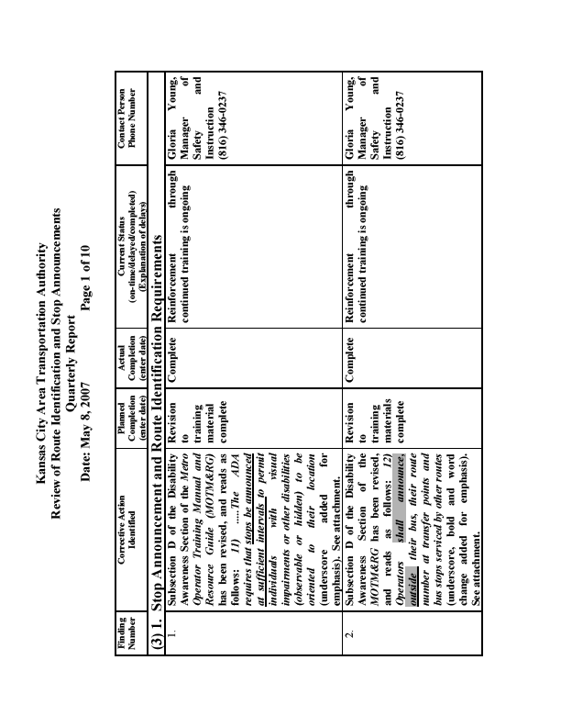

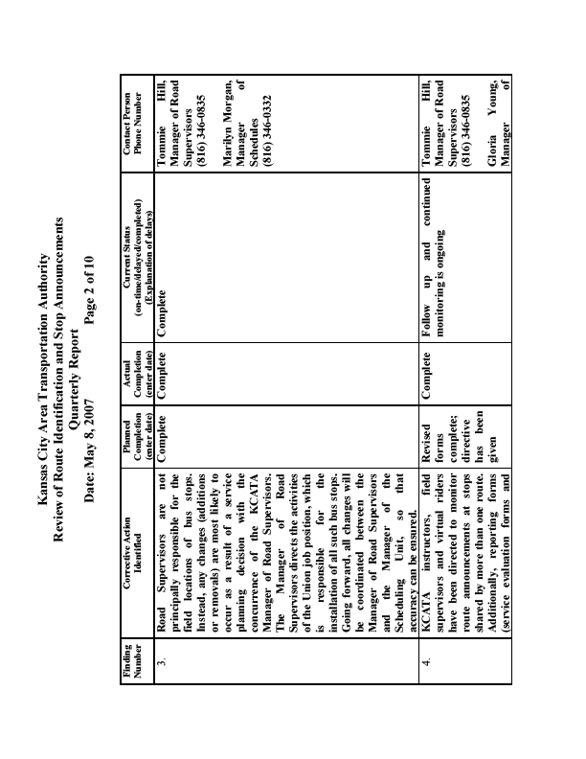

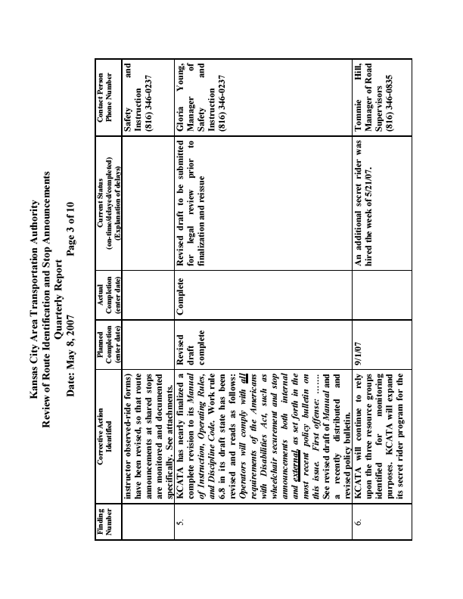

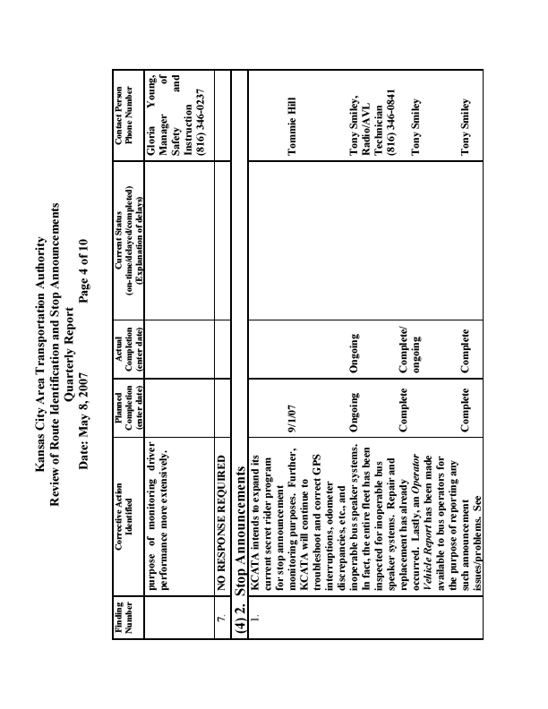

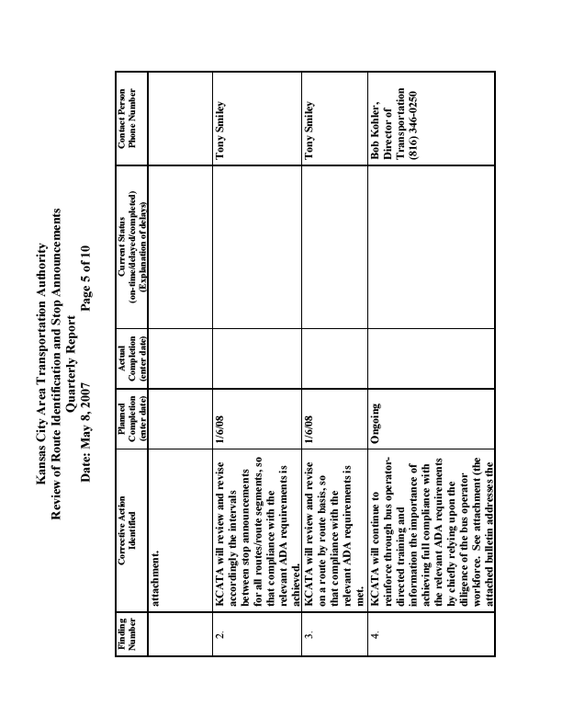

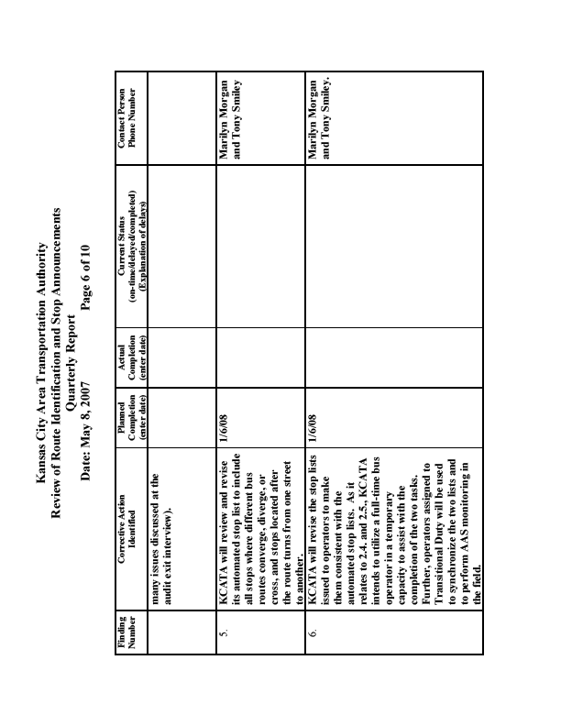

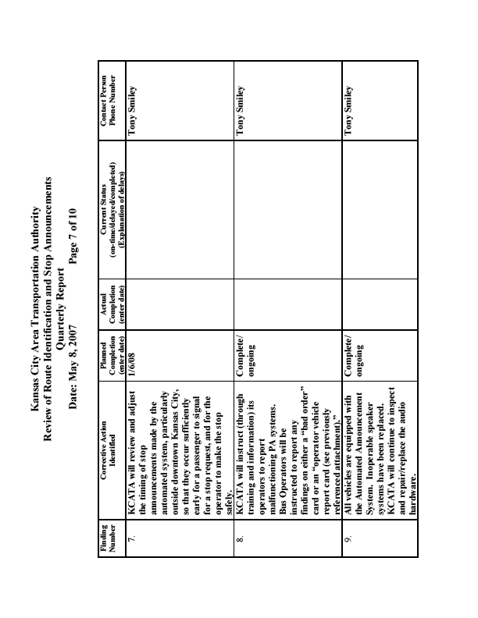

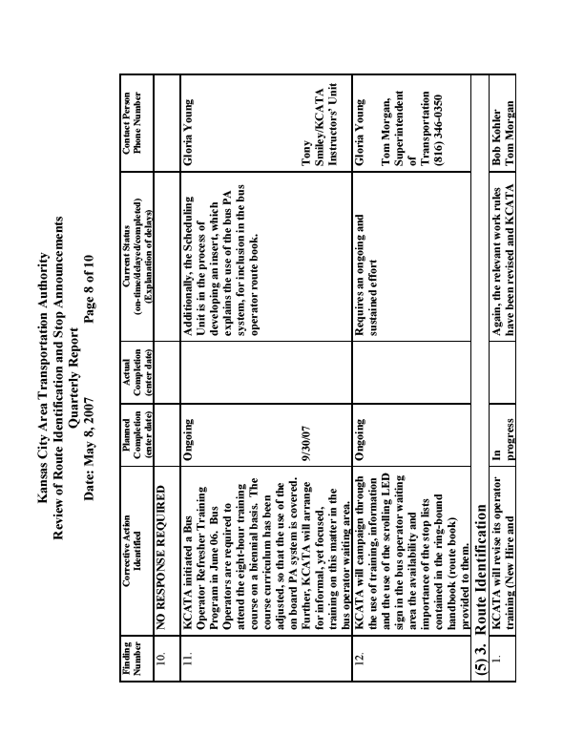

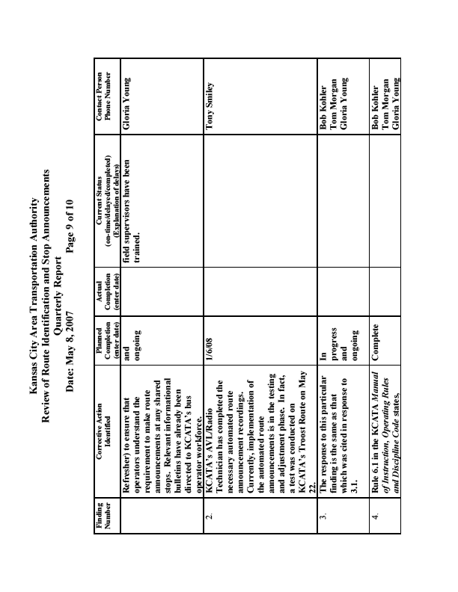

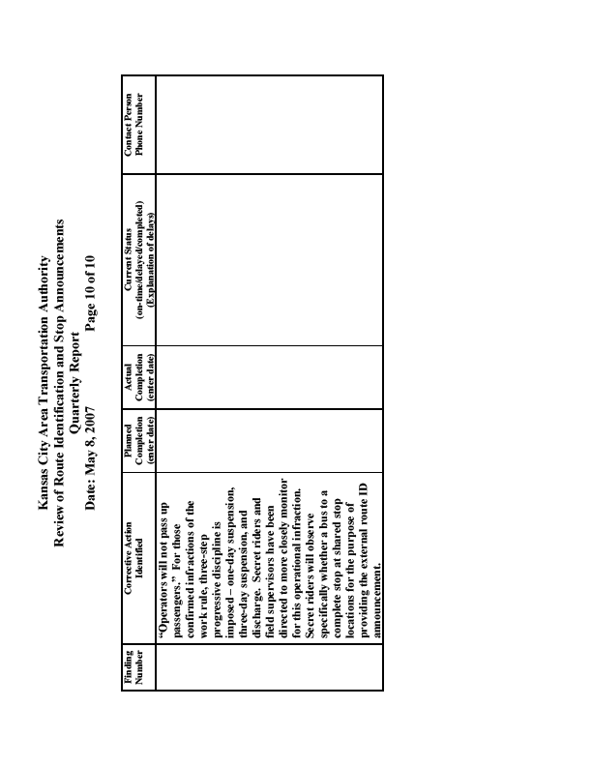

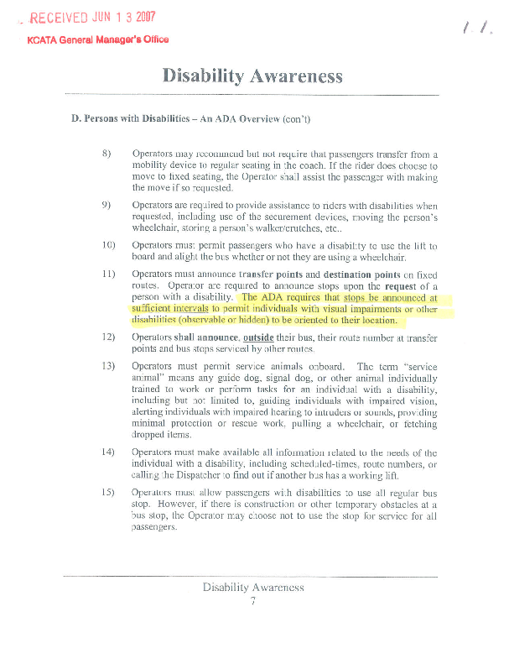

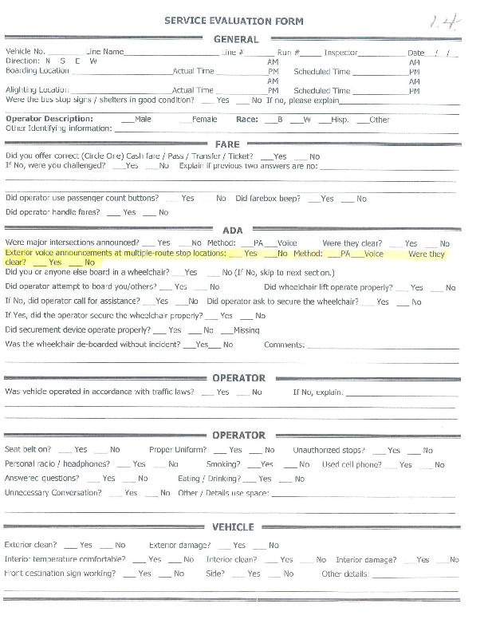

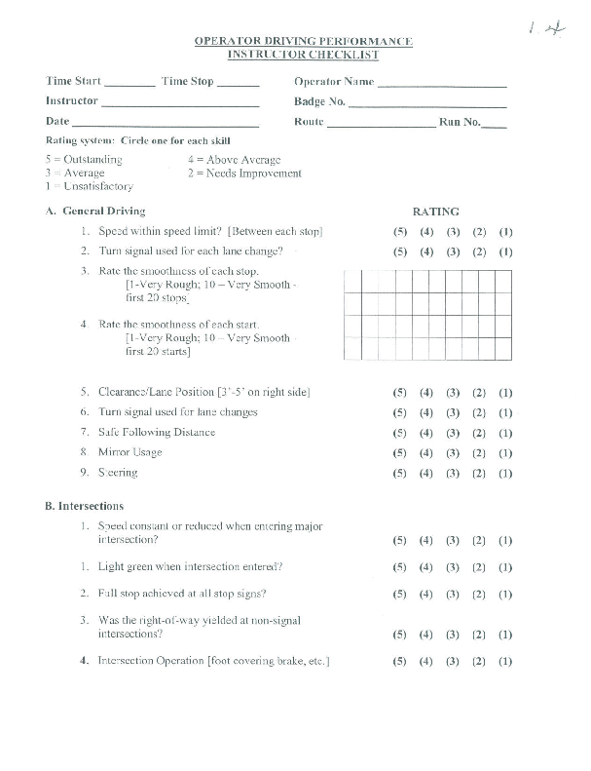

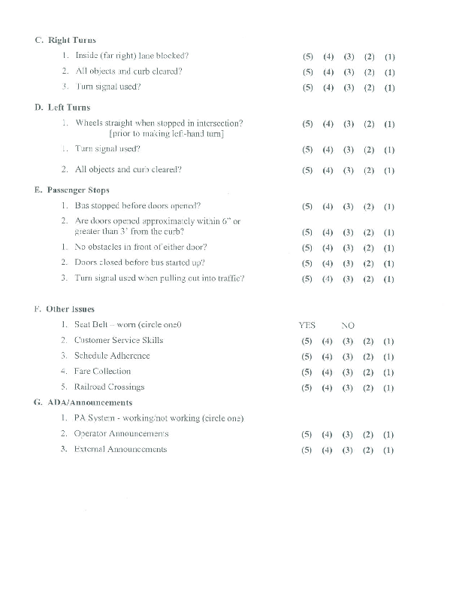

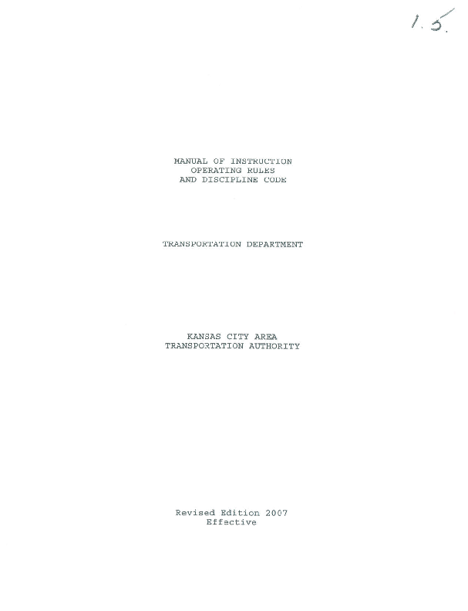

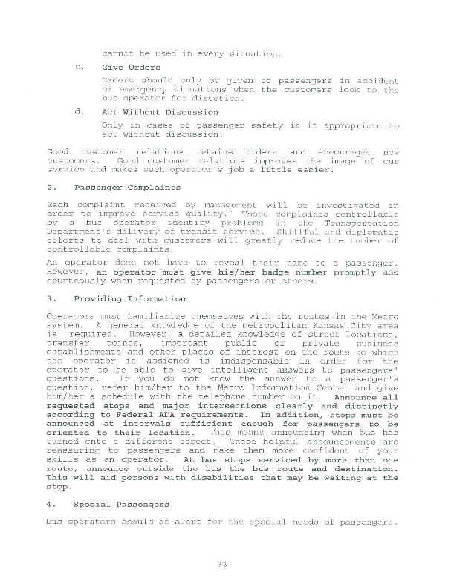

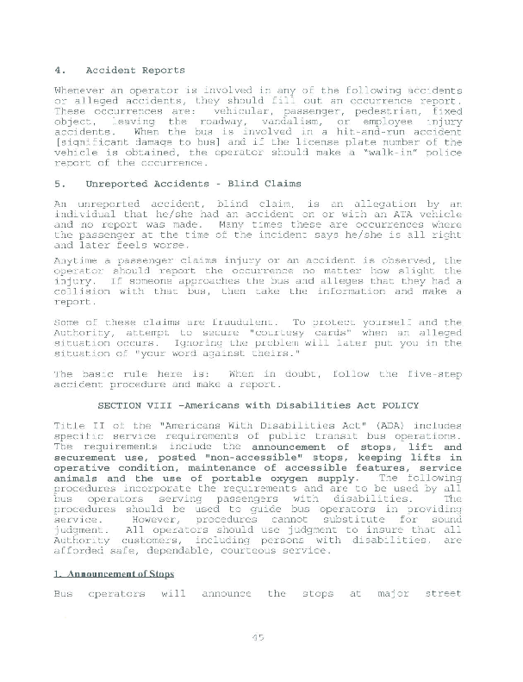

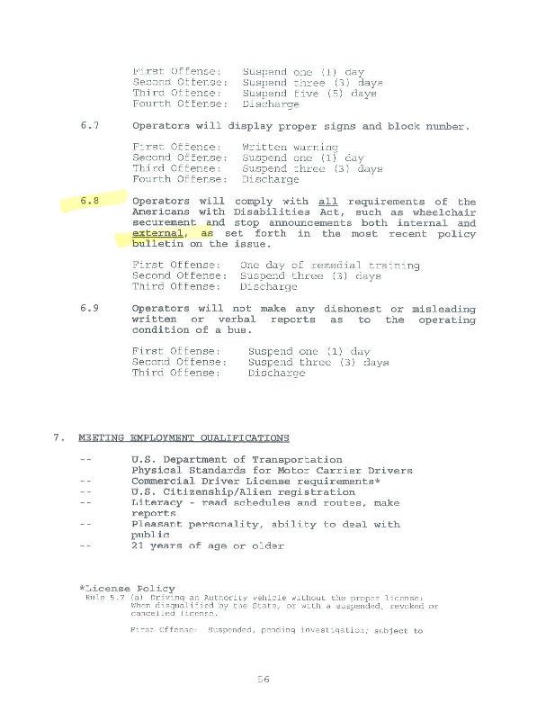

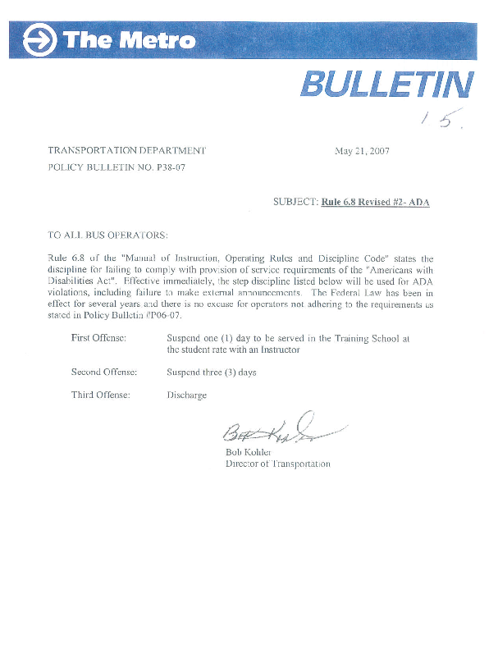

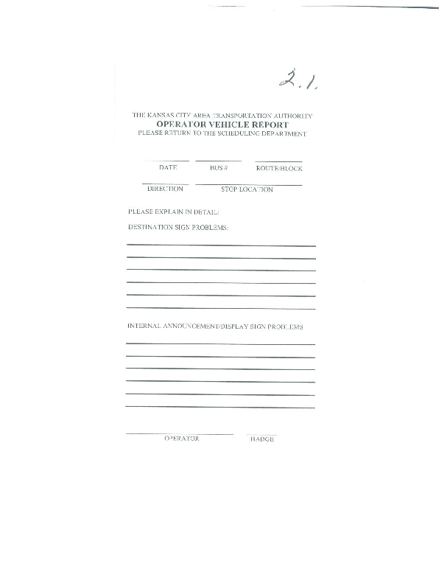

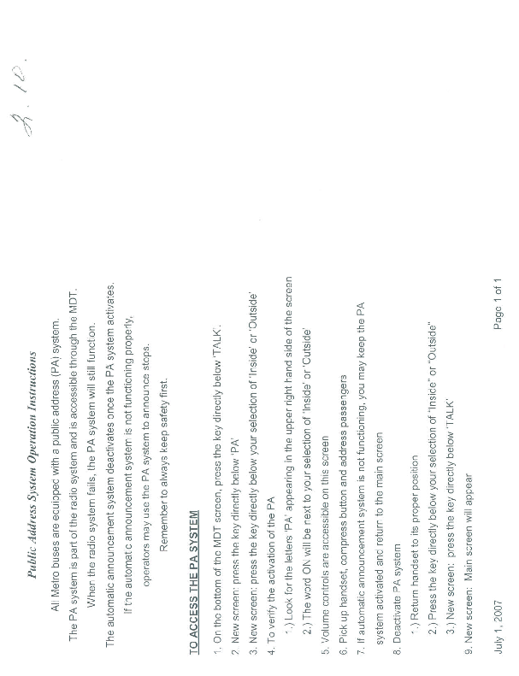

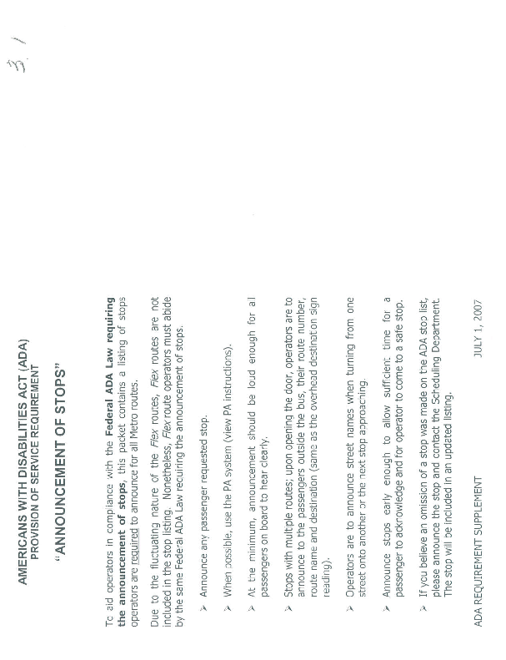

Attachment C

KCATA Instructor
Observation or Ride Report of Driving Practices
Attachment D

Service Evaluation Form
Attachment E

Operators Vehicle Report
Attachment F

Periodic Maintenance Inspection Forms
Attachment G

Fixed Route Operator Interview Form
Fixed Route Driver Interview Form

Agency: Kansas City Area Transportation Authority - KCATA

Driver Name ___________________________________________

Date and Place of Interview _______________________________

Reviewer ___________________________________________

- How long have you been a bus operator?

- When do you make on-board stop announcements?

- Are you provided a list of stops to announce?

- What do you do if a passenger asks you to announce a stop?

- Do you announce your route to waiting customers?

  - If yes, when, at what type of stops?

  - What do you announce?

- Do you drive buses that have automated stop announcement systems? How often

a. In your experience, does the automated stop announcement system typically work?

b. What do you do if the stop announcement system is not working?

- Do you drive buses that make automated external bus route announcements? How often?

  - In your experience, does the external route announcement system typically work?

  - What do you do if the bus route announcement system is not working?

- Do you use the PA system to make on-board stop announcements? How often?

  - In your experience, does the PA system typically work?

  - What do you do if the PA is not working?

- Do you check at the beginning of each shift to see if the PA or enunciator equipment is working?

  - If it is not working what do you do?

- Do you have any problems with making on-board stop and route announcements?

- Do you feel that you have all the information and training that you need to make the proper on-board stop announcements? Is there anything that would help you?

Attachment H

On-Board Fixed Route Stop Announcement
Assessment Form
On-Board Fixed Route Stop Announcements Assessment Form

Transit System Name: KCATA: Kansas City, MO Date: _______________________
Route #/Line Name: ______________________________________ Bus or Car #_________________
Boarded at: __________________________ Disembarked at: _____________________________
Time: _____________ AM / PM Time: _____________ AM / PM
Indicate below the stops that should be announced (transfer points, major intersections, major destinations).  Source: bus scheds, CDTA memos | Indicate Location Type |  |  | On-board Announcement Made? |  | External ID  Announcement Made?
Location | Transf | Intersect | Dest | Yes | No | Yes | No | N/A
Note: If announcements are made, how? using the PA system, by voice, or by automated system:
_____PA _____Voice _____Auto
Announcements Clear/Audible? _____Yes _____No _____Sometimes
Were other stops/locations called? _____Yes _____No
Notes:______________________________________________________________________________________________________________________________________________________________________________________________________________________________________________________
Signature and Name: ___________________________________________________
Attachment I

On-Board Stop Announcement Data
Date | Route | Dir | Bus | Boarding |  | Alight |  | Time | Stops Announced
 |  |  |  | Time | Location | Time | Location | Observed | Auto | Voice | Total | Inaudible
1/17 | 12 | EB | 2610 | 11:23 | 12th + Main | 11:39 | Jackson + Truman | 0:16 | 11 |  | 11 | 0
1/17 | 12 | WB | 2208 | 11:44 | Truman + Jackson | 12:01 | 11th + Baltimore | 0:17 | 9 |  | 9 | 0
1/16 | 24 | WB | 2308 | 5:29 | Rt 24 + Brookside | 6:02 | 11th + Grand | 0:33 | 10 |  | 10 | 0
1/16 | 24 | EB |  | 7:19 | 11+ Grand | 7:37 | Independence + Winner | 0:18 | 0 |  | 0 | 0
1/17 | 25 | NB | 2614 | 1:00 | 95 Livival + Bannister | 1:40 | 11th + Cherry | 0:40 | 15 | 0 | 15 | 0
1/16 | 25 | SB | 2315 | 9:08 | 11th + Main | 10:44 | 39th + Troost | 1:36 | 29 | 0 | 29 | 0
1/16 | 25 | NB | 2315 | 10:55 | 39th + Troost | 11:14 | 17th + Troost | 0:19 | 10 | 0 | 10 | 0
1/16 | 25 | NB | 2215 | 11:15 | 17th + Troost | 11:30 | 11th + Cherry | 0:15 | 4 | 0 | 4 | 0
1/16 | 28 | EB | 2229 | 10:23 | Lindwood + Gillham | 10:46 | Blue Ridge Park n Ride | 0:23 | 0 |  | 0 | 0
1/17 | 30 | EB |  | 8:58 | 11th + Grand | 9:16 | Belmont + Gladstone | 0:18 | 8 |  | 8 | 0
1/16 | 37 | NB | S-47 | 5:05 | Armour + Burlington | 5:41 | Metro North Mall | 0:36 | 2 | 0 | 2 | 1
1/17 | 38 | SB | S-97 | 7:58 | Antioch | 8:23 | 11th + Grand | 0:25 | 11 | 0 | 11 | 5.5
1/16 | 39 | EB | 8930 | 9:53 | 39th + Main | 10:05 | 39th + Indiana | 0:12 | 0 | 0 | 0 | 0
1/16 | 47 | EB |  | 8:44 | state Line + 42nd | 9:03 | 9th + Baltimore | 0:19 | 4 | 0 | 4 | 0
1/16 | 51 | SB | 2601 | 9:05 | 10th + Main | 9:25 | 47th + Nichols Pkwy | 0:20 | 0 | 0 | 0 | 0
1/16 | 53 | RT | 2611 | 12:05 | Armour + Troost | 12:45 | 12th + Grand | 0:40 | 2 | 2 | 4 | 0
1/16 | 54 | SB | 2611 | 9:38 | 10th + Grand | 10:00 | 31st + Linwood | 0:22 | 6 | 0 | 6 | 0
1/16 | 57 | NB | 2209 | 9:38 | 47th + Main | 9:43 | 39th + Main | 0:05 | 3 | 0 | 3 | 0
1/17 | 57 | SB | 9016 | 10:10 | 10th + Main | 10:55 | 74th + Terrace | 0:45 | 13 | 0 | 13 | 2
1/16 | 57 | NB | 8969 | 11:05 | 47th + Broadway | 11:30 | 11th + Walnut | 0:25 | 0 | 0 | 0 | 0
1/16 | 71 | SB | 2414 | 11:11 | 11th + Grand | 11:30 | 35th + Prospect | 0:19 | 0 | 0 | 0 | 0
1/16 | 101 | WB | 9613 | 7:45 | 10th + Main | 8:23 | Indian Springs | 0:38 | 2 |  | 2 | 0
1/17 | 101 | EB | 5110 | 8:22 | Armstrong + 7th | 8:41 | 10th + Main/Transit Ctr | 0:19 | 0 |  | 0 | 0
1/17 | 102 | WB | 5??? | 7:30 | 11th + Baltimore | 7:41 | 10th + Central | 0:11 | 3 |  | 3 | 1.5
1/17 | 104 | EB | 592 | 8:07 | 10th + Central | 8:18 | Ann + 7th -KC,KA | 0:11 | 2 |  | 2 | 0
1/16 | 106 | EB | 5118 | 2:00 | 7th + Armstrong | 2:16 | 10th + Main | 0:16 | 1 |  | 1 | 0
1/16 | 107 | WB | 591 | 1:19 | 47th + Rainbow | 1:38 | 7th + Armstrong - KC,KA | 0:19 | 5 | 1 | 6 | 0
1/16 | 107 | EB | 104 | 11:15 | Indian Springs | 11:59 | 43rd + Booth | 0:44 | 6 |  | 6 | 0
1/16 | 108 | NB | 9327 | 10:29 | 39th + Indiana | 10:49 | 11th + Grand | 0:20 | 7 | 0 | 7 | 0
1/16 | 109 | WB |  | 7:38 | Independence + Winner | 7:55 | 11th + Grand | 0:17 | 3 |  | 3 | 0
1/17 | 123 | EB | S-39 | 3:25 | Union Station | 3:45 | 23rd + Cleveland | 0:20 | 7 | 0 | 7 | 0
1/16 | 132 | NB | 280 | 4:55 | 8th + Grand | 5:02 | Armour + Burlington | 0:07 | 3 | 0 | 3 | 0
1/17 | 133 | NB | 540 | 7:49 | Vermont + Armour | 7:57 | Antioch | 0:08 | 3 | 0 | 3 | 1.5
1/16 | 133 | SB | 3387 | 11:08 | Antioch | 11:30 | 11th + Walnut | 0:22 | 13 | 0 | 13 | 6.5
1/17 | 135 | NB | 5123 | 7:27 | 11th + Walnut | 7:44 | Armour + Vernon | 0:17 | 10 | 0 | 10 | 0
1/16 | 137 | SB | 1248 | 9:00 | Metro North | 9:30 | Antioch | 0:30 | 0 | 2 | 2 | 2
1/16 | 137 | NB | 1129 | 9:30 | Antioch | 9:57 | Boardwalk Sq + Metro Ctr | 0:27 | 3 | 0 | 3 | 0
1/16 | 142 | SB | 119 | 6:14 | Metro North Mall | 6:40 | 11th + Grand | 0:26 | 9 | 0 | 9 | 4.5
1/16 | 142 | NB | 372 | 7:45 | Grand + 8th | 8:15 | Metro North Mall | 0:30 | 6 | 0 | 6 | 3
1/16 | 156 | RT | 585 | 11:20 | 74 Terrace | 12:16 | 74 Terrace | 0:56 | 0 | 0 | 0 | 0
1/17 | 173 | SB | 2313 | 9:50 | Front St + Sears | 10:11 | Pershing + McGee | 0:21 | 8 | 0 | 8 | 0
1/16 | 183 | EB | 94 | 12:01 | Independence Transfer | 12:14 | Rt 291 + Frontage | 0:13 | 0 | 0 | 0 | 0
1/16 | 235 | EB | 1131 | 11:46 | 35th + Prospect | 12:00 | 31st + Van Brunt | 0:14 | 4 | 0 | 4 | 0
1/16 | 243 | SB | 1236 | 10:19 | Boardwalk | 11:05 | Antioch | 0:46 | 0 | 1 | 1 | 0
1/16 | 257 | SB | 1127 | 12:40 | 74th + Terrace | 13:00 | 95 Livival + Bannister | 0:20 | 2 | 0 | 2 | 0
1/16 | 285 | NB | 1123 | 11:35 | Blue Ridge PnR | 11:55 | Independence Transfer | 0:20 | 0 | 0 | 2 | 0
1/16 | 291 | SB | 1113 | 4:41 | Truman Library | 4:50 | Independence Transfer | 0:09 | 1 | 0 | 1 | 0
1/16 | 292 | WB | 109 | 5:03 | Independence Transfer | 5:27 | Rt 24 + Brookside | 0:24 | 0 | 0 | 0 | 0
1/16 | 293 | WB | 1123 | 12:45 | Southview Manor | 12:58 | Independence Transfer | 0:13 | 1 | 6 | 7 | 0
1/16 | MAX | SB | 3504 | 3:06 | 11th + Grand | 3:21 | Main + Linwood | 0:15 | 8 | 0 | 8 | 0
1/16 | MAX | NB | 3506 | 3:22 | Main _ Linwood | 3:40 | 9th + Grand | 0:18 | 11 | 0 | 11 | 0
1/16 | MAX | SB | 3511 | 3:40 | 14th + Wyandotte | 4:00 | Main + 45th | 0:20 | 10 |  | 10 | 0
1/16 | MAX | NB | 3512 | 4:35 | Main + 45th | 4:52 | 12th + Main | 0:17 | 10 |  | 10 | 0
1/16 | MAX | NB | 3507 | 7:37 | 9th + Oak | 8:00 | Plaza | 0:23 | 0 | 13 | 13 | 6.5
1/16 | MAX | NB | 3500 | 8:10 | Plaza | 8:55 | 11th + Main | 0:45 | 19 | 0 | 19 | 0
1/16 | MAX | SB | 3508 | 9:45 | Convention Center | 9:56 | Linwood | 0:11 | 6 | 0 | 6 | 0
1/16 | MAX | NB | 3500 | 10:10 | Linwood | 10:20 | Union Station | 0:10 | 3 | 0 | 3 | 0
1/16 | MAX | SB | 3508 | 10:32 | Union Station | 11:00 | 47 + Nichols Pkwy | 0:28 | 8 | 0 | 8 | 0
58 observations |  |  |  |  |  |  |  | 22:48 | 311 | 25 | 338 | 34
 |  |  |  |  |  |  |  |  | 92% | 7% |  | 11%

Attachment J

KCATA Transfer Points

Attachment K

External Route Identification Data
Date | Location | Time | Route | Bus # | Route Announced?
17-Jan | 10th + Grand | 07:25 | 53 | 8952 | No
17-Jan | 10th + Grand | 07:30 | 28xx | 2409 | No
17-Jan | 10th + Grand | 07:30 | 30 | 2605 | No
17-Jan | 10th + Grand | 07:35 | 71 | 9606 | No
17-Jan | 10th + Grand | - | 24 | 2323 | No
16-Jan | 10th + Main | 05:02 | 28 | 2223 | No
16-Jan | 10th + Main | 05:06 | - | 2606 | Yes
16-Jan | 10th + Main | 05:07 | 28x | 8969 | No
16-Jan | 10th + Main | 05:11 | 47 | S-67 | No
16-Jan | 10th + Main | 05:15 | 28x | 9633 | No
16-Jan | 10th + Main | 05:17 | 51 | 9624 | No
16-Jan | 10th + Main | 05:22 | 28x | 9616 | No
16-Jan | 10th + Main | 05:30 | 173 | 2617 | No
16-Jan | 10th + Main | 05:31 | 28x | 2232 | No
16-Jan | 10th + Main | 05:41 | 126 | 9630 | No
16-Jan | 10th + Main | 05:45 | 28x | 2220 | No
16-Jan | 10th + Main | 05:45 | 47 | S-101 | No
16-Jan | 10th + Main | 06:01 | 47 | S-41 | No
16-Jan | 10th + Main | 07:31 | 106 | S-71 | No
16-Jan | 10th + Main | 07:45 | 101 | 613 | No
16-Jan | 10th + Main | 09:00 | 51 | 2601 | No
16-Jan | 10th + Main | 09:01 | 10 | 573 | No
16-Jan | 10th + Main | 09:02 | 101 | 9613 | No
17-Jan | 10th + Main | 06:56 | 51 | 2316 | No
17-Jan | 10th + Main | 07:05 | 106 | S-120 | No
17-Jan | 10th + Main | 07:05 | 173 | 2313 | No
17-Jan | 10th + Main | 07:10 | 51 | 2210 | No
17-Jan | 10th + Main | 07:15 | 101 | S-110 | No
17-Jan | 11th + Baltimore | 07:21 | 126 | - | No
17-Jan | 11th + Baltimore | 07:25 | 25 | 9628 | No
17-Jan | 11th + Baltimore | 07:29 | 101 | - | No
17-Jan | 11th + Baltimore | 07:30 | 102 | - | No
16-Jan | 11th + Grand | 01:48 | 24 | 9602 | No
16-Jan | 11th + Main | 08:54 | 25 | - | No
16-Jan | 11th + Main | 09:00 | 12 | 9515 | No
16-Jan | 11th + Main | 09:08 | 25 | 2315 | No

Date | Location | Time | Route | Bus # | Route Announced?
16-Jan | 12th + Grand | 01:12 | - | 2802 | No
16-Jan | 12th + Grand | 01:20 | 71 | 2307 | No
16-Jan | 12th + Grand | 01:24 | 53 | 9609 | No
16-Jan | 12th + Grand | 01:56 | 53 | 5401 | No
16-Jan | 12th + Grand | 02:01 | 24 | 2218 | No
16-Jan | 12th + Grand | 02:07 | 71 | 2210 | No
16-Jan | 12th + Grand | 02:08 | 142 | 5113 | No
16-Jan | 12th + Grand | 02:11 | 108 | 2230 | No
16-Jan | 12th + Grand | 02:16 | 71 | 9631 | No
16-Jan | 12th + Grand | 02:17 | 24 | 2310 | No
16-Jan | 12th + Grand | 02:24 | 71 | 2414 | No
16-Jan | 12th + Grand | 02:25 | 8 | 9327 | No
16-Jan | 12th + Grand | 02:25 | 28x | 2614 | No
16-Jan | 12th + Grand | 02:26 | 54 | 5303 | No
16-Jan | 12th + Grand | 02:27 | 57 | 9621 | No
16-Jan | 12th + Grand | 02:29 | 24 | 9620 | No
16-Jan | 12th + Grand | 02:36 | 71 | 2607 | No
16-Jan | 12th + Grand | 02:42 | 108 | 2609 | No
16-Jan | 12th + Grand | 02:43 | 71 | 2307 | No
16-Jan | 12th + Grand | 02:44 | 24 | 2221 | No
16-Jan | 12th + Grand | - | - | 9327 | No
16-Jan | 12th + Grand | - | 142 | S-100 | No
17-Jan | 12th + Main | 11:20 | Max | 3500 | No
17-Jan | 12th + Main | 11:23 | 12 | 2610 | No
16-Jan | 39th + Troost | 10:46 | 39 | - | No
16-Jan | 39th + Troost | 10:48 | 39 | - | No
16-Jan | 39th + Troost | 10:55 | 25 | 2610 | No
16-Jan | Plaza | 08:10 | Max | 3500 | No
16-Jan | Union Station | 10:20 | - | 2209 | No
16-Jan | Union Station | 10:22 | Max | 3506 | No
16-Jan | Union Station | 10:32 | Max | 3508 | No
16-Jan | Union Station | 11:05 | 57 | 8969 | No

Total observations: 68
Route identifications: 1

